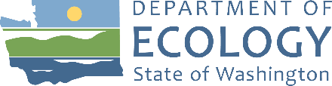
Agenda
Resource Damage Assessment (RDA) Committee Meeting
August 10, 2022, 9:00 a.m. to 12:00 p.m.
Committee Chair: Geoff Baran (geoff.baran@ecy.wa.gov)

Location
Zoom
Meeting number: 834 0324 4817
Join by phone (if not using computer audio): 253-215-8782
Meeting Link: Click Here
Zoom Help
Handouts
Found on Committee Webpage
- ERTS# 705942 Edgmon Trucking spill summary
- ERTS# 710387 Sea Scouts spill summary

Welcome and Introductions
9:00 a.m. | 10 minutes | Baran

Approval of July 13, 2022 Meeting Minutes
9:10 a.m. | 5 minutes | Baran | Decision

New Business

ERTS# 705942 Edgmon Trucking
9:15 a.m. | 30 minutes | Baran | Decision
Handout: ERTS# 705942 Edgmon Trucking spill summary
- Incident Review
- Discussion
- Vote

ERTS# 710387 Sea Scouts
9:45 a.m. | 30 minutes | Baran | Decision
Handout: ERTS# 710387 Sea Scouts spill summary
- Incident Review
- Discussion
- Vote

Old Business

Open Case Updates
10:15 a.m. | 10 minutes | Baran

Announcements

Roundtable
10:25 a.m. | 5 minutes | All

Adjournment
10:30 a.m. | 5 minutes | Baran
Next meeting – Wednesday, September 14, 2022 9:00 a.m. to 12:00 p.m., Zoom

