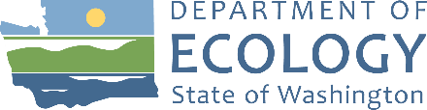
Agenda
Resource Damage Assessment (RDA) Committee Meeting
June 14, 2023, 9:00 a.m. to 12:00 p.m.
Committee Chair: Geoff Baran (geoff.baran@ecy.wa.gov)

Location
Department of Ecology HQ
Room R0A-32
300 Desmond Dr SE
Lacey, WA 98503
Handouts
Found on Committee Webpage
- ERTS #722807 P/C South Sound Fire and Diesel Spill
- Virtual Meeting Room: Zoom
Meeting number: 834 0324 4817
Join by phone (if not using computer audio): 253-215-8782
Meeting Link: Click Here
Zoom Help

Welcome and Introductions
9:00 a.m. | 10 minutes | Baran

Approval of May 10, 2023 Meeting Minutes
9:10 a.m. | 5 minutes | Baran | Decision

New Business

ERTS #722807 P/C South Sound Fire and Diesel Spill
9:15 a.m. | 30 minutes | Baran | Decision
Handout: ERTS #722807 P/C South Sound Fire and Diesel Spill report summary
- Incident Review
- Discussion
- Vote

Old Business

Open Case Updates
9:45 a.m. | 10 minutes | Baran
- ERTS #720988 Tug Tulalip Sinking and Oil Spill

Announcements

Roundtable
9:55 a.m. | 5 minutes | All

Adjournment
10:00 a.m. | 5 minutes | Baran
Next meeting – Wednesday, July 12, 2023, 09:00 a.m. to 12:00 p.m., Room R0A-32 and on Zoom

