Structural Stormwater Control

Policy Advisory Committee
May 31, 2022
1:00-4:00 p.m.

Meeting Notes

Welcome – Jim Nelson (1:04)
- Tech check

Review PAC Purpose, Objectives, Agenda, Rules
- See Jim Nelson’s PPT for reference.

Updates
- May 5th Evaluation Summary
  - Thank you for your helpful feedback! The facilitation team uses this information to try to improve each meeting. Your thoughts are helping us strike the right balance for our meeting dynamics.
- Topics Survey Summary and Schedule
  - Summary provided in Jim Nelson’s PPT
- Doodle Poll (Future Meetings)
  - Proposed schedule in Jim Nelson’s PPT
  - Poll is currently open. Will close June 2nd.
    - We have received 15 responses so far.
    - Will set meeting dates after poll closes, using whatever responses we have.
Planned Public Meetings – Abbey Stockwell (1:20)
- We are starting the listening sessions for the Phase I and Phase II permits and the stormwater manuals (events will be on June 6th and June 13th). Both events will cover the same content.
  - Our intent is to share our early thinking and receive feedback on the proposed permit changes.
  - One topic at the listening sessions will be street sweeping. We may want to revisit this topic at a future PAC meeting.
Aaron: What is the expected level of participation for PAC members in these sessions?
Abbey: We will cover some overlapping subjects, but otherwise PAC members do not have a required/specific role, though they are welcome to attend.

Project Type & Selection Criteria – Jim Nelson (1:24)

Questions for PAC Discussion
- Is the current project type list sufficient? Do we need more, less, or different project types?
- How are the Stormwater Management Plan requirements for describing progress; correct/sufficient?
Blair: Does “selection criteria” refer to item (g) on the slide, or something different?
Abbey: Phase I permittees select their projects based on their own selection process right now. Focuses on the level of flexibility around how permittees decide which comments they do.

JamBoard used to Collect PAC Feedback
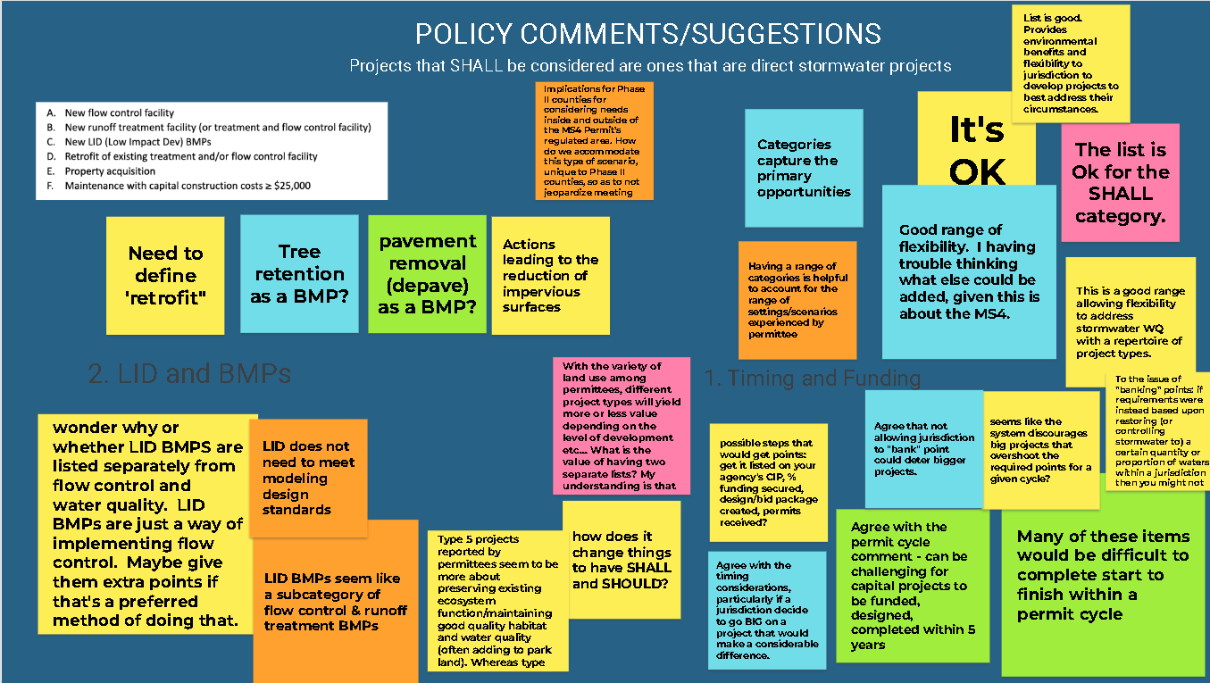
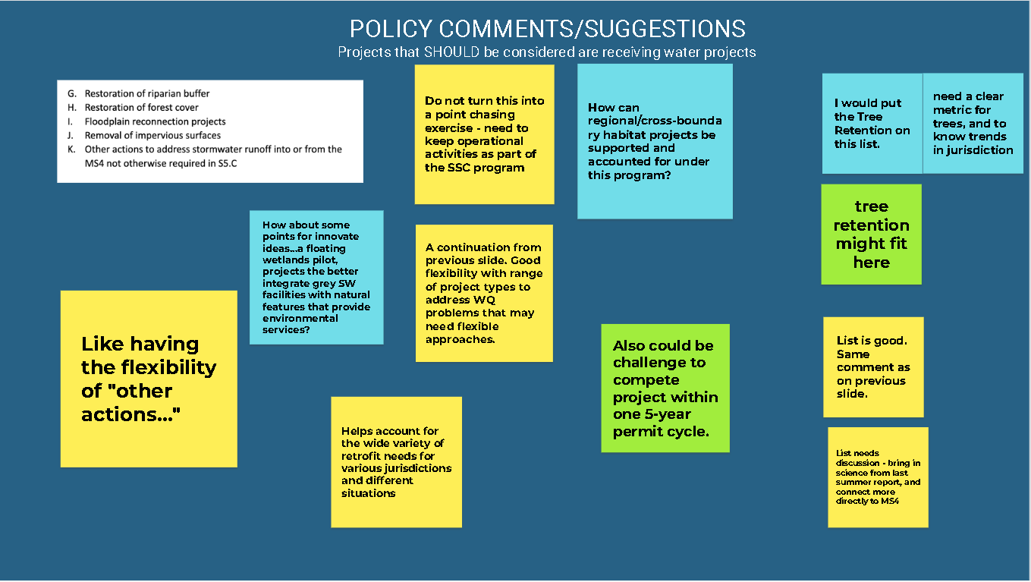

Themes
- PAC appreciates the flexibility in SSC’s existing framework.
- Some concerns around ability to complete projects within in a single permit cycle.

Discussion
Abbey: Are concerns around project completion time coming from Phase I or Phase II permittees?
Maureen: This is a concern for Phase I permittees. If any single step holds us up, we do not meet our deadline and do not receive points. Is there a way to grant points for steps within a project/process?
Merita: Agree with Maureen. Differences in budget cycles vs. permit cycles need to be considered. May leave municipalities very little time to plan/complete capital projects within a permit cycle.
Maureen: What if we get points in the planning phase for one permit cycle, but the project doesn’t start building until the next cycle?
- Propose that the planning points be broken up into sub-categories where points can be awarded before planning is fully complete.
Peter: What is ECY’s actual position on this? Can we allow jurisdictions to go for big projects that take longer than a permit cycle to “get off the ground?”
Abbey: Appendix 12 (in reference to the Phase I permit) says you can take things off your list if you are not going to use them to complete your points, but you are not required to take them off the list. It says “may”. You can keep your project on the list and count the planning points when the planning is complete, then the project sits on the list until it moves to construction status, at which point you get points for construction.
Doug: Right now, points are given at two milestones: planning and construction. We could add more checkpoints to award points, but need to define what constitutes sufficient effort for a checkpoint, particularly when planning a project.
- Abbey: 60% designed is a current mark that we have set to award points.
Aaron: Do permittees get to “carry over” points across permit cycles?
Abbey: No, they cannot carry them over, but they can receive planning points for a project in one permit cycle, then construction points in the next permit cycle.
Arthur: ECY’s requirements do not consider jurisdictional issues relating to Tribal lands.
Abbey: The permit requirements apply to a permittee’s jurisdiction, not to Tribal lands. ECY does not permit Tribal lands (that is EPA).
Peter: Is there a possibility of a “point bank” allowing jurisdictions to carry over points? Not allowing municipalities to time their own projects when it works best for them could introduce inefficiency and reduce overall project output.

BREAK (2:08)
Resume in 5 minutes

Project Type & Selection Criteria, Cont. - Jim Nelson (2:14)

Discussion
Alyssa: What about the idea of having separate requirements to retrofit the existing developed environment vs. preserving undeveloped land?
- Comment from Alyssa on draft notes: “on page 3, my intent with that comment is to have separate requirements to retrofit the built environment vs. preserving waters on less developed/undeveloped land because those are 2 different strategies and allowing permittees to select from, first, either strategy, and then second, the list of 11 types of qualifying SSC projects, has enabled permittees to report (and claim "credit" for) projects done in undeveloped areas that have little to no stormwater nexus. To Ingrid's comment that it would be difficult for Seattle to meet requirements to preserve undeveloped land - that's fine - such a new requirement could be applicable only for counties or areas with more rural/less developed area to actually preserve. I think separating the two strategies - retrofitting projects must actually retrofit the built environment, vs. protecting high quality waters from future development impacts - merits deeper consideration and would necessitate more impactful "true" retrofit projects. This ties in to my tailoring question on page 4.”
Ingrid: Initial reaction is that it would be difficult for Seattle to preserve undeveloped land since we are highly urbanized. Not much land left to preserve.

Moving Forward
Abbey: It would help to group the comments into categories. Share what we have learned with the PAC for review/consideration.

How does ECY offer sufficient flexibility for counties vs. cities? Is there more they could do?
Larry: For counties, should consider implications for potential annexations. What happens if a county pursues a large SSC project in an annexation prone area?
Abbey: That is a good point. More to think about.
Blair: How could the permit incentivize regional approaches around assistance/project selection? Could we explore planning on a watershed/basin scale? Maybe award points jointly to allow municipalities to work cooperatively?
Abbey: That could be worthy of discussion as part of the “how points are allocated” topic. We do not want the permit to be a barrier to watershed collaboration. We currently have a multiplier for points that are selected for projects that are in a watershed/basin plan.
Colleen: We allow collaborative work/approaches to a variety of permit requirements. It would be important to demonstrate that the project is having a local effect and that everyone’s level of participation is detailed and recorded.
- Alyssa: Would it be beneficial for requirements to be tailored to different municipalities with different land types based on their land characteristics?
Doug: You do not have to do everything on the SSC project type list. It is a menu of options to choose from, with the intent that each municipality should choose the options that are best for them.
- Adding more types/options to the list would be a good way to offer permittees more flexibility
Abbey: Is there a need for more clarity around the stormwater management nexus and the list of available options?
Alyssa: Yes, more clarity around which projects are eligible and how these projects are making an impact would be helpful.
Comment from Alyssa on Draft notes: “this comment gets to my earlier point that permittees have reported and claimed "credit" for projects with no (stated/reported) stormwater nexus. These include projects adding land to parks, demolishing homes in floodplains, riparian plantings as part of other projects, etc.”
Jim: How would you propose improving this?
Alyssa: A switch to more of a watershed-based approach, where you look at projects that restore/improve water within different jurisdictions within a permit cycle. Use outcome-based measurements instead of an effort-based or “point system” metric.
Abbey: How do PAC members feel about this idea?
Maureen: Using the watershed approach can be extremely expensive, not always maximally efficient, and can be difficult to measure without specific definitions. What does “demonstrative outcome” mean in this case? For example, what about land preservation? No demonstrative effect, but still has an impact.
Merita: Also concerned about what “demonstrative” would mean if this method were applied. How would this be measured? These approaches are often costly and time-consuming.
Blair: The amount of monitoring data that would need to be collected to answer these questions would be prohibitive. We might be better served spending money on active projects as opposed to passive monitoring.
Larry: This reminds me of why courts reaffirm that municipal discharges are regulated under a presumptive compliance framework (unlike industrial discharges). How can permittee SSC compliance be measured under this presumptive compliance framework? Think the Phase I permit’s “level of effort” approach attempted to define the presumptive compliance for the SSC obligation.
Jim: Alyssa, we would benefit from getting to see your written articulated thoughts on this.
Ingrid: The TAC’s work determined that the science is not yet there to facilitate a demonstrative-based evaluation model.
Abbey: The way that we use the permit to describe what permittees need to do to be compliant is through the performance measures, as articulated through the point system and use of multipliers. This sets a measurable level of progress and incentivizes the selection of projects that will have especially significant impact.
Jenny Gaus: We are facing the balance between lots of planning to make sure we are doing the right thing vs. “just do something” and not planning as much. Whatever we do will be a small drop in a big bucket. It is a complex problem.

BREAK (2:54)
Resume in 5 minutes

Phase I vs. Phase II – (3:03)
Abbey: As we are thinking about permit reissuance and what is next for Phase II requirements, we have these SMAP that should identify planned retrofits that they could potentially implement, or other specific measures identified in the permit.
As we consider what a Phase II stormwater retrofit program could look like, we would like to get feedback on its design. Should we:
- Model after the Phase I program?
- Take some elements of the Phase I program and make changes?
- Do something different?
Also looking for feedback from Phase I’s about how it is going, and what they think might work for Phase II?

What suggestions does the PAC have for ECY to help make the transition to Phase II?
Peter: There needs to be a delineation between big and small. Understand the different capacities between these two groups.
Some smaller jurisdictions were saying that if many new requirements came on during the next permit cycle, it would be “devastating.”
Jenny: Flexibility and cost considerations are important.
Maureen: If the SSC level of effort could support the recommendations that come out of the Phase II SMAP, that seems like the best outcome, but not sure how to do that.
Abbey: Agreed. We asked permittees to go through the process of developing the SMAP, so it makes sense that the requirements would support it. We attempt to do that through the multipliers, but unsure of other ways to accomplish it. Open to other ideas.
Jim: The flexibility of a large menu of options is desirable for Phase II, but how to implement/characterize that flexibility is tougher. Any thoughts on how to best accomplish this?
Larry: We ought not lump Phase II’s permittees into a single category. Their characteristics (e.g., staffing, funding, population, land use characteristics, etc.) range too broadly to describe them homogenously as single group. Defining level of effort appropriately across the range of Phase II municipalities is important to set them up for success. There should be some serious consideration that at least one of the SSC compliance options allows their SMAP to dictate the actions considered to support meeting their SSC program obligations.
Aaron: One lesson learn from the Phase I program is that most Phase I’s were able to meet their point requirements with a handful of projects, then they did a lot more than was required. Having more information (knowing where the retrofits are actually happening, where is the runoff actually going, etc.) would be helpful in helping us make meaningful progress.

What are examples of success from Phase I that might be informative for Phase II?
Blair: This requirement generated more conversations that might not have otherwise happened across agencies within King County. Made our internal coordination better.
Ingrid: Allowed us to show that we are making progress/providing benefit without defining/driving our program. It is a good start, but more science is needed to be sufficiently flexible to accommodate each municipality’s unique circumstances.
Jim: I encourage PAC members to offer their thoughts in writing about successful ways to transition to Phase II.

Presented a Mentimeter for PAC Members to Consider and Rate
- PAC feedback was captured in a screenshot by facilitation team.

Discussion
Merita: There is so much variability among Phase II’s it is hard to characterize.
Maureen: Are all these processes “shalls” in the current SMAP process?
Abbey: The SMAP process is not specific about project types.

Future Meeting Schedule (3:33)
REMINDER: Doodle Poll closes Thursday morning.

What would you like to discuss at July 6th meeting? What is most important to discuss?
Peter: July 6th seems pretty full. Not sure we can cover it all.
Jim: Agreed. It is ok if we do not get to all the topics in a meeting and push some of them to a future meeting.
Larry: Moving the Phase I vs. Phase II conversation later in the sequence may be beneficial.
Sheena: Agree with Larry. Seems like the Phase I vs. Phase II conversation would really benefit from talking about the multiplier systems first. Answering questions about appropriate level of effort, etc., would help inform the Phase I vs. Phase II discussion.
Abbey: There have been some comments about reporting. Should reporting be a discussion topic that is added to the list?
- Yes, we will add this to a future agenda.

Public Comments – Jim Nelson (3:43)
Jeremy: Thank you everyone for putting this together. This is a lot of work and it is appreciated. Hope that as the multiplier discussion comes up, hope that anything related to SMAP, TMDLs, and other forms of credit could be awarded/utilized.

Also hoping PAC could discuss projects that might not be viewed as an environmental lift, but are essential. For example, large maintenance projects like dredging for Capitol Lake.

Abbey: One of the major issues raised today was the variability of Phase II’s. Would love to hear feedback from the PAC about ways to classify/categorize the different Phase II’s.

Also heard there needs to be a range of project types. Is the list of projects from Phase I adequate? Do we need to add more projects types, or do we need a different model, such as choosing between following the SMAP or project type list?

Peter: How to deal with scenarios where a municipality tries something and it does not work?
Jeff: Appreciated the discussion about the variability of Phase IIs permittees. Agree that we cannot really put them all in one bucket.
When we return to the “level of effort” discussion, hoping PAC will have ideas about implementable metrics for their particular situation/level of financial capacity. What is the right attribute or attributes to focus on when scaling the requirement?
Some suggestions: Population of MS4 in the permitted area with a correction factor for hardship communities. Maybe multiplied by median household income?

Adjourn (3:55)

https://www.ezview.wa.gov/Portals/_1962/Documents/StructuralStormwaterControls/May%2031%20Slides%20JN%20fINAL.pdf

