Symbol | Polymer Name | Packaging & Product Examples |  |  |  | 2.13% of WA Waste
PETE | Polyethylene  Terephthalate  {PETE or PET) | - Soft drink bottles  - Water bottles  - Sports drink bottles  - Salad dressing bottles  - Vegetable oil bottles | - Peanut butter jars  - Pickle jars  - Jelly jars  - Prepared food trays  - Mouthwash bottles |  | 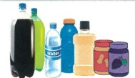 | - PETE Plastic Bottles 0.6%  - PETE Plastic Non-bottles 0.5%
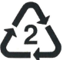  HDPE | High-density  Polyethylene  (HDPE) | - Milk jugs  - Juice bottles  - Yogurt tubs  - Butter tubs  - Cereal box liners | - Shampoo bottles  - Motor oil bottles  - Bleach bottles  - Household cleaner Grocery bags |  | 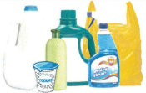 | - HDPE Natural Bottles 0.2%  - HDPE Colored Bottle 0.2%  - HDPE Jars & Tubs 0.1%
PVC or V | Polyvinyl  Chloride  {PVC or V) | - Clear food packaging  - Wire/cable insulation  - Pipes/fitting  - Siding  - Flooring | - Fencing  - Window frames  - Shower curtains  - Lawn chairs  - Children's toys |  | 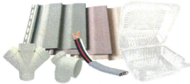 | - PVC Plastic Packaging 0.002%
LDPE | Low-density  Polyethylene  (LDPE) | - Dry cleaning bags  - Bread bags  - Frozen food bags  - Squeezable bottle | - Dispensing bottles  - 6 pack rings  - Molded Lab Equipment  - Wash bottles | 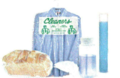 |  | - LDPE Plastic Packaging 0.002%
PP | Polypropylene  (PP} | - Ketchup bottles  - Most yogurt tubs  - Syrup bottles  - Bottle caps  - Straws | - Dishware  - Medicine bottles  - Some auto parts  - Pails  - Packing tape |  | 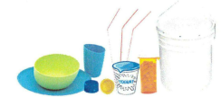 | - PP Plastic Packaging 0.3%
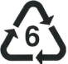  PS | Polystyrene  (PS} | - Disposable plates  - Disposable cutlery  - Cafeteria trays  - Meat trays  - Egg cartons | - Carry out containers  - Aspirin bottles  - CD/video cases  - Packaging peanuts  - Other Styrofoam |  | 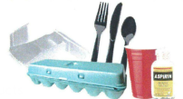 | - PS Plastic Packaging 0.025%
Other | Other Plastics  (OTHER or O) | - 3/5 gallon water jugs  - Citrus Juice bottles  - Plastic lumber  - Headlight lenses  - Safety glasses | - Gas containers  - Bullet proof materials  - Acrylic, nylon  - Misc. Plastic combo |  | 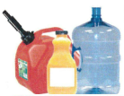 | - Other Plastic Packaging 0.2%
Overall, plastic packaging comprises 5.7% of WA’s waste stream by weight when combined with plastic packaging from other less common sources (such as plastic film at 2.7%). Source: 2016 WA DOE Waste Characterization Study. Image/List source: Action Environmental Group.
