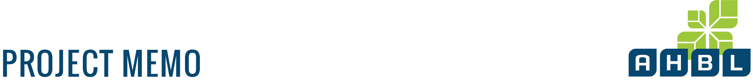

|  |  |  |  |  |
| --- | --- | --- | --- | --- |
|  |  | |  |  |
| **To:** | Joshua Beach  609 8th Street  Hoquiam, WA 98550 | | **Date:** | November 13, 2014 |
| **from:** | Brad Medrud | | **Project No.:** | 2130611.30 |
|  | Tacoma Office - (253) 383-2422 | | **Project Name:** | Aberdeen, Cosmopolis, Hoquiam SMP Update |
|  |  | | | |
| **Subject:** | Proposed Shoreline Environment Designations | | | |
|  | |  | |  |



This memo is for distribution before the first Citizen Advisory Committee (CAC) meeting.

It provides the CAC with information about Ecology’s requirements for developing shoreline environment designations as part of the Shoreline Master Plan (SMP) update process and background on the City’s proposed shoreline environment designations.

# What Are They?

For areas under Shoreline Management Act (SMA) jurisdiction, the intent of shoreline environment designations is to encourage uses that will protect or enhance the current or desired character of a shoreline. WAC 173-26-211(2)(a) requires that SMPs classify all shoreline areas into specific environment designations.

# How Are They Determined?

The State SMP Guidelines (WAC 173-26-211(2)(a)) require that local governments classify and map all of their shoreline of the state into environment designations based on the following four criteria:

1. Existing land use patterns
   1. What land uses have developed in each of the shoreline reaches to date as documented in the *Shoreline Inventory and Characterization*.
2. Biological and physical character of the shoreline
   1. The range of ecological characteristics and functions identified for each of the reaches in the City as documented in the *Shoreline Inventory and Characterization*:
   2. These include, but are not limited to:
      1. Channel movement and hydrological systems
      2. Areas subject to flooding
      3. Extent of riparian vegetation
      4. Fish and wildlife habitat and presence of species
      5. Areas of erosion and sedimentation
      6. Water quality and temperature
      7. Presence of nutrients and pathogens
      8. Critical areas
      9. Sites with potential for protection or restoration
3. The goals and aspirations of the community as expressed through each City’s Comprehensive Plan.
   1. This includes the goals and policies in the Comprehensive Plan(s) and its land use designations, as well as documents that translate the Comprehensive Plan’s goals and policies into action, such as
      1. Municipal Codes
         1. City of Aberdeen Municipal Code, especially Title 14 – Environmental Regulations, Title 15 – Building and Construction, Title 16 – Subdivisions, and Title 17 – Zoning.
         2. City of Cosmopolis Municipal Code, especially Title 14 – Building & Construction, Title 15 – Environment, Title 17 – Subdivisions, and Title 18 – Zoning.
         3. The City of Hoquiam Municipal Code, especially Title 9 – Subdivisions, Title 10 – Land Development, and Title 11 – Environment.
      2. Comprehensive Park and Recreation Plans
         1. Aberdeen Comprehensive Parks & Recreation Plan (2011 – 2016)
         2. Cosmopolis Park Plan
         3. Hoquiam Comprehensive Park & Recreation Plan 2011 - 2017
   2. The State SMP Guidelines (WAC 173-26-211(3)) note that the Comprehensive Plan provides the underlying framework for the SMP. The Growth Management Act (GMA) establishes the SMP as an element of the City’s Comprehensive Plan and, therefore, environment designations must be consistent with the City’s Comprehensive Plan.
4. Specific criteria for each of the environment designations found in WAC 173-26-211(5)

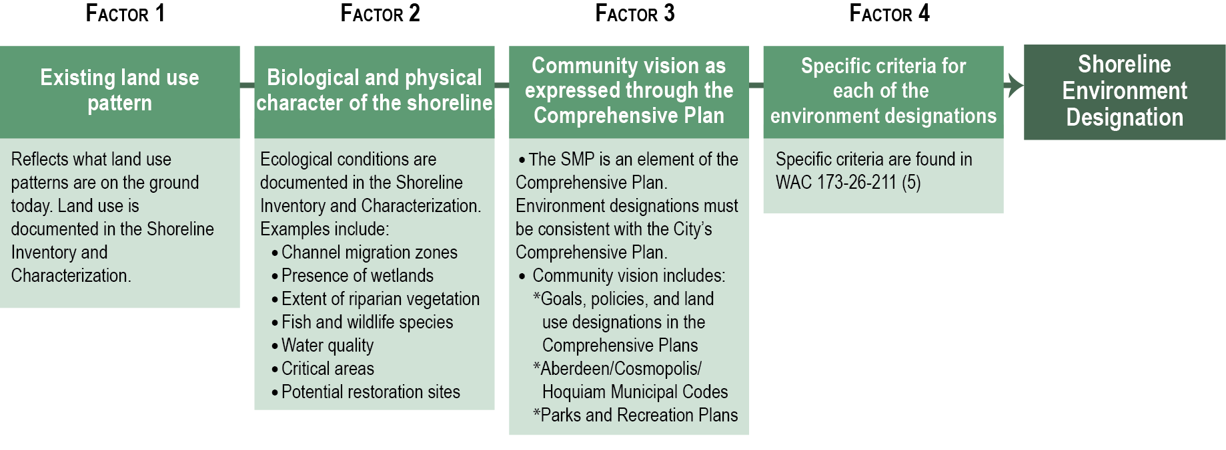

# What Do They Do?

Once each environment designation is established, management policies and regulations specific to the environment designations will be prepared as part of the Shoreline Master Program (SMP) draft that the CAC will review and provide comments on. The management policies and regulations will reflect the purpose and intent of each environment designation. Environment designations provide “the framework for implementing shoreline policies and regulatory measures specific to the environment designation” (WAC 173-26-191(1)(d)).

These policies and regulations will apply to all uses within each environment designation. They establish what kind of uses will be permitted outright, will need a shoreline conditional use permit, or are prohibited in that part of the shoreline jurisdiction. They also establish bulk and dimensional regulations for development within each environment designation. Analogous to a zoning code, these regulations can include maximum heights, setbacks, maximum lot coverage, maximum impervious surface coverage, as well as specific regulations that, for example, address site development, vegetation, and public access.

# What Can They Be?

For urban areas, the [SMP Guidelines](http://www.ecy.wa.gov/programs/sea/sma/guidelines/index.html) recommend using the five environment designations below. The purposes are defined in WAC 173-26-211(5). Local governments may establish a different environment designation system, provided it is consistent with the purposes and policies of the SMP Guidelines.

1. High-intensity - The purpose of the "high-intensity" environment is to provide for high-intensity water-oriented commercial, transportation, and industrial uses while protecting existing ecological functions and restoring ecological functions in areas that have been previously degraded.  
     
   Specific designation criteria in WAC 173-26-211(5)(d)(iii): *Assign a "high-intensity" environment designation to shoreline areas within incorporated municipalities, urban growth areas, and industrial or commercial "limited areas of more intensive rural development," as described by RCW 36.70A.070, if they currently support high-intensity uses related to commerce, transportation or navigation; or are suitable and planned for high-intensity water-oriented uses.*
2. Shoreline residential - The purpose of the "shoreline residential" environment is to accommodate residential development and appurtenant structures that are consistent with this chapter. An additional purpose is to provide appropriate public access and recreational uses.

Specific designation criteria in WAC 173-26-211(5)(f)(iii): *Assign a "shoreline residential" environment designation to shoreline areas inside urban growth areas, as defined in RCW 36.70A.110, incorporated municipalities, "rural areas of more intense development," or "master planned resorts," as described in RCW 36.70A.360, if they are predominantly single-family or multifamily residential development or are planned and platted for residential development.*

1. Urban conservancy - The purpose of the "urban conservancy" environment is to protect and restore ecological functions of open space, flood plain and other sensitive lands where they exist in urban and developed settings, while allowing a variety of compatible uses.

Specific designation criteria in WAC 173-26-211(5)(e)(iii): *Assign an "urban conservancy" environment designation to shoreline areas appropriate and planned for development that is compatible with maintaining or restoring of the ecological functions of the area, that are not generally suitable for water-dependent uses and that lie in incorporated municipalities, urban growth areas, or commercial or industrial "limited areas of more intensive rural development" if any of the following characteristics apply:*

1. *They are suitable for water-related or water-enjoyment uses;*
2. *They are open space, flood plain or other sensitive areas that should not be more intensively developed;*
3. *They have potential for ecological restoration;*
4. *They retain important ecological functions, even though partially developed; or*
5. *They have the potential for development that is compatible with ecological restoration.*

*Lands that may otherwise qualify for designation as urban conservancy and which are designated as "mineral resource lands" pursuant to RCW 36.70A.170 and WAC 365-190-070 may be assigned a designation within the "urban conservancy" environment that allows mining and associated uses in addition to other uses consistent with the urban conservancy environment.*

1. Natural - The purpose of the "natural" environment is to protect those shoreline areas that are relatively free of human influence or that include intact or minimally degraded shoreline functions intolerant of human use. These systems require that only very low intensity uses be allowed in order to maintain the ecological functions and ecosystem-wide processes. Consistent with the policies of the designation, local government should include planning for restoration of degraded shorelines within this environment.

Specific designation criteria in WAC 173-26-211(5)(a)(iii): *A "natural" environment designation should be assigned to shoreline areas if any of the following characteristics apply:*

1. *The shoreline is ecologically intact and therefore currently performing an important, irreplaceable function or ecosystem-wide process that would be damaged by human activity;*
2. *The shoreline is considered to represent ecosystems and geologic types that are of particular scientific and educational interest; or*
3. *The shoreline is unable to support new development or uses without significant adverse impacts to ecological functions or risk to human safety.*

*Such shoreline areas include largely undisturbed portions of shoreline areas such as wetlands, estuaries, unstable bluffs, coastal dunes, spits, and ecologically intact shoreline habitats. Shorelines inside or outside urban growth areas may be designated as "natural."*

*Ecologically intact shorelines, as used here, means those shoreline areas that retain the majority of their natural shoreline functions, as evidenced by the shoreline configuration and the presence of native vegetation. Generally, but not necessarily, ecologically intact shorelines are free of structural shoreline modifications, structures, and intensive human uses. In forested areas, they generally include native vegetation with diverse plant communities, multiple canopy layers, and the presence of large woody debris available for recruitment to adjacent water bodies. Recognizing that there is a continuum of ecological conditions ranging from near natural conditions to totally degraded and contaminated sites, this term is intended to delineate those shoreline areas that provide valuable functions for the larger aquatic and terrestrial environments which could be lost or significantly reduced by human development. Whether or not a shoreline is ecologically intact is determined on a case-by-case basis.*

*The term "ecologically intact shorelines" applies to all shoreline areas meeting the above criteria ranging from larger reaches that may include multiple properties to small areas located within a single property.*

*Areas with significant existing agriculture lands should not be included in the "natural" designation, except where the existing agricultural operations involve very low intensity uses where there is no significant impact on natural ecological functions, and where the intensity or impacts associated with such agriculture activities is unlikely to expand in a manner inconsistent with the "natural" designation.*

1. Aquatic - The purpose of the "aquatic" environment is to protect, restore, and manage the unique characteristics and resources of the areas waterward of the ordinary high-water mark.

Specific designation criteria in WAC 173-26-211(5)(c)(iii): *Assign an "aquatic" environment designation to lands waterward of the ordinary high-water mark.*

*Local governments may designate submerged and intertidal lands with shoreland designations (e.g., "high-intensity" or "rural conservancy") if the management policies and objectives for aquatic areas are met. In this case, the designation system used must provide regulations for managing submerged and intertidal lands that are clear and consistent with the "aquatic" environment management policies in this chapter. Additionally, local governments may assign an "aquatic" environment designation to wetlands.*

**Table 1 – Shoreline Environment Designation Descriptions**



# What Is Being Proposed?

Rationale for the proposed shoreline environment designations is detailed in the *Shoreline Inventory and Characterization* beginning on page 61*.* The *SIC* provides designation criteria from WAC 173-26, existing land uses, Comprehensive Plan designations, and zoning designations for each shoreline reach. In addition, a map showing the shoreline environment designations proposed for the Cities of Aberdeen, Cosmopolis, and Hoquiam is included.

# Background Information

In you packet, the following items have been provided:

* *SMP Handbook* - Chapter 13 - Shoreline Environment Designations. This provides a good background to the requirements and the process for establishing shoreline environment designations.
* Copies of the final *Shoreline Inventory and Characterization Report*.
* Comprehensive Land Use Designation Map and the Zoning Map
* WAC 173-26-211 – Environment designation system

# Next Steps

We would like to have consensus from the CAC on what they believe are the appropriate shoreline designations, so we can move forward with discussions of the SMP goal, policies, and regulations.

**Figure 1  
Shoreline Environment Designation Flow Chart**

