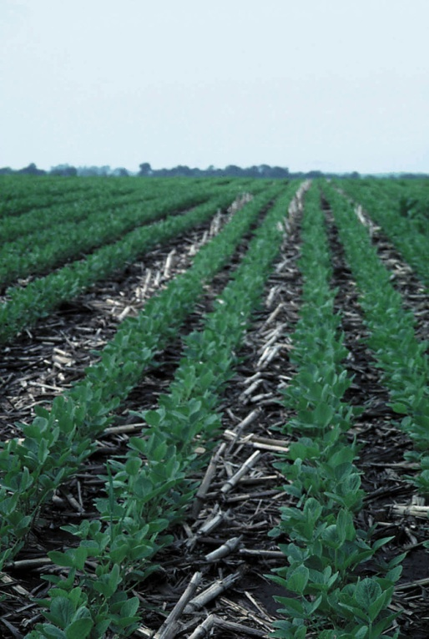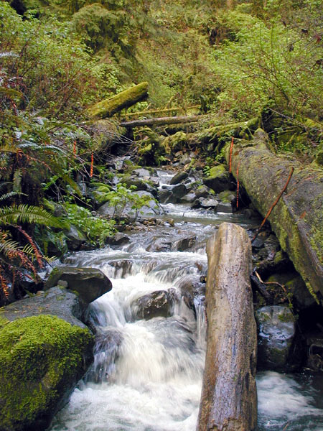ECOLOGO-C

Picture Description

**Insert picture here**

**Insert picture here**

Picture Description

Picture Description

**Project Description**

**[**This project improves water quality in the (Name of Waterbody) through the installation of (Type of Water Quality Facilities) at (Project Location) in the (City/County) of (Name). This project provides treatment or prevention for (list of specific pollutants). Additional benefits of this project include (list).**]**

**[**Provide a brief narrative to describe why your community needed this water quality project. Describe the pre-project conditions and the water quality problem. Include information related to the problems the project will fix/help fix, such as beach closures, complaints, health hazards, citizen complaints, regulatory compliance issues, newspaper articles, ugly smelly water etc.**]**

**Project Accomplishments**

**[**Provide a narrative and/or list of specific activities that were implemented by the project including, BMPs, outreach and education, and other deliverables. Include project partners.**]**

**[Project Title]**

**[Recipient]**

**[Grant Number]**

[Project open and close dates]

Final Total Project Cost: $

Final Ecology Grant Contribution: $

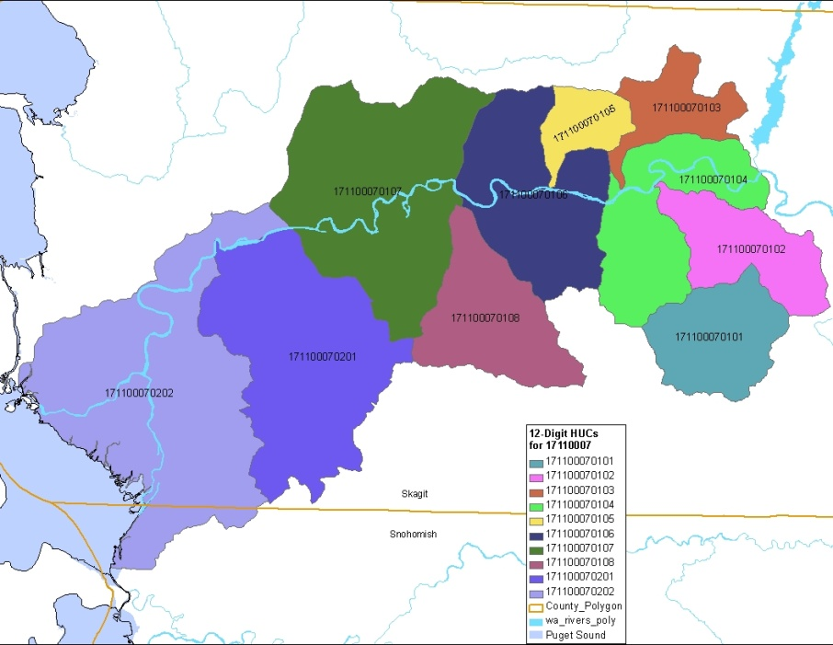

**Insert project map here**

Project Map caption

**Recipient Contact Information**

**The Next Step for Continued Success**

**[**Is there more work to be done to complete this project? If so, what is the estimated time frame and will the project be continued with or without Ecology funding? What operations and maintenance tasks will be performed and who will be performing them?**]**

**Lessons Learned**

**[**Discuss any notable and unexpected successes or challenges, if any**]**

**Water Quality Improvements**

**[**Discuss real and anticipated water quality improvements as a result of the project, mention any evidence.Is there any media coverage on this project?**]**