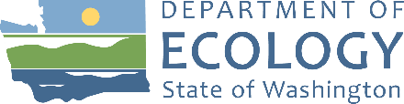
Agenda
Resource Damage Assessment (RDA) Committee Meeting
December 14, 2022, 9:00 a.m. to 12:00 p.m.
Committee Chair: Geoff Baran (geoff.baran@ecy.wa.gov)

Location
Zoom
Meeting number: 834 0324 4817
Join by phone (if not using computer audio): 253-215-8782
Meeting Link: Click Here
Zoom Help
Handouts
Found on Committee Webpage
- ERTS# 710394 Deep River Derelict Barge spill summary

Welcome and Introductions
9:00 a.m. | 10 minutes | Baran

Approval of November 9, 2022 Meeting Minutes
9:10 a.m. | 5 minutes | Baran | Decision

New Business

ERTS# 710394 Deep River Derelict Barge Spill
9:15 a.m. | 30 minutes | Baran | Decision
Handout: ERTS# 710394 Deep River Derelict Barge spill summary
- Incident Review
- Discussion
- Vote

Old Business

Open Case Updates
10:45 a.m. | 10 minutes | Baran

Announcements

Roundtable
10:55 a.m. | 5 minutes | All

Adjournment
11:00 a.m. | 5 minutes | Baran
Next meeting – Wednesday, January 11, 2023 09:00 a.m. to 12:00 p.m., Room R0A-32 and on Zoom

