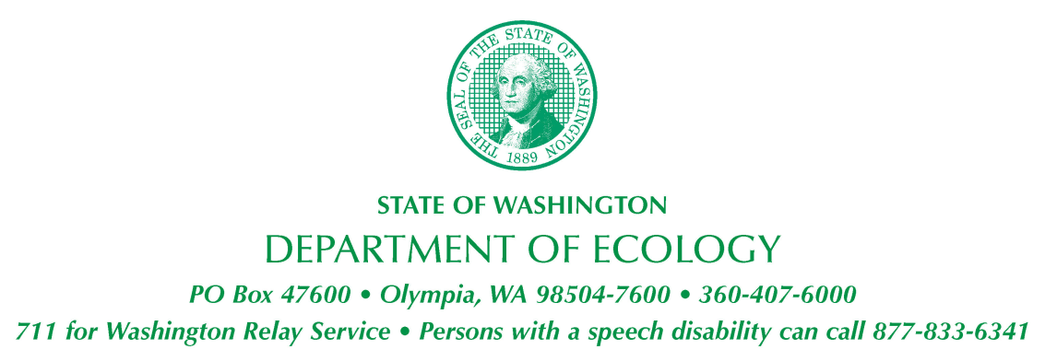

Natural Resource Damage Assessment Committee

January – December 2022 Meeting Schedule

The Washington State Natural Resource Damage Assessment (NRDA) Committee, which is chaired by the Department of Ecology, includes representatives of the State Departments of Fish and Wildlife, Natural Resources, Health, Archaeology and Historic Preservation, and the Parks and Recreation Commission. The committee makes decisions regarding the most appropriate damage assessment to pursue for oil spills in state waters, and evaluates restoration projects proposed by responsible parties in lieu of monetary claims.

Meetings for January through December 2022 will be held on the second Wednesday of each month, and start at 9:00 a.m.

This public meeting will be held virtually via WebEx and Zoom. Meeting links are available at the following web address:
https://ecology.wa.gov/Events/Search/Search-all?searchtext=natural+resource+damage+assessment+committee&searchmode=allwords

January 12, 2022 WebEx
February 9, 2022 Zoom
March 9, 2022 Zoom
April 13, 2022 Zoom
May 11, 2022 Zoom
June 8, 2022 Zoom
July 13, 2022 Zoom
August 10, 2022 Zoom
September 14, 2022 Zoom
October 12, 2022 Zoom
November 9, 2022 Zoom
December 14, 2022 Zoom

For more information, please contact Geoff Baran at (360) 790-9725, geoff.baran@ecy.wa.gov, or visit the Ecology website:
https://ecology.wa.gov/Spills-Cleanup/Spills/Spill-preparedness-response/Restoring-resources-after-spills

