EVALUATION GUIDANCE VISION
Proposed guidance will be provided for the following items in the training manual.
- Overview of the permit requirements that the report template and evaluation guidance are intended to support. Reference attached flow chart for WWA permit requirements.
- How to use this manual.
- An overview of community based social marketing vs social marketing. Reference attached diagram for comparison of methods.
- Selecting sample size for the target audience.
- Guidance for identifying the priority audience
- Information about recruiting participants to be involved in studies and increasing participant response rates
- Guidance for selecting methods and instruments that can be used to measure change. Instruments may include:
  - Surveys
  - Interviews
  - Focus groups
  - Observational
  - Photos
  - Drawings
- Guidance for designing and validating instruments
- Overview of the types of data that maybe collected and methods for analyzing the data.
- Responses to:
  - Multiple choice questions
  - Yes/no/maybe questions
  - Open ended questions
  - Responses to questions that follow a Likert scale: strongly agree, agree, neutral, disagree, strongly disagree
- Guidance for selecting statistical analysis methods including hypothesis testing including a comparison of methods that outlines recommended applications and limitations
- Software options for data analysis (reference attached example table)
- Quantitative data analysis methods including converting multiple choice data into a Likert scale
- For qualitative data (i.e., open ended survey/interview questions): guidance for coding data into common themes and validating themes
- Provide level of expertise/time needed to follow through with the evaluation tools as well as confidence in the results or limits of the method. For example, data collected from self-reporting surveys has a lower confidence compared to observational data due to social desirability bias.
- References and weblinks to resources for items such as evaluation training

Proposed format for guidance:
- A check list will be included that outlines a step-by-step process for evaluating changes in understanding and adoptions of behavior change. The checklist will also reference the relevant training manual sections for additional guidance.
- Flow charts that provide overview of selection process followed by details about decisions for each step (reference attached flow chart for sample size selection example)
- Examples
- References and weblinks for locating additional information

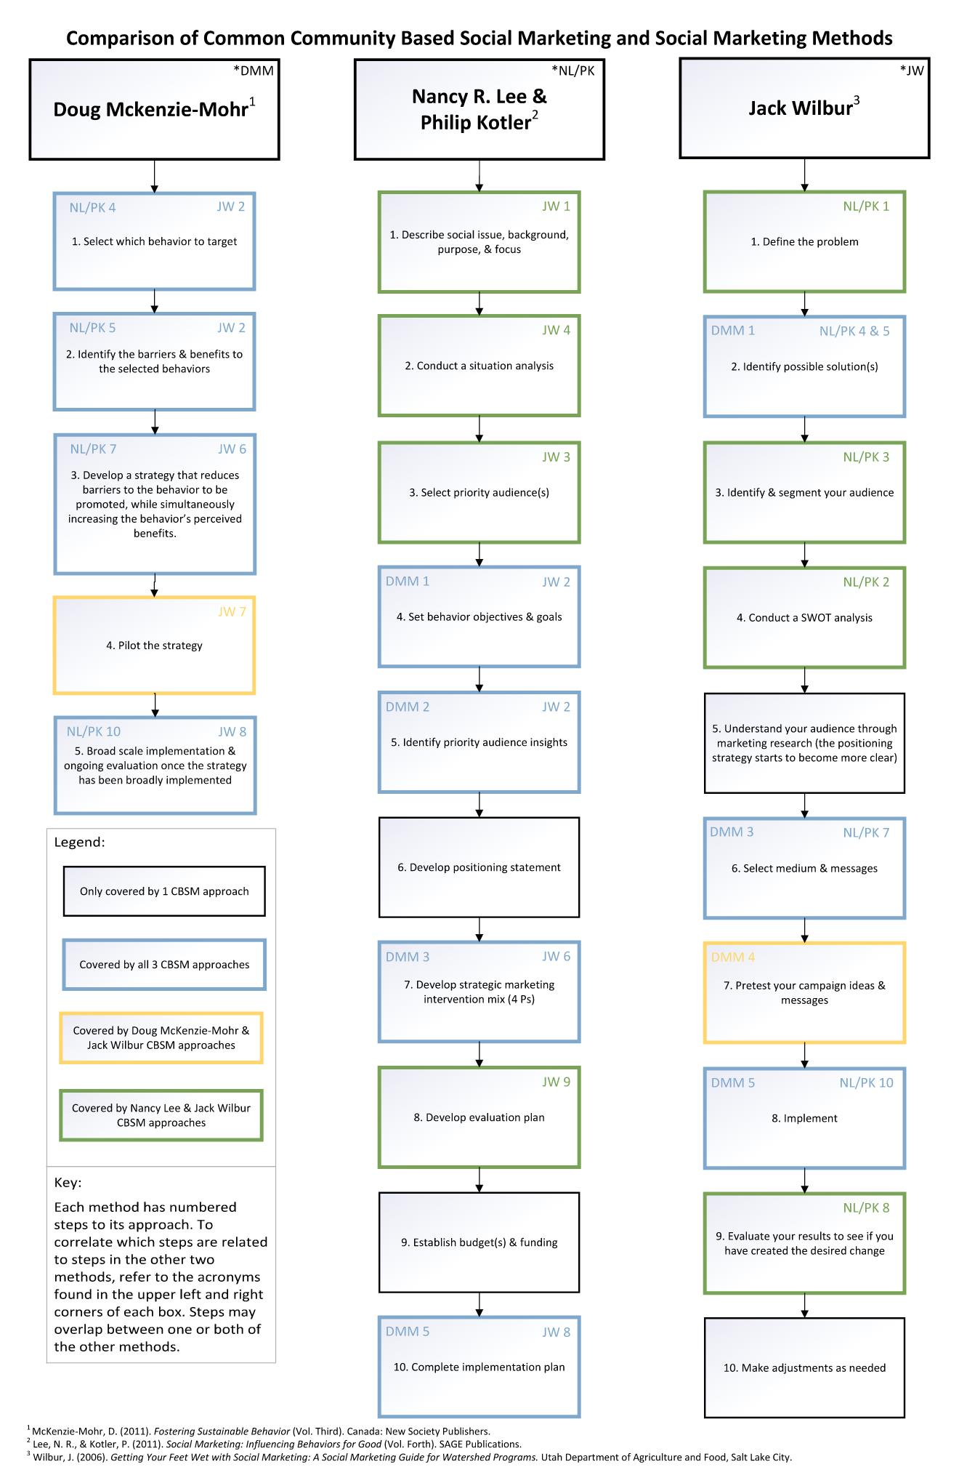
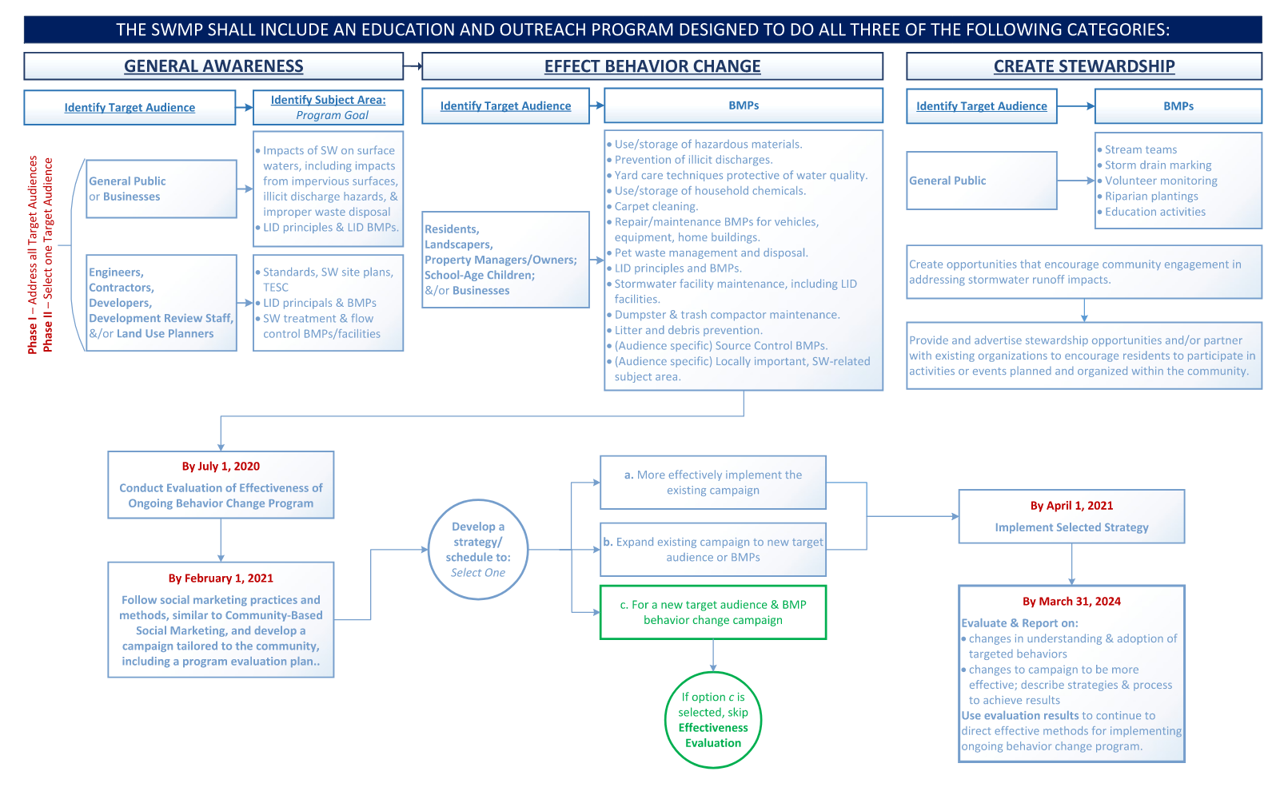
SUMMARY OF SOFTWARE OPTIONS
Software | Types of data analysis methods | Additional Description | Cost | Current version released | Manufactured/Developed By | Link to Website | Source
Excel |  |  | Free version; $139.99 without Microsft Office 365 | Microsoft Excel 2019 | Microsoft |  | Personal Experience
Minitab | t tests; one and two proportions; normality test; chi-square; equivalence tests | Offers government pricing on implementation, training, & maintenance | Starts at ($1,400/user)/yr | 20.1.3  (January 2021) | Minitab Inc. | Data Analysis, Statistical & Process Improvement Tools | Minitab | Ali & Bhaskar (2016)
Statistical Package for the Social Sciences (SPSS) | t-tests, ANOVA, z-tests, confidence intervals, proportions, non-parametric tests, etc. |  | Starts at ($99.00/user)/month | 27.0.1.0  (November 2020) | IBM corporation | SPSS Statistics - Overview | IBM | Ali & Bhaskar (2016)
Statistical Analysis System (SAS) |  | Advertises to benefit a number of industries (public sector being one) | Must contact for pricing | 9.4M7  (August 2020) | SAS Institute North Carolina, USA | Data Management Software | SAS | Ali & Bhaskar (2016)
R | ANOVA; t-tests; "linear and generalized linear models, nonlinear regression models, time series analysis, classical parametric and nonparametric tests, clustering and smoothing" | A programming language used for statistical computing and graphics (charts, graphs, etc.) Base for Rstudio software. | Free | 4.0.4  (February 2021) | Ross Ihaka & Robert Gentleman from R core team | R: The R Project for Statistical Computing (r-project.org) | Ali & Bhaskar (2016)
Rstudio | vectors; lists; matricies; arrays; factors; data frames | Uses the R language to develop statistical programs. Provides further functionality for R. | Starts at $995/yr | Rstudio 1.4  (January 2021) | Founded by J.J. Allaire | RStudio | Open source & professional software for data science teams - RStudio | Personal Experience
Stata |  |  | Starts at ($765/user)/yr | Stata 16.1  (February 2020) | StataCorp | Stata: Software for Statistics and Data Science | Ali & Bhaskar (2016)
Web: G-Power | t tests; F tests; x² tests, z tests, ANOVA (one-way & multi-way); chi-square tests; some exact tests | Compute data and graphics | Free | 3.1.9.7 for Windows (March 2020); 3.1.9.6 for Mac (February 2020) | Heinrich-Heine-Universität Dusseldorf (HHU) - German company | Universität Düsseldorf: gpower (hhu.de) | Ali & Bhaskar (2016)
Web: Sample Power | t tests; ANOVA; McNemar's Z test; Cox; test odds | Web-based calculator | Free |  | SPSS | Power and Sample Size Calculators | HyLown | Ali & Bhaskar (2016)
Web: StatPages.net |  | Statistical search engine | Free |  |  |  | Ali & Bhaskar (2016)

