Process for preparing a QAPP Addendum
_____ Get QA Officer approval for writing a QAPP Addendum as opposed to a new QAPP.
_____ Complete these four documents:
_____ QAPP Addendum Checklist for Authors
_____ Approval to Begin Work form
_____ Distribution List
_____ QAPP Addendum Template

DRAFT – (Today’s date)

Addendum to
Quality Assurance Project Plan

Measuring PCBs in Biofilm, Sediment, and Invertebrates in the Spokane River: Screening Study

Month Year
Publication No. xx-03-1xx

Publication Information
This Quality Assurance Project Plan Addendum is on the Department of Ecology’s website at https://fortress.wa.gov/ecy/publications/SummaryPages/xx031xx.html This is an addition to an original Quality Assurance Project Plan. It is not a correction (errata) to the original plan.
Data for this project will be available on Ecology’s Environmental Information Management (EIM) website at EIM Database. Search Study ID SWON0001.
Activity Tracker code
Ecology’s Activity Tracker code for this addendum is 18-002.
Original Publication
Quality Assurance Project Plan: Measuring PCBs in Biofilm, Sediment, and Invertebrates in the Spokane River: Screening Study. Publication No. 19-03-103. https://fortress.wa.gov/ecy/publications/SummaryPages/1903103.html.

Contact Information
For more information contact:
Publication Coordinator
Environmental Assessment Program
P.O. Box 47600, Olympia, WA 98504-7600
Phone: 360-407-6764
Washington State Department of Ecology – ecology.wa.gov
Headquarters, Olympia 360-407-6000
Northwest Regional Office, Bellevue 425-649-7000
Southwest Regional Office, Olympia 360-407-6300
Central Regional Office, Union Gap 509-575-2490
Eastern Regional Office, Spokane 509-329-3400

Any use of product or firm names in this publication is for descriptive purposes only and
does not imply endorsement by the author or the Department of Ecology.
To request ADA accommodation for disabilities, or printed materials in a format for the visually impaired, call Ecology at 360-407-6764 or visit https://ecology.wa.gov/accessibility. People with impaired hearing may call Washington Relay Service at 711. People with speech disability may call TTY at 877-833-6341.

Addendum to
Quality Assurance Project Plan

Measuring PCBs in Biofilm, Sediment, and Invertebrates in the Spokane River:
Screening Study

Month Year

Approved by:

Signature: |  | Date:
Karl Rains, Client, WQP, Eastern Regional Office
Signature: |  | Date:
Adriane Borgias, Client’s Unit Supervisor, WQP, Eastern Regional Office
Signature: |  | Date:
Siana Wong, Author / Project Manager, EAP
Signature: |  | Date:
Brandee Era-Miller, Author / Principal Investigator, EAP
Signature: |  | Date:
Debby Sargeant, Author’s Unit Supervisor, EAP
Signature: |  | Date:
Jessica Archer, Author’s Section Manager, EAP
Signature: |  | Date:
George Onwumere, Section Manager for Project Study Area, EAP
Signature: |  | Date:
Alan Rue, Director, Manchester Environmental Laboratory
Signature: |  | Date:
Arati Kaza, Ecology Quality Assurance Officer

Signatures are not available on the Internet version.
EAP: Environmental Assessment Program

1.0 Table of Contents
3.0 Background 1
3.1 Introduction and problem statement 1
3.2.2 Summary of previous studies and existing data 1
4.0 Project Description 4
4.1 Project goals 4
4.2 Project objectives 4
4.4 Tasks required 4
5.0 Organization and Schedule 4
5.3 Organization chart 4
5.4 Proposed project schedule 5
5.5 Budget and funding 6
6.0 Quality Objectives 6
6.2 Measurement quality objectives 6
7.0 Study Design 7
7.1 Study boundaries 7
7.2 Field data collection 7
7.2.1 Sampling locations and frequency 7
7.2.2 Field parameters and laboratory analytes to be measured 2
7.4 Assumptions in relation to objectives and study area 2
8.0 Field Procedures 1
8.3 Containers, preservation methods, holding times 1
9.0 Laboratory Procedures 1
9.4 Laboratories accredited for methods 1
10.0 Quality Control Procedures 1
10.1 Table of field and laboratory quality control 1
14.0 Data Quality (Usability) Assessment 2
14.3 Data analysis and presentation methods 2
14.4 Sampling design evaluation 2
15.0 References 2

List of Figures
Page
Figure 1. Map of the Spokane River showing sampling locations during the 2018 field study. 2
Figure 2. Relative PCB congener concentrations (PCB Congener/Total PCB) for unweathered Aroclor 1260 (top) and site SR3A (bottom). The bars represent each PCB congener, ordered from PCB-001 (left) to PCB-209 (right). 3
Figure 3. Overview map of biofilm sampling sites planned for 2019. Green dots represent 7

List of Tables
Table 1. Organization of project and staff responsibilities. 4
Table 2. Proposed schedule for completing field and laboratory work, EIM data entry, and final report. 5
Table 3. Project budget and funding for 2019 sampling. 6
Table 4. Measurement quality objectives. 6
Table 5. List of biofilm sampling sites planned for 2019. 1
Table 6. Sample containers, preservation, and holding time for ash-free dry weight samples. 1
Table 7. Laboratory measurement method for ash-free dry weight. 1
Table 8. Quality control samples, types, and frequency. 2

3.0 Background

3.1 Introduction and problem statement
In August 2018, the Washington State Department of Ecology’s (Ecology’s) Environmental Assessment Program conducted a broad spatial survey of the Spokane River using biofilms to assess possible suspected and unknown sources of PCBs to the river (Wong and Era-Miller 2019). The goals of the sampling were to collect and analyze PCB concentrations in biofilm, sediment, and macroinvertebrates in the river, and to assess the presence of unidentified sources of PCBs to the river. The study was initiated in collaboration with the Spokane River Regional Toxics Task Force (SRRTTF), which has been working to identify PCB sources in the Spokane River watershed since 2012.
The 2018 sampling identified locations of the river where biofilm PCB concentrations were particularly high (Section 3.2.2). This addendum to the original Quality Assurance Project Plan (QAPP) describes additional biofilm sampling for 2019 that focuses on these areas of the river. The main goal is to hone in on where PCBs are entering the river at these locations and to identify the possible sources. A secondary goal is to confirm the relative PCB concentrations and homolog patterns found at the 2018 sampling locations.
This addendum only includes sections of the original QAPP that have been modified.

3.2.2 Summary of previous studies and existing data
The 2018 sampling for this study took place August 27–30, 2018. Biofilm samples were collected at 19 sites in the Spokane River between the Washington-Idaho state line (SL) and just below Nine-Mile Dam (NMD; Figure 1). Sediment and macroinvertebrate samples were also collected at a small subset of the biofilm sites and analyzed for PCBs.
Total PCB concentrations in biofilms during the 2018 sampling ranged from about 90 – 630,000 pg/g, parts per trillion. The highest biofilm PCB concentrations were observed within the Spokane City limits, specifically between the Mission Bridge (MIB) and Spokane Gage (SG) sites (Figure 2).
The SR3A site (just upstream of the Trent Avenue bridge) had a biofilm PCB concentration that was over 100 times greater than the next highest concentration observed at the Spokane Gage site. The PCB congener pattern of the SR3A sample was most comparable to that of unweathered Aroclor 1260 (Figure 3).

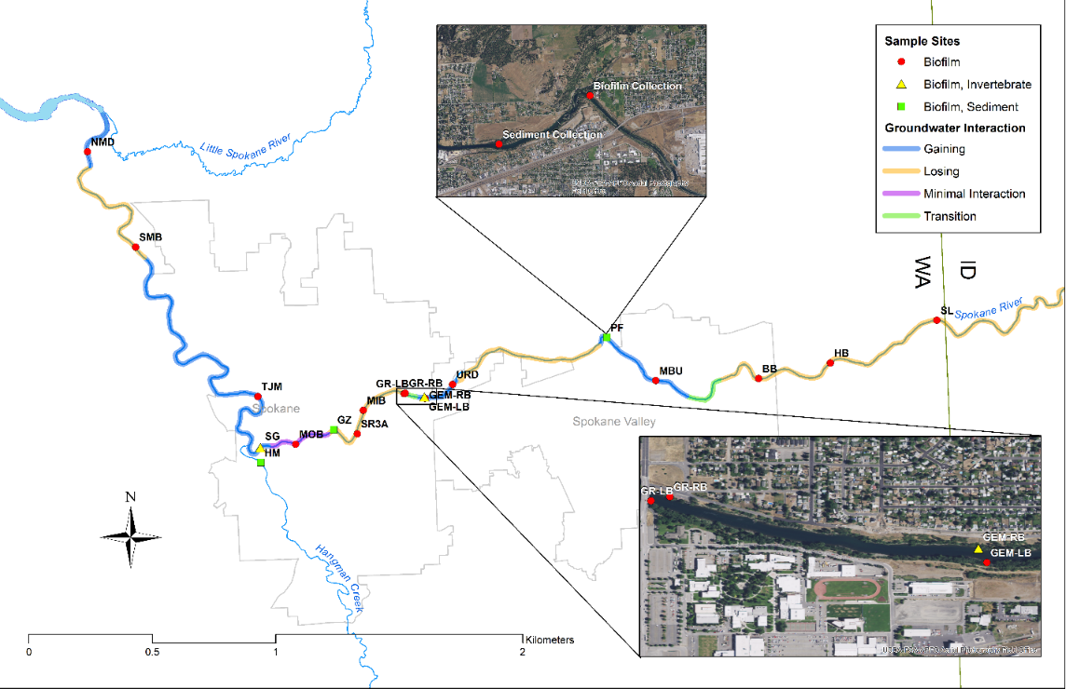
Figure 1. Map of the Spokane River showing sampling locations during the 2018 field study.

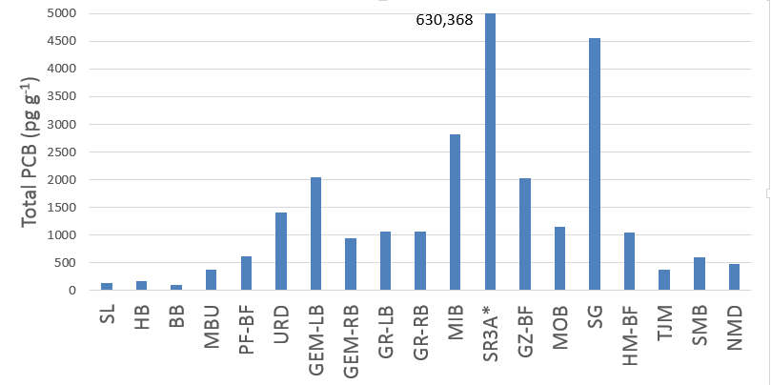
Figure 2. Total PCB concentrations measured in biofilms collected at sites in the Spokane River in 2018. Sites are ordered from upstream (left) to downstream (right). *Site SR3A had a concentration of 630,000 pg/g and is off the scale of this plot.

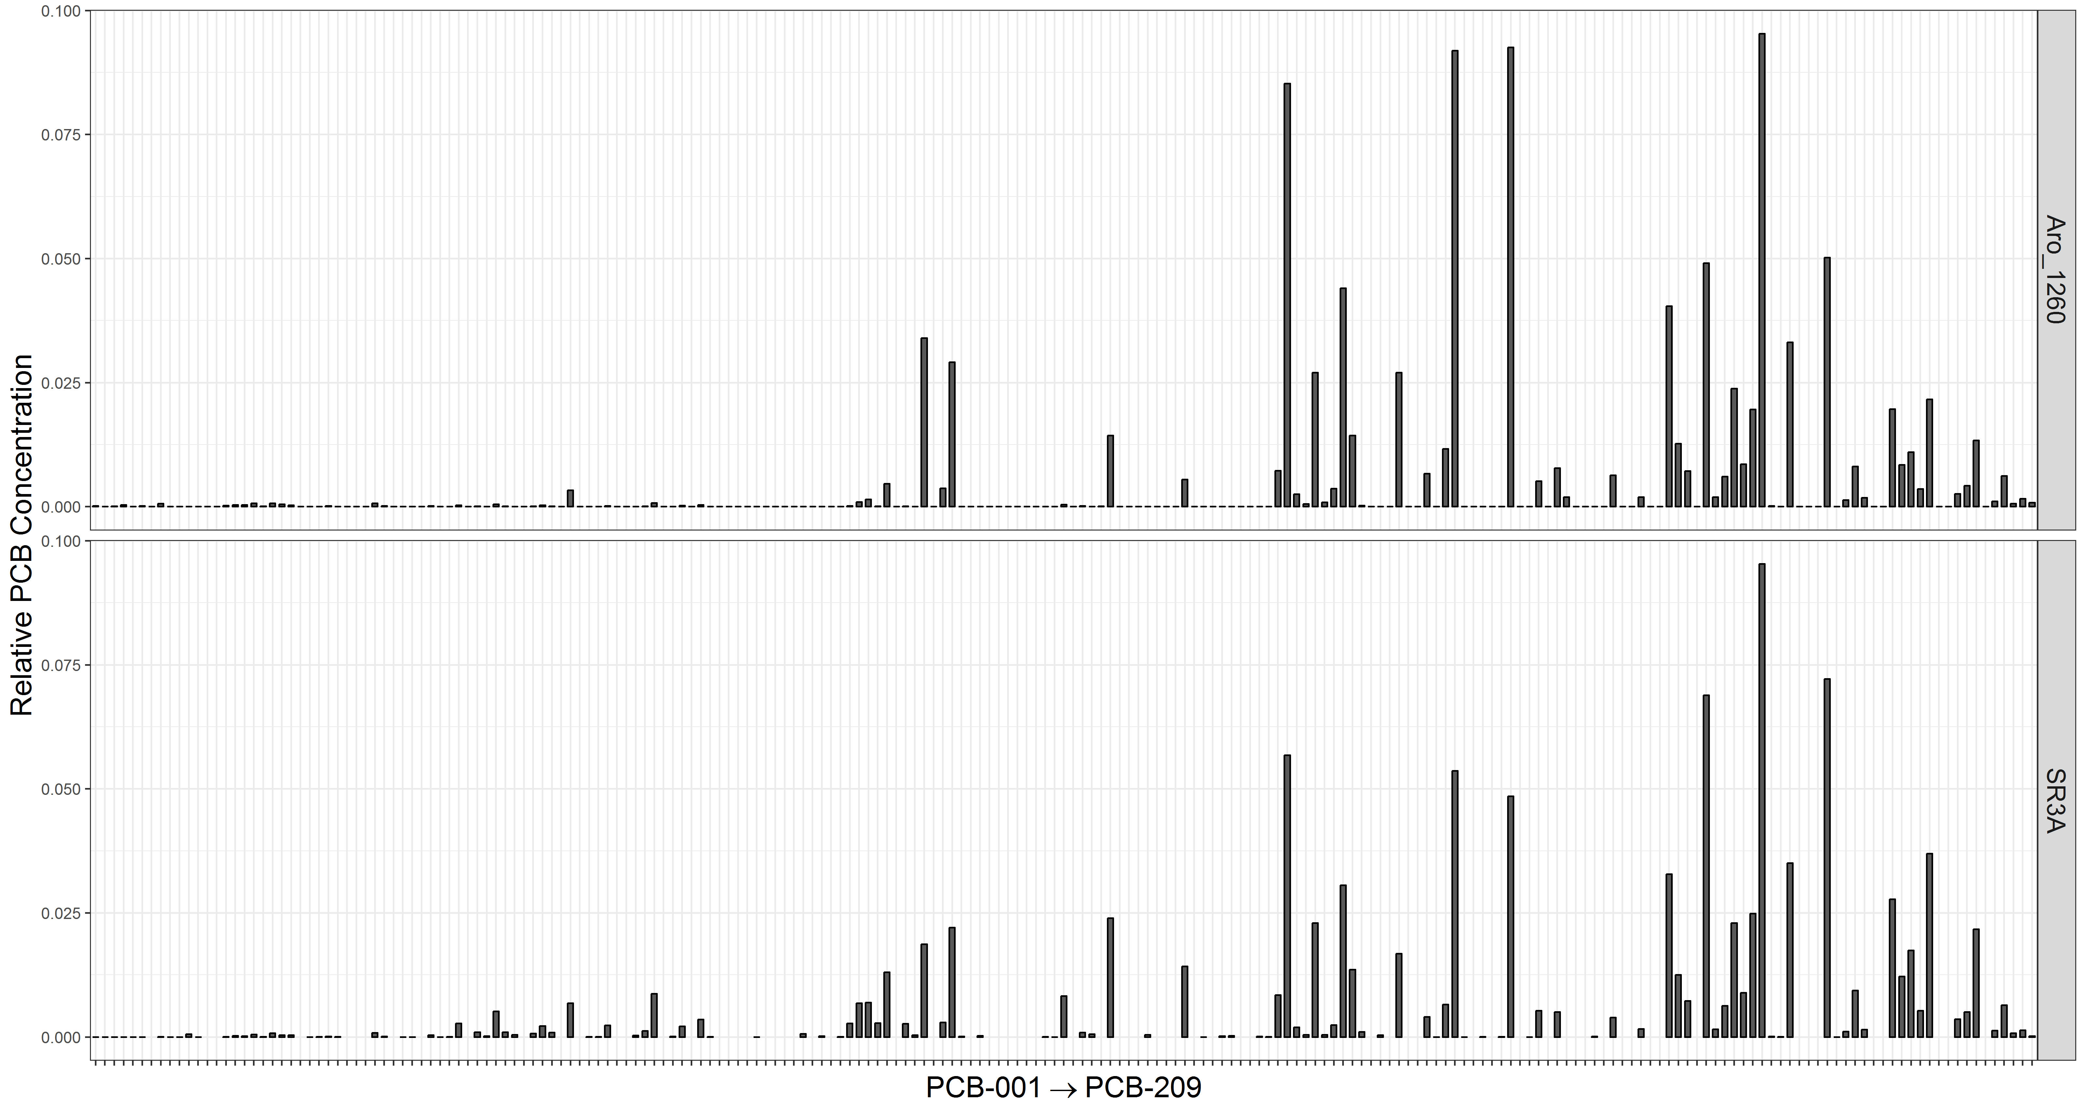
Figure 2. Relative PCB congener concentrations (PCB Congener/Total PCB) for unweathered Aroclor 1260 (top) and site SR3A (bottom). The bars represent each PCB congener, ordered from PCB-001 (left) to PCB-209 (right).

4.0 Project Description

4.1 Project goals
The goals of this project addendum are to:
- Verify biofilm PCB concentrations observed in 2018 in the Spokane River.
- Hone in on possible PCB sources, focusing on the stretch of river within Spokane City limits where the highest biofilm concentrations were observed.

4.2 Project objectives
Objectives of the follow-up sampling are to:
- Collect and analyze PCBs in biofilm samples at 33 sites in the Spokane River.
- Compare biofilm PCB concentrations and congener patterns among sites.

4.4 Tasks required
Tasks required include:
- Collaborate with SRRTTF in the final selection of biofilm sampling locations.
- Conduct site reconnaissance prior to sampling.
- Coordinate with laboratories in preparation for biofilm analyses.
- Collect biofilm samples during the low-flow period in late summer 2019.
- Review and assess laboratory data quality.
- Enter data into Ecology’s Environmental Information Management System (EIM).
- Conduct data analysis and complete final report.

5.0 Organization and Schedule

5.3 Organization chart
Table 1. Organization of project and staff responsibilities.
Staff  (All EAP except client) | Title | Responsibilities
Karl Rains  Water Quality Program  Eastern Regional Office  Phone: 509-329-3515 | EAP Client | Clarifies scope of the project. Provides internal review of the QAPP and approves the final QAPP.
Siana Wong  Toxic Studies Unit  SCS  Phone: 360-407-6432 | Project Manager | Primary author of the QAPP. Oversees field sampling and transportation of samples to the laboratory. Conducts QA review of data, analyzes and interprets data, and enters data into EIM. Primary author of the draft report and final report.
Brandee Era-Miller  Toxic Studies Unit  SCS  Phone: 360-407-6771 | Principal Investigator | Assists with writing the QAPP. Oversees field sampling and transportation of samples to the laboratory. Provides technical assistance. Conducts QA review of data, analyzes and interprets data. Assists with writing the draft report and final report.
Debby Sargeant  Toxic Studies Unit  SCS  Phone: 360-407-6775 | Unit Supervisor for the Project Manager | Provides internal review of the QAPP, approves the budget, and approves the final QAPP. Provides review of draft report and final approval.
Jessica Archer  SCS  Phone: 360-407-6698 | Section Manager for the Project Manager | Reviews the project scope and budget, tracks progress, reviews the draft QAPP, and approves the final QAPP.
George Onwumere  Eastern Operations Section  Phone: 509-454-4244 | Section Manager for the Study Area | Reviews the project scope and budget, tracks progress, reviews the draft QAPP, and approves the final QAPP.
Alan Rue  Manchester Environmental Laboratory  Phone: 360-871-8801 | Director | Reviews and approves the final QAPP.
Ginna Grepo-Grove Manchester Environmental Laboratory  Phone: 360-871-8829 | Quality Assurance  Coordinator | Develops the scope of work for contract laboratory. Validates contract laboratory data.
Arati Kaza  Phone: 360-407-6964 | Quality Assurance  Officer | Reviews the draft QAPP and approves the final QAPP.  May review and comment on the draft project report.
EAP: Environmental Assessment Program
EIM: Environmental Information Management database
QAPP: Quality Assurance Project Plan
SCS: Statewide Coordination Section

5.4 Proposed project schedule
Table 2. Proposed schedule for completing field and laboratory work, EIM data entry, and final report.
Field and laboratory work | Due date | Lead staff
Field work completed | September 2019 | Siana Wong
Laboratory analyses completed | January 2020
Contract lab data validation completed | April 2020
Environmental Information System (EIM) database
EIM Study ID | SWON0001
Product | Due date | Lead staff
EIM data loaded | May 2020 | Siana Wong
EIM QA | June 2020 | To Be Determined
EIM complete | July 2020 | Siana Wong
Final report
Author lead / support staff | Siana Wong / Brandee Era-Miller
Schedule
Draft due to supervisor | May 2020
Draft due to client/peer reviewer | June 2020
Draft due to external reviewer(s) | July 2020
Final (all reviews done) due to publications coordinator | September 2020
Final report due on web | October 2020

5.5 Budget and funding
The laboratory cost for this addendum is estimated to be $47,124. Table 3 shows the budget broken down by sample type and number of samples. Ecology will cover the costs of analyses for 21 samples and 2 quality control (QC) samples per analyte ($30,107). In agreement with SRRTTF, SRRTTF will supplement the project by covering the costs of 12 samples and 1 QC sample per analyte ($17,017).
Table 3. Project budget and funding for 2019 sampling.
 | Number of Samples | Number of Field QC Samples | Total Number of Samples | Cost Per Sample | Contract Lab Subtotal
Biofilm
PCB Congeners | 33 | 3 | 36 | $960 | $34,560
Lipids¹ | 33 | 3 | 36 | $ - | $ -
C:N Stable Isotopes | 33 | 3 | 36 | $21 | $756
Ash Free Dry Weight | 33 | 3 | 36 | $40 | $1,440
PCB Contract Lab Fee Total (30%)²: |  |  |  |  | $10,368
GRAND TOTAL: |  |  |  |  | $47,124
¹ Costs for lipids analyses are included in PCB congener analyses.
² Contract/data validation fee.

6.0 Quality Objectives

6.2 Measurement quality objectives
Measurement quality objectives (MQOs) for this addendum are shown in Table 4. MQOs for biofilm samples are the same as the original QAPP and are repeated in Table 4. Ash-free dry weight is included.
Table 4. Measurement quality objectives.
MQO → | Precision |  | Bias |  |  | Sensitivity
 | Laboratory Duplicate/Field Split or Duplicate | Matrix Spike Duplicate | Lab Control Standard¹ | Matrix Spike | Internal Standard Recovery² | Lowest Concentrations of Interest
 | Relative Percent Difference (RPD) |  | Recovery Limits (%) |  |  | Concentration Units
Biofilm
PCB Congeners | ± 20% | - | 50 - 150% | - | 50 - 150% | 0.5 pg/g ww
Lipids | ± 20% | - | - | - | - | 0.10% ww
C & N Stable Isotopes | ± 20% | - | - | - | - | 0.01‰ dw
Ash-Free Dry Weight | ± 20% | ± 20% | - | - | - | 1.00 mg/L
C = carbon; N = nitrogen

7.0 Study Design

7.1 Study boundaries
2019 biofilm sampling locations range from the Washington-Idaho state line (SL) to just below Nine Mile Dam (NMD). Figure 4 and Table 5 show the tentative sampling sites for 2019. Sampling sites may be refined based on collaborative inputs from SRRTTF members and site reconnaissance.
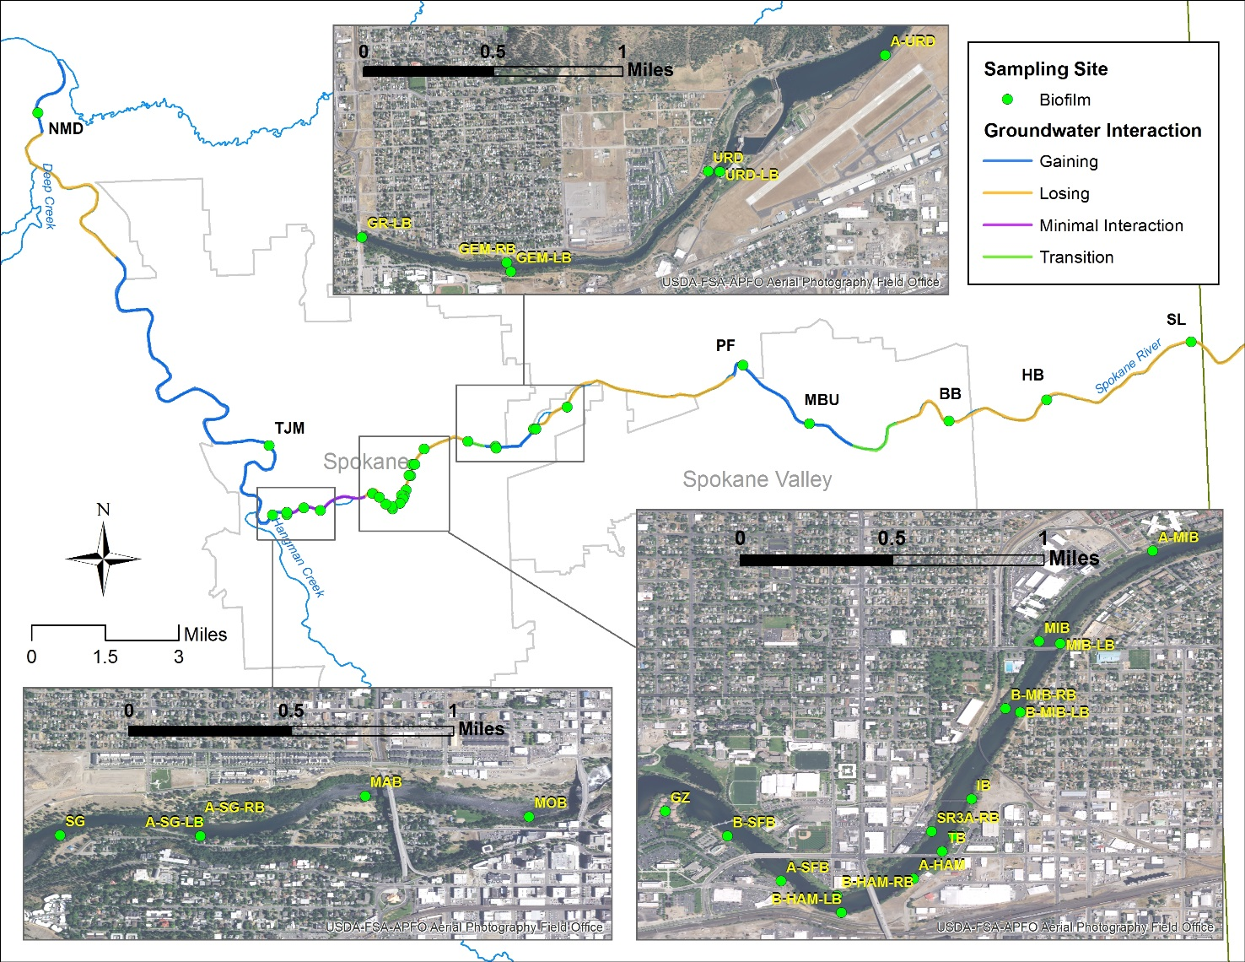
Figure 3. Map of biofilm sampling sites planned for 2019.

7.2 Field data collection

7.2.1 Sampling locations and frequency
Biofilm samples will be collected at 33 sites on the Spokane River. The sampling will occur as a one-time event during the dry, low-flow season in August 2019.
The majority of sites will be located within the Spokane City boundary to hone in on where PCBs may be entering the river, especially in locations where high biofilm concentrations were observed in 2018.
As in 2018, three upstream sites (SL, BB, and HB) will serve as reference locations to assess background levels of PCBs in biofilm in the river.

7.2.2 Field parameters and laboratory analytes to be measured
All biofilm samples will be analyzed for the 209 PCB congeners. Ancillary parameters will also be analyzed by the laboratory for each sample to help assess sample variability. These include lipid content, biomass, and carbon (C) and nitrogen (N) isotopes. At each site, periphyton samples for microscopic identification will also be collected, and conductivity and temperature of the water will be measured using a calibrated DiST Hanna EC/TDS handheld meter.

7.4 Assumptions in relation to objectives and study area
Hobbs (2018) demonstrated that biofilms could be useful for identifying potential sources of PCBs in the Wenatchee River. The same methods used in Hobbs (2018) were applied to the Spokane River during the 2018 biofilm sampling. Results from the 2018 biofilm sampling seemed to corroborate the use of biofilms as a suitable tool for source identification in the Spokane River. Biofilm sampling in 2019 will include revisiting many of the 2018 sampling sites to confirm results. The 2018 sampling also showed that right and left bank sampling may be useful for distinguishing among PCB sources. Its application in the Spokane River will be further tested in this follow-up sampling.

Table 5. List of biofilm sampling sites planned for 2019.
Site ID | Site Name | Bank | Latitude (NAD83) | Longitude (NAD83) | 2018 Sampling Site | Groundwater Interaction | Rationale for Sampling
SL | Stateline | Left | 47.69861 | -117.04626 | x | Losing | Reference location
HB | Harvard Bridge | Right | 47.68336 | -117.11036 | x | Losing | Reference location
BB | Barker Bridge | Right | 47.67835 | -117.1533 | x | Losing | Reference location
MBU | Mirabeau | Right | 47.67928 | -117.21422 | x | Gaining | Confirm 2018 results
PF | Plantes Ferry | Right | 47.69734 | -117.24207 | X | Gaining | Confirm 2018 results
A-URD | Above Upriver Dam | Left | 47.6871582 | -117.319545 |  | Losing | Bracket URD
URD | Upriver Dam | Right | 47.68106 | -117.33459 | x | Gaining | Possible source area based on 2018 sampling
URD-LB | Upriver Dam-Left Bank | Left | 47.6810248 | -117.333622 | x | Gaining | Bracket URD
GEM-LB | GE Mission-Left Bank | Left | 47.6759 | -117.35124 | x | Gaining | Confirm 2018 results
GEM-RB | GE Mission-Right Bank | Right | 47.67641 | -117.35155 | x | Gaining | Confirm 2018 results
GR-LB | Green Street-Left Bank | Left | 47.67815 | -117.36348 | x | Transition | Confirm 2018 results
A-MIB | Above Mission Bridge | Right | 47.6764298 | -117.382663 |  | Losing | Bracket MIB
MIB | Mission Bridge | Right | 47.67211 | -117.3881 | x | Losing | Possible source area based on 2018 sampling
MIB-LB | Mission Bridge-Left Bank | Left | 47.6719968 | -117.387084 |  | Losing | Bracket MIB
B-MIB-LB | Below Mission Bridge-Left Bank | Left | 47.6687158 | -117.388992 |  | Losing | Bracket MIB
B-MIB-RB | Below Mission Bridge-Right Bank | Right | 47.6688918 | -117.389697 |  | Losing | Bracket MIB
IB | Iron Bridge | Left | 47.6645768 | -117.39131 |  | Losing | Bracket SR3A
SR3A | SR3A (Upstream of Trent Ave Bridge) | Left | 47.66285 | -117.39217 | x | Losing | Possible source area based on 2018 sampling
SR3A-RB | SR3A-Right Bank | Right | 47.6630278 | -117.393229 |  | Losing | Bracket SR3A
TB | Trent Bridge | Left | 47.6620728 | -117.39273 |  | Losing | Bracket SR3A
A-HAM | Above Hamilton Bridge | Left | 47.6607808 | -117.394099 |  | Losing | Bracket SR3A
B-HAM-LB | Below Hamilton Bridge-Left Bank | Left | 47.6591588 | -117.397535 |  | Losing | Bracket SR3A
B-HAM-RB | Below Hamilton Bridge-Right Bank | Right | 47.6599668 | -117.397757 |  | Losing | Bracket SR3A
A-SFB | Above Spokane Falls Blvd | Left | 47.6606598 | -117.400419 |  | Losing | Bracket SR3A/GZ
B-SFB | Below Spokane Falls Blvd | Left | 47.6628088 | -117.40298 |  | Losing | Bracket SR3A/GZ
GZ | Gonzaga | Left | 47.664 | -117.40595 | x | Losing | Confirm 2018 results
MOB | Monroe Bridge | Left | 47.65962 | -117.42886 | x | Minimal Interaction | Confirm 2018 results
MAB | Maple Bridge | Left | 47.6605428 | -117.436184 |  | Minimal Interaction | Bracket SG
A-SG-LB | Above Spokane Gage-Left Bank | Left | 47.6587578 | -117.443548 |  | Minimal Interaction | Bracket SG
A-SG-RB | Above Spokane Gage-Right Bank | Right | 47.6594198 | -117.443605 |  | Gaining | Bracket SG
SG | Spokane Gage | Left | 47.65879 | -117.44981 | x | Gaining | Possible source area based on 2018 sampling
TJM | TJ Meenach | Right | 47.67931 | -117.45013 | x | Gaining | Confirm 2018 results
NMD | Nine Mile Dam | Right | 47.77985 | -117.54559 | x | Gaining | Confirm 2018 results

8.0 Field Procedures

8.3 Containers, preservation methods, holding times
Sample containers, preservation, and holding times for PCB congeners, lipids, and C and N isotopes are the same as in the original QAPP. Ash-free dry weight is included in Table 6.
Table 6. Sample containers, preservation, and holding time for ash-free dry weight samples.
Parameter | Matrix | Minimum Quantity Required | Container | Preservative | Holding Time
Ash-Free Dry Weight | Biofilm | 2 g ww | 2 oz clear glass jar w/ closed Teflon lid | Cool to < 4° | 14 days

9.0 Laboratory Procedures
9.1 Lab procedures table
Laboratory measurement methods for PCB congeners, lipids, and C and N isotopes are the same as in the original QAPP. Ash-free dry weight is included in Table 7.
Table 7. Laboratory measurement method for ash-free dry weight.
Analyte | Sample Matrix | Samples | Expected Range of Results | Detection or Reporting Limit | Analytical (Instrumental) Method
Ash-Free Dry Weight | Biofilm | 28 | 1 - 50,000 mg/L | 1.00 mg/L | SM10300C

9.4 Laboratories accredited for methods
An Ecology-accredited contract laboratory will analyze all PCB samples. C and N isotopes will be analyzed by the University of Washington IsoLab. Ash-free dry weight will be analyzed by Manchester Environmental Laboratory in Port Orchard, WA.

10.0 Quality Control Procedures

10.1 Table of field and laboratory quality control
The number and type of QC samples to be collected in the field and analyzed by the laboratory are summarized in Table 8.

Table 8. Quality control samples, types, and frequency.
 | Field | Laboratory
 | Splits/Duplicates | Lab Control Standard¹ | Method Blanks | Internal Standard Recovery²
Biofilm
PCB Congeners | 3/batch³ | 1/batch | 1/batch | All samples
Lipids | 3/batch | - | - | -
C & N Isotopes | 3/batch | 1/batch | 1/batch | -
Ash-Free Dry Weight | 3/batch | - | - | -
¹ Laboratory Control Standard is also referred to as Ongoing Precision and Recovery (OPR) Standard, in which a laboratory blank sample is spiked with known quantities of analyte.
² Internal Standard Recovery is also referred to as Surrogate or Labeled Compound Recovery, using ¹³C₁₂-labeled congeners.
³A batch is a group of samples (typically of the same matrix) processed and analyzed in the laboratory together as a unit.

14.0 Data Quality (Usability) Assessment

14.3 Data analysis and presentation methods
Data collected as part of this addendum will be analyzed and presented similarly as stated in the original QAPP, including calculations and graphic analyses of total PCBs and homologs. We will also compare biofilm results from 2019 to results from 2018.

14.4 Sampling design evaluation
This project is designed to verify 2018 results and hone in on possible PCB sources entering the Spokane River by bracketing areas where high biofilm PCB concentrations were observed in 2018. The sampling strategy and number of biofilm samples is expected to be adequate to draw conclusions from the study.

15.0 References
Hobbs, W. 2018. Wenatchee River PCB Source Assessment: 2016 and 2017. Publication No. 18-03-010. Washington State Department of Ecology, Olympia. https://fortress.wa.gov/ecy/publications/documents/1803010.pdf.
Wong, S. and B. Era-Miller. 2019. Quality Assurance Project Plan: Measuring PCBs in Biofilm, Sediment, and Invertebrates in the Spokane River: Screening Study. Publication No. 19-03-103. Washington State Department of Ecology, Olympia. https://fortress.wa.gov/ecy/publications/SummaryPages/1903103.html.

