Final
Report to Washington Department of Ecology Structural Stormwater Control (SSC) Policy Advisory Committee

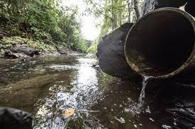

December 16, 2022

Contents
Introduction 3
Background 3
Mission of the Policy Advisory Committee (PAC) 3
List of PAC meetings and the content for each 3
Products from the Policy Advisory Committee (PAC) 4
Conclusion 5
References 5
Attachments 6
Attachment A Acronyms 6
Attachment B - Charter 7
Attachment C Make-up of the Policy Advisory Committee (PAC) 14
Attachment D Survey 16
Attachment E - PAC Workgroup notes 41
Phase II Workgroup 42
Simplified metrics Workgroup 44
Multipliers Workgroup 47
Collaboration Workgroup 54
Attachment F - Meeting notes November 15 59
Welcome – Jim Nelson 59
Sub-Workgroup Report Out 59
BREAK 63
Ecology Feedback Cont’d 64
Key Recommendations for Ecology 64
Next Steps and Close – Jim Nelson 68
Adjourn 68

Introduction

Background
In 2018, Phase I municipal stormwater permittees requested a scientific and stakeholder process to develop recommendations for improving the Structural Stormwater Control (SSC) framework and associated requirements. The Washington State Department of Ecology (Ecology) proceeded with a technical study in the fall of 2020, convening a technical advisory committee to discuss the current state of scientific knowledge. In June 2021, the SSC Science Synthesis white paper outlining the current state of scientific knowledge was finalized. Attachment A contains a list of acronyms.

Ecology also convened a Policy Advisory Committee (PAC). The purpose of this PAC was to discuss and provide recommendations to help inform the SSC requirements, specifically in terms of a system for quantifying SSC requirements and the level of effort in Ecology’s Municipal Stormwater Permit reissuance. The recommendations generated by PAC were to be submitted to Ecology by December 2022. This is a summary of the process and the information that was provided to Ecology.

Mission of the Policy Advisory Committee (PAC)
This PAC was established to discuss the SSC topics identified in Section V of the Charter (see Attachment B), and to provide recommendations to inform the SSC requirements in Ecology’s Municipal Stormwater Permit reissuance. PAC members (see Attachment C) represented diverse interests and brought a range of expertise and perspectives (see list of participants below). To gather background information, the PAC used the SSC Science Synthesis white paper, Ad Hoc White Papers and other sources. New information from PAC members was also taken into consideration. The PAC provided advantages, disadvantages, and any limitation associated with their recommendations.

List of PAC meetings and the content for each
The PAC met over a period of eight months. Interviews were conducted with PAC members prior to the first meetings and used to help shape the agenda and processes for the PAC
meetings. These interviews resulted in the grouping of topics into several “topic buckets”.
These helped to guide the distribution of topics through the meeting schedule.

May 5 - Policy Advisory Committee Charter review and ratify.
May 31 - Project Type and Selection Criteria; Phase I WWA Phase II; Schedule of upcoming topics.

July 6th – Project type and selection criteria Recommendations; Counties v. Cities; Rural
v. Urban; Multipliers, Metrics and Point System. Breakout rooms.

August 24 – Phase I and WWA Phase II project types; Level of Effort; Multipliers and Point System. Breakout rooms. Establish volunteer teams.

September 21 – Review Draft Recommendations from volunteer teams; PAC Survey of interests.

October 25 - Review and comments on survey result; create workgroups on top priority specific topics.

November 15 – Review workgroup products and recommendations.

December 7 – Final review and comments. Capture PAC comments on process.

*These were proposed sequence meetings and topics. Adjustments were made as needed to help complete the recommendations to the Department of Ecology.

Products from the Policy Advisory Committee (PAC)
- PAC Final Charter
The PAC Charter was considered and ratified by PAC members on its first meeting on May 6, 2022. It is attached as Attachment B.
- PAC Survey regarding the importance of relevant issues
A team of PAC members created a survey to identify issues of concern and levels of agreement of the entire PAC.

- Results of the Survey are included as Attachment D
- Notes from four Workgroups included as Attachment E
- November Meeting Notes included as Attachment F

Conclusion
As a diverse group of interested parties, the SSC Policy Advisory committee came together over eight months to present the Department of Ecology with their views and recommendations. There was a clear dedication to protecting water quality by way of the structural stormwater controls requirement, yet few areas of full concurrence on specific modifications to the existing Phase I Permit approach or the development of Western Washington Phase II requirements.
Ecology program staff will use the rich spectrum of views shared by the PAC to help guide their preparation of the next round of permit issuance for Phase I and permit development for Phase II.

References
Puget Sound Keepers. Nature’s Scorecard: Local Stormwater Pollution Controls - A Report for the Washington State Department of Ecology. May 2022
Navickis‐Brasch et al. Final White Paper. Structural Stormwater Controls. Science Review and
Synthesis Project. Prepared for: Washington State Department of Ecology. June 2021
Ad Hoc Committee on Stormwater Management Action Planning in the 2024 NPDES MS4 Permit. Final Report to Ecology. February 2022
OTHER Documents:
- PAC July Group Google Document–Draft Policy Recommendations
Here is the link to a Google Doc that has compiled notes from July breakout room discussions. This was used to develop survey and recommendations. https://docs.google.com/document/d/1lhN1WBfJ335usEA5cdPp_JjRVPeAp42GvBqXkBiVXDk/e dit?usp=sharing
- September 21, 2022 Phase II Meeting Prep Questions https://docs.google.com/document/d/1thCWcjqZFG1ckfors- BLyOcRl8XHF73nWP0BsmZlEjA/edit

Attachments

Attachment A Acronyms

Acronyms

Ac: acre
AADT: Annual Average Daily Traffic
BMP: Best Management Practice
ECY: Washington State Department of Ecology
FHWA: Federal Highway Administration
IDDE: Illicit Discharge Detection and Elimination
LDW: Lower Duwamish Waterway LID: Low Impact Development LOE: Level of Effort
MS4: Municipal Separate Storm Sewer System
NPDES: National Pollutant Discharge Elimination System
PAC: Policy Advisory Committee
SWMMWW: Stormwater Management Manual for Western Washington
SAM: Stormwater Action Monitoring
Sf: square feet
SMAP: Stormwater Management Action Plan
SSC: Structural Stormwater Control
TBD: To Be Determined UGA: Urban Growth Areas WQ: Water Quality
WWHM: Western Washington Hydrology Model
6ppd-q: An organic chemical used as an antiozonant and antioxidant in rubber tires and is toxic to aquatic organisms

Attachment B Charter

Policy Advisory Committee (PAC)

FINAL Charter

Mission and Charge

Background:

In 2018, Phase I municipal stormwater permittees requested a project to launch a scientific and stakeholder process to develop recommendations to improve the Structural Stormwater Control (SSC) framework and associated requirements. In addition, the hope was that this process would result in a product that could inform project/activity selection by permittees.

Initially, the permittees envisioned a scientific and stakeholder process that first convened a policy group to inform technical needs and perform technical analysis with the group’s results informing further policy discussion. However, due to concerns related to the ongoing appeal and other factors, the Washington State Department of Ecology (Ecology) decided to proceed with a technical study first. In fall 2020, Ecology allocated stormwater grant program funds to address the SSC section of the existing Phase I permit and convene a technical advisory committee to discuss the current state of scientific knowledge. In June 2021, the SSC Science Synthesis white paper which outlines the current state of scientific knowledge was finalized.

Policy Advisory Committee (PAC) Mission:
PAC is responsible for discussing the SSC topics identified in Section V of this Charter and providing recommendations to help inform the SSC requirements in Ecology’s Municipal Stormwater Permit reissuance. PAC members represent diverse interests and bring a range of expertise and perspectives. PAC will reference the SSC Science Synthesis white paper
(including all appendices) for background knowledge in addition to other sources such as Phase I watershed-scale stormwater plans from the 2013 Municipal Stormwater Permits, Washington State Department of Transportation’s retrofit program, municipal stormwater management capital facility programs, available Stormwater Management Action Plan (SMAP) documents, relevant Pollution Control Hearings Board (PCHB) rulings for their discussions, and other relevant materials. New information will also be taken into consideration to the greatest extent
possible as it arises and as time allows. The PAC will provide advantages, disadvantages, and any limitation associated with their recommendations.

PAC Purpose:
To discuss and provide recommendations to help inform the SSC requirements, specifically in
terms of a system for quantifying SSC requirements and the level of effort in Ecology’s
Municipal Stormwater Permit reissuance. The recommendations generated by PAC will be submitted to Ecology by November/December, 2022.

Roles and Responsibilities

Roles and Responsibilities of PAC Members and Designated Alternate:
PAC is comprised of a diverse membership. PAC members should consider diverse perspectives and work to find common ground. The full list of PAC members can be found in Attachment C. Representatives of other interest groups will be invited to participate in PAC meetings as needed/appropriate to provide additional perspectives.

Honesty, mutual respect, civility, and common courtesy should underscore all discussions. Ecology needs to understand all of the differing opinions and goals of the PAC members. PAC members are expected to listen, ask questions, learn from each other, and create a problem- solving atmosphere.

PAC members will:

- Identify appropriate constituents and how they will keep them informed and solicit their input.

- Come prepared to fully and constructively participate in PAC discussions.
- Following meetings, each member will review the draft meeting summary and share any concerns or suggested edits with all PAC members.

- Work between meetings to educate themselves on the topics. All members should be committed to learning and understanding the topics at hand.

- Work cooperatively with each other, the facilitator, and Ecology staff to accomplish the purpose of PAC (see section I).

- Inform the facilitator of any concerns or suggestions about meeting agendas and management of discussions, and support changes in our approach that allow the group to proceed in accomplishing its goals and purpose.

- Provide recommendations to help inform the SSC requirements in Ecology’s Municipal Stormwater Permit reissuance.

- Follow the discussion Ground Rules included in Appendix A.

PAC members and alternates should keep their constituents informed of PAC efforts, solicit input on issues discussed, and share this input with PAC members. It is up to each PAC member to decide how best to seek constituent input: any combination of in-person or video conference meetings, phone calls, webinars, or email exchanges is appropriate. PAC members are expected to seek assistance from the facilitator as needed.

Each member may designate a single alternate to participate in the event of their absence. This designated alternate should attend as many meetings as possible so that they, too, can fully and constructively participate in the event of the primary member’s absence. Members and their alternates will provide only one set of written comments when providing input. In the event the primary member is not in attendance, their alternate can take part in the decision-making process.

Roles and Responsibilities of Ecology Staff
Up to three Ecology staff will participate in each PAC meeting and fully engage in meetings but will not participate in decision-making. Ecology staff will:

- Solicit letters of interest to create PAC membership based on desired PAC composition (see Section IV).

- Be responsible for making sure PAC members understand Ecology’s underlying legal and regulatory prerequisites for meetings as well as modifying the Phase I Permit SSC requirement and consider an approach for a retrofit requirement for WWA Phase II P Permit.

- Work with the facilitator to schedule PAC meetings as well as develop PAC meeting agendas, review meeting summaries, and prepare the sequence of topics for discussion.

- Share out project information, progress, and results through appropriate forums, including but not limited to a project webpage, email listservs, Ecology’s Water Quality Partnership, Permit Coordinator meetings, etc.

- Provide additional support as requested by the facilitator and PAC members and as time and resources allow.

Roles and Responsibilities of Facilitator

The facilitator is an impartial individual who guides the process and facilitates meetings. The facilitator will:

- Work with Ecology to develop the meeting agenda and associated meeting packet to be distributed one week in advance of PAC meetings.

- Keep the group focused on the agreed-upon agenda.

- Suggest alternative methods and procedures to move forward when necessary.

- Encourage participation by all PAC members.

- Halt or redirect dialogue that is disrespectful, off-topic, or dominating the conversation to allow others to effectively participate.
- Ensure that PAC members and other meeting participants adhere to the ground rules found in Appendix A.

- Prepare and distribute clear and concise draft and finalized summaries of each meeting.

- Develop a final recommendations package as per PAC discussions/decisions.

Decision-making
The sequence of developing PAC recommendations for a given topic should look like this: PAC members have robust discussions sharing their own perspectives at the first discussion and take note of others’ perspectives. PAC members share information from the first discussion with their constituents, gather their feedback, and bring that information to the next discussion.
Emerging discussions are documented in meeting summaries, which highlight consensus agreements, areas of emerging agreement, and divergent opinions and concerns. This approach allows for gathering additional information and ideas between the first discussion and a final group decision on each topic.

Documenting levels of agreement: PAC members will work toward consensus in developing
PAC recommendations. However, because reaching consensus on all recommendations may be challenging, the PAC may submit non-consensus recommendations to Ecology noting the range of opinions and concerns. The PAC may alternatively decline to submit a recommendation. Because this is a complicated process, the final recommendation package is expected to include an appropriately worded articulation of the level of agreement from each
PAC membership around each recommendation.

Approval of recommendations: The PAC agrees to forward a recommendation to Ecology along with, as applicable, documentation about concerns and dissenting opinions related to the decision.

The facilitator will draft the recommendations package based on PAC discussions. All PAC members must review and agree that the final recommendation package delivered to Ecology represents their perspective, including their constituents. Even if members disagree with a final recommendation, they should see their concern clearly and accurately articulated in the record. Ecology will consider the entire package of recommendations and dissenting opinions when developing the permit language.

PAC Member Composition

Size of PAC
  - Ideal 15-20 members, small enough to have meaningful discussion, but large enough to encompass a representative number of stakeholders and tribal partners.

Composition of PAC
    - Up to 6 PH I representatives
    - 3-6 PH II representatives
    - 1 WSDOT representative
    - 2 Environmental advocacy group representatives
    - Tribal representatives
    - 2 Other state agencies (besides ECY and WSDOT) (i.e. – WDOH or Dept of Commerce)
    - 1 EPA

Topics
- Phase I share-out of current program successes and challenges
- Refresher to review, refine, and adopt charter and set expectations
- Define “benefits” and “recommendations”
- How to identify metrics to measure benefits when both scientific metrics and benefits data are not conclusive?
- Identify the benefits and drawbacks of the current Phase I permit SSC point system
- Identify metrics to measure benefits of SSCs to receiving water bodies
- Define level of effort required for Phase I permittees to meet their permit requirements
- Discuss whether a similar approach can or should be used for the Phase II permittees
- Create and refine recommendations to help inform the SSC requirements, specifically in terms of a system of measurement and the level of effort in Ecology’s next Permit reissuance.

Charter Appendix A. Groundrules for successful PAC meetings
- All meetings will be held remotely on Zoom.
- We will start and stop on time;
- We ask all PAC members share and encourage sharing by all. Build on the ideas of others;
- PAC members please show your name and “PAC”;
- We ask members of the public to show their name and organization;
- PAC members are asked to have their video on. We ask non-PAC members to keep their video off.
- All participants are asked to keep muted (microphone off) unless speaking to the group.
- The Chat Box can be used for questions or comments.
- There will be a short period for public comments toward the end of the meeting.

Attachment C Make-up of the Policy Advisory Committee (PAC)
The following representatives participated in the PAC:

Name | Representing | Permit
Aaron Clark | Stewardship Partners | NA
Alyssa Barton | Puget Soundkeeper | NA
Annelise Hill | USFWS | NA
Bill Leif | Snohomish County | Phase I
Arthur Lee (Alt.) | Snohomish County | Phase I
Blair Scott | King County | Phase I
Navetski, Doug (alt.) | King County
Ingrid Wertz | City of Seattle | Phase I
Jane Dewel | Port of Seattle | Phase I
Jason Quigley | Skagit County | Phase II
Jenny Gaus | City of Kirkland | Phase II
Ken Gill | City of Shelton | Phase II
Larry Schaffner | Thurston County | Phase II
Nate Ensley (alt.) | Thurston County | Phase II

Maureen Meehan | Pierce County | Phase I
Merita Trohimovich | City of Tacoma | Phase I
Mindy Roberts: | include on correspondence | NA
Peter Holte | City of Redmond | Phase II
Rod Swanson | Clark County | Phase I
Sean Dixon | Puget Soundkeeper | NA
Sheena Pietzold | WSDOT | Phase I
Valerie Chu | USFWS | NA

Attachment D - PAC Survey Responses

- What Phase I SSC framework should be pursued for the 2024 Permit?
1A. Continue with the existing Phase I Permit’s point system without modifications. 1B. Continue with Point System with modifications (modifications TBD)
1C. Switch to a simpler metric (e.g., acres treated or controlled) (method TBD)
1D. Switch to a framework based on progress made to realize a receiving water outcome (PSK proposal) (method TBD. Methods suggested for Ecology’s consideration include: controlling stormwater pollution to a certain % or # of receiving waters within the jurisdiction each permit cycle; restoring a certain % or # of receiving waters presently impaired or detrimentally affected by stormwater pollution in the jurisdiction each permit cycle, etc.).
1E. Other (Please describe in comments section).
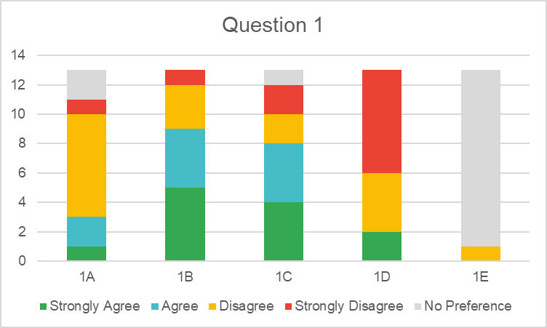
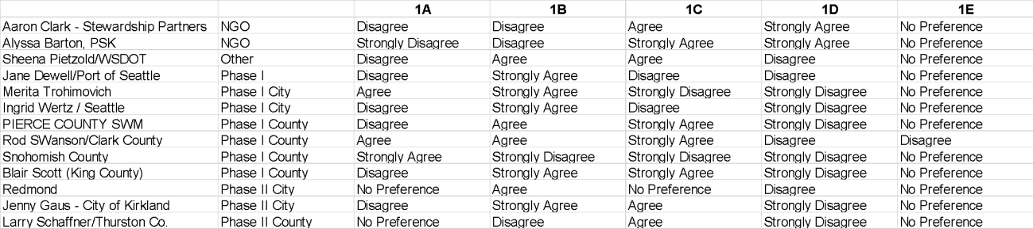

Comments
Alyssa Barton, PSK | I think the form requires me to cast a vote for 1E, but I don't have another option to offer.
Jane Dewell/Port of Seattle | Need to account for benefits from LID/GSI and flood plain reconnection
Ingrid Wertz / Seattle | Although an imperfect framework, ECY should continue with the current Point System with modifications (Option 1B) while addressing some of the greatest issues (e.g., maximum

points for flow control exempt waterbodies, AADT). ECY should also be aware of the risk that the imperfect (due to scientific uncertainty (refer to TAC white paper)) points framework could lead to jurisdictions with established SSC programs (that address the highest environmental priorities in their jurisdiction) having to address lower environmental priorities to achieve points if the point level of effort is set too high. The point system should not drive the priorities of jurisdictions with existing SSC programs.
Although Option 1C would be simpler for reporting and tracking, it would be even a less precise framework than current point system framework.
Option 1D is not a feasible method to develop due to scientific and other limitations.
PIERCE COUNTY SWM | If the goal is for Phase 1 & II SSC requirements to be the same, we need a different metric.
Rod SWanson/Clark County | The current system is reasonable but the point system should be replaced by an area treated metric.
Snohomish County | The SSC ad hoc committee white paper did not give support to modifying program structure. Ecology could consider fine tuning but we would need to see proposal before deciding whether we agree.
Jenny Gaus - City of Kirkland | Modify framework to reflect that street sweeping is proposed to be moved to a different section.

- What Project Types should be included in Section S5.C.7 of the Phase I Permit?
2A. Maintain Current Project Types in S5.C.7. If requirements for any Project Types (e.g., street sweeping) are moved to other sections of the Permit, anything beyond that permit-required level of effort would be eligible for SSC points.
2B. Remove street sweeping (Project Type 11) from S5.C.7 and put in other section of permit (e.g., S5.C.10).
2C. Remove line cleaning (Project Type 11) from S5.C.7 Project Types and put in other section of permit (e.g., S5.C.10).
2D. Remove Project Type 5 (Property acquisition), Project Type 7 (Restoration of riparian buffer), Project Type 8 (Restoration of forest cover), and Project Type 9 (Floodplain reconnection) from S.5.C.7 and create new permit section (e.g., in S.5)
2E. Remove Project Type 6. Maintenance projects with capital construction costs >=
$25,000 and put in other section of the permit (e.g., S5.C.10).
2F. Other (Please describe in comments section)

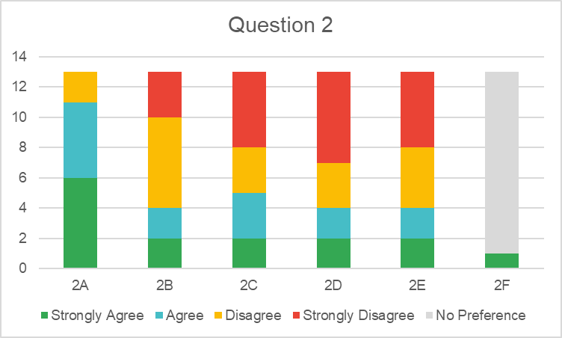
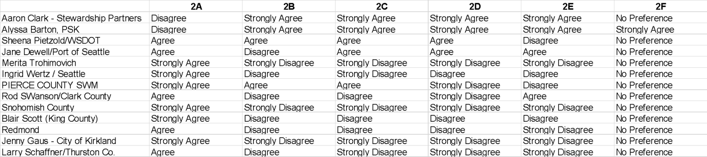

Aaron Clark - Stewardship Partners
Alyssa Barton, PSK | The point here is that S5C7 is too broad and should be narrowed to focus on retrofits, types 1-4 and 10. The other projects are valuable and should have separate minimum baseline levels of effort that don't take away from a  standalone retrofit requirement.
Sheena Pietzold/WSDOT
Jane Dewell/Port of Seattle
Merita Trohimovich
Ingrid Wertz / Seattle
PIERCE COUNTY SWM | The Type 6 $ amount should be raised. We should not have numeric LOE  prescribed in multiple areas. Depending on current land use, muni's should choose any type of project with high benefit to WQ.
Rod SWanson/Clark County
Snohomish County | The SSC ad hoc committee white paper did not give support to modifying program structure. Ecology could consider fine tuning but we would need to see proposal before deciding whether we agree. We need to further assess benefits of existing options before eliminating them. Also, reducing options may have unfair effect on smaller jurisdictions or in areas that would favor  one type of project over another.
Blair Scott (King County)
Redmond
Jenny Gaus - City of Kirkland | Need more definition around street sweeping before it can be in a different section of the permits. This is said having seen the proposed new language in the preliminary draft.
Larry Schaffner/Thurston Co.

- Should any Project Types be added to Section S5.C.7 of the Phase I Permit?
3A. Do not add any new Project Types
3B. Add “vehicle reduction” as a new Project Type (method TBD)
3C. Add “invasive species removal” as a new Project Type (method TBD)
3D. Add ability to propose new Project Types during Permit term to ECY for approval (method TBD)
3E. Other (Please describe in comments section)
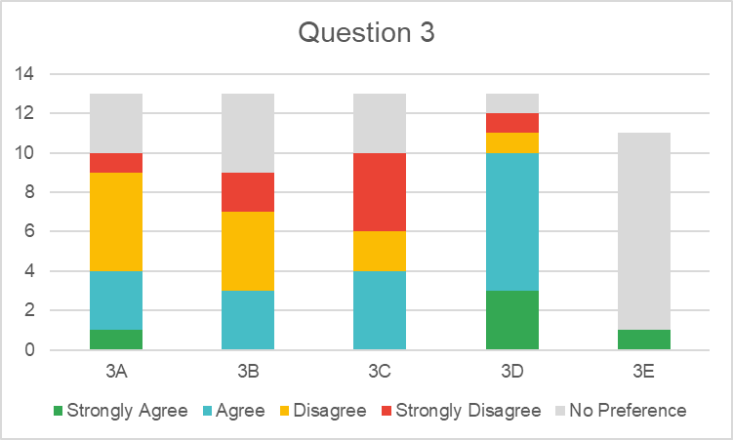
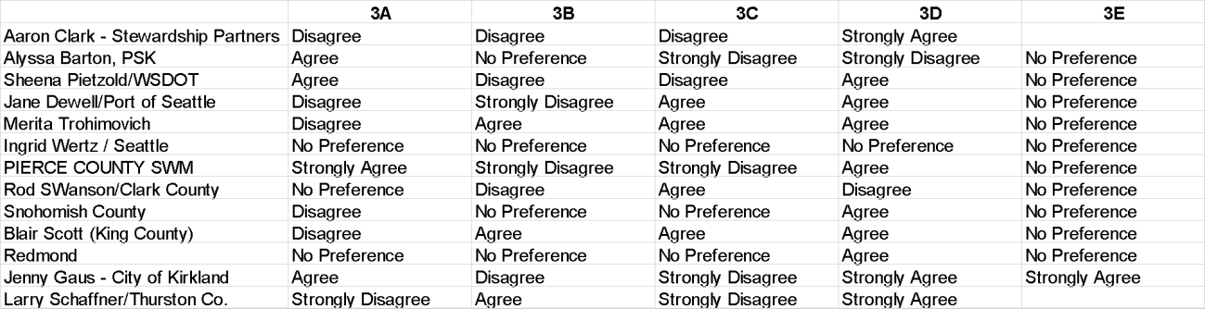

Comments
Aaron Clark - Stewardship Partners | I support creating incentives for vehicle reduction and invasive removal, but not within S5.C7
Alyssa Barton, PSK | Nothing for 3E (have to put something.
Sheena Pietzold/WSDOT
Jane Dewell/Port of Seattle
Merita Trohimovich | For 3c. There are scenarios where invasive species removal is a  stormwater benefit and those should be allowed in SSC (for example ivy removal where the ivy is leading to tree mortality).
Ingrid Wertz / Seattle
PIERCE COUNTY SWM
Rod SWanson/Clark County | Keep the current list of projects. Don't add projects without a simple means to measure them.
Snohomish County | We don’t know enough about the specifics to agree or not, but we want to encourage continued thinking about these issues
Blair Scott (King County)

Redmond
Jenny Gaus - City of Kirkland | Add process for proving that a proposed project type results in STORMWATER benefit - kind of like TAPE protocol but for project types. Would help spur research.
Larry Schaffner/Thurston Co.

- If maintaining the majority of Project Types, the list of “shall” and “should” Project Types should continue to be differentiated.
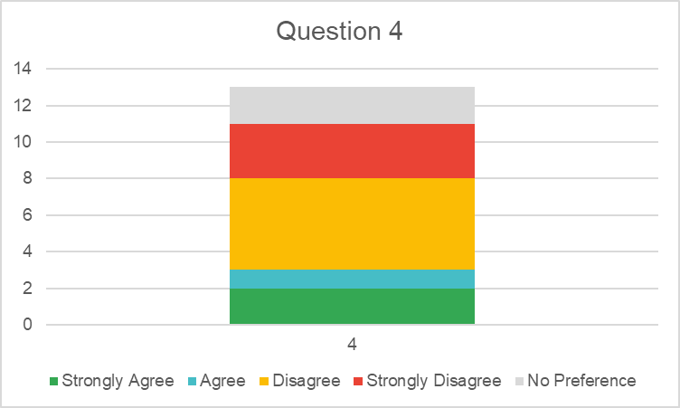
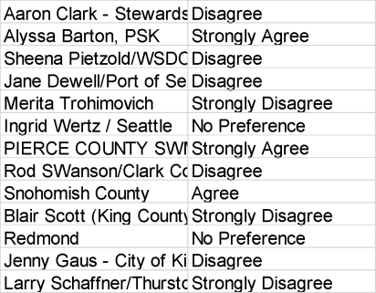

Comments
Aaron Clark - Stewardship Partners
Alyssa Barton, PSK | Ideally each section should be "shall" and have separate baseline LOEs
Sheena Pietzold/WSDOT
Jane Dewell/Port of Seattle | The shall and should distinctions are confusing and unclear
Merita Trohimovich | All options provide a benefit and should be available for all permittees to use without hierarchy.
Ingrid Wertz / Seattle | Need background about Ecology’s intent is with the “shall” and “should” list in order to have an opinion.
PIERCE COUNTY SWM | We already have the ability to propose new project types to Ecology. We should keep that.
Rod SWanson/Clark County
Snohomish County | The current system functions fine and there is no advantage to changing it at this point.

Blair Scott (King County) | There is no clear reason for these two categories in the permit. They should be combined into one category of SSC projects.
Redmond
Jenny Gaus - City of Kirkland | Not clear that the current distinction means much, but I think time could better be spent on other issues. If restoration/preservation goes to  another permit section, this would be moot.
Larry Schaffner/Thurston Co. | RE Q4, Eliminate "shall" "should" and instead differentiate project type preference via point weighting

- What updates (if any) should be made to the Phase I point system (points and/or multipliers) to better reflect environmental (i.e., flow control and water quality) benefits?
Note: SSC requirement currently considers the following environmental benefits as a “point factor”: addresses known water quality or flow control problem area; achieves enhanced or phosphorus treatment; meets WQ standards for target pollutant. In addition, the following
“multipliers” in table notes: ECY approved basin plan, Watershed-Scale Stormwater Plan, Special Condition S5.C.5.C, TMDL, ECY approved Adaptive Management Plan.
5A. Account for roadway use (e.g., AADT) (through multiplier and/or point factor update) (method TBD)
5B. Flow-control exempt waterbodies have same potential to earn points as non-exempt waterbodies (through multiplier and/or point factor update) (method TBD)
5C. LID projects receive more points than in the current point system (through multiplier and/or point factor update) (method TBD)
5D. Smaller projects receive more points than in the current point system (through multiplier and/or point factor update) (method TBD)
5E. Add multiplier for land use (e.g., industrial) for water quality projects (method TBD)
5F. Add multiplier for coordination with WRIA salmon recovery plan (method TBD)
5G. Add multiplier for projects that address URMS (urban runoff mortality syndrome) (method TBD)
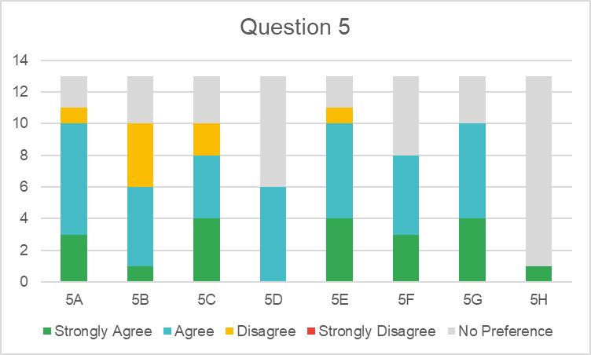
5H. Other (Please describe in comments section)
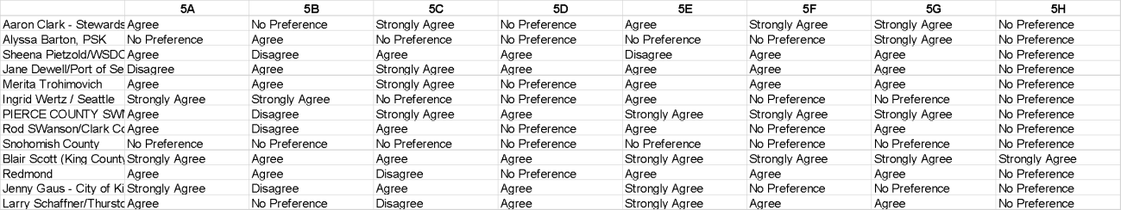

Alyssa Barton, PSK | I'm not an expert on the point system, but feel that points should be awarded in a logical way that scales to match the pollutant reduction/stormwater pollution  protection provided. Nothing for 5H.
Merita Trohimovich | note - above their is a reference to S5.C.5.C - there is no such condition in the Phase I permit.
Ingrid Wertz / Seattle | AADT (Option 5A) should be accounted for. Under current system, treating 1acre of roadway received the same amount of points whether it is a rural, infrequently used roadway or a high traffic, industrial, high AADT arterial.  Flow-control exempt receiving waters should be able to receive the same amount of points as flow controlreceiving waters (Option 5B). Under current system, constructing bioretention to manage1 acre draining to a non-salmon bearing stream would earn approximately twice as many points as constructing bioretention to manage 1 acre draining to the Lower Duwamish Waterway.  Need a better understanding of what "coordination with WRIA salmon recovery plan (Option 5F) and "projects that address URMS (Option 5G)" look like to have any opinion.
PIERCE COUNTY SWM | The PAC may not have time to address all of these issues. If Ecy, wants LID to be a priority, that is the one thing that should get addressed for this permit.
Rod SWanson/Clark  County | The point system is already too complicated.
Snohomish County | We might agree with some but since there are no details or method set forth we cannot say whether we agree or disagree. All of these proposals could be  considered further and details brought forward for consideration
Blair Scott (King County) | Add multiplier for SSC projects providing additional flow control upstream of culvert replacement projects. Also, for smaller projects I see the real issue being the  reporting burden of the current SSC requirement - the time and energy put into calculating SSC points for small projects in some cases is not viable.
Jenny Gaus - City of Kirkland | Would needs extensive research and mapping for URMS. WRIA integration could be messy.

- What updates (if any) should be made to the Phase I point system multipliers to better reflect other benefits?
Note: SSC requirement currently considers the following multiplier in table notes: overburdened community.
6A. Climate resiliency
6B. Overburdened community
6C. Multiple partners (including other jurisdictions) 6D. Community Driven – co-design
6E. Provides education and outreach benefits
6F. No updates. It’s complicated enough already (or for other reason)
6G. There should not be multipliers for “other” benefits. “Overburdened community” multiplier should be removed.
6H. Other (Please describe in comments section)
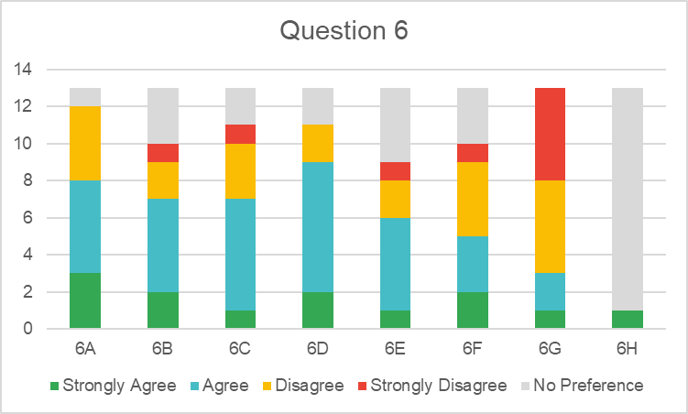
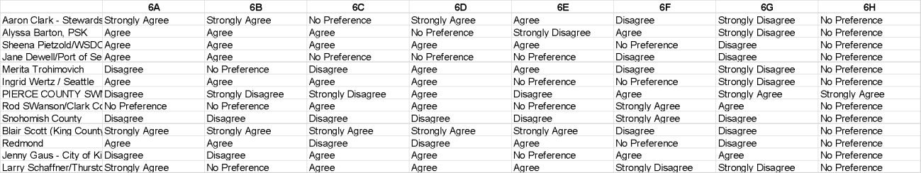

Aaron Clark - Stewardship Partners
Alyssa Barton, PSK | Climate resiliency should be a part of all projects and incorporated throughout all permit requirements not just in S5C7. For 6F: updates shouldn't be made if they further complicate the calculations process. Nothing for 6H.
Sheena Pietzold/WSDOT
Jane Dewell/Port of Seattle
Merita Trohimovich | 6B - there is a multiplier for overburdened communities.
Ingrid Wertz / Seattle
PIERCE COUNTY SWM | The primary driver for the multipliers should be water quality. We get permit "credits" elsewhere for community involvement, education and outreach, and overburdened communities.
Rod SWanson/Clark County | It's hard to weigh in on these questions because we disagree with the point system.
Snohomish County | We might agree with some but since there are no details or method set forth we cannot say whether we agree or disagree.  All of these proposals could be considered further and details brought forward for consideration.
Blair Scott (King County)
Redmond
Jenny Gaus - City of Kirkland
Larry Schaffner/Thurston Co.

- If multipliers are updated, develop a “project value stacking” approach (KC table is an example).

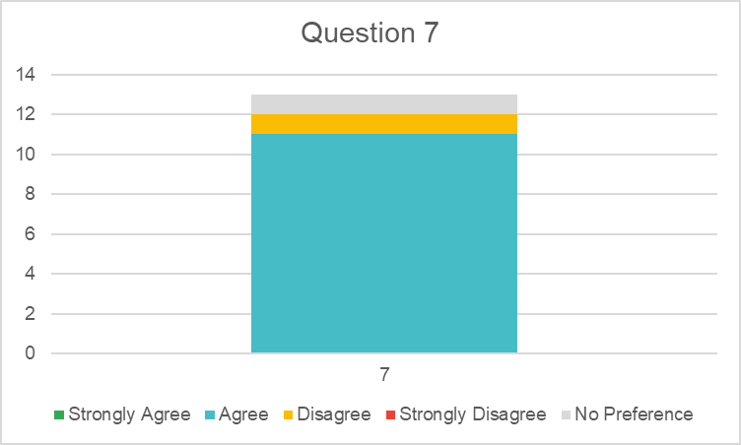

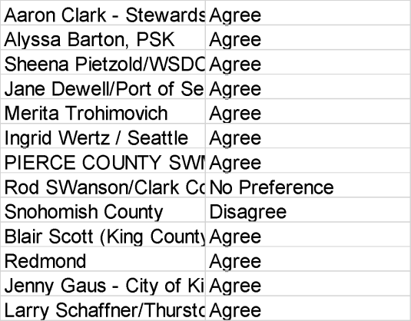

Aaron Clark - Stewardship Partners
Alyssa Barton, PSK | I could agree to this concept if Ecology continues to rely on a point system, so long as this can be easily done and doesn't  make things complicated.
Sheena Pietzold/WSDOT
Jane Dewell/Port of Seattle
Merita Trohimovich
Ingrid Wertz / Seattle
PIERCE COUNTY SWM | The stacking would provide clarity to those that view it as "double dipping". Stacking indicates a higher value project and  should be recognized.
Rod SWanson/Clark County
Snohomish County | Without knowing details of any other proposals, developing a “project value stacking” approach dilutes available resources from figuring out details of those proposals, and would have  unknown effect.

Blair Scott (King County)
Redmond
Jenny Gaus - City of Kirkland
Larry Schaffner/Thurston Co. | Agree, but avoid going overboard with the complexity of the scoring equation

- The LOE should be categorized by Project Types (Retrofit, Restoration, Maintenance/Enhanced Operations) with a LOE for each category. Example:

 | Retrofits | Restoration | Maintenance, Enhanced Operations
Project Type #s | 1, 2, 3, 4, 10 | 5, 7, 8, 9 | 6, 11
Design Points | # tbd | # tbd
Construction Points | # tbd | # tbd
Maintenance & Enhanced Operations Points |  |  | # tbd

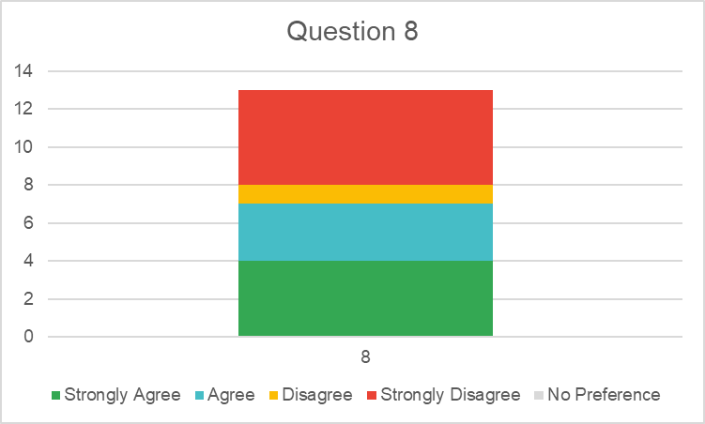
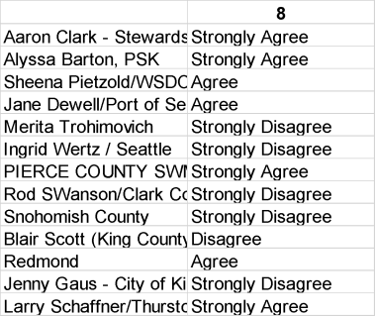

Alyssa Barton, PSK | Not sure about expanding the phases from 2 to 3 and awarding "maintenance and enhanced operations phase" points. Seems that all  infrastructure must be maintained.

Merita Trohimovich | the above categories may not be achievable by each permittee within every permit cycle. In addition, Phase I of the SSC project did not  show that these categories were any better than any other. There is no data to support this idea.
Ingrid Wertz / Seattle | Level of effort requirements should not be categorized. Each Phase I jurisdiction is unique (e.g., land use, receiving water types and impairments) which influences the Project Types utilized in each Permittees SSC program. Permit should maintain the flexibility for the Permittees to select project types that best meet the environmental needs of their jurisdictions’ receiving waters.
PIERCE COUNTY SWM | Identified only. It should not be segregated into separate LOE's.
Rod SWanson/Clark County | More arbitrary complexity is not needed.
Snohomish County | This proposal could improperly constrain the selection of best solutions, especially for smaller Phase II communities who have inherently fewer options and resources to begin with. Also, removal of an SSC project from any of the categories could affect the total LOE attainable by a Permittee, and could force non-compliance on an otherwise compliant permittee, so the LOE could need to be adjusted  lower if a project type is removed that would otherwise provide a viable means for permit compliance.
Larry Schaffner/Thurston Co. | Suggest developing multiple milestones within "design". Feasibility efforts should still receive credit even in the event the project is  determined to be a "no go". For counties, would reduce barriers for considering projects subject to future annexation.

- Should the Level of Effort (LOE) consider environmental factors for Phase I jurisdictions? If so, what factors should be considered in developing the LOE:
9A. % impervious surface (method TBD)
9B. density/surface area/ miles of road network (method TBD)
9C. total area of jurisdiction
9D. total area served by the MS4
9E. total impervious area (method TBD)
9F. Total effective impervious area (method TBD)
9G. Commensurate with the Permittee’s MS4’s impact on receiving waters (method TBD)
9H. No scaling for environmental factors
9I. Other environmental factors (Please describe other factors in comments section)

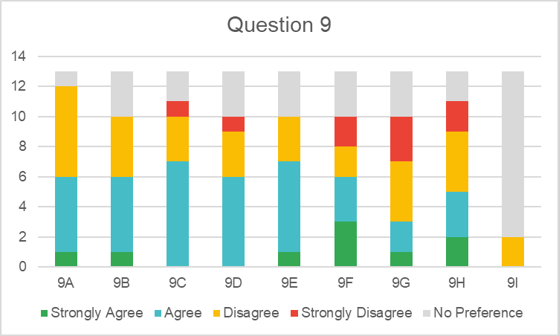
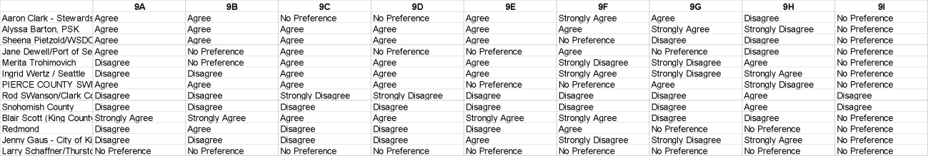

Comments

Aaron Clark - Stewardship Partners
Alyssa Barton, PSK | Agree with considering these factors to the extent that affect water quality in the MS4. Nothing for 9I.
Sheena Pietzold/WSDOT
Jane Dewell/Port of Seattle
Merita Trohimovich | Many of these items will be difficult to determine with accuracy. Information from different jurisdictions will use varying methods and accuracy. That is not good.  9B is not clearly defined, I am not sure what those items mean or how they would be determined.  9F and 9G would be very difficult to determine with accuracy.
Ingrid Wertz / Seattle | Ideally, the LOE could be scaled by total uncontrolled effective impervious area IN THE MS4. That being said, there is not a method, nor the science, to effectively determine this metric for each jurisdiction in a standardized manner. Recommend that all Phase Is continue to have the same LOE due to the scientific and data challenges in developing a standardized  scaling factor.
PIERCE COUNTY SWM | This effort will take a lot of work, which I don't think is feasible for this permit cycle.
Rod SWanson/Clark County
Snohomish County | This is a well intended idea, but since we don’t have the scoring methods  and ideas for existing factors finished, we can’t know what effect this would have. We recommend continued study.
Blair Scott (King County)
Redmond
Jenny Gaus - City of Kirkland
Larry Schaffner/Thurston Co. | These scaling metrics have the potential to drive equitable outcomes; however, the methodology requires much more fleshing out considering the wide range of Permittee characteristics, settings, underlying geological and  hydrogeological conditions, etc.

- Should the Level of Effort (LOE) consider community factors for Phase I jurisdictions? If so, what factors should be considered in developing the LOE:
10A. Population
10B. Ability to pay (e.g., median household income, median residential ratepayer income/commercial & industrial ratepayer revenue, or other) (method TBD)
10C. Cost ($/point) (method TBD)
10D. No scaling for community factors
10E. Other community factors (Please describe other factors in comments section)
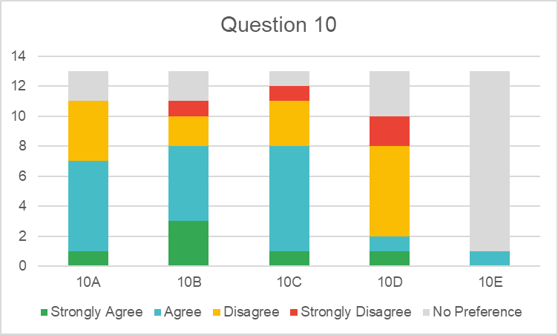
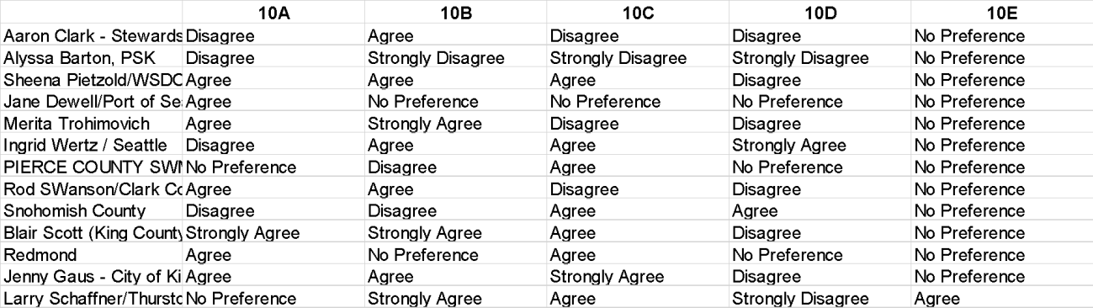

Alyssa Barton, PSK | I think stormwater pollution is the key factor that must determine the LOE under the Clean Water Act.  Nothing for 10E.
Ingrid Wertz / Seattle | Population (Option10A) is not a good scaling factor as does not take into account the impervious areas contributing to water quality impairments and does not take into account that increasing density (high populations in small area) is a tool for minimizing environmental impacts on receiving waters.  Ability to pay (Option10B) should be considered if a standardized, meaningful method can be developed. Average or median household income is not a good metric for several reasons. First, all rate payers (whether wealthy or economically challenged) pay the same utility rates (although there are program to assist lowest income ratepayers in some jurisdictions). In addition, AHI or MHI does not take in to account the cost of living in various areas of the Phase I permit area (e.g.,., it is much more expensive to live in Seattle than a rural county location). Different metrics that Seattle  has looked at, none of which provide a holistic picture, include: Bill in Hours at

Minimum Wage (presents the number of hours of work per month at King County minimum wage ($15/hour) required to pay the typical annual total water service costs); Household Burden Indicator (HBI) (calculated by dividing the total annual water service costs (water, wastewater and drainage) by the upper limit of the annual income of the 20th percentile of households in the Seattle; and, Affordability Ratio (AR20) (measures the percent of discretionary income being spent to pay for total annual water costs for a household at the LQI).
Cost ($/point) (Option 10C) should also be considered. In highly urban areas, using population alone as a scaling metric would be a double whammy – not only would a highly urban jurisdiction have to achieve more points, each point costs more to achieve (due to highly urbanized landscape) – even though the impervious MS4 area contributing to receiving body impairments is less.
Recommend that all Phase Is continue to have the same LOE due to the scientific and data challenges in developing a standardized scaling factor that accounts for environmetnal and community factors. If a scaling factor is developed should account for both population AND MS4 area to balance the drawbacks of each metric on its own.
If possible to have a meaningful, standardized “ability to pay”, should include as well.
Snohomish County | More details are needed to know whether we support a specific proposal.
Jenny Gaus - City of Kirkland | Of these factors, cost per point of SSC projects is the most important - in low-income communities that are very dense the cost of building a retrofit facility might be really high. Should somehow account for that.
Larry Schaffner/Thurston Co. | Population density (i.e., residential density); commercial/industrial development density

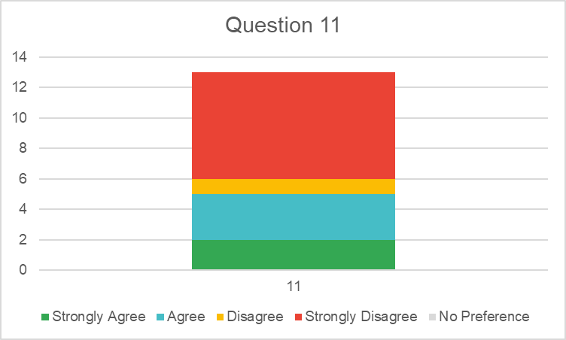
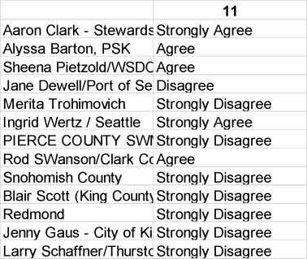
- Phase I Permittees should be required to report all implemented projects that are an SSC Project Type.

Aaron Clark - Stewardship Partners | This may not be needed if 9f (total effective impervious area) becomes a factor for LoE, as that would incentivize reporting all retrofits to ecology already. I do want permitees

 | keeping track of all the impervious area they are able to capture/manage with retrofits/SSCs so we can see if we are making progress and how quickly.
Alyssa Barton, PSK | I agree that Permittees should, if they already have complete system maps with all stormwater infrastructure, provide those to Ecology (not on request, but required) and have these be made publicly available. I don't know that I'd agree that Permittees should have to calculate points for all the projects they've done and report all the required info to Ecology about every single project as this could be overly burdensome and not have any immediate benefit (since the information doesn't include how much stormwater is being treated or controlled, for what pollutants, out of how much stormwater coming from  the MS4).
Jane Dewell/Port of Seattle | Jurisdictions need to meet requirements, but it should be up to them which projects they report on above the minimum. Reporting takes time away from actual project work and other regulatory compliance requirements.
Merita Trohimovich | If this suggestion was implemented it would limit activities that Permittees are doing as they would stop doing things that were difficult to calculate.
Ingrid Wertz / Seattle | Reporting on all projects that qualify as an SSC Project Type is an ineffective use of resources that would be better spent on actions to improve receiving waters. For example, permanent removal of impervious surfaces (Project Type 10) happens all over the City on projects whose primary focus is not to provide stormwater benefits. The effort to track this work for reporting purposes is not worth the effort.  In addition, points can be complex to calculate on non-standard projects (e.g., projects that aren’t sized to treat the entire basin, not designed according to SWMWW, or are project that are only getting points for treatment that goes beyond Stormwater Code requirements, etc..). Seattle found that it needed to spend thousands of dollars on a Consultant to help develop point estimates for some of its complex projects.  ECY should clarify in Permit updates that reporting on all projects that qualify as an SSC Project Type is NOT required. Permit reporting is to demonstrate that requirements are being met, not for the Permittee to report on all Permittee actions related to stormwater  management for environmental benefits.
PIERCE COUNTY SWM | As shared in our PAC meetings, it is a very difficult process to calculate points and not worth the effort on smaller projects as currently calculated.
Rod SWanson/Clark County | This data will be useful for establishing level of effort for varying size permittees
Snohomish County | Requiring the reporting of “all” projects creates a variety of possible unintentional violations of the reporting requirements, as well as creating potential liability issues if a project is seen by some to be “inside” the permit and by others to be “outside” the permit. However, Ecology could possibly craft a requirement in the reporting section to list “projects that might be eligible for the SSC program” thus gathering information while  allowing a permittee to not have to state whether the project is in fact an SSC project, or whether the permittee intends to consider it such in the future.
Jenny Gaus - City of Kirkland | Strongly disagree because permit non-compliance actions could be based on failing to report an SSC project. Would rather that jurisdictions focus on implementing as  opposed to reporting.
Larry Schaffner/Thurston Co. | The ability to achieve a given LOE can change overtime (e.g., diminish after the "low hanging fruit" projects have been achieved

- The Permit should provide a mechanism for point distribution between Permittees (Phase I and Phase II or combinations of the two) for collaborative projects. (method TBD (e.g., cost, area of MS4 treated))

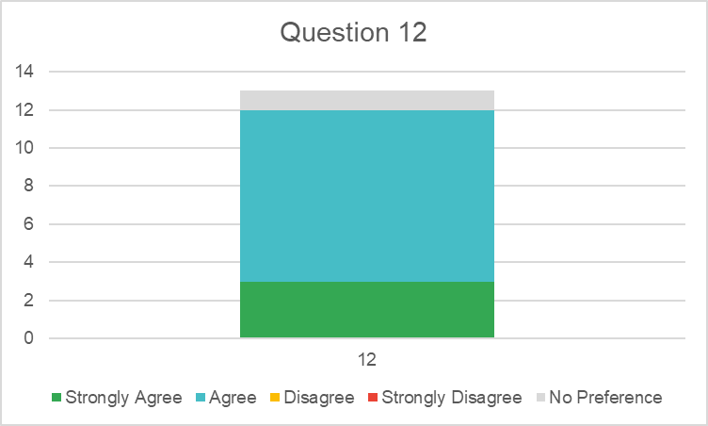
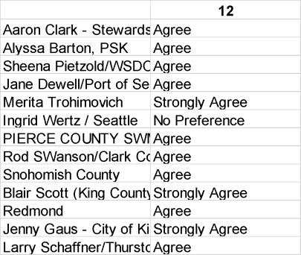

Aaron Clark - Stewardship Partners
Alyssa Barton, PSK
Sheena Pietzold/WSDOT
Jane Dewell/Port of Seattle | Since watersheds and water quality impacts are not bound by municipal boundaries, collaboration is important and should get recognition in the permit
Merita Trohimovich
Ingrid Wertz / Seattle
PIERCE COUNTY SWM | Although I don't think this can be completed in time for this permit.
Rod SWanson/Clark County
Snohomish County | Agree in principle, but need more study to determine details.
Blair Scott (King County) | I see this as an essential part of the SSC requirement's success. Regional facilities are known to have the best cost/benefit and there are significant opportunities for permittees to partner on these projects.
Redmond
Jenny Gaus - City of Kirkland
Larry Schaffner/Thurston Co.

- Should there be an SSC requirement in the next Phase II Permit?
13A. No SSC requirement in the next Permit
13B. Reporting only– no level of effort but report to Ecology on SSC projects using Point System Framework (i.e. same as Phase I 2013 Permit)
13C. Yes – there should be a Phase II requirement – see questions below for opinions on details
13D. Depends on the size of the Phase II jurisdiction -size threshold below which there would be no requirement
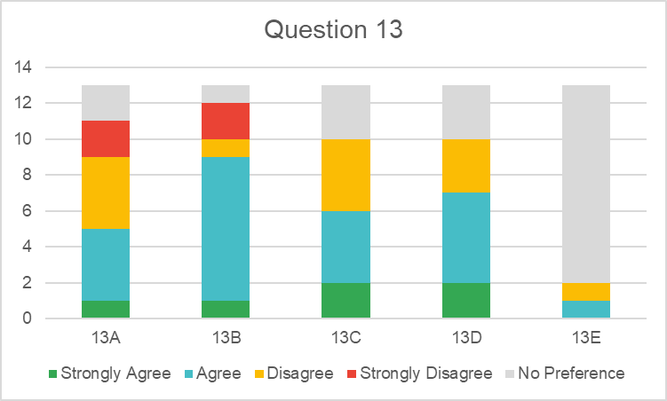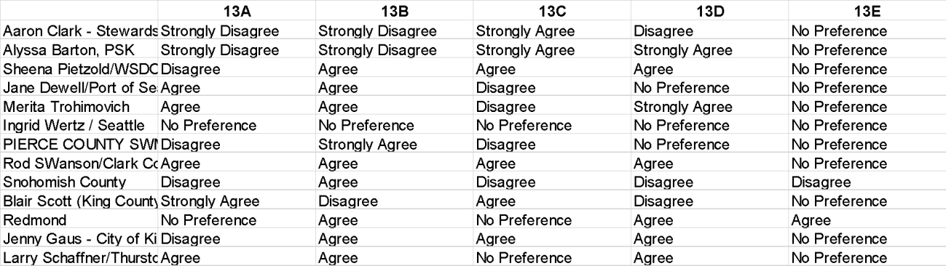13E. Other (Please describe other ideas in the comments section)

Comments
Aaron Clark - Stewardship Partners
Alyssa Barton, PSK | 13D: Base on Phase I population thresholds. Nothing for 13E.
Sheena Pietzold/WSDOT
Jane Dewell/Port of Seattle
Merita Trohimovich
Ingrid Wertz / Seattle
PIERCE COUNTY SWM | The PAC has not provided a workable metric for Phase II's and I don't think the PAC  has time to address this before this permit term. Having Phase II's report their projects would be a good learning opportunity for Ecology.
Rod SWanson/Clark County
Snohomish County | We don’t know enough to establish equitable point system in 2024 permit, but data reporting from Phase IIs without minimum point requirement would be provide useful data for next permit, in same way that such Phase I data in 2013 permit was useful in developing 2019 permit requirement. If the Phase I framework stays the same and Phase II’s will be following that—treat Phase II’s same as Phase I’s, but recognize  the great range of Phase II types and capabilities and need for more study and

discussion before developing new regulations. Would not be good if the Phase I framework gets more complicated and Phase II’s have to jump into it, even without
LOE. Also, reporting on projects takes significant time and engineering expertise on some calculations, and some Phase II’s will be strapped for that kind of help.
Blair Scott (King County)
Redmond | 13B with a variation--perhaps Ecology can create a framework by which Phase II's prioritize the structural retrofits and generate a plan that meets that framework...much diffferent than the SMAP in that it would be jurisdiction wide
Jenny Gaus - City of Kirkland | Should somehow provide credit to Phase II jurisdictions that are already doing SSC projects, and should nudge other jurisdictions to get started.
Larry Schaffner/Thurston Co. | A reporting-only requirement can help provide insight to the diversity of Phase II permittees' abilities to effectively deploy this program. This in turn can help better  calibrate Permit expectations.

- The Phase II SSC framework should be:
14A. The same framework as the Phase I permit (i.e., points system and project types; however, a different level of effort (LOE))
14B. A different framework. SSC requirements should include implementation of short-term SMAP actions, (method TBD)
14C. A different framework. SSC requirements should include implementation of a stormwater CFP (Capital Facilities Plan)/CIP (Capital Improvement Program) (method TBD)
14D. A different framework. SSC requirements should include implementation of stormwater portions of a watershed plan (method TBD)
14E. A different framework. Framework based on progress made to realize a receiving water outcome (PSK proposal) (method TBD. Methods suggested for Ecology’s consideration include: controlling stormwater pollution to a certain % or # of receiving waters within the jurisdiction each permit cycle; restoring a certain % or # of receiving waters presently impaired or detrimentally affected by stormwater pollution in the jurisdiction each permit cycle, etc.)
14F. A different framework. Other (Please describe other framework in comments section)
(method TBD)
14G. No preference.
14H. Need more information. (Please indicate what information is needed in comments section)
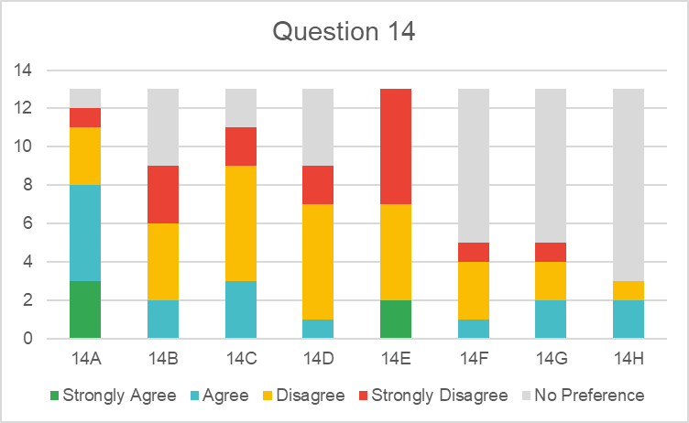
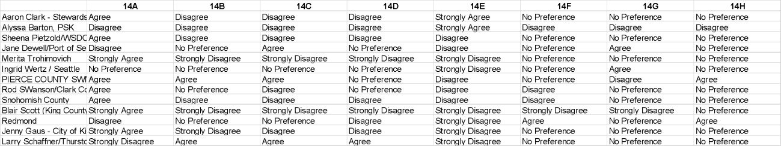
Comments

Aaron Clark - Stewardship Partners | I support phase 1s and 2s having the same framework but would like it to clearly be based on and move the whole region toward achieving the goals of the CWA.
Alyssa Barton, PSK | For 14E, could be a watershed plan, a SMAP, or other plan so long as its strategic and focused on restoring stormwater affected waterbodies in the jurisdiction.
Sheena Pietzold/WSDOT
Jane Dewell/Port of Seattle | Need to balance level of effort in tracking and reporting versus effort toward watershed improvements, and whether jurisdictions can easily gain credit for benefits without overburdening staff with complex reporting
Merita Trohimovich
Ingrid Wertz / Seattle | Option 14E is not a feasible method to develop due to scientific and other limitations.
PIERCE COUNTY SWM | I don't understand ow some of these metrics would work. It would take much more time than we have to gain an dequate understanding of how these efforts would be calculated.
Rod SWanson/Clark County
Snohomish County | As indicated in Question 13, we favor not setting a Phase II level of compliance, but data reporting from Phase IIs without minimum point requirement would be provide useful data for next permit, in same way that such Phase I data in 2013  permit was useful in developing 2019 permit requirement.
Blair Scott (King County)
Redmond | see above
Jenny Gaus - City of Kirkland | Would be very difficult to show real progress based on environmental factors because progress is cumulative and incremental, and because water quality is influenced by things that are beyond the control of the jurisdiction.
Larry Schaffner/Thurston Co. | The items we indicated "agreement" on were intended to represent multiple compliance pathways.

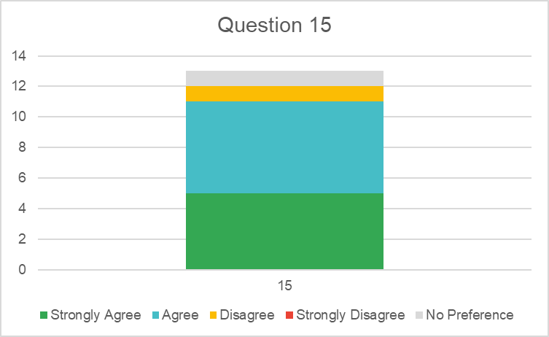
- If there is a LOE for Phase IIs, it should be scaled as I responded above for questions 9 and 10.

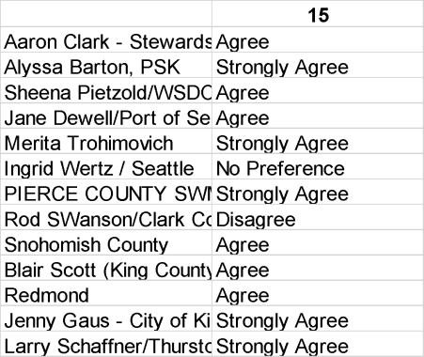

Comments

Aaron Clark - Stewardship Partners
Alyssa Barton, PSK
Sheena Pietzold/WSDOT
Jane Dewell/Port of Seattle
Merita Trohimovich
Ingrid Wertz / Seattle
PIERCE COUNTY SWM | No additional comments.
Rod SWanson/Clark County
Snohomish County | See responses to Questions 13 and 14.
Blair Scott (King County)
Redmond
Jenny Gaus - City of Kirkland
Larry Schaffner/Thurston Co.

- Should the SMAP be integrated with SSC requirements? If so, how should this be done:
16A. No – keep SMAP and SSC requirements separate
16B. Yes - require some quantifiable portion of SMAP implementation as the SSC points for the jurisdiction (method TBD)
16C. Yes - Allow an option for implementation of SMAP projects to be used for SSC points/credit but don’t require SMAP implementation
16D. Yes - Give extra credit/points for implementing SMAP as the SSC requirement (method TBD)
16E. Other. (Please indicate other suggestions for SMAP/SSC integration in comments section)

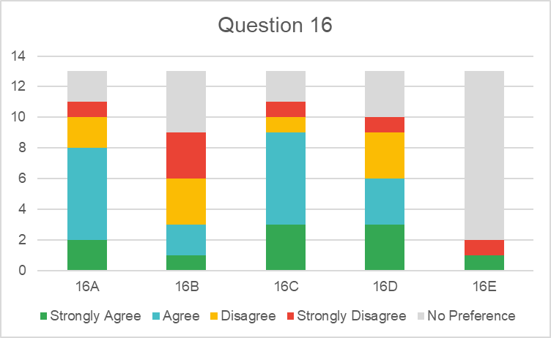
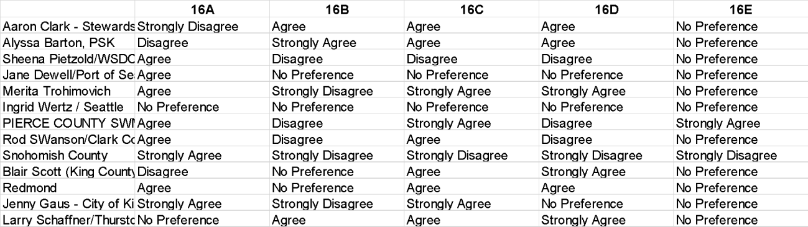

Aaron Clark - Stewardship Partners
Alyssa Barton, PSK | Would want to discuss this further.
Sheena Pietzold/WSDOT
Jane Dewell/Port of Seattle
Merita Trohimovich
Ingrid Wertz / Seattle
PIERCE COUNTY SWM | The highest value projects are the ones that should be implemented first. It shouldn't matter whether the project is in the SMAP or not.
Rod SWanson/Clark County | The SMAPs may not include SSC projects depending on development history and planned development.
Snohomish County | The SMAP is but one document and body of knowledge that can guide an SSC program. Permittees must have the flexibility to decide which projects to pursue, and to justify these decisions on all relevant information, not just a SMAP.
Blair Scott (King County)
Redmond
Jenny Gaus - City of Kirkland
Larry Schaffner/Thurston Co.

- SSC requirements should be different for Phase II cities and Phase II counties.
(If you strongly agree with this statement, please indicate in comment section how they should be different.)
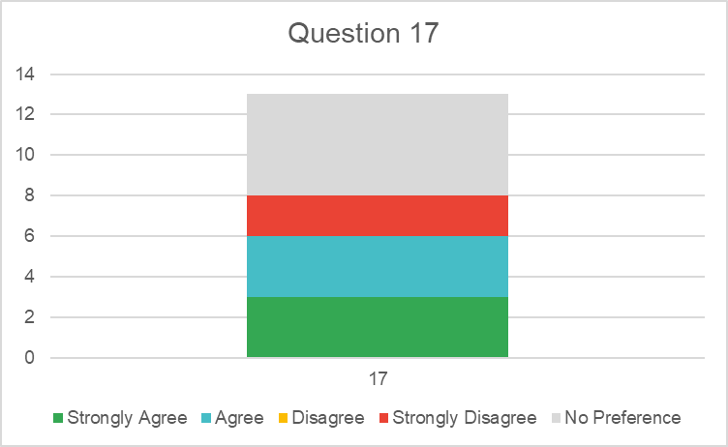
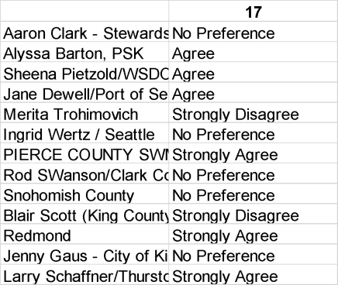
Comments
Aaron Clark - Stewardship Partners
Alyssa Barton, PSK | If using an impervious surface threshold for cities that triggers retrofit requirements  and an undeveloped areas threshold for counties that triggers conservation projects (types 5, 7, 8, 9) - could do same for Phase I's and II's.
Sheena Pietzold/WSDOT
Jane Dewell/Port of Seattle | This seems like a good idea (counties with more rural/open space, cities more densely paved with more roads and pollution potential), but the devils in the details. Logical metrics and reporting ease are the challenge.
Merita Trohimovich | The types/sizes /resources of phase II cities and phase II counties are too different to have the same requirements (talking city to city and county to county)
Ingrid Wertz / Seattle
PIERCE COUNTY SWM | Only in LOE, not in actually projects.
Rod SWanson/Clark County
Snohomish County | No comment
Blair Scott (King County)
Redmond
Jenny Gaus - City of Kirkland

Larry Schaffner/Thurston Co. | Phase II counties need to continue to provide services to ratepayers as well as address priority needs outside the regulated area.
- A promise/guarantee of non-competitive grant funding or other type of support (e.g., grants or program implementation support) would provide greater ability for Phase II jurisdictions to implement any SSC requirements.
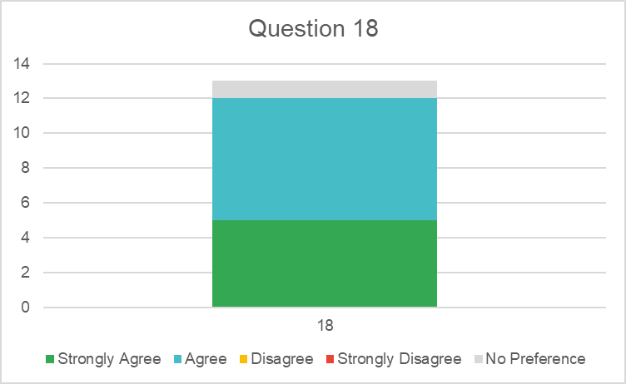
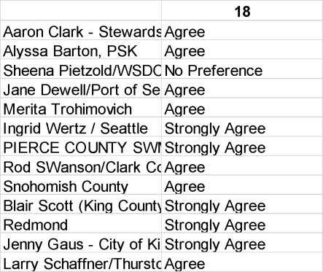

Comments

Aaron Clark - Stewardship Partners
Alyssa Barton, PSK | Sure but requirements cannot be made contingent on funds, that's not how the CWA works.
Sheena Pietzold/WSDOT
Jane Dewell/Port of Seattle
Merita Trohimovich | For very small permittees, no matter how much financial support they are given, they will still have staff capacity issues that will limit their ability to use that money.
Ingrid Wertz / Seattle
PIERCE COUNTY SWM
Rod SWanson/Clark County
Snohomish County | This looks like the existing capacity grant program, which we support, and capacity grant funds could be spent for SSC projects. We agree in principle, but the current amount of capacity grants ($50,000) is far less will be needed for any SSC  program.

Blair Scott (King County)
Redmond
Jenny Gaus - City of Kirkland
Larry Schaffner/Thurston Co. | Administering the grant can still potentially pose a hardship on resourced- constrained permittees.

Attachment E - PAC Workgroup notes
After much discussion in the first couple of PAC meetings, due to significant time constraints, the members of the PAC were asked to identify which issues were most important to try to address during this process. The results of this survey were used to form 4 workgroups to investigate further. Four workgroups were formed to look at significant issues identified in the Survey. These workgroups and their volunteers were:

Phase II Workgroup
- Jenny Gaus
- Peter Holte
- Aaron Clark
- Larry Schaffner

Simplified metrics Workgroup
- Merita Trohimovich (Lead)
- Rod Swanson
- Emma Trewhitt
- Aaron Clark

Multipliers Workgroup
- Ingrid Wertz (Lead)
- Merita Trohimovich
- Emma Trewhitt

Collaboration Workgroup
- Blair (Lead)
- Merita Trohimovich
- Maureen Meehan
- Emma Trewhitt
Phase II retrofit framework workgroup

Participants: Jenny Gaus, Peter Holte, Aaron Clark, Larry Schaffner
Purpose of Workgroup
From Survey: The Phase II SSC framework should be: (5 options given and opportunity to fill in “other.”)
Discussion of Options that could be considered
Items in bold are possible categories of compliance for Phase II SSCs in the next Permit
Reporting-Only Option – Report on known jurisdictional qualifying SSC projects using the Phase I project type list
Set lower number of points for Phase IIs using Phase I system
Consider scaling Level of Effort by changing compliance timelines
Recognize variability amongst permittees and maintain flexibility
Consider multiple compliance pathway options or menu as part of “full scale implementation”–
· Implement an adopted plan
· adopted basin/watershed
· some portion of SMAP
· Stormwater functional plan (component of Comprehensive Plan required under Growth Management)
· Capital Improvement Plan
· Implement something (facility or program) based on local knowledge or regional planning efforts
· Set lower threshold for number of points for Phase IIs using Phase I system (could also be a stand-alone pathway)
[Same framework but level of effort is less]

Maintain widest possible range of project and program types for SSC implementation
Define MS4 Nexus for items noted above – how is it relevant to the MS4 impact on water quality?
Might be faster to implement some of the items above than if starting from scratch
Develop criteria for eligibility to take certain pathways/options – report to Ecology the jurisdiction’s compliance pathway choice from the list of methods for which Ecology considers them eligible. For example, jurisdictions that get more capacity grant dollars should be considered eligible for either different pathway or different compliance timeline (use same formula)
Consider providing program support to address equity issues – communities that have fewer resources still need wq improvement, so look for ways to add support that are in addition to grant funding
Generate information to help calibrate requirements in this Permit, then ramp up requirements in the next Permit
Consider regional compliance with SSC requirements? Prioritize by pollutant potential, build regional facilities using pooled resources
Consideration for all Phase IIs:
Counties – not all of county is in the MS4, so areas that are under Permit are not always contiguous, likely more open systems, if required to focus on Permit area may not be doing the highest priority environmental projects and may not produce result that meets social equity needs [see SMAP development and guidance where this was also an issue]
Cities and Counties - annexations may change MS4
Size and Resource Level of Community -Tiny jurisdictions and moderately large jurisdictions – look at scaling LOE or changing compliance timeline or ramp-up timeline to account for this
Consider equity – under-resourced communities may not have resources to comply, but also need the WQ improvements provided by SSC
Consider the Cumulative Impact of ALL new NPDES Permit Requirements – For example, if street sweeping, SSC, and new design manual requirements all hit at once. Don’t want to end up with G20s from the majority of jurisdictions.

Simplified Point Metric Workgroup

Participants: Emma Trewitt, Rod Swanson, Merita Trohimovich, Aaron Clark
There was general agreement to most of the thoughts included in the document. We tried to note when there were some disagreement.
Purpose of Workgroup
From Survey: “What updates (if any) should be made to the Phase I point system (points and/or multipliers) to better reflect environmental (i.e., flow control and water quality) benefits?”
The intent of the group was to discuss possible ways to simplify the points determination for Permit compliance. During our discussion three items seemed to come into focus.
Summary of Discussion
1) Overall Simplified Metric for Permit Compliance Reporting
2) Simplified Points for Small Projects
3) Separation of points by retrofit and maintenance project types
Item three is outside of the scope of the group, but the group spent some time on the idea and some notes are included in this document.
1. Overall Simplified Metric for Permit Compliance Reporting
Clark County came forward with an idea and that was discussed by the group. No one in the group had any major objections to the concept, however, as with any system, there are some factors that complicate the proposal.
The Permit allows credit for projects that reduce MS4 pollutant discharges by adding capital projects and performing maintenance above the minimum required in S5.C. The permit also allows credit for projects that enhance and protect watershed functions, such as forest restoration and acquisitions.
There is an interest in area-based compliance measures or SSC performance metric by both permittees and environmental advocates. At this point it is not feasible to replace the point system as a permit compliance measure, but it is feasible to begin tracking and reporting projects using an area treated metric for retrofit projects inside the MS4 and for enhancement projects in the permit area.
Such a system would provide data to compare Phase I permittee programs. It would also provide data on the amount of retrofitting and enhancement by permittees.
Clark County proposes to use acres with no multipliers. Permit compliance should be based on number of acres and the metric should be acres for all the project types. (Sweeping and pipe cleaning would need a different metric). As the Phase I (the Osborne report) of this study illustrated, the current multipliers do not have rigorous science based support.
The current Permit point system does not provide an area-treated metric or area-enhanced metric, but instead attempts to reward projects for environmental benefit and other benefits such as addressing overburdened communities.
Some Permittees see incorporating environmental benefit into permit compliance as an issue. Those Permittees already have a process for developing and implementing projects for optimal environmental benefit considering their conditions and financial capacity, and assert that when points are determined for permit compliance, environmental benefit should not be part of the calculation.
While some on the group were a bit hesitant to remove all the multipliers including things like additional points for work in overburdened community areas, all agreed that it is good to know the acres that each project affects. Note that, while the current Permit metric is points, the current reporting from Appendix 12 does indicate area in acres on the reporting spreadsheet for many project types.
The project design engineer can calculate capital retrofit projects for LID area, treatment area and flow control area. These can be reported as total area retrofitted for each metric during a year or permit term.
Individual project value could be the sum of the three areas. For example, a project that includes an LID or infiltration BMP would get acres credit for LID, treatment, and flow control (contributing area times 3). The areas would be totaled for the overall project retrofit area, similar to the current App 14 calculation.
Enhancement project (SSC types 7-10) credits could be as simple as the project area or assume the project addresses all three retrofit components by restoring forest cover or natural system function. Note: these are options for Ecology to think about, the group didn’t have time to dive into this too deeply.
A challenge of having a metric of “acres” is how are different levels of stormwater treatment accounted for? It would be acres treated so a basic treatment project would get the same value in acres as an enhanced treatment project. Maybe have a multiplier for that, but we are trying to keep it simple.
Sweeping could use acres swept as a metric (compare to the current number of points? Based on 3 years of Tacoma sweeping data and assuming a sweeping width of 8.5 feet, this would come out to 0.24 points per acre.)
Based on limited sweeping cost data and rough assumptions, some of the group thought that giving sweeping credit for a (0.1) tenth of an acre since the benefit from sweeping is more transitory than a formal water quality device.
Or should 1 acre of sweeping = 1 acre of retrofit? the group thinks that 1 acre of sweeping should not be equivalent to 1 acre of retrofit.
Pipe cleaning would need some type of conversion to get to a metric that might be comparable to acres.
Another idea for SSC project types 6 and 11, such as sweeping and line cleaning could just be an expense total and indexed to overall capital project expense to get an equivalent area.
The Permit metric could be established based on looking at historical submittals to see approximately how many acres were equivalent to a point and then determine the required number of acres per Permit cycle.
2. Simplified Points for Small Projects
The group liked the idea that small projects could just get a “lump sum” type number of points without having to do modeling or calculations.
What should be the definition of a small project? The group thought a small project should be projects that triggered MR #1-5 and did not hit the thresholds for MR #6-9. (Greater than 2,000 sf and less than 5,000 sf) The group also thought for the “lump sum points” only would be applicable if it was SSC project type 1-5. The following table has some results from WWHM modeling of example projects.

SSC Points for small projects
 | Project Type
Project Contributing Area Size |  | 5000 sq ft | 10000 sq ft | 0.5 ac.
 | Flow Control (FC) | 0.115 | 0.23 | 0.5
 | Treatment (T) | 0.115 | 0.23 | 0.5
 | Low Impact Development (LID) | 0.173 | 0.35 | 0.75
 | Average SSC Points | 0.134 | 0.270 | 0.583
 | FC+T | 0.23 | 0.46 | 1
 | FC+LID | 0.288 | 0.58 | 1.25
 | T+LID | 0.288 | 0.58 | 1.25
 | All 3 | 0.403 | 0.81 | 1.75
 | Average SSC Points | 0.302 | 0.608 | 1.313

The group felt like to get points under this simplified way that the project minimum contributing area would be 5000 sf and based on “averaging” the results above, we felt like 1.25 points for non-LID and 1.5 points for LID could be appropriate.
An alternate way would be to give these small projects 0.5 (or any number) points for each of the components (FC, WQ, LID) that the project achieved.
For projects between 5,000 sf and 0.5 acre contributing area, Permittees could just use the values and not have to accomplish any modeling. If a Permittee wanted to model their project, they could then use whatever points the modeling yielded.

3. Separation of points by retrofit and maintenance project types
This topic is outside of the main purpose of the group which was to discuss a simplified metric. Not all of the group thought the following could be a viable consideration for the SSC program.
Some of the group wanted to encourage doing as much structural retrofitting as possible and possibly having a separate number of maintenance points. It was also discussed that the break between the number of structural retrofit type points (SSC types 1-5 and 7-10) vs. maintenance points (SSC types 6 and 11) could be based on how much of a Permittees system was currently managed in some way. If a system has zero treatment and flow control, then that Permittee can only do structural retrofit types, if a system has 3% (not sure of the number) then you can do some structural retrofit types and some maintenance types. However, it is difficult to determine how much of a stormwater system is managed in some way and the margin of error on those calculations is large.
It also should be noted that in the course of a permit cycle, it may not be possible for every Permittee to bring a project from conception to completed construction and so permittees need to have options available to them to achieve compliance.

Environmental Point Multiplier Workgroup

Participants: Ingrid Wertz, Merita Trohimovich, Emma Trewhitt
Purpose of the Workgroup
From Survey: “What updates (if any) should be made to the Phase I point system multipliers to better reflect other benefits?”
Summary of Discussion
The SSC PAC Multipliers Workgroup developed recommendations for the following environmental factors: AADT, Land Use, Small Projects, LID, Flow Control Exempt Receiving Water Bodies. See below for more detail on each.
AADT & Land Use
Policy Recommendation
Update Appendix 12, Table 3 to include a higher value “SSC Program Point Multiplier” if basin is “high pollutant generating” (see markup at end of document, orange edits)
PAC Input Needed
· Agree that high pollutant generating land uses and AADT, should receive additional points?
· If so, agree with format for incorporating AADT and commercial/land use projects?
· If so, what should the increase value to “SSC Program Point Multiplier” be for “high pollutant generating”? Currently indicates +0.3.
· If so, what should the criteria be for “high pollutant generating” for land use? Currently indicated “greater than 50% commercial and/or industrial land use”. Greater than 65%?
· If so, what should the AADT criteria be (see discussion in Background)?
1. Certain level AADT – suggestions?
2. FHWA Classifications. - Include all “Arterials”?
Background. There is PAC interest in including more points for projects that have greater pollutant generating potential due to Land Use or High AADT Roadways. The PAC Multipliers Group thought the best way to do this was to update Table 3 to include a higher value “SSC Program Point Multiplier” if basin was “high pollutant generating” and adding a definition of “high pollutant generating” as a footnote to the table. This was preferred over adding, for example, a 0.1 or more multiplier to footnote 2 as the Table “SSC Program Point Multiplier” reflects the environmental benefit of a project whereas Footnote 2 was more about whether a project was included in an Ecology related plan.
Related to AADT, two approaches were discussed.
1. Use AADT as in SWMMWW (see below). If AADT, used proposed update to Appendix I:
2. Use FHWA Functional Classifications. Section 3. Criteria - Highway Functional Classifications - Related - Statewide Transportation Planning - Processes - Planning - FHWA (dot.gov) Advantage is that all jurisdictions probably? have classification done already. Recommend all arterials? Or only principal arterials?
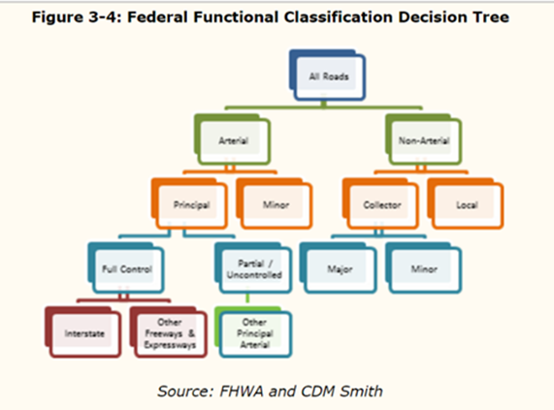
FYI… What this looks like in Seattle- Downtown & More residential
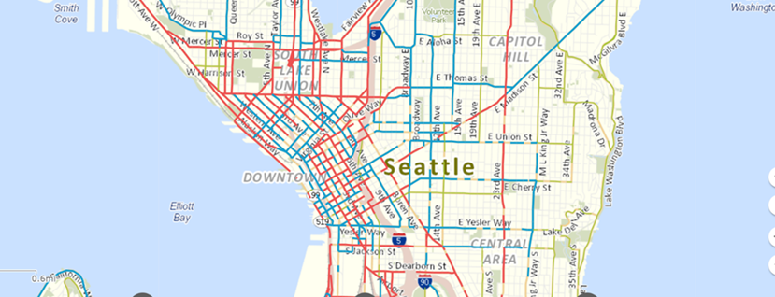
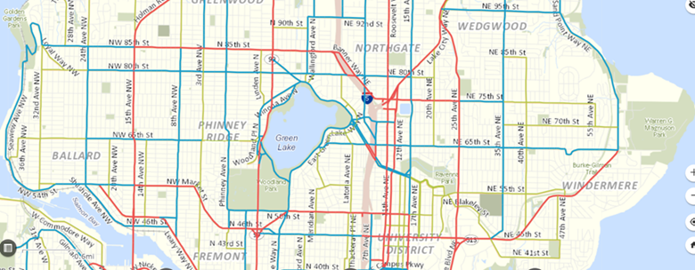
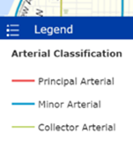
LID Projects
Policy Recommendation
Update Appendix 12, Table 3 to include an additional footnote to provide a multiplier if a project uses an LID BMP. (see markup at end of document, blue edits)
PAC Input Needed
· All PAC members (and Permittees) should understand that flow control, water quality, and LID SSC program points are additive.
· Agree that projects that use a LID BMP should receive additional points?
o One question volunteer group had: If a LID BMP is used, will it always get some water quality points and flow control points. If so, maybe a multiplier not needed?
· If so, agree with format for incorporating LID additional weighting?
· If so, what should the increased multiplier be for using LID BMPs for water quality and flow control? Currently shows 1.5 multiplier for on-site management LID.
Background
There is PAC interest in including more points for LID projects due to ECY’s stated goal to make LID the preferred approach to managing stormwater (for redevelopment? It had been unclear to some in the group that the LID SSC Program Points are in addition to Flow Control SSC Program Points and Water Quality SSC Program Points. It seemed to some in the Volunteer Group that LID projects already could receive more points as would those projects also have water quality and flow control points. There was a question about whether using a LID BMP would by default provide some water quality points and some flow control points; and, of so, whether another multiplier was needed.

Small Projects
Policy Recommendation
No changes to multipliers to account for small projects. The Simplified Metric work group did some preliminary work on a method for easier point calculation for small projects which would make it easier to report and receive credit for small projects.
PAC Input Needed
· Agree with recommendation not to have a multiplier for small projects?
· Agree to use the method from the Simplified Metric work group?
· If not, what are your concerns about small projects and how do you recommend addressing?
Background
There is PAC interest in including more points for small projects. The Volunteer Group did not understand the rational. We thought it was because smaller projects have greater unit costs ($/point) due to overhead. We thought this was similar to the challenge of greater unit costs ($/point) of projects in high urban areas and should be considered when setting level of effort, not necessarily as a multiplier. Seems that some of the concern was about small LID projects which are already incentivized by the LID multiplier. See note in Policy Recommendation about simplifying reporting for small projects.

Flow Control Exempt Receiving Water Bodies
(be forewarned that much of this was developed by Ingrid last minute with minimal review from other subgroup volunteers)
Policy Recommendation
Add “discharges to a receiving water with to a sediment Superfund clean up site” to Appendix 12, Table 3 as a plan that receives a 0.1 multiplier. Then add language following language at end of Footnote 2 “If project the discharges to a flow control exempt receiving water utilizes a multiplier from this note, than add 1.0 to the multiplier.“ (see markup at end of document, red edits)
In addition, recommend ECY develops clearer language re: how to apply Footnote #2.
PAC Input Needed
· All PAC members (and Permittees) should understand that Ecology’s intent for Footnote #2 is that all those items were additive.
· Agree that high priority projects to flow control exempt receiving waters (e.g, water quality projects in the LDW) which can only receive water quality incentive points should be able to receive at least as many points as a creek project which can receive both water quality incentive points and flow control incentive points.
· If so, agree with format for incorporating?
· If so, agree with adding 1 multiplier (basically doubling the value would otherwise receive?)
· Is there another situation where a PAC member thinks a flow-control exempt project should get more points other than draining to a Superfund cleanup site? If so, is there a way or broaden or add to this?
Background
There is PAC interest in including more points for flow-control exempt projects because, even though they are high priority for a jurisdiction (e.g., water quality projects to the Lower Duwamish Waterway) those projects typically only receive a portion of what the same project could receive in a creek basin as flow control is not required in flow control exempt receiving waters, so typically these projects are only designed for water quality and then only receive water quality incentive points (vs. water quality and flow control incentive points as in a flow control required creek basin). To address this, the thought is to add “drains to a sediment Superfund Cleanup” to the list of “plans’ in Footnote #2 for additional points.
Draft Markup Appendix 12, Table 3
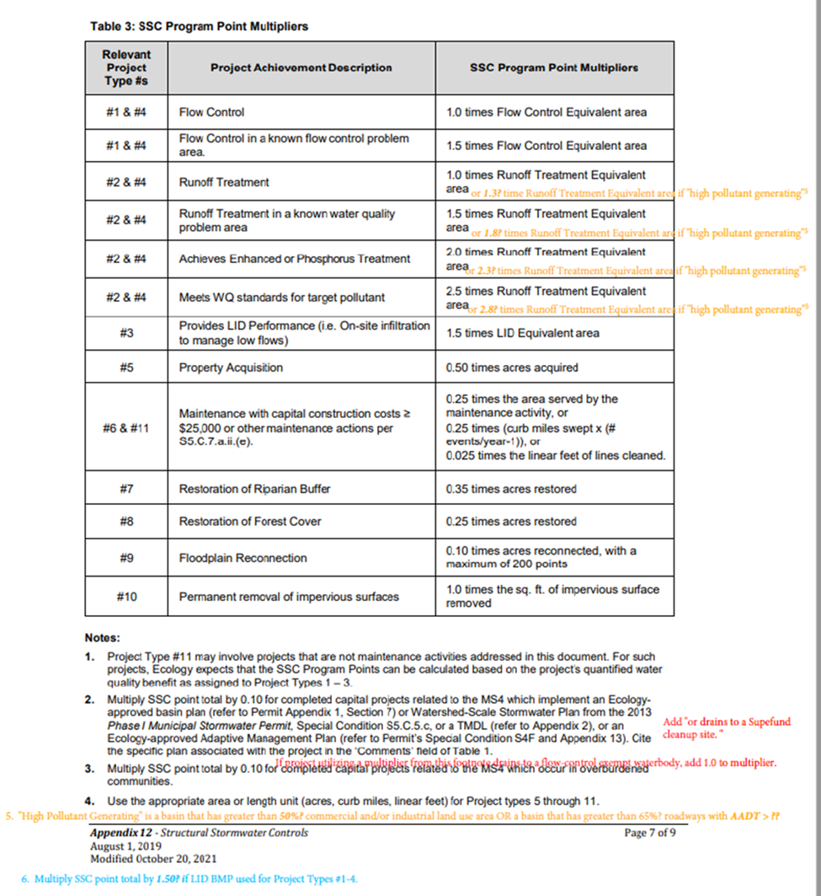

Collaboration Workgroup

Participants: Blair Scott, Merita Trohimovich, Maureen Meehan, Aaron Clark, Larry Schaffner

Where there was concern, issues mentioned in comments are indicated in italics

Purpose of Workgroup

From Survey: “The Permit should provide a mechanism for point distribution between Permittees (Phase I and Phase II or combinations of the two) for collaborative projects. (method TBD (e.g., cost, area of MS4 treated))”
(Comment: Incentives?: Time, or others? Most funding sources require that projects meet certain standards and align with regional priorities. Incentives should be focused on removing barriers to collaboration.)

Summary of Discussion
The workgroup set out to discuss the following ideas for allowing and incentivizing collaboration on SSC projects through permit requirements, yet did not have time to discuss all ideas equally:
1) Joint Structural Stormwater Control (SSC) Projects in Urban Growth Areas (City of Olympia/Thurston County)
2) Regional Retrofit Fund Recommendation (2024 Ad Hoc Committee)
3) Cost Mechanism
4) Contributing Area from Jurisdiction
5) Project Based Agreements
The SSC PAC members in attendance seemed to agree that there were some particularly worthwhile elements of the ideas brought forward.
- The group thought that breaking SSC projects into more distinct pieces and awarding points for those pieces is worth considering.
- In addition, the idea of using a percentage of total project cost as a mechanism for dividing up SSC project points seemed to be logical to many.
- There was also a desire to not over-complicate things and maintain flexibility with whatever SSC collaboration mechanism is proposed in permit language. This is why the group also seemed to think there may be value in allowing for project-based agreements to determine the appropriate way to divvy up SSC points on collaborative projects.

Ideas for SSC project collaboration permittees:
- Joint Structural Stormwater Control (SSC) Projects in Urban Growth Areas (City of Olympia/Thurston County):
  - Potential Solutions:
  - The current Phase I Permit SSC program structure appears to presume that a single jurisdiction will complete qualifying projects from start to finish. Allowing multiple jurisdictions to acquire SSC credits for completing various project phases, and/or providing a meaningful multiplier incentive for interjurisdictional collaborative projects can address the annexation-prone risk issue in unincorporated UGAs.
  - Propose allocating credits for each of the following project phases:
(Comment 1; I’m not comfortable getting to this level of point awards.
Comment 2: Consider simplifying to avoid over-reporting burden.)
    - Feasibility studies
    - Annexation planning
    - Project scoping
    - Project planning, including community-related engagement during this phase
    - Grant application submittals for jurisdictions that can only bring retrofits to fruition through grant assistance
    - Project design
    - Project construction
  - In addition, to account for the additional effort, time, and complexity involved as well as benefits realized via interjurisdictional project collaboration, collaboration jurisdictions would receive an incentive multiplier during any of the project’s phases jointly carried out.

- Regional Retrofit Fund Recommendation (2024 Ad Hoc Committee):
Microsoft Word - AdHoc_WhitePaper_SharedPriorities-Final.docx (wastormwatercenter.org)
(Comment 1: Is this something the SSC PAC wants to support as a recommendation to ECY
Comment 2: Not much discussion on this in our meeting)
  - Idea: We recommend advancing this concept through the proposed Structural Stormwater Controls Policy group, and we hope this document can serve to provide some initial thoughts to guide the conversation. Some items for the SSC Policy group to consider ought to include:
    - - Structure
      - If participation for this regional fund were to become a permit requirement, it’s recommended that it sit within the Structural Stormwater Controls section of the Phase I and Phase II permit.
      - The Regional Retrofit Fund could draw on the function and organizational structure of SAM. The fund would be managed and distributed by a consortium of contributing agencies (like SAM) or an impartial third party (public or private).
      - Permit language could use concepts highlighted in S.8 Monitoring and allow for full, partial, or no participation.
      - Determination of contribution amounts would need to be discussed by the SSC policy group o The Regional Fund could be created in a way that allows for contributions by Private agencies and non-profit partners. Contributing entities, along with non-profit and tribal partners, could be eligible to receive regional funds.
      - Regional Fund permittees would establish funding priorities annually, or on a given permit cycle - Function
      - Incentives for participating in this program would be necessary. Some possible ideas include, but are not limited to: Permittees that contribute to the regional fund could receive a multiplier on all projects used to meet compliance with their SSC requirement Permittees that contribute to the regional fund could receive a portion of the points on all projects completed with this money – whether in their jurisdiction or not. Being able to meet compliance by only contributing funds
(Comment 1: Flagging for discussion compliance by only paying into a fund. This may result in inequities, can be seen as trading (without proper trading oversight), etc.?
Comment 2: I am not very comfortable with this idea, the purpose of SSC is to do things, contributing to a fund is going to lead to so much process etc., that the funds will be used for admin not actual doing. It will also be lengthy.)
      - The regional fund would operate as a competitive awarding agency based on estimated outcomes and regional benefits (TBD by the SSC Policy group)
    - - Additional Items to Consider
      - Applicable projects could be focused on a singular parameter of concern and specific to existing/emerging environmental issues (e.g., 6ppd-q). Focusing efforts like this on one primary parameter or in targeted watersheds would prioritize available resources for relatively more significant problems and those projects would provide stormwater treatment benefits as part of their implementation. These actions could also provide benefits for related outcomes such as fish passage, habitat improvement, and flood reduction projects. Finally, a structure like this could help set the stage for expansions into regional in-lieu fee programs and water quality and flow credit trading frameworks.

- Cost Mechanism:
(Comment 1: Seems like an easy way to include non-permittees.
Comment 2: I am not sure how I feel about including non-permittees, SSC is a permit thing, I am interested in more info on that piece.
Comment 3: This collaboration mechanism seems like the most viable SSC PAC recommendation to ECY - Assuming we add more detail to consider breaking out project phases permittees could get credit for and/or leaving flexibility for leaving up to agreements under (S3.B.1 in the Phase I permit)
Comment 4: @SSC PAC: Most discussion/energy around ideas #1/3/5. Potentially combine them? )
  - Idea: Percentage of project funded correlates to percentage of total project points received.
    - Considerations:
      - How would this work with a third party funder (Grant, PPP, etc.)?
      - What are the bounds of the cost of a project? Does this include maintenance, etc.?
(Comment: Consider leaving this up to an agreement between project partners?)
- Contributing area from jurisdiction:
    - Multiple MS4s contributing to a regional facility?
(Comment 1: Mapping data may be a limitation?
Comment 2: May be a challenge at the planning stage depending on the permittee? Should be feasible during design.
Comment 3: this could also work or a combo of contributing area and who is paying.)

- Project based agreements:
(Comment: Point back to "S3"? related to relying on other entity for permit compliance.
Comment 2: Yes, S5.C.3 outlines coordination mechanisms, both intrajurisdictional and interjurisdictional.
Comment 3: Actually - I think we were referencing S3.B under "Responsibilities of Permittees")
  - Idea: SSC requirement allows flexibility for permittees to establish agreements for how they want to divvy up points based on the circumstances of the project.
    - Considerations:
May need to revise Non-Qualifying Projects language in Appendix 12?

Attachment F - Meeting notes November 15
Structural Stormwater Control Policy Advisory Committee

November 15, 2022 1:00-4:00 p.m.

Welcome – Jim Nelson

Reviewed PAC Purpose, Ground Rules, & Meeting Agenda

- See Jim’s PPT for details.

Sub-Workgroup Report Out
Phase II
Jenny Gaus shared Phase II Retrofit workgroup document on screen.

The group tried to include the concept of flexibility for Phase IIs. To that end, they tried to create a wide range of things Phase II could work from, and introduce the idea of LOE being scaled based on capacity, and timeline when requirements kicked in.

Document lays out different possibilities for what the requirement could be, then details different ways Phase II’s could implement each possible requirement. Lists points of consideration at the end that should be incorporated into any Phase II requirements.

Phase II’s are even more diverse than Phase I’s, and requirements should reflect that.

Simplified Metrics

Merita shared the Simplified Metrics workgroup document on screen.

Group generally agreed on many things, but not everything. Talked about three main topics:

- Simplified Overall Metric
Considered different metric alternatives, but didn’t conclude on a definitively better
solution. Details recorded in workgroup document.
- Simplified Points for Small Projects
Group supports that small projects (triggering MR 1-5), should get a set amount of points. Workgroup document provides example modeling.
- Retrofit vs. Maintenance Project Points
Difference of opinion among the group on this topic. Potential methods of approach recorded in workgroup document.

Multipliers
Ingrid shared the Multipliers Workgroup document on screen.
*Note: Bill Leif was unable to participate in this workgroup.
Workgroup grouped the different environmental factors into the following groups:
- AADT & Land Use
  - LID Projects
  - Small Projects
  - Flow Control Exempt Receiving Water Bodies
Recommended unique multipliers for each group, except for Small Projects. No recommendations for this group. Recommendation details provided in workgroup document.

Collaboration
Blair shared the Collaboration Workgroup document on screen.
Group catalogued ideas related to the notion that the permit should have a mechanism to distribute points among permittees for collaborative projects. Contributing ideas and resulting recommendations are available in the workgroup document.
PAC Discussion
Ingrid: I really appreciate everyone’s work on these. I know they take a lot of time and effort. For the simplified metric, I love the concept, but it’s tough to create a unified metric that’s
truly flexible enough for all the different permittees.

I thought the Collaboration group had a lot of really good ideas. The joint funding concept makes me nervous, especially if it becomes required.

Blair: On the simplified metric, was there any discussion on the level of rigor/modeling required to drive the equivalent area? Does it have to be based on WWHM, or could it use some other method?

Rod: We didn’t get into that level of detail, specifying how ECY would require permittees to
calculate the area.

Peter: It would be good if you could carry points over from one permit to another if you complete a very big project within a single permit cycle.

Bill: This gets back to a discussion from 2018 when we realized that each Phase I had a
different palette of projects they completed, that weren’t strategically designed to fit into any kind of point system. You don’t want a point system that disincentivizes the most important project because of their size.

Abbey: Is the concern that a permittee would complete a single project from start to finish within one permit cycle that exceeds their point requirements for the cycle?

Peter: Yes.

Aaron: I think the idea of using acres as an LOE metric allows the “amount you have done” to
indicate “how much you have left”. Seeing the “how much you have left” number go down over time seems like an ideal goal. Would love to see future discussion on this after the PAC concludes.

Ecology Feedback

Abbey: Thank you for this additional feedback. It really helps clarify some of the initial feedback from the survey results.
We’ve had a chance through this initial information, and here are some of our initial thoughts:

Phase II

Appreciated hearing the group’s support for an SSC-type requirement for Phase II’s separate
from SMAP.

We are definitely still figuring out the best way to scale requirements that captures the wide diversity of Phase IIs.

Regarding annexations for Phase II counties, are annexations planned in advance?

Larry: No. It can be spurred by development, advocacy from a jurisdiction, or a number of other factors. Our region does not have an annexation plan. We run into an issue where cities resist annexation unless systems are upgraded, but then the area gets upgraded and then leaves. We want to remove this barrier, and incentive collaboration.

Multipliers

We are still grappling with the recommendation that Flow Control Exempt projects get more points.

Doug: Why are you spending your money on a flow control device for a flow control exempt basin? Why not spend that money on treatment?

Ingrid: I agree. My concern is if you build bioretention in the Duwamish vs. a creek, you’ll automatically get more points for the creek. Is there a way to make it that high priority areas get enough points to balance out the lack of flow control points?

Doug: That would be addressed by additional multipliers on the treatment side.

Merita: We would appreciate more clarity about what the items in the table mean and how to apply them to permittees.

Doug: We can try to add training on it in the future.
Amy: We are currently looking at the definitions of “high pollution generating” in that table for
review.

Ingrid: If you’re doing an LID BMP, will you automatically get credit for flow control?

Doug: It depends, you have to run the numbers. You certainly could get credit for it.

Merita: We all say we want LID, but are we adequately incentivizing it enough? The infeasibility requirement seems to be a hindrance to this.

Doug: The infeasibility requirement only applies to MR5. There are lots of projects that aren’t
impacted by the infeasibility requirement.

Simplified Reporting

This is a really tough topic, and we appreciate how far this group got in suggesting recommendations.

The idea around points for small projects also intrigues us. We also like this idea. Were the limits that were selected chosen because that’s the range where projects tend to be cost- ineffective? Are projects larger than one acre typically cost effective?

Emma: Those numbers were really just a starting point. We were trying to solve a few problems:
- How to make it easy to report those projects to ECY?
- Projects over that half-acre threshold tend to get that engineering/evaluation
anyway, so didn’t necessarily need to have a set value.

Doug: If Ecology came up with a project size threshold and said “all projects below this size don’t need to calculate equivalent area, you just get credit for the number of acres.” would that be helpful?

Blair: Yes, that would be helpful. Just a matter of determining what threshold to set.

BREAK
Return at 2:52 PM

Ecology Feedback Cont’d (2:52)

Collaboration

These are great thoughts. This is a very tough piece to incorporate in a permit.

The idea of a collaborative regional retrofit fund seems like something that’s beyond our capacity for this reissuance, but perhaps has merit in the future (possibly in coordination with NEP).

Appreciate the ideas about how points could be shared. Also like the idea of using cost as a mechanism/option for distribution.

Key Recommendations for Ecology

Blair

- The level of retrofit needed in the PS Basin is so vast, we should remove barriers to collaboration so large scale projects for the health of these waterbodies can be accomplished.

- Simplified reporting is important.

Emma

- Agree with Merita about being mindful of how much we change.

- Agree with Bill that it would be good to be mindful about data collection and the usefulness of that data in the future. Want to design the data we get from our program in a way that it can be used later.

Ingrid

- We are very diverse permittees (Phase I’s, and Phase II’s even more so). Given that, I think that maintain flexibility is paramount. Give people as many tools as possible to meet their goals.
- Don’t let the LOE requirement drive jurisdictions that already have well- developed programs that are getting things done.

- I think the suggestions we’ve made to improve/refine the permit are worthwhile.

- Looking at the Phase II’s, it’s so important that any requirement that’s developed considers their diversity and capacity (especially the ones who can’t be here at the table).

Sean

- Our thoughts have been put into writing through many forms throughout this process.

- At the end of the day, there are WQ goals that need to be met. If there’s ever a time to try and get something done that is planned and intentional for great benefit, it’s now.

- Everybody’s got concrete, everybody has an impact. Glad folks are digging it up
and doing it better.

Merita

- Whatever we develop needs to be implementable.

- Also agree flexibility is paramount.

- It’s important to think what is already being added to the permit. Sweeping is
already going to be a huge LOE.

- Also, not every permittee’s budget cycle lines up with the new permit cycle, and
sometimes we just don’t get more money for permit implementation.

Bill

- Don’t constrain opportunism. We feel like the system still allows for opportunism.

- Improve the existing point system.
- Try to find ways to value projects that are currently outside the SSC scope.

- Metrics

  - Make the data “pool-able” between Phase I and II permits. We don’t want the datasets to be so different they can’t be compared and iterated upon.

Jenny

- Flexibility for Phase II’s is especially important. Building in projects from a variety of sources that are all stormwater related would be super helpful (e.g. data gathering and analysis vs. building vs. planning). The need is so great, it’s hard to see any effort being “wrong.” We want to encourage them to do whatever they are capable of doing. Whatever we come up with needs to be implementable.

Jason

- Having a lot of flexibility is paramount. Being able to work outside of our permit area and get points for that would be huge. We have a lot of locations outside the permit areas that could use some attention.

- Am unclear about the nexus of fish passage and SSC points, but if there’s any
room to award points for that we would benefit greatly.[TM(1]

Peter

- Also agree flexibility is paramount.

- We want a permit that “lifts all boats” as it were, but we don’t want it to punish
anyone who is trying to do more, or go above and beyond.

- It’s really important to look at the cumulative effort across all the requirements. People are feeling stretched thin between programs.

Sheena

- From the WSDOT perspective, collaboration is the key with funding out there being inconsistent. In writing and reissuing the permit, it would be good if ECY could break down barriers and predict where disincentives will occur (e.g. Flow Control Exemptions).
- We need to remember the human aspect of this. How is this going to affect our ratepayers/communities? If we add elements that require more funding, are we
expecting to raise taxes/rates? At what point does that affect peoples’ ability to pay and
impose disproportional impact?

Rod

- Agree with the importance of being implementable.

- Support keeping the language between the Phase I and Phase II permits very similar.

- Incentivizing certain types of projects over others takes permittees ability to prioritize what they think is most important for them.

Aaron

- The need for retrofits right now is pretty immense. They are new and a burden,
but they are necessary. There’s an urgency to rise to this challenge in big ways.

- Separate out things that aren’t really SSC vs. true SSC projects would help prevent
confusion. We need to focus on true SSC retrofits to really achieve net ecological gain.

- Better data is important. If we all have metrics on the true state of things, we can begin to use that as a driver for our efforts to make the most impact.

Maureen

- My overall experience of this process is that it’s really complicated, there’s a lot of detail we didn’t get to.

- Ecology, don’t change too much. We aren’t there yet.

Larry

- The voices that you’ve heard from on the PAC are only some of them. There are many jurisdictions that don’t have the capacity to engage in this kind of process. It’s easy for them to become invisible.
- Phase II’s permittees have different abilities and challenges from Phase I’s. They should have different requirements, can’t be treated the same as Phase I’s.

- Be careful that we don’t create a framework where we end up chasing points
instead of effective actions.

Next Steps and Close – Jim Nelson

Ingrid: There are two deliverables already, the survey results with comments and the sub- workgroup papers we’ve developed.

I think the one thing that might be a good addition is a way for respondents to add comments to their survey responses.

Bill: I would like to have ECY come forth at the last meeting and tell us where they’re at. What
they can and can’t do in the next permit cycle. What are their thoughts on these ideas that we’ve been sharing?

Abbey: That does sound like a satisfying way to wrap up this process. We will provide feedback the best we can within the limited timeframe we have between now and our next meeting.

Jim: We would love to have some PAC members volunteer to help the facilitation team compile the work done here into a single document.

Ingrid: I would be hesitant to synthesize this too much. It might be ok to summarize a few key concepts (flexibility, implement ability), but I wouldn’t try to synthesize everything we’ve covered into a single report.

Call for Public Comments: No members of the public present. Adjourn

