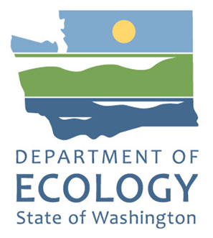

Food Donation Work Group  
Draft Operating Procedures

Organics Management Law 2.0 ([HB 2301](https://app.leg.wa.gov/billsummary?BillNumber=2301&Initiative=false&Year=2023))

By

Food Center Team

For the

**Solid Waste Management Program**

Washington State Department of Ecology

Olympia, Washington

August 2024

Contact Information

**Solid Waste Management Program**

Headquarters

P.O. Box 47600

Olympia, WA 98504-7600

Phone: 360-628-4031

**Website[1]:** [Washington State Department of Ecology](https://ecology.wa.gov/contact)

ADA Accessibility

The Department of Ecology is committed to providing people with disabilities access to information and services by meeting or exceeding the requirements of the Americans with Disabilities Act (ADA), Section 504 and 508 of the Rehabilitation Act, and Washington State Policy #188.

**To request an ADA accommodation, contact Ecology by phone at 360-628-4031 or email at FoodCenter@ecy.wa.gov. For Washington Relay Service or TTY call 711 or 877-833-6341. Visit** [**Ecology's website**](https://ecology.wa.gov/About-us/Accountability-transparency/Our-website/Accessibility) **for more information.**

Department of Ecology’s Regional Offices

Map of Counties Served

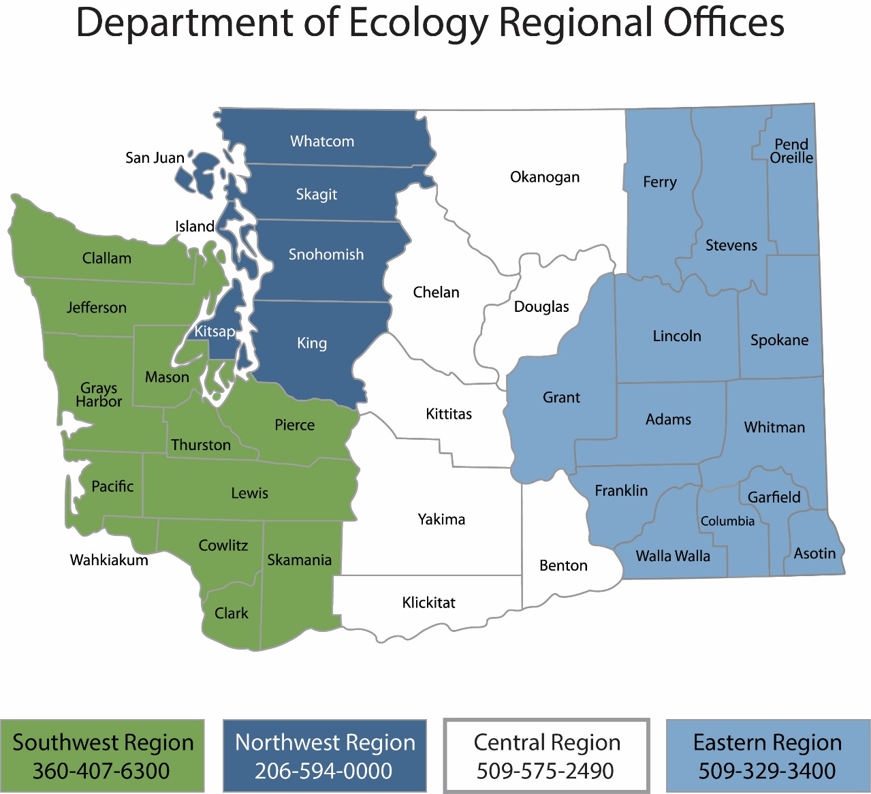

| Region | Counties served | Mailing Address | Phone |
| --- | --- | --- | --- |
| Southwest | Clallam, Clark, Cowlitz, Grays Harbor, Jefferson, Mason, Lewis, Pacific, Pierce, Skamania, Thurston, Wahkiakum | P.O. Box 47775  Olympia, WA 98504 | 360-407-6300 |
| Northwest | Island, King, Kitsap, San Juan, Skagit, Snohomish, Whatcom | P.O. Box 330316 Shoreline, WA 98133 | 206-594-0000 |
| Central | Benton, Chelan, Douglas, Kittitas, Klickitat, Okanogan, Yakima | 1250 West Alder Street  Union Gap, WA 98903 | 509-575-2490 |
| Eastern | Adams, Asotin, Columbia, Ferry, Franklin, Garfield, Grant, Lincoln, Pend Oreille, Spokane, Stevens, Walla Walla, Whitman | 4601 North Monroe  Spokane, WA 99205 | 509-329-3400 |
| Headquarters | Statewide | P.O. Box 46700  Olympia, WA 98504 | 360-407-6000 |

Food Center Work Group  
Research Design Plan

Organics Management Law 2.0 ([HB 2301](https://app.leg.wa.gov/billsummary?BillNumber=2301&Initiative=false&Year=2023))

Solid Waste Management Program

Washington State Department of Ecology

Headquarters Office

Olympia, WA

**August 2024**

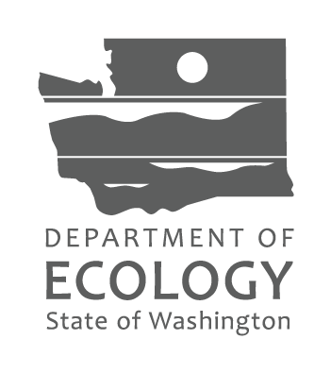

Table of Contents

Food Donation Work Group 5

Background 5

Work Group Mission 5

Member Roles and Responsibilites 6

Department of Ecology 7

Washington State Department of Agriculture 7

Work Group Member Composition 8

Nomination of Members 8

Replacement of Members 9

Decision Making and Voting 9

Communications 10

Public Comments 11

Research Topics 11

Work Group Timeline 12

Meetings Schedule 12

Appendix A. Food Donation Work Group Participants 13

Appendix B. Community Agreements 14

Community Agreements 14

Appendix C. Recommendation Worksheet 15

## Food Donation Work Group

### Background

The Organics Management Law 2.0 ([HB 2301](https://app.leg.wa.gov/billsummary?BillNumber=2301&Initiative=false&Year=2023)) requires Ecology to set up a work group to studies and recommends ways to improve edible food rescue from commercial generators, including food service, grocery stores, and processors.

The work group will address:

* Logistics to phase in edible food donation programs, including incentives;
* The food recovery network system necessary to support increased donation of edible food by commercial generators;
* Assess asset gaps and food infrastructure development needs.
* How to facilitate the creation of networks and partnership to address gaps and needs;
* Develop innovative partnership and models where appropriate;
* Actions taken, costs, and lessons learned by other jurisdictions in the United States that have enacted policies focused on reducing edible commercially generated food waste, including studying voluntary pilot projects carried out by commercial generators.

Ecology will submit a report to the legislature by September 1, 2025, with recommendations from this work group, which will make recommendations based on consensus (see page x).

These operating procedures discuss background, member roles and responsibilities, work group composition, timelines, and other notes before the first meeting in July 2024. This document and other supporting materials can be found on the [Food Donation Work Group EZ View webpage](https://www.ezview.wa.gov/site/alias__1962/39940/food_donation_workgroup.aspx).

### Work Group Mission

The Food Donation Work Group (FDWG) is dedicated to enhancing food rescue efforts from commercial sources. The FDWG will prioritize food waste prevention, food rescue, and managing the remaining material through recovery systems. Success will be driven by forging strong partnerships and ongoing discussions about current issues and research.

### Member Roles and Responsibilites

Work group members come from different backgrounds and industries. They should consider these perspectives to find common ground when needed. Members were selected based on requirements from the legislation. A full list of members is in Appendix A. Food Donation Work Group Participants

The work group will be responsible for making recommendations on improving edible food rescue from commercial generators (including food service, retail establishments, and processors that generate excess supply of edible food).

The work group will meet for 2-hour sessions using Zoom. Meetings will begin July 2024 and happen monthly through April 2025. See work group Timeline for more information.

To craft recommendations, the work group will refine the research plan and provide insights from their respective fields. Honesty, mutual respect, civility, and common courtesy will underscore all discussions. Work group members are expected to listen, ask questions, learn from each other, and create a problem-solving atmosphere.

Work group members will:

* Come prepared to engage in work group discussions by reviewing research memos sent by Ecology and not multi-tasking during monthly meetings.
* After each meeting, review the draft summary and email any concerns or edits to all work group members and/or Ecology.
* Educate themselves on research topics, including reviewing research memos, asking questions of members, and listening to presenters.
* Collaborate with other work group members, facilitators, and speakers for the purpose of the work group (See Work group Purpose). Email Ecology with concerns or suggestions about meeting agendas and facilitation. Feedback can support changes that allow the group to accomplish its purpose.
* Review and vote on recommendations to improve edible food rescue from commercial generators to the legislature by September 1, 2025.
* Follow community agreements (See Appendix B. Community Agreements).
* Attend all meetings, if possible. If not able to attend a meeting, tell Ecology staff in advance. Or email Ecology staff after the meeting so facilitators can document Work group member perspectives and/or votes.

### Department of Ecology

At least one Ecology staff member will participate in each work group meeting. Ecology is a member of the work group in addition to providing facilitation.

Ecology staff will:

* Review work group meeting agendas.
* Respond to information requests from work group members.
* Upload meeting agendas, summaries and other materials to [EZ View](https://www.ezview.wa.gov/site/alias__1962/39940/food_donation_workgroup.aspx).
* Support Work group member requests as time and resources allow.
* Set up Work group meetings.
* Research barriers and opportunities related to edible food rescue from commercial generators.
* Provide support to Work group meetings including staff facilitators.
* Draft reports, meeting summaries, research memos and other materials for review by the Work group.
* Submit the final report to the legislature by September 1, 2025.

As facilitators, the Ecology team will:

* Remind members about upcoming meetings.
* Develop meeting agendas and associated meeting packets and email to work group one week before each meeting.
* Keep discussions focused on the monthly agenda.
* When needed, suggest other ways for the work group to discuss or address its purpose.
* Ask all Work group members to share equally.
* Stop or redirect members who are disrespectful, off-topic, or dominating the conversation.
* Remind members and meeting participants to follow the ground rules (Appendix B. Community Agreements).
* Draft the legislative report with Work group recommendations.

### Washington State Department of Agriculture

One Washington State Department of Agriculture (WSDA) staff member will participate in each Work group meeting. WSDA Staff will:

* Review work group meeting agendas.
* Respond to information requests as needed.
* Support work group member requests as time and resources allow.
* Assist Ecology review the draft report, meeting summaries, and other work group materials.

### Work Group Member Composition

Work group members are set in RCW and call for at least one member from:

* Cities, including both small and large cities and cities located in urban and rural counties, which may be represented by an association that represents cities in Washington
* Counties, including both small and large counties and urban and rural counties, which may be represented by an association that represents county solid waste managers in Washington
* An environmental nonprofit organization that specializes in waste and recycling issues
* A statewide organization representing hospitality businesses
* A retail grocery association
* The department of ecology
* Two different nonprofit organizations that specialize in food recovery and hunger issues
* Three different hunger relief organizations that represent diverse needs from throughout the state
* The department of agriculture
* The office of the superintendent of public instruction
* The department of health
* One large and one small food distribution company
* An organization representing food processors
* An organization representing food producers
* A technology company currently focused on food rescue in Washington
* Two open seats for appointed members of the work group to nominate for department of ecology appointment if gaps in membership are identified.

Ecology added Tribes, Local Health Jurisdictions, and community food hubs to join the work group. In total, Ecology sent 58 invitations to potential members and 44 organizations accepted. A full list of work group members can be found in Appendix A.

### Nomination of Members

Work group members can nominate two (2) additional organizations to join. This will be a topic in the July 2024 meeting. Members can nominate until August 13, 2024, by emailing FoodCenter@ecy.wa.gov. The Food Center will work to onboard the two nominated organizations before the September meeting.

### Replacement of Members

Work group members may need to leave the work group for various reasons. If a member leaves the work group:

* If a work group member can appoint a replacement within their organization, the contact can be updated, and no process is needed.
* If a member leaves the table before the January 2025 meeting, work group members can nominate a new member by emailing FoodCenter@ecy.wa.gov. Ecology will make the final decision whether to invite the new nominee.
* After the January 2025 meeting, leaving members will not be replaced. It is important for all members to be informed and present in discussions throughout the entire process; too much will be missed for members to join after January 2025.

### Decision Making and Voting

The work group intends to have robust conversations. Members will share their perspectives and learn by listening to others. Note takers will highlight agreement, emerging agreement areas, and dissent. Summaries will be provided to members after each meeting. This approach allows the work group to “show their thinking” from the first discussion to the final decision on each topic.

For recommendation development, the work group can use three key ways to share input with the researchers:

* Meetings – Meetings will be designed to capture input and feedback on the research and recommendation development.
* Worksheet development – Work group members can develop worksheet analysis to bring recommendations and ideas forward to the group.
* Surveys – Surveys will be distributed and analyzed each meeting to glean information and feedback from the work group participants.

#### Documenting levels of agreement

The work group will use consensus-based decision making. The final report must include recommendations where general stakeholder consensus has been achieved while noting dissenting opinions or areas without agreement.

Work group members will vote on potential recommendations using an agreement scale (below). This helps facilitators know where more discussion is needed and get to solutions that have broad support. Meeting summaries will record decisions, agreement, and disagreements. Members can email facilitators if they believe meeting summaries do not contain their perspectives.

The agreement scale:

1. Whole-hearted endorsement
2. Support with Some Reservation
3. Neutral
4. Don’t Like but Will Support
5. Do Not Support

Approval of recommendations

Work group members agree to forward a recommendation to Ecology and the WA State legislature along with, as applicable, documentation about concerns related to the decision. Ecology will draft the report to the legislature based on work group recommendations.

All work group members must review and agree that the final report represents their perspective. Work group members should see any concerns clearly and accurately articulated in the record.

### Communications

Meeting summaries will be posted following each meeting. Each will be posted on the Ecology’s EZ View website: [Department of Ecology - Committees, Boards, and work groups (wa.gov)](https://www.ezview.wa.gov/site/alias__1962/39940/food_donation_workgroup.aspx)

Draft recommendations and other supporting research will also be posted throughout the work group process.

### Public Comments

The public can give comments to the work group by:

* Attending Zoom meetings and:
  + typing a comment in the chat box during the meeting, or
  + speaking during the comment period at the end of each meeting.
* Contacting individual members of the work group.
* Emailing the Food Center: [FoodCenter@ecy.wa.gov](mailto:FoodCenter@ecy.wa.gov).

### Research Topics

Work group recommendations and research must focus on topics assigned by the legislature:

* Logistics to phase in edible food donation programs, including incentives;
* The food recovery network system necessary to support increased donation of edible food by commercial generators;
* Assess asset gaps and food infrastructure development needs.
* How to facilitate the creation of networks and partnership to address gaps and needs;
* Develop innovative partnership and models where appropriate;
* Actions taken, costs, and lessons learned by other jurisdictions in the United States that have enacted policies focused on reducing edible commercially generated food waste, including studying voluntary pilot projects carried out by commercial generators.

Research will help the work group’s mission by grounding recommendations in data and fact-based information. Food Center staff will assist the work group with research needs by:

* reviewing existing literature review,
* responding to written information requests from the work group,
* doing other desktop research and source interviews,
* and sharing results with the work group through research memos or other reports.

## Work Group Timeline

The first meeting is in July 2024, and the work group will meet monthly until April 2025. Work group members can add to discussions and recommendations through meetings, surveys, and by filling out a recommendation worksheet (see Appendix C. Recommendation Worksheet). Ecology will send surveys between meetings to poll members and get feedback on the work group process. Below is the meeting schedule and important deadlines to consider:

* July 2024 – April 2025: Work group convenes and develops recommendations.
* April 2025: Work group final review and comments due.
* April – August 2025: Ecology staff work to publish final report.
* September 2025: Ecology delivers report to the legislature by September 1, 2025.

### Meetings Schedule

Meetings are held on Zoom, and all work group members must [register for the meeting](https://waecy-wa-gov.zoom.us/meeting/register/tZwpde-rpjMuG9TH8EU22k7jyFQklSDET34E). (After registering, a confirmation email will give you an optional calendar attachment to add all the work group meetings). All meetings are from 10am – noon on the dates below:

* July 30, 2024
* August 20, 2024
* September 24, 2024
* October 22, 2024
* January 21, 2025
* February 25, 2025
* March 25, 2025
* April 22, 2025

## Appendix A. Food Donation Work Group Participants

**Updated: 2/20/2025**

2nd Harvest

Bellingham Food Bank

Benton-Franklin Health District

Careit

Cascadia Produce

Charlie's Produce

City of Seattle

City of Spokane

Clark County

Colville Confederated Tribes

Copia

Divert

Eat Local First

Feeding Washington

Food Lifeline

Food Northwest

Free Food For All

GoodRoots Northwest

King County

Kittitas County Public Health Department

LeanPath

Miracle Food Network

Northwest Food Alliance

Northwest Grocery Association

Office of Superintendent of Public Instruction

Pierce County

Safeway/Albertsons

Seattle Good Business Network

Snohomish County Health Department

Snoqualmie Tribe

Sustainable Connections

Tacoma-Pierce County Health DIstrict

Thurston County Food Bank

Too Good To Go

Washington Department of Health

Washington Food Coalition

Washington Food Industry Association

Washington Hospitality Association

Washington State Department of Agriculture

Washington State Department of Health

Washington State Department of Ecology

Zero Waste Washington

## Appendix B. Community Agreements

### Community Agreements

1. Treat other work group members, facilitators, and speakers with respect.

2. Allow one person to speak at a time and listen actively to others; thinking of a rebuttal often means you are not listening.

3. Come to work group meetings with an open mind.

4. Assume best intent.

5. Intend no malice with what you say, assume no malice in what you hear.

6. Represent your interests and those of your constituents while being constructive; don’t disagree just to disagree – add a solution.

7. Be present and engaged throughout the meeting

8. Come prepared to use meeting time productively

9. When possible, provide data and information to support statements

10.If you find yourself in a speaking role throughout a meeting, move back into a listening role to make space for others. If you find yourself mostly in a listening role, move into a speaking role.

## Appendix C. Recommendation Worksheet

**This document is intended to assist in research efforts only. Boxes can be left blank or incomplete. Please email worksheets to FoodCenter@ecy.wa.gov.**

**DATE:**

**TITLE:**

**ORGANIZATION MAKING RECOMMENDATION:**

**ANALYSIS PREPARED BY:**

|  |  |
| --- | --- |
| **Summary of Issue** Please provide background on the issue the recommendation works to solve or improve. |  |
| **Summary of Recommendation** Please provide a summary of the proposed recommendation. |  |
| **Barriers and Incentives** Are there rules, legislation, or perceptions that create barriers to solving the issue? Are there incentives that would help the recommendation succeed? |  |
| **Summary of Resources**  Please list and estimate the resources needed to make the recommendation happen. (For example, labor, finances, equipment, etc.) |  |
| **How do we measure and evaluate success?** Please describe any metrics or evaluation criteria that can be used to measure the success of this recommendation. |  |
| **What are the social impacts to this recommendation?** Please estimate the social benefits and value of this recommendation. |  |
| **What are the environmental impacts to this recommendation?** Please estimate the environmental benefits and value of this recommendation. |  |
| **What are the economic impacts to this recommendation?** Please estimate the economic benefits and value of this recommendation. |  |
| **Research** Please provide research or literature citations that support this recommendation. |  |
| **Are there consequences to this recommendation?**  Please share any known or assumed positive or negative consequences to this recommendation. |  |
| **Any additional comments?** |  |

1. www.ecology.wa.gov/contact