Washington State
Recycling Contamination Reduction and Outreach Plan (CROP)
August 2020 Draft
Publication 20-07-021

Publication Information
This report is available on the Department of Ecology’s website at: https://fortress.wa.gov/ecy/publications/SummaryPages/2007021.html.
Authors: Peter Guttchen, Heather Church, Steven Gimpel, Shannon Jones, Amber Smith, and Paula Wesch.
2020 Washington State Contamination Reduction Outreach Plan

Contact Information
Publications Coordinator
Solid Waste Management Program
Washington State Department of Ecology
P.O. Box 47600
Olympia, WA 98504-7600
Phone: 360-407-6764
Washington State Department of Ecology – https://ecology.wa.gov
- Headquarters, Olympia 360-407-6000
- Northwest Regional Office, Bellevue 425-649-7000
- Southwest Regional Office, Olympia 360-407-6300
- Central Regional Office, Union Gap 509-575-2490
- Eastern Regional Office, Spokane 509-329-3400

COVER PHOTO: iStock by Getty Images: January 4, 2018 – Photographer: CarryonDroning

Any use of product or firm names in this publication is for descriptive purposes only
and does not imply endorsement by the author or the Department of Ecology.
To request ADA accommodation for disabilities, or printed materials in a format for the visually impaired, call the Ecology ADA Coordinator at 360-407-6831 or visit ecology.wa.gov/accessibility. People with impaired hearing may call Washington Relay Service at 711. People with speech disability may call 877-833-6341.
Washington State
Recycling Contamination Reduction
and Outreach Plan (CROP)

by
Peter Guttchen and Ecology’s Clean Stream Dream Team,
including Heather Church, Steven Gimpel, Shannon Jones, Amber Smith, and Paula Wesch.
Solid Waste Management Program
Washington State Department of Ecology
Olympia, Washington
This page is purposely left blank.
Table of Contents
Washington State Recycling Contamination Reduction and Outreach Plan (CROP) i
Publication Information ii
Acknowledgments iv
Executive Summary v
Introduction 1
Context and Background 1
The Dirty Truth is Out 1
State CROP Basics 3
Principles and Assumptions 5
The Root Causes of Recycling Contamination 7
Cleaning the Stream 16
Industry Consolidation and Funneling of Recycling 17
The Harmonization Choir 19
Regional and MRF-Shed Planning 22
Taking Control of the Future 23
The Statewide Action Plan 24
Guide to Local CROPS 26
Who Needs to Develop a CROP 26
How to Develop a Local CROP 27
The Local CROP Template 28
How to include a CROP in your Solid Waste Management Plan 36
Contamination Reduction Best Management Practices 38
Overview 38
Regional Strategies 39
Communications & Outreach 39
Operations and Collection 46
Incentives and Pricing 53
Policies and Mandates 54
Measurement and Reporting 55
Glass Collection 57
List of Figures 61
Resources 64
Ecology Resources 64
The Recycling Partnership Resources 64
The Context for Contamination 66
Certificated Hauler Service Area Maps 67
Gable Top - Aseptic Containers 68
Contracting for Processing of Recyclables 68
Multi-Family 69
Cart Tagging 70
Single & Dual Stream 70
General Contamination Reduction 70
Hauler Websites 71
Glass 71
Measurement and Cost Analysis 71
Life Cycle Analysis 72
Product Design for Recyclability 72
Glossary, Acronyms, and Abbreviations 73
Acronyms and Abbreviations 73
Glossary 73

Acknowledgments
The authors of this report thank the following people for their contributions to this study:
- Amber Smith - for working her editing and graphic design magic to bring the CROP to life
- Ryan Summerlin - for orchestrating the CROP web pages and developing cool charts and maps
- Diana Wadley - for her rigorous review and pithy edits
- Katherine Walton - for making it all happen behind the scenes, organizing meetings, managing public comments, and documenting CROP resources and references
- Dan Weston - for his tenacious data sleuthing and data mining acumen
- The members of the local government CROP review team for their invaluable feedback and for sharing their in-the-trenches wisdom and resources
  - Travis Dutton, Kim Harless and Tina Kendall – Clark County
  - Mason Giem, City of SeaTac
  - Kristine Major – City of Spokane
  - Susanne Tresko – Spokane River Forum
  - Laura Tucker – Jefferson County
  - Meggan Uecker – Clallam County
  - Rory Wintersteen – Lincoln County
  - Matt Zybas – Snohomish County
- Members of the Recycling Steering Committee for their keen insights and for bringing a full system perspective to the CROP
- The Recycling Partnership team - Asami Tanimoto, Cody Marshall, and Rob Taylor for sharing their expertise, experience, and resources
- And all the rest of Ecology’s solid waste management team who rolled up their virtual sleeves to bring the CROP to harvest in the midst of unprecedented uncertainty

Executive Summary
When China shut the shipping container door on accepting what they call yang laji, or foreign trash, we could no longer hide how much garbage was in the materials collected for recycling in our state. The days of exporting large quantities of highly contaminated material to Asian and other export markets are over. The mess we were sending overseas is now ours to clean up.
To address this challenge, the Washington State legislature and Governor Inslee passed House Bill 1543 in 2019. The act created the Recycling Development Center to expand regional markets for recycled commodities and products, and required the Department of Ecology to create and implement a Statewide Recycling Contamination Reduction and Outreach Plan (CROP), based on best management practices. The State CROP fulfills this mandate.
The act also requires most counties and some cities in the state to include a CROP in their local Solid Waste Management Plans (SWMP). To assist local governments in meeting this requirement, the State CROP includes a Local CROP Template that jurisdictions can cut and paste into their SWMPs. Along with the template, Ecology developed and assembled a robust set of resources for local governments to help them customize and implement their CROPs. This includes the creation of a Recycling Contamination Reduction Resource Library.
The State CROP includes a statewide action plan to reduce recycling contamination. It outlines Ecology’s next steps to assist local governments in their anti-contamination efforts. These steps include:
- Promoting alignment and harmonization across recycling programs statewide.
- Encouraging and supporting regional solid waste planning and aligned or joint contracting for services.
- Gathering and share more comprehensive data to measure the performance of the recycling system.
- Pursuing legislative, funding, and policy solutions.
No one is happy with the status-quo and there is broad agreement that our recycling system needs to change in fundamental ways to thrive over the long-term. This presents us with a unique opportunity to develop the kind of public-private partnerships needed to build a more sustainable future. A future where recycling contamination is a thing of the past. Developing the State and local CROPs is an important next step in creating that future.

Introduction

Context and Background
The context for drafting and releasing the State Contamination Reduction Outreach Plan (CROP) is so extraordinary that it needs acknowledgement right up front. These are uncertain and turbulent times with little visibility into what the future of our communities, economy, and institutions will look like. Of course, all of this applies to our recycling system as well. A system already trying to recover from the shock of export bans, plummeting commodity prices, confounding levels of contamination, and consumer confusion.
Due to the COVID-19 pandemic, local and state governments face precipitous declines in tax and fee revenue and increasing costs for all public services, including solid waste management. Washington state and the local governments who are the primary audience for the State CROP were hit particularly hard. In that context, making progress on reducing contamination may be limited in the near-term. However, even though resources are constrained right now, this is the time to begin working together on a strategy to reduce recycling contamination. By planning now, we can quickly take action as the fog lifts and the economy improves.
The State CROP is a roadmap to identify opportunities to reduce recycling contamination, build community support, and secure the needed resources. These include opportunities to:
- Rethink and reimage our recycling system.
- Build more aligned, integrated, and efficient recycling programs and services.
- Create a more sustainable funding model where the costs, burdens, and benefits of recycling are more equitably distributed and shared.

The Dirty Truth is Out.
When China shut the shipping container door on accepting what they call yang laji, or foreign trash, we could no longer hide how much garbage was in the materials collected for recycling in our state, country, and in other developed nations around the world. The days of exporting large quantities of highly contaminated bales of material to Asian and other export markets are over. The mess we were sending overseas is now ours to clean up.
See Resource Recycling’s From Green Fence to red alert: A China timeline and CNBC’s Why China Stopped Buying U.S. Recycling. For a local perspective, read the Seattle Times April, 26, 2020 article on “Recycling’s dirty truths exposed”

Why a State Crop?
In 2019, the Washington State legislature and Governor Inslee passed House Bill 1543 to address sustainable recycling issues. The act created the Recycling Development Center to expand regional markets for recycled commodities and products, and required the Department of Ecology to “create and implement a statewide recycling contamination reduction and outreach plan based on best management practices.” Drafting the State CROP is Ecology’s fulfillment of this mandate. In addition, the act requires Ecology to provide technical assistance and guidance to help local jurisdictions understand contamination in their regional recycling, and to develop their own local CROPs. The State CROP serves as a foundation for guidance and support.
Counties with a population of more than 25,000 must include a CROP in their Solid Waste Management Plan (SWMP) by July 1, 2021. The requirement also applies to cities with independent Plans within these counties. The Guide to Local CROPs section includes a Local CROP Template that jurisdictions can adopt in lieu of developing their own CROP or revise and customize for their SWMP. See provisions of the act in RCW 70.95.090 (10) and RCW 70.95.100.
See Who Needs to Prepare a CROP for a list of all jurisdictions required to include a CROP in their Solid Waste Management Plan.

Why Now?
Chinese export bans like National Sword, and similar bans imposed by other foreign markets, forced a reckoning over recycling in our state and around the world. We are at a crossroads, and smack in the middle of the intersection are the choices we make about how to manage recycling contamination.
Addressing recycling contamination will allow us to:
- Develop more robust domestic recycling markets and remanufacturing supply chains.
- More fully realize the significant environmental, public health, social, and economic benefits of recycling.
- Open up exciting new opportunities to create a more circular, sustainable, and resilient materials management system and economy.
Not addressing recycling contamination, and continuing business as usual, puts the future of recycling programs at risk and will result in:
- Higher costs to local governments and consumers
- Increased risk of injury to collection and processing workers
- More environmental harm including higher greenhouse gas emissions
Creating a brighter future for recycling in Washington requires producing a consistently clean recycling stream. That’s the purpose of the State CROP, and why Ecology is providing assistance to local governments to develop and implement their own CROPs.

State CROP Basics

Who is the State CROP For?
The State CROP serves as a guide for cities and counties in Washington to partner with residents, businesses, haulers, material recovery facilities (MRF), and other participants in the recycling system to reduce the costs and impacts of contamination on their recycling programs.

What is Recycling Contamination?
Recycling contamination is anything collected for recycling that’s not accepted for recycling in a given community’s recycling program, or is too wet or dirty for processing into new products and ends up in the garbage.

What Contamination Does the State CROP Address?
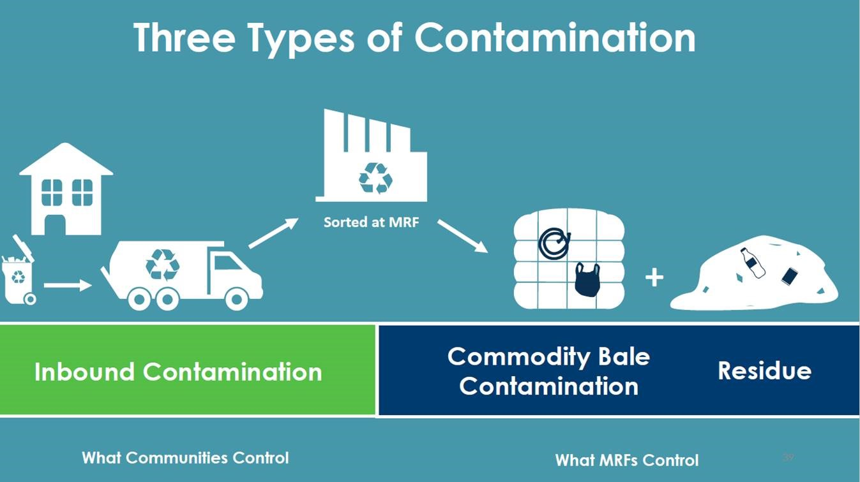
The State CROP addresses contamination of the traditional recycling stream from single-family and multifamily residences, drobox collection sites, and commercial recycling programs. Traditional recyclables include paper, metal cans, glass bottles and jars, and plastic bottles. The CROP does not directly address the contamination of organics, construction and demolition debris (C&D), commodity bale contamination or residuals controlled by MRFs, or material removed by remanufacturers from their secondary material feedstock.
Because the primary audience is local government, the State CROP focuses on reducing inbound recycling contamination. This is the material delivered primarily to MRFs for processing on its way to an end-market. Residents, businesses, communities and haulers control this material. If a recycling program hauls some of its material directly to an end-market, the strategies included in the State CROP would also apply.
Figure 1: The State CROP focuses on reducing inbound contamination. Graphic from the TRP 2020 State of Curbside Report.

What’s Not Included in the State CROP
- Organics and C&D Debris Contamination Reduction Strategies
The State CROP does not include specific strategies to reduce contamination in other material streams including organics and C&D debris. However, jurisdictions can use the basic contamination reduction strategies provided in the CROP to develop targeted strategies for all collection programs. Local governments are encouraged, but not required, to address these streams in their local CROPs. As resources allow, Ecology will assist communities in this work.
- A List of Materials to Collect or Not Collect for Recycling
Ecology strongly encourages local governments located in the same MRF-shed or region to harmonize their acceptable materials list. The State CROP provides some guidance on what to consider in deciding what materials to collect. However, it is up to local jurisdictions to decide what should and shouldn’t be included in their recycling programs. Local community values, and partnerships with haulers, MRFs, and end-markets should guide these decisions.
- Initiatives to Reduce Contamination at MRFs and Mills
The focus of the State CROP is on cleaning up inbound contamination. It only addresses one part of what will need to be a system-wide strategy to create a consistently clean recycling stream in the state. MRF operators and end-markets are deploying new sorting strategies and investing millions of dollars in new technology to clean up the material delivered to them for processing or remanufacture. These investments are critical to creating long-term solutions to our contamination woes, but are outside the scope of the State CROP.
- Market Development Initiatives
The legislation calling for the State CROP also created the Recycling Development Center (The Center) to expand and create markets for recyclables collected in Washington State. Creating a consistently clean recycling stream makes it easier for the RDC to achieve its goals.
- Initiatives Addressing Plastic Waste and Pollution
Ecology and many other organizations are working to address the growing environmental and public health problems caused by the plethora of plastic products produced and consumed in our country and around the world. The State CROP does not directly address these issues, except by supporting strategies ensuring better management of plastics in residential and commercial recycling programs.
Ecology is, however, in the process of implementing two important pieces of legislation passed in 2019 to reduce plastic waste. These will also boost efforts to reduce recycling contamination. They are:
- A Statewide Single-Use Plastic Bag Ban: When it goes into effect in 2021, this ban eliminates one the most vexing sources of recycling contamination in the state.
- The Plastics Packaging Evaluation and Assessment Law: This law sets the goal that all packaging in the state is 100% recyclable, reusable, or compostable and contains at least 20% percent postconsumer recycled content by 2025. The first step is completing a study on the impacts of plastic packaging in Washington by October 2020.

Principles and Assumptions
The principles and assumptions below embed the critical work of reducing recycling contamination in the context of the overall goals of reducing waste and creating a sustainable materials management system. They serve as the foundation for the contamination reduction strategies and recommendations included in the State CROP.

Prevention First
We need to produce less stuff to realize the full environmental, social, and public health benefits of a more sustainable approach to materials management. Even though recycling is preferable to disposal, it comes with its own set of financial, social, and environmental costs. Any product that isn’t produced is one less product that may end up contaminating the recycling stream.

Recycling is a Means to an End
Our environmental, social, public health, and community development goals and values should drive decisions about designing the recycling system and what materials to collect.

Contamination Flows Downstream
Recycling contamination is fundamentally a design problem. Most product and package designs do not meet end-market specifications, causing higher recycling program costs and increased contamination. Designing products and packaging with recycling in mind would solve many of the contamination problems addressed in the State CROP.

Good Data is Foundational
Recycling contamination is a serious problem, but there isn’t reliable, consistent collection of local, regional, or statewide data on the nature and scope of the problem. Without good data, we won’t know if your efforts to reduce contamination and achieve our larger materials management goals are working. Investing in a more robust, aligned, and coordinated system to collect data on metrics like the composition of the recycling stream is key to successfully reducing contamination.

Recycling Has Costs, and They Shouldn’t Be Hidden
Making responsible choices about what materials to collect and process in community recycling programs requires accounting for their environmental, financial, and other benefits and costs. The costs of recycling should not be hidden in the rates charged for garbage collection. Making it appear that recycling is free encourages “wishful recycling” and increases recycling contamination.

Collection and Processing is not Recycling
Collecting materials and processing them for recycling is not recycling. The environmental, and other, benefits of recycling are only realized when the material collected for recycling replaces virgin feedstocks to produce new products. It’s inefficient, costly, and causes unnecessary environmental harm when MRFs have to sort and haul non-recyclable or contaminated material to a disposal site or when mills have to sort that material out of their feedstocks.

Both Quality and Quantity Are Possible
The choice between quality and quantity is a false one. A successful contamination reduction program that lowers consumer confusion about what can and cannot be recycled can also increase the capture rate of clean materials collected for recycling. The capture rate is the percentage of available material in a given community recovered at collection. The capture rate for some commonly collected materials with reliable long-term, and sometimes high-value markets are low.
The Recycling Partnership’s 2020 State of Curbside Recycling Report estimates nationwide residential curbside collection programs capture (by weight) only:
- 53% of aluminum cans,
- 55% of PET bottles,
- 60% of mixed paper, and
- 79% of cardboard

Regional Planning and Coordination is Key
Optimizing the recycling system and dramatically reducing contamination requires integrating and aligning all parts of the system. One primary cause of contamination is the lack of coordinated regional planning, program design, and education and outreach. Our state needs robust regional planning, program standardization, and harmonized messaging to achieve long-term meaningful reductions in contamination. The State CROP includes data and resources to support these kinds of initiatives.

The Root Causes of Recycling Contamination
There are many root causes of recycling contamination and they go back decades. Most efforts to reduce contamination, other than those implemented by MRFs and end markets, focus on the consumer and their decisions about what to put in their recycling containers and how to prepare materials for collection. Although it’s true that consumers need to be part of the solution, meaningful reductions in contamination, they are not the primary source of the problem.
In the bigger picture, recycling contamination is a symptom of a mostly linear and broken materials management system. It results, for the most part, from decisions made upstream from the consumer. These include decisions made by manufacturers, brand owners, product and packaging designers, and retailers. It also results from decisions made by haulers and local governments. These include what and how to collect materials for recycling, how to promote services, and the metrics used to measure program success.
In this context, it’s important to ensure the root causes of contamination that created today’s problems are not ignored. Without reducing recycling contamination it will not be possible to realize the full environmental, social, and economic benefits of recycling. Making substantial reductions in recycling contamination requires all parts of the system working together in more aligned and accountable ways. Our long-term success depends on learning the lessons of the past and not repeating the same mistakes.
Candy Castellano’s presentation Recycling at the Curb – A Brief History (1975-2018) provides an excellent local history. She presented this at WSRA’s 2018 ContaminationFest.
Below is an exploration of some of the root causes of recycling contamination and how they contribute to consumer confusion and erosion of trust in the recycling system. These include complacency, complexity, and commingling.

Complacency
In 2004, the Northern California Recycling Association (NCRA) produced a short video titled Point of Return: Oakland’s Place on the Pacific Rim . It advocates for the economic development opportunities and environmental benefits of using recyclables to manufacture new products in California. The video highlights the rapid growth in the shipment of materials collected for recycling in U.S. cities to countries in Asia, especially from west coast ports. Those countries, many with significantly lower labor costs, few worker protections, and lax environmental standards, would use this scrap to manufacture products to sell back into the U.S. In this 16-year-old video, Nina Butler, NCRA’s Vice-President at the time, and now President of More Recycling, made this prophetic statement:
“The export market, while it is strong and may continue for a long time, is also volatile and puts us in a pretty vulnerable state.”
Events in recent years revealed just how vulnerable we were. We choose to ignore the many obvious signs that major disruptions to the recycling system were coming and failed to prepare for them. The relatively high prices some countries were paying for our materials, combined with their low quality standards and the easy, cheap access we had to foreign markets caused complacency. This complacency is one of the root causes of the high levels of recycling contamination we see today in our recycling programs.
Today, the economic development opportunities highlighted in the NCRA video are reemerging. All over the country, new mills are being built, existing mills are expanding, and old mills are restarting. One of the keys to ensuring the continued growth and long-term viability of these new domestic markets is supplying them with a consistently clean recycling stream. The purpose of this CROP, and other initiatives like the Recycling Development Center, is to get us ready to fully seize these opportunities and make our region’s recycling system more resilient and durable.

Complexity
The rapidly increasing complexity and scale of consumer packaging types and designs is far outpacing the capacity of local recycling programs, MRFs, and secondary material industries to adapt. The pace of change in the types of packaging on the market is accelerating. This is another major root cause of recycling contamination. As the How2Recycle Program noted in their April 2020 Insights report:
“How2Recycle has issued labels to over 75,000 products in the Member Platform, reflecting around 25,000 different packaging designs. For those different packaging designs, How2Recycle has issued over 3,500 custom How2Recycle labels—which represents not only the massive diversity of packaging design in the marketplace but also the complexity of certain package designs. On average, How2Recycle issues labels for 225 products every day.”
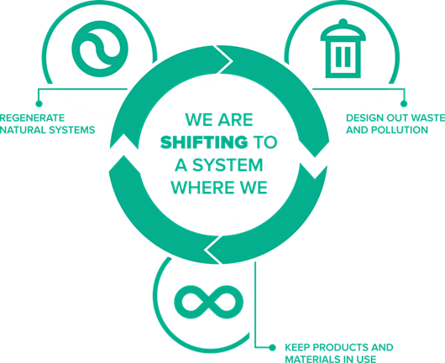
The How2Recycle program is doing critical and important work to increase the recyclability of packaging in what they call the consumer product goods (CPG) space. Their recommendations to improve packaging design are making some progress in increasing the recyclability of some kinds of packaging. However, they currently only represent about 34% of the CPG industry. Although 44% of their member packaging is currently recyclable, they estimate only 18% is optimally designed for recycling. Clearly there is a lot of room for improvement. In the big picture, a more integrated, circular approach to designing products and packaging is required to achieve our sustainability goals and to make long-term and substantial reductions in recycling contamination.
Figure 2: A truly circular economy designs waste and recycling contamination out of the system. Ellen MacArthur Foundation – The Circular Economy in Detail.

Commingling, Landfill Aversion, and the Diversion Trap
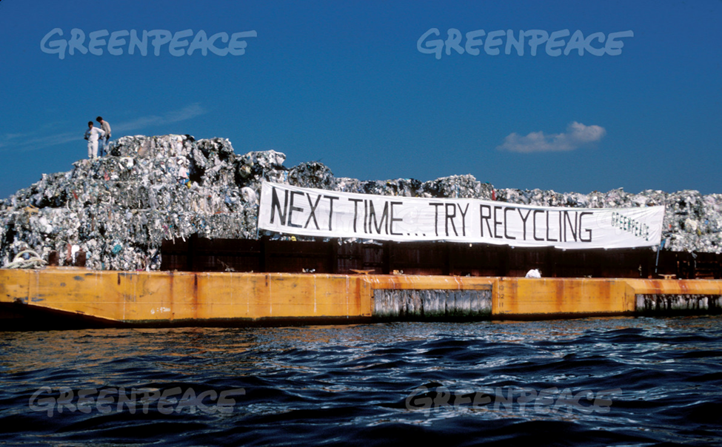
Curbside recycling programs took off in the late 1980s when some parts of the country, especially on the East coast, began to panic about running out of landfill space. The issue made national headlines in 1987 when the infamous garbage barge called the Mobro left New York with more than 6 million pounds of trash bound for a landfill in North Carolina. This unsuccessful early effort to export trash gave birth to the modern recycling movement by focusing attention on the growing amount of stuff we were consuming and landfilling or burning.
Figure 3: Mobro's journey is a fascinating tale. Listen to Planet Money's two-part podcast called A Mob Boss, A Garage Boat, and Why We Recycle. It's also profiled in a PBS Frontline Retro Report called The Garbage Barge That Fueled a Movement.
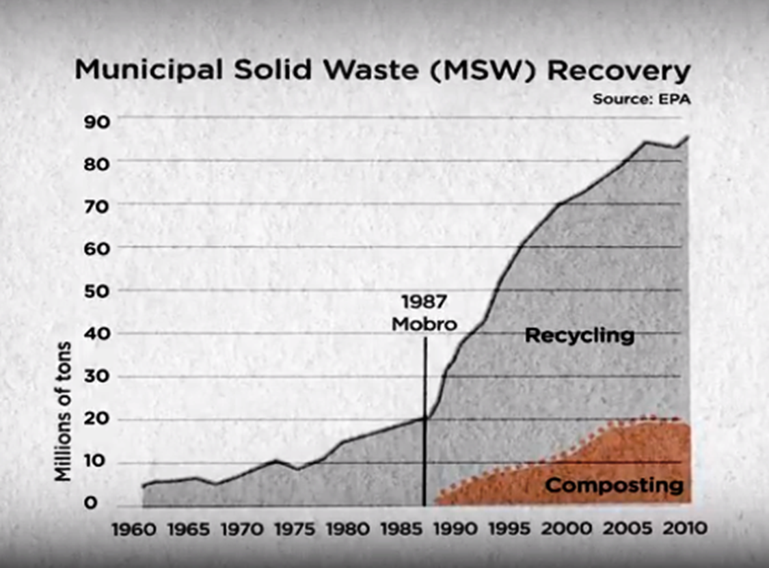
This gave rise to what became an explosion in the number of communities offering curbside collection of recyclables across the country. In Washington, it started in cities like Seattle and Olympia that began their citywide curbside programs in 1988 and 1989 respectively. Today, according to ZeroWaste Washington’s 2019 survey, there are 168 curbside programs statewide. The Recycling Partnership’s 2020 State of Curbside Recycling Report estimates that nationally 59% of all households, or about 69.8 million homes, had access to curbside recycling in 2019.
Figure 4: The number of recycling programs and the amount of material collected for recycling skyrocketed after the Mobro hit the high seas.

Landfill Aversion
The initial focus on recycling as a solution to a landfill crisis is a stubborn legacy of the Mobro journey and continues to hinder current efforts to shift to a more circular economy and a more sustainable materials management system. The legacy is so strong that David Allaway with the Oregon Department of Environmental Quality calls it “landfill aversion.” The aversion some people feel to throwing stuff in the garbage contributes to recycling contamination because it results in “wishful recycling.” Wishful recycling is the act of tossing items in the recycling bin believing they should be recyclable and with the hope they will be recycled. This aversion can also make it difficult for some people who are convinced they know how to recycle right to change their behavior and admit they might be making some mistakes about what they put in their recycling bin.
More importantly, landfill aversion, as David Allaway points out, turns recycling into a solution to a “waste problem“ and appears to deactivate and undermine solutions” further upstream like reuse and waste prevention. The goal becomes recycling more, not generating less. Communities and individuals feel like they’ve done their part by simply putting stuff in bins to be collected for recycling. This dynamic results in paying less attention to larger goals of protecting public health and the environment, and results in making less responsible choices about what we produce and consume.
See David Allaway’s Rethinking Recycling presentation to the NE Recycling Coalition on March 19, 2020.

The Diversion Trap and a Dearth of Data on Contamination
In 1989, Washington set a goal to achieve a recycling rate of 50%. Many communities around the state set similar or more ambitious goals and have increased those goals over time. Using this metric, the amount of material collected for recycling was used to measure the success of recycling programs instead of how much was recycled into new products. This diversion trap, partly caused by defining recycling as a solution to a waste problem, had the perverse effect of counting all the stuff collected in recycling bins as diverted from disposal. A growing percentage of that material was actually landfilled or burned here or in the countries where it was shipped to be recycled.
As we realized the error of our ways, it became apparent we needed data on “real” recycling. However, that requires gathering accurate, credible data on contamination levels in all parts of the recycling system regardless of where the material ends up. That data hasn’t been collected, consolidated, or tracked in any consistent way because it wasn’t considered important. The goal was to collect more material for recycling and increase our recycling rates. With China and other export markets taking almost everything in the bales sent to them, and paying relatively well for the material, there were few economic incentives to reduce contamination.
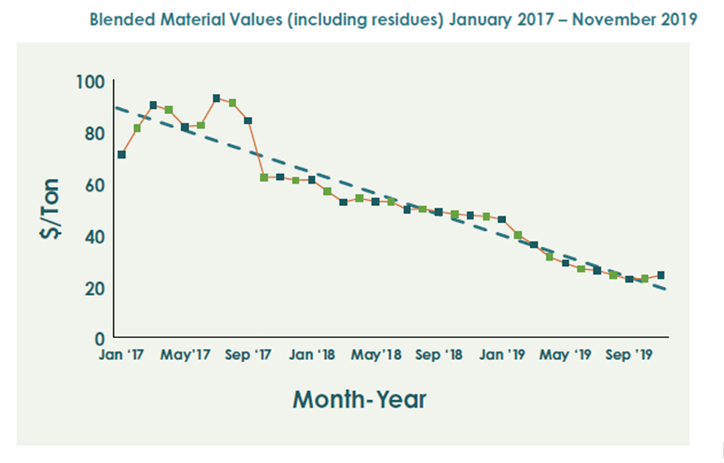
After China’s export ban went into effect, the costs to manage recycling contamination rose dramatically while the blended value of the materials collected for recycling plummeted. Today, The Recycling Partnership (TRP) estimates that contamination costs the U.S. recycling system more than $300 million each year.
Figure 5: China’s export ban shifted the costs of handling low-value and contaminated material onto local communities and MRFs, and caused a dramatic decline in market value. TRP’s 2020 State of the Curbside Report.
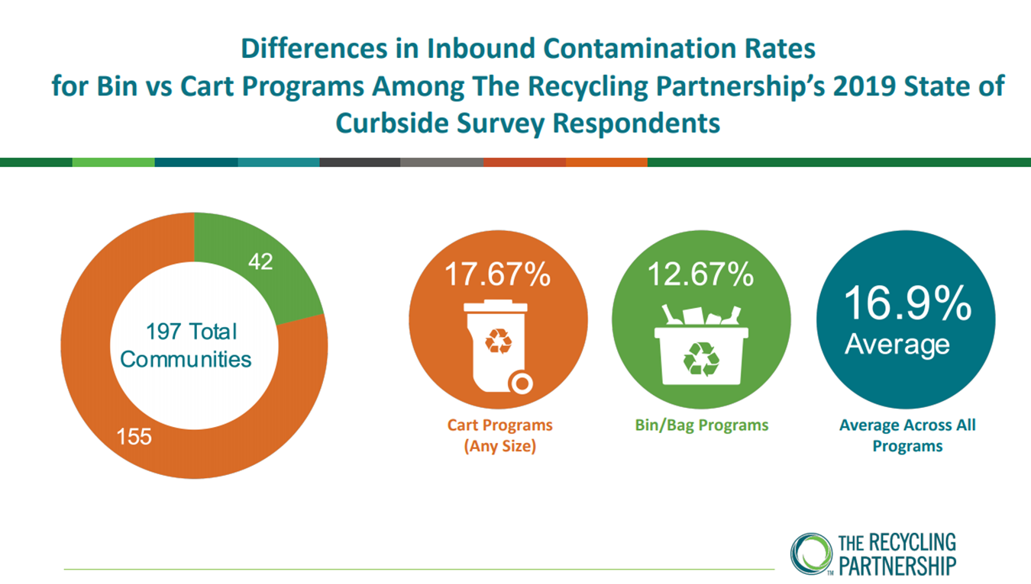
TRP is beginning to collect recycling contamination data in communities across the country and has collected some data on contamination in Washington. Their support to local governments to improve their data collection systems includes providing resources like their Municipal Measurement Program.
In Washington, the data on recycling contamination and its costs are spotty and were collected using many different methodologies. Some local governments are gathering this data on their own to help reduce contamination in their communities. However, right now the levels and types of recycling contamination statewide are unclear.
Figure 6: TRP’s 2019 survey of 196 MRFs across the country found an average contamination rate of 16.9%. It also revealed that what they call Bin/Bag programs or dual- or multi-stream programs had a contamination rate about 5% lower than for single-stream cart programs.
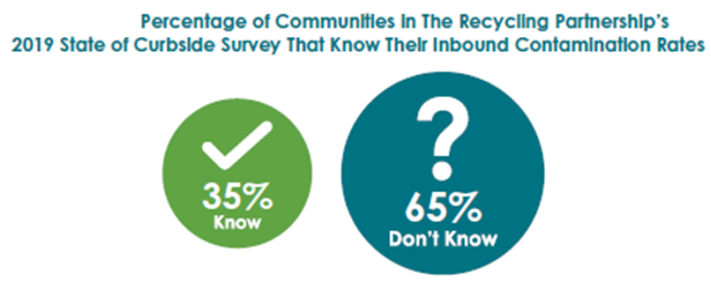

Figure 7: 65% of communities surveyed in The Recycling Partnership’s 2019 State of Curbside Survey did not know their inbound contamination rates.

The list below shows just how much the data can vary.
- A 2019 survey of 7 Washington State MRFs conducted by the TRP as part of their West Coast Contamination Initiative found inbound levels of contamination from commingled recycling collection programs ranging from 5% to 20% by weight.
- City of Seattle’s 2015 Recycling Composition study revealed an estimated 10.5% contamination by weight. Seattle’s first Recycling Composition study done in 2000-2001 found only 3.7% contamination by weight.
- 2019 Lid Lift Audits in Olympia showed contamination rates that varied significantly by neighborhood ranging from just under 10% to over 40% by weight. Detailed information is located in the local resources section of the Resource Library.
- Jefferson County’s Drop-Box Recycling Audits revealed an average of 30% contamination by volume. Detailed information is located in the local resources section of the Resource Library.
- In 2018, Northwest Recycling reported an impressively low contamination rate of 1%. They attributed this to Whatcom County’s three-bin collection system that requires residents to separate paper from glass, metal, and plastic containers.
Effectively reducing recycling contamination statewide requires developing a much more robust system to consistently gather, track, and analyze recycling contamination data. The fact that this kind of system is not in place today is an unintended consequence of falling into the diversion trap. According to TRP, only 34% of the communities they surveyed in 2019 knew the contamination rate for their curbside programs. This data hasn’t been gathered because success in the past was measured based on how much was collected for recycling. More was usually better, whether it got recycled or not.

Commingling and the Myth That Recycling is Free
As curbside recycling’s popularity grew and the costs of manual collection increased, communities looked for ways to operate more efficiently, reduce worker injuries, and to increase diversion and program participation. This led to the use of larger carts, more automated collection systems, and in many communities, the adoption of single-stream commingled collection programs. During this shift, many programs also expanded the types of materials on their acceptance lists for recycling.
At the same time, many communities decided to embed the costs of recycling in their garbage rates, making it seem like recycling was free. The intent was to increase participation in recycling, get people to put more stuff in their recycling bins, and to increase the recycling rate. It had the unintended consequence of increasing contamination. This really didn’t seem like a problem at the time because a lot of that contamination was shipped to Asia and, in many cases, scrap exporters were getting paid for it. On top of that, it made programs look more successful than they actually were because the trash they shipped overseas was counted as recycling.
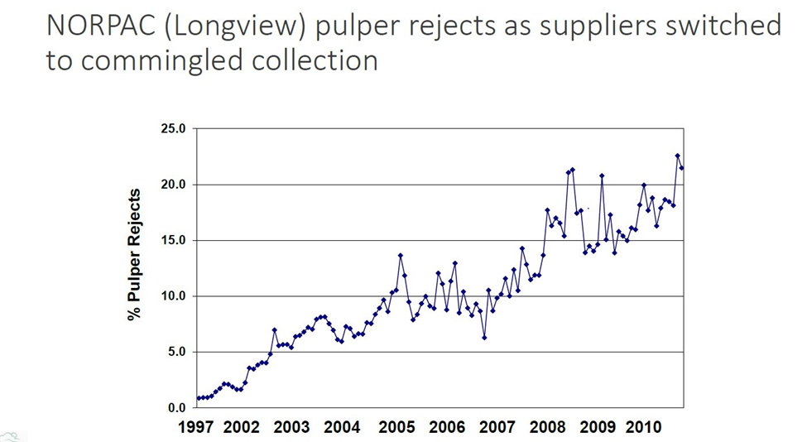
Figure 8: The shift to commingled collection dramatically increased the amount of inbound contamination received at MRFs causing pulper rejects at mills like NORPAC in Longview, WA. From David Allaway’s Rethinking Recycling presentation.

Consumer Confusion, Doubt, and Good Intentions
As mentioned earlier, the roots of our current recycling contamination woes are deep. And out of them a jungle of individual, separate, and unique local recycling programs was born. Many of these programs have different collection systems, accepted materials, and education and outreach strategies. Some programs like Whatcom County’s three-bin system produce a very clean stream. However, overall, the wide diversity of local community recycling programs, combined with the exploding variety of new plastic and multi-material packaging has created a very big mess.
Figure 9: Figure 10: TRP’s 2019 national survey found high levels of confusion about recyclable in their communities.

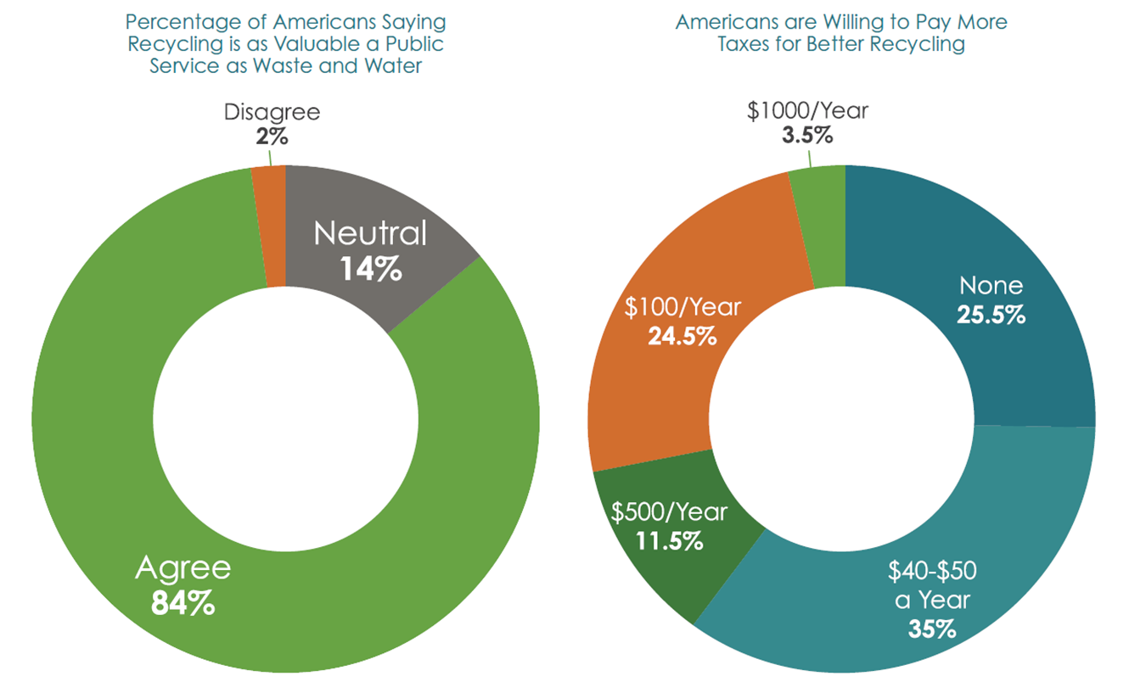
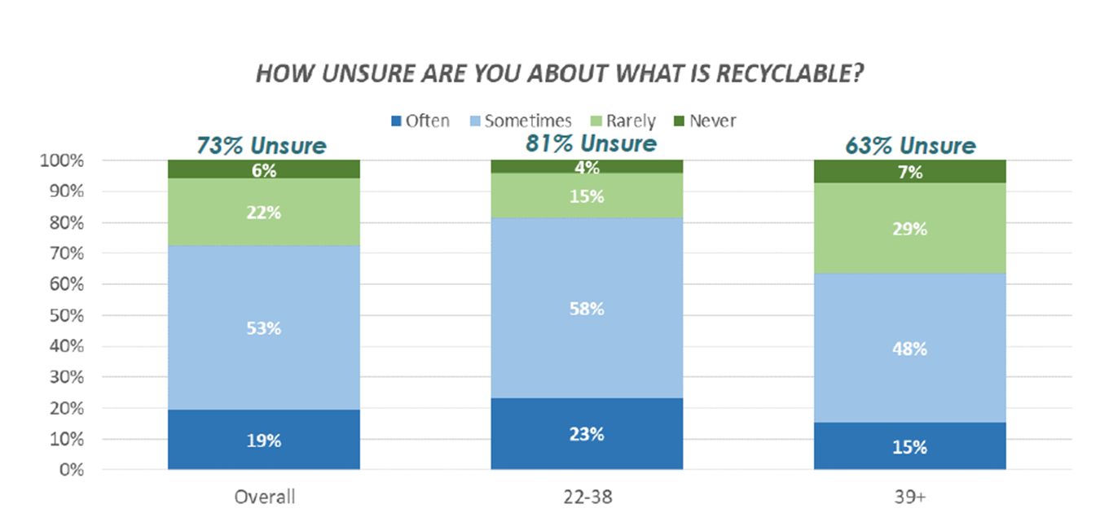
No wonder consumers are confused. A recent TRP national consumer research survey found 73% of consumers were unsure about what is recyclable, with millennials being most unsure. Although there is still strong support for recycling, many people are not recycling right despite their good intentions. The recent news about export bans and landfilling material collected for recycling sowed doubts about whether the effort to sort and prepare material properly is worth it. Because of the almost obsessive focus on increasing recycling rates, many people think if recycling is good then more recycling must be better. Therefore, some people think the responsible thing to do is to put more in the recycling bin even if they have doubts about whether it will be recycled. The message “when in doubt throw it out” is a hard one for many people to hear and follow. They’ve been taught for many years that landfilling is bad and now it’s being encouraged. Not only that, they have to pay to put stuff in their garbage cart. If they put stuff in their recycling bin they think it’s being collected for free.
Figure 11: TRP found there is still strong support for recycling and that people are willing to pay more to make recycling work better – 2020 State of Curbside report

Figure 12: TRP’s 2019 national survey found high levels of confusion about recycling in their communities.

Cleaning the Stream
Unfortunately, until some of the root causes of contamination are addressed fully and effectively, the costs of reducing contamination will continue to be borne primarily by local governments and consumers. That is why this initial CROP focuses primarily on reducing contamination in the parts of the recycling system that communities and consumers control.
Some things local governments can control, especially those communities providing their own collection services, include:
- Program design
- Accepted materials lists
- Educating residents and businesses
- What and how to charge for services
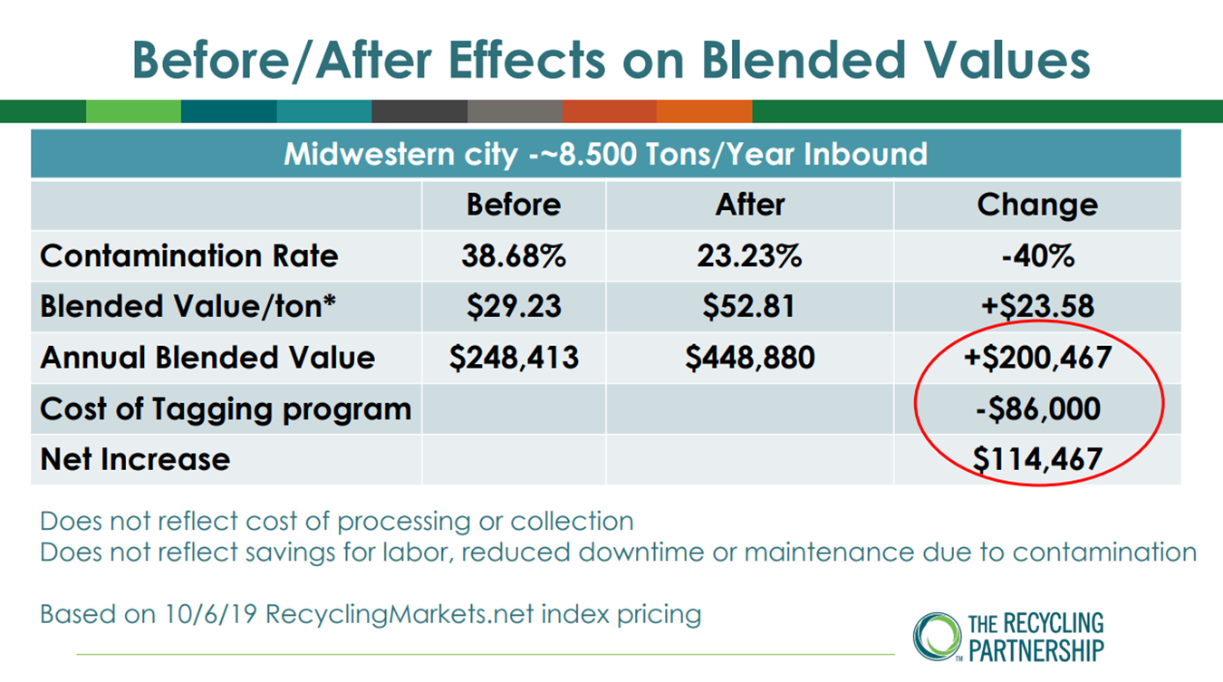
Making changes to individual programs in these areas can help reduce contamination. However, as noted above, one of the root causes of contamination is the lack of alignment and harmonization of recycling programs regionally and statewide. To address this challenge, local governments need to work together differently and let go of some local control. This means doing a different kind of regional planning, making compromises, and leveraging the collective power of local governments to enter into joint agreements or contracts for collection and MRF processing services. This allows local governments to build programs that cost less, include incentives to reduce contamination, and more effectively achieve a community’s larger sustainability goals.
Figure 13: Well-crafted contracts that reward communities for cleaner materials can pay large dividends. The data above comes from TRP’s How to Build a Better MRF Contract presentation. Their MRF contracting BMP guide provides more detail. The King County Responsible Recycling Task Force also prepared an excellent guide on Using Contract Language to Improve Recycling.

Efforts to get local governments to cooperate comes with many challenges. However, the consolidation of the recycling industry over the last twenty years means that, beyond the curb, the recycling system is already managed at a regional level. This provides opportunities for local governments to pursue and adopt more regional and aligned strategies more easily.

Industry Consolidation and Funneling of Recycling
Although there are a large number of diverse recycling programs, once material is collected at the curb it’s funneled into trucks owned by a small number of haulers that deliver material to an even smaller number of MRFs. This system can undermine the efforts of residents and businesses who recycle right and keep their streams clean. Their material may end up being processed with material collected from other customers and other communities. As a result, and to varying degrees depending on the MRF, the dirtiest loads determine the overall quality of material processed at a MRF.
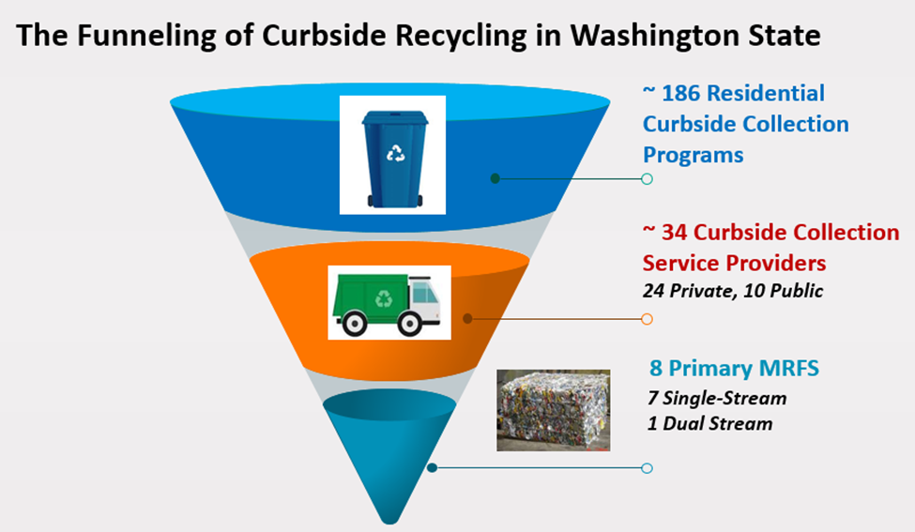
Figure 14: Approximately 186 residential curbside collection programs in Washington funnel to 34 curbside collection service providers and 8 MRFs. Beyond the curb, the recycling system is already managed at a regional level. Data from Zero Waste WA - The State of Residential and Organics Collection Washington State.
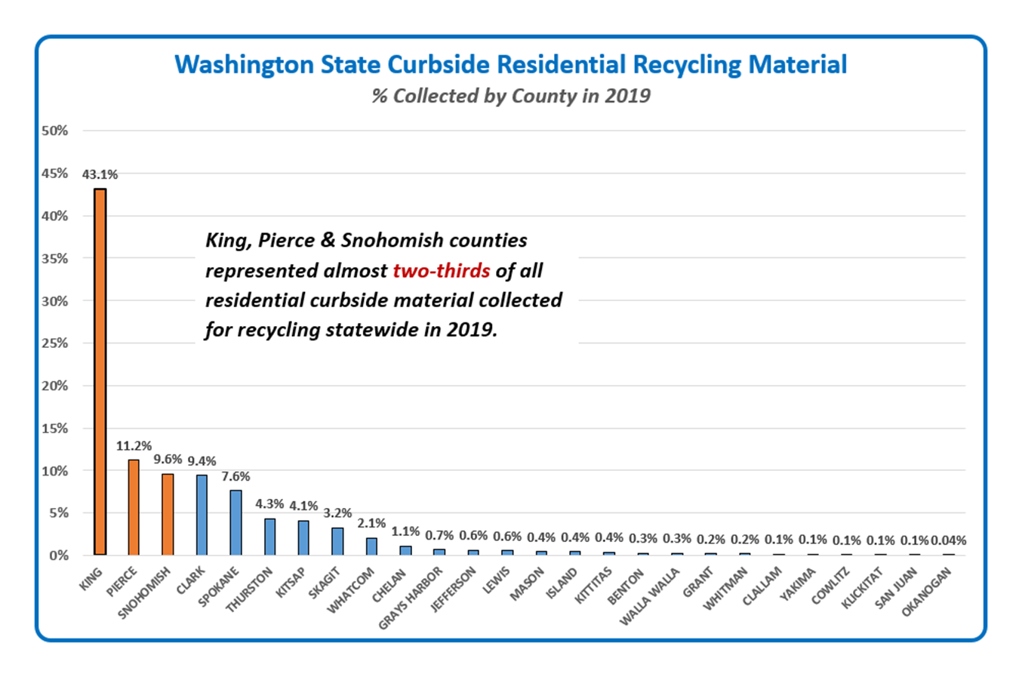
Taking a statewide view, where people live and the number of curbside collection programs in the Puget Sound region amplify this effect. According to Zero Waste Washington’s report, 96 or just over half of the curbside recycling programs in the state are in the Puget Sound waste generation area (King, Snohomish, Pierce, Kitsap and Thurston counties). Sixty-six percent of the curbside material collected for recycling statewide comes from King, Snohomish and Pierce counties.
Figure 15: Most materials from smaller counties are processed at the same MRFs as the largest counties. This underscores how important it is for all communities across the state to work together to reduce contamination. Data from Ecology’s 2019 solid waste facility database.
The privately owned collection companies providing curbside collection services to the highest number of service areas in 2019 were:
See Zero Waste Washington’s November 2019 – The State of Residential and Organics Collection Washington State. You can also download a database with more detail.

- Waste Connection (62)
- Waste Management (61)
- Republic Services (32)
- Recology CleanScapes (10)
Together these haulers served 165 or 89% of all the areas provided with residential curbside collection statewide.
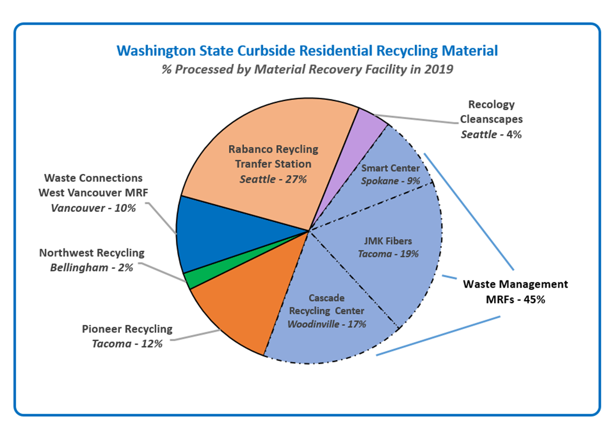
The same kind of industry consolidation exists for the sorting and processing of the materials collected for recycling as illustrated below.
Figure 16: Three of the 8 MRFs in the state are owned and operated by Waste Management and handle 45% of all the commingled residential material collected for recycling statewide. Data from Ecology’s 2019 solid waste facility database.

The Harmonization Choir
The funneling and consolidation of material once it leaves the curb offers a compelling opportunity to reduce recycling contamination regionally and across the state.

To seize this opportunity, everyone needs to start singing the same tune about what’s accepted for recycling, how it’s prepared, and what messaging is used to educate residents and businesses. Of course, that’s easier said than done, but there is already wide agreement on the need for more alignment and harmonization across programs. Since China’s export ban, a consensus is emerging on the priority materials to include in residential curbside programs.
These priority materials are what in Lincoln County they call The Recycling Gang.
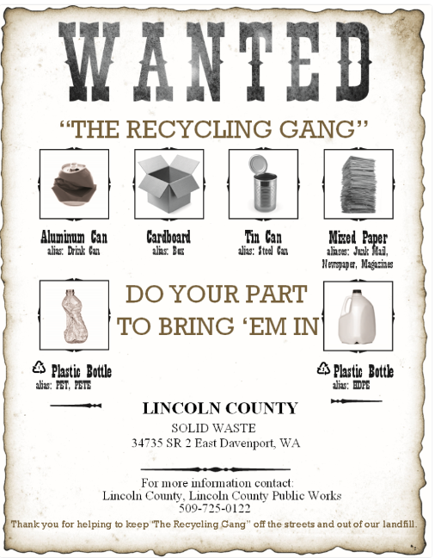
- Paper (including office and notebook paper, newspaper, mail, catalogues, magazines, and cereal or cracker boxes)
- Cardboard
- Plastic Bottles and Jugs (clear, colored, and natural)
- Steel and Aluminum Cans

Since 2018, the choir of voices calling for the harmonization of recycling programs across the state continues to grow. Members of the choir now include:

- Department of Ecology
Beginning in 2009, well before China’s export ban, Ecology began working with local governments and other stakeholders across the State to reduce recycling contamination. The agency’s most recent initiatives include the 2019 statewide Recycle Right campaign. This campaign featured one common message about how to prepare recyclables, and the same list of priority materials included in the Recycling Gang. It also includes a toolkit with outreach materials that local programs can customize for their communities. In 2018, in response to the export ban, Ecology published its Best Management Practices Guide for commingled residential recycling. It includes the same Recycling Gang list of priority acceptable materials, as well as criteria to help communities make informed decisions about what materials to collect in their recycling programs.
Figure 17: Lincoln County’s drop box recycling program only collects the priority materials on Ecology’s, WACSWM’s, and WRRA’s suggested acceptable material lists.

- Washington Association of Counties Solid Waste Managers Affiliate (WACSWM)
In response to the crisis caused by China’s export ban, WACSWM released their Commingled Recycling Guidance to support local governments to make informed decisions on what to accept for recycling to help ensure the long-term sustainability of their collection programs.
- Washington State Refuse and Recycling Association (WRRA)
In 2019, WRRA produced a suggested List of Materials to Include in Comingled Recycling Programs developed by their member Material Recovery Facilities. The WRRA also called for more uniformity in program design and for statewide campaigns to reduce contamination.

- King County Responsible Recycling Task Force
Two of the primary elements of the task force’s framework for creating a responsible recycling system call for the adoption of regional polices and harmonized messaging.
  - Regional Policy Alignment: Recycling systems benefit from regional coordination and policy alignment around the collection and processing of materials. Such alignment optimizes sorting and processing, reduces contamination, and leads to maximized marketability of materials.
  - Harmonized Messaging: Reduce contamination by using consistent messaging across the region or state to reduce confusion for the public around what should and shouldn’t be recycled.

In the Bin or Out?
There is an ongoing debate about what types of materials, other than the members of The Recycling Gang should be included on the accepted materials list for recycling programs in Washington. These materials include glass, polycoat and aseptic containers, and non-bottle plastics.
Many of these materials did not appear to be a problem when China was taking it all and even paying for it. Now that has all changed. As some markets collapsed and collection and processing costs increased, some Washington communities decided to remove some or all of these materials from their curbside recycling programs. One city even suspended their service altogether. These were not easy decisions to make. They were challenging and sometimes costly to implement and raised the collection rates for households and businesses across the state. However, these communities determined if they continued with business as usual, the long-term viability of their recycling programs were at risk.
The CROP does not include recommendations on what local governments and haulers should and should not collect for recycling beyond the broadly agreed upon priority materials. Instead, the CROP includes resources to help communities make better-informed decisions taking into account what MRF-sheds they are in and their access to end-markets. In the Best Management Practices Section, there is information on these materials and suggested criteria for deciding what materials to add, keep, or consider removing from the accepted materials lists. Suggested criteria is also included in the Local CROP Template and in the Recycling Contamination Reduction Resource Library. The Library includes information on polycoat and aseptic carton recycling, including resources from the Carton Council. You can also find information on glass recycling, including resources from the Glass Packaging Institute and others.

Regional and MRF-Shed Planning
Like a watershed, MRF-sheds have streams of materials flowing from communities and haulers into larger rivers of materials flowing into one massive ocean of stuff to be sorted. As mentioned earlier, ZeroWaste Washington’s November 2019 report on The State of Residential and Organics Collection in Washington State, listed 186 residential curbside collection programs operating across the state. These represent a dizzying array of collection systems, acceptable material lists, and education and outreach programs even among programs offered in the same counties by neighboring jurisdictions. As noted above, even just one contaminated stream can significantly increase the costs of processing, and decrease bale quality and the commodity value of cleaner streams of materials delivered to the same facilities.
The shocks caused by China’s export ban revealed just how much this highly fragmented, inconsistent, and uncoordinated approach puts the long-term viability of our recycling programs at risk. If we don’t begin to develop a more coordinated and aligned system, even successful community-level contamination recycling reduction programs will only have a limited impact on the overall rates of contamination regionally and statewide.
Regionalization and MRF-shed level planning can have many benefits beyond reducing recycling contamination. These include:
- Shared costs between jurisdictions for equipment, transportation, education and outreach, operating and capital costs for facilities.
- Increased volumes of recyclables that open new marketing possibilities.
- Cooperative marketing possibilities that could increase revenues.
To support more regional and MRF-shed planning, the CROP includes MRF-shed maps and a sortable spreadsheet for counties to quickly identify what other counties send material to the same MRFs. The spreadsheet also includes contact information for each of the primary MRFs in the state. The MRF-shed maps are also downloadable as a PDF. In addition, Ecology has created an interactive Municipal Solid Waste flow map that shows the quantities of waste that flow to landfills in the region from each county in the state.
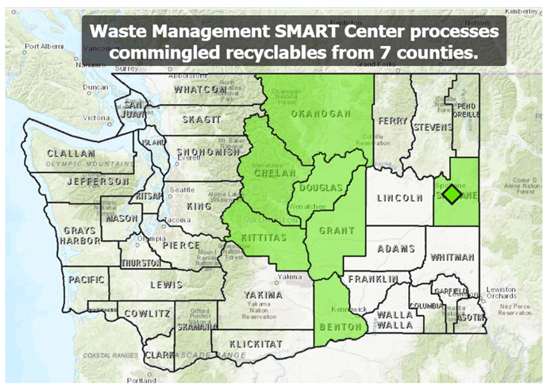
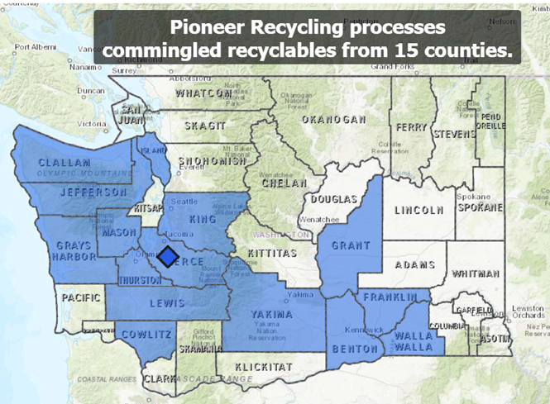
Figure 18: MRF-shed maps can help identify opportunities for regional partnerships to lower costs, reduce contamination, and reduce recycling program costs. Data from Ecology’s 2019 solid waste facility database.

Taking Control of the Future
To varying degrees, local governments have given away control of their recycling programs to the large companies that own and operate most of the system. Many of these companies have expressed the same frustrations and concerns about contamination and the impacts of disjointed and uncoordinated local programs on system costs and performance. They also strongly support more aligned and harmonized programs statewide.
No one is happy with the status-quo. There is broad agreement in government and in the recycling industry that our recycling system needs to change in fundamental ways to thrive over the long-term. This presents a unique opportunity to develop the kind of public-private partnerships needed to build a more sustainable future. A future where recycling contamination is a thing of the past.
The CROP and new Resource Library include resources to help realize that future, including MRF-shed maps, BMPs for reducing recycling contamination, and lots more. The statewide action plan below, and the Local CROP Template, can help with the initial steps on that journey.

The Statewide Action Plan
This action plan supports local governments in successfully developing and implementing their CROPs. Implementation of this statewide plan began with completing the State CROP, launching the Recycling Contamination Reduction Resource Library, creating MRF-shed maps, and developing other regional planning resources. Implementing other items in the plan, like extending and enhancing the Recycle Right campaign and conducting recycling characterization studies, is on hold until funds become available to support that work.
- Promote alignment and harmonization of recycling programs statewide
- Support the Recycling Steering Committee, the Recycling Development Center, and other groups working to develop more aligned and harmonized regional and statewide recycling programs.
- Promote the use of a priority list of materials accepted for recycling statewide.
- Enhance existing resources to support communities to make better informed decisions on what to accept in their recycling programs. This includes recycling market data and data on the environmental and social costs and benefits of recycling specific materials.
- Expand and continue to support successful statewide contamination reduction campaigns like Recycle Right.
- Encourage and support regional solid waste planning and aligned or joint contracting for services
- Enhance and maintain MRF-shed and MSW flow maps, and other resources to assist in identifying opportunities for regional collaboration.
- Convene regional meetings to explore joint planning and program development opportunities.
- Share MRF processing and collection contracting resources to assist local governments in their efforts to reduce recycling contamination and improve the overall performance of their recycling programs.
- Gather and share more comprehensive data to measure the performance of the recycling system
- Conduct recycling characterization studies to gather data on recycling contamination and other key metrics like the capture rate for recyclables. These studies should be done on the same schedule as Ecology’s waste characterization studies. In the future, these studies could be expanded to include organics and other streams.
- Develop and maintain an easily accessible and searchable database on local recycling programs across the state.
- Pursue legislative, funding, and policy solutions
- Work to secure increased state and federal funding for local government solid waste programs, including restoring funding for the Local Solid Waste Financial Assistance program.
- Forge new and enhance existing public, private, and non-profit partnerships to support local recycling contamination reduction programs.
- Evaluate Extended Product Responsibility, product labeling, product bans and restrictions, right to repair, market development, recycled-content, and other targeted legislative and policy options to assist in achieving recycling contamination reduction goals and strengthen our recycling system.

Guide to Local CROPS

Who Needs to Develop a CROP
RCW 70.95.090(10) requires all counties with a population of more than 25,000 to include a Contamination Reduction and Outreach Plan (CROP) in their Solid Waste Management Plan (Plan) by July 1, 2021. This requirement also applies to cities with independent Plans in counties with more than 25,000 people.

Counties and Cities Required to Include a CROP in Their Solid Waste Management Plans

- Benton
- Chelan
- City of Cheney
- City of Liberty Lake
- City of Seattle
- City of Spokane Valley
- Clallam
- Clark
- Cowlitz
- Douglas
- Franklin
- Grant
- Grays Harbor
- Island
- Jefferson
- King
- Kitsap
- Kittitas
- Lewis
- Mason
- Okanogan
- Pierce
- Skagit
- Snohomish
- Spokane
- Stevens
- Thurston
- Walla Walla
- Whatcom
- Whitman
- Yakima

Counties where CROPS are not required:
- Adams
- Asotin
- Columbia
- Ferry
- Garfield
- Klickitat
- Lincoln
- Pacific
- Pend Oreille
- San Juan
- Skamania
- Wahkiakum

How to Develop a Local CROP
Jurisdictions can amend their Solid Waste Management Plan (SWMP) to include a CROP or add a CROP when revising or updating their SWMP. Jurisdictions may use the Local CROP Template in the following section as developed under RCW 70.95.100 in-lieu of creating their own CROP.
A local jurisdiction’s CROP must include the following:
- A list of actions to reduce contamination in existing recycling programs for single-family and multi-family residences, commercial locations, and drop boxes.
- A list of key contaminants identified by the jurisdiction or Ecology.
- A discussion of problem contaminants and their impact on the collection system.
- An analysis of the costs and other impacts to the recycling system from contamination.
- An implementation schedule and details on conducting outreach. Contamination reduction outreach may include sharing community-wide messaging through newsletters, articles, mailers, social media, websites, community events, educating drop box customers about contamination, and improving signage.

Overview of the Local CROP Template
The local CROP template in the following section is an example of a CROP that meets the requirements of the law. It includes eleven action steps and a 4-year implementation schedule. A jurisdiction may cut and paste the template into their SWMP to meet the requirement that they include a CROP in their SWMP by July 1, 2021.

Action Steps in the Local CROP Template:
- Stakeholder engagement
- Develop an implementation plan and secure or allocate funding and assistance
- Inventory current recycling collection services and programs
- Prioritize the recycling program(s) to focus on first
- Define what data to collect to determine baseline levels of recycling contamination
- Gather baseline recycling contamination data
- Identify key contaminants and their costs and impacts
- Establish acceptable materials lists
- Develop and implement contamination reduction education and outreach strategies
- Explore contamination reduction strategies beyond education and outreach
- Evaluate the effectiveness of anti-contamination strategies and set next steps

The Local CROP Template
The Local CROP Template is also available for download in Ecology’s Contamination Reduction Resource Library.
Jurisdictions can use or modify the local CROP template below, and paste it into their SWMP as an Appendix or in an existing chapter or section.

Jurisdictions are not required or expected to implement all of the specific strategies presented in the template. They are included to provide a diverse set of options to consider during the process of developing a more detailed implementation plan. The Contamination Reduction Best Management Practices Section and the Contamination Reduction Resource Library include additional ideas and information to help identify the strategies that best meet a jurisdiction’s specific needs.

Including this local CROP template in your SWMP will satisfy the requirements in RCW 70.95.090(10). The template can also serve as a framework for developing a more customized CROP in the future. Details on how to include a CROP in your SWMP and submit it to Ecology for review are in the following section.
(Jurisdiction’s Name)
Recycling Contamination Reduction and Outreach Plan (CROP)
The goal of the CROP is to reduce contamination of the materials collected in (Jurisdiction Name)’s single-family, multi-family, drobox, and commercial recycling programs. This, in turn, helps (Jurisdiction Name) more fully realize the economic, environmental, social, and public health benefits of these programs. The CROP does not specifically include strategies to reduce contamination of other material streams such as organics or construction and demolition debris. However, many of the same strategies apply to these streams and may be included in future CROP updates.

The CROP intends to meet the requirement in RCW 70.95.090(10) that counties with a population of more than 25,000, and cities within these counties with independent Solid Waste Management Plans (SWMP), include a CROP in their SWMP by July 1, 2021.

This CROP includes eleven action steps and is a framework for developing a more detailed and customized implementation plan in the future. Ensuring the CROP and SWMP are aligned is also an important step included in the list below. It can happen at any time during the implementation process.

Step 1: Stakeholder engagement
(Jurisdiction Name) will work with key stakeholders to develop a scope of work for the CROP addressing the specific challenges and opportunities associated with local recycling contamination. This includes the work included in Step 2 to secure funding and forge partnerships to provide the resources required for full implementation of the CROP.

These stakeholders may include, but are not limited to:
  - Solid Waste Advisory Committee members
  - Elected officials and key staff from other local governments, including potential regional partners in the same MRF-shed
  - Garbage and recycling collection companies and their front-line staff
  - Organizations representing homeowners, tenants, and multifamily and business interests
  - Material recovery facilities (MRF) and transfer station operators
  - End-markets for recovered materials
  - (Jurisdiction Name)’s Ecology Regional Planner and grant manager
  - Regional, statewide, and national organizations that can provide technical assistance and/or financial support.

Step 2: Develop an implementation plan and secure funding and assistance
(Jurisdiction Name) will implement the initial CROP over about 4 years. During this process, (Jurisdiction Name) will work with Ecology and other key stakeholders to secure additional state funding, and forge partnerships with agencies and organizations to provide technical and financial assistance.

The State CROP and Ecology’s Recycling Contamination Reduction Resource Library are tools to get started on implementing the CROP. The library includes contamination reduction best management practices, contracting guides, MRF-shed maps, materials from successful programs in Washington State and across the country, and more.

An initial 4-year implementation schedule for all eleven steps in the CROP is included at the end of the CROP. As (Jurisdiction Name) clarifies and defines the scope of work, and identifies the resources to complete the work, a more detailed and refined schedule will be developed.

Step 3: Inventory current recycling collection services and programs
(Jurisdiction Name) will inventory single-family, multi-family, drobox, and commercial collection programs to identify what is accepted for recycling, where and how it is collected and by whom, and how it should be prepared for recycling.

This inventory may include, but is not limited to the following:
- Designated recyclables list in the SWMP
- Cart or container colors
- Minimum service-level or other ordinances, resolutions, or interlocal agreements
- Collection or material processing contracts
- Local government and recycling collector websites and social media sites
- Stickers and signs on containers, in businesses, etc.
- Brochures, newsletters, information shared at community events, etc.
- Recent media coverage

(Jurisdiction Name) will identify differences or inconsistencies across contracts and agreements for recycling programs, and in the information provided to residents and businesses about what is accepted for recycling and how it should be prepared for collection. (Jurisdiction Name) will use this data to identify opportunities for more consistent and aligned programs. The data will also be used to help determine what specific contamination reduction strategies to implement.

Step 4: Prioritize the recycling program(s) to focus on first
Together with key stakeholders, (Jurisdiction Name) will identify what recycling collection program(s) to focus on first. Driving this decision could be current knowledge of contamination levels and their estimated impact on costs and material quality, the number of customers, total quantity of material collected, etc.

Step 5: Define what data to collect to determine baseline levels of recycling contamination
Starting with the highest priority program(s), and based on the review completed in Step 3, (Jurisdiction Name) will identify what the acceptable materials are and what is considered contamination for the purposes of establishing a baseline recycling contamination rate. This data will also inform decisions about what, if any, changes to make to the accepted materials list in the future.

Step 6: Gather baseline recycling contamination data
Starting with the highest-priority program(s), (Jurisdiction Name) will establish baseline levels and types of recycling contamination. Recycling contamination rates can vary significantly across different programs and communities. Nationally, The Recycling Partnership (TRP) estimated an average contamination rate of about 17% across 197 programs that participated in their 2019 State of Curbside Survey. In Washington State, TRP’s 2019 survey of seven MRFs found inbound levels of contamination from commingled recycling collection programs ranging from 5%-20% by weight. Recent drop-off programs and cart lid-lift audits in Washington showed rates as high as 40%. For this reason, it is important to gather specific data on local recycling contamination levels.

In discussions with stakeholders, and building on the information in the State CROP and Ecology’s Resource Library, and on the work completed in Step 5 (Jurisdiction Name) will identify and develop ways to track specific contaminants. For example, tracking the number of carts containing plastic bags may be a more useful metric than an estimated overall percentage of contamination by volume.

Data collection methods may include, but are not limited to:
- Recycling stream composition studies
- Survey of transfer stations and MRF operators
- Tracking contamination using on-board truck or container-mounted cameras
- Container lid-lift audits for residential, multi-family and commercial accounts
- Dropbox composition studies or visual audits
Step 7: Identify key contaminants and their costs and impacts
Based on the data collected in Step 6 and collaborating with key stakeholders, (Jurisdiction Name) will identify the most problematic and costly contaminants starting with the highest-priority program(s). Although the types and impacts of contamination don’t vary as much as the levels of contamination across different communities and programs, it is still important to gather locally specific data. This data is critical to designing outreach campaigns and other strategies targeting the most problematic materials. It can also be helpful in calculating the economic and other benefits of removing problematic materials from the recycling stream.

In recent surveys, such as the one conducted by the TRP in 2019, MRFs and cities in Washington identified the following recycling contaminants as the most problematic and costly to manage:
- Plastic bags and film
- Tanglers including rope, cords, chains, and hoses
- Food and liquids
- Shredded paper
- Non-program plastics
- Hypodermic needles

These contaminants can:
- Slow down the sorting and processing of materials.
- Reduce the quality and value of secondary material feedstocks.
- Result in costly shutdowns.
- Damage collection, processing, and remanufacturing equipment.
- Cause serious injuries to collection and processing facility staff.

According to TRP, the greatest costs associated with managing a contaminated recycling stream at MRFs nationally come from the following and represent 80% of total contamination-related costs:
  - 40% for disposal of residuals
  - 26% in value lost from contaminated recyclables
  - 14% in labor to remove contamination from sorting equipment, etc.

Step 8: Establish acceptable materials lists
Starting with the highest-priority program(s), (Jurisdiction Name) will establish lists of acceptable materials. This effort will be coordinated with the SWAC, MRF operators, collectors, end-markets, and other key stakeholders. Criteria for determining the acceptable materials lists may include, but are not limited to:
- Alignment with the SWMP mission, goals, and community values
- Degree of uniformity across local programs, regionally, and statewide
- Diversion potential
- Cost to collect and process relative to other management options
- Strength and long-term viability and stability of end-markets
- Environmental, social, and other benefits and costs
- Potential to cross-contaminate or lower the value of other materials
- Potential to cause customer confusion
The Department of Ecology, the Washington State Refuse and Recycling Association, and the Washington State Association of Counties Solid Waste Managers Affiliate advocate for establishing regional and, where possible, statewide uniformity in what materials are accepted for recycling and how they should be prepared. More harmonization across programs reduces customer confusion and contamination. To that end, they identified these four priority materials for statewide recovery:
- Paper (including office and notebook paper, newspaper, mail, catalogues, magazines, and cereal or cracker boxes)
- Cardboard
- Plastic bottles and jugs (clear, colored, and natural)
- Steel and aluminum cans
The resources and guidelines developed by these organizations to establish their list of priority materials will help guide the development of (Jurisdiction Name)’s acceptable materials list. Ecology's Resource Library contains this information along with other resources to assist in developing an accepted materials list.

Step 9: Develop and implement education and outreach strategies to reduce contamination
(Jurisdiction Name) will develop and implement education and outreach strategies based on best practices. This starts with addressing any inconsistencies in recycling information and messaging identified in Step 3. All new outreach materials and messages will be aligned and consistent across all platforms.

Depending on the type of recycling program, outreach and education strategies may include, but are not limited to:
  - Moving toward uniformity in cart and container colors (or at least lids)
    - blue for recycling, gray or black for garbage, and green for organics
  - Visual, easy-to-understand signage using photos and universal pictures and symbols
  - Cart-tagging and cart rejection
  - On-route monitoring tools, including apps and cameras
  - Pairing right-sized recycling and trash bins
  - On-site assistance and outreach at drop-off sites
  - Up-to-date, and easy-to-find and access websites with clear, consistent messaging
  - Social media posts, campaigns, mailings, brochures, and other communications
  - Online apps for residents and businesses to get answers to their recycling questions
  - Community presentations, tabling, and activities at community events
  - School presentations and activities focused on recycling right
  - Translation and transcreation of educational materials and campaigns to ensure recycling information is clearly understood by all audiences
  - Social marketing campaigns to effectively promote long-term behavior change

Where possible, free and customizable resources will be utilized, including Ecology’s Recycle Right campaign materials and The Recycling Partnership’s Anti-Contamination Kit. Best management practices and examples of successful anti-contamination programs are included in Ecology's Resource Library.

Step 10: Explore contamination reduction strategies beyond education and outreach
(Jurisdiction Name) will research and evaluate strategies and solutions beyond education and outreach. These could address regional planning, operations and collection, contracting, incentives, pricing, policies, mandates, enhanced data collection, etc. Based on this evaluation, (Jurisdiction Name) will identify and pursue the most promising initiatives.

These options may include, but are not limited to:
  - Regional planning and aligned or joint contracting for services to harmonize messaging, lower program costs, and improve program performance.
  - Evaluating the costs and benefits of operational changes, including collection frequency, level of source-separation at the curb, and innovative drop-off container designs on contamination levels and overall program performance.
  - Product bans or restrictions.
  - Strengthening contracts with haulers and MRFs to include provisions focused on reducing contamination, collecting and reporting data on program performance and ensuring materials on the accepted materials list are responsibly recycled. Consult The Recycling Partnership’s BMPs for MRF contracting and their supporting materials for guidance.

Step 11: Evaluate the effectiveness of anti-contamination strategies and set next steps
(Jurisdiction Name) will conduct periodic assessments on the effectiveness of recycling contamination reduction programs and strategies, and share the results with key stakeholders and the public. These assessments will use, at least in part, the same methodology used in Step 6 to establish baseline contamination levels.

The assessment results inform what’s working and what adjustments may need to be made to get better results. This includes reducing contamination in other recycling programs that were not a focus during the initial CROP implementation.

Ensure alignment of the CROP and SWMP
The work of ensuring alignment of the CROP and SWMP may happen during any phase of the CROP implementation. Updates to the CROP can occur during SWMP revisions, including the required five-year revision process.
This work includes involving key stakeholders in reviewing, and if necessary, updating related elements in the SWMP to ensure they are aligned and consistent with the contents of the CROP and implementation work. This information may include, but is not limited to:
- Designated recyclables list
- Recycling facilities including transfer stations, drop-off sites, and material recovery facilities
- Recycling collection services and providers, and collection systems and fees
- Waste reduction and recycling education and outreach strategies
- Funding sources and mechanisms for recycling programs and services

CROP Implementation Schedule

Year 1
Step 1: Stakeholder engagement
Step 2: Develop an implementation plan and secure funding and assistance
Step 3: Inventory current recycling collection services and programs
Step 4: Prioritize the recycling program(s) to focus on first
Step 5: Define what data to collect to determine baseline levels of recycling contamination
Year 2
Step 6: Gather baseline recycling contamination data
Step 7: Identify key contaminants and their costs and impacts
Step 8: Establish acceptable materials list
Year 3
Step 9: Develop and implement education and outreach strategies to reduce contamination
Step 10: Explore contamination reduction strategies beyond education and outreach

Year 4
Step 11: Evaluate the effectiveness of anti-contamination strategies and set next steps

Ensure Alignment of the CROP and SWMP - This work may happen during any phase of the CROP implementation.

How to include a CROP in your Solid Waste Management Plan
This section includes information on how to include a CROP in your Plan and how to submit it to Ecology for review. There is specific guidance for jurisdictions that are and are not in the process of updating their SWMP.

How do we include a CROP in our Plan?
If you are not in the process of a Plan revision:
You should amend your Plan to include a CROP by July 1, 2021. Your Plan likely already includes a defined amendment process. This is the process you should follow and document to include a CROP in your Plan. If you don’t have a defined amendment process, contact your regional Ecology Planner. They’ll work with you to come up with an approach.

If you are in the process of a Plan revision:
You still need to prepare a CROP and submit it to Ecology by July 1, 2021. Even if you’re still working on your Plan. You should submit a copy of your draft Plan, including your CROP, along with your expected timeline for completing your Plan revision. If you choose to modify and adopt the Local CROP Template in lieu of preparing your own, you can still revise and refine your CROP while revising your Plan.
To avoid unnecessary delays, you are strongly encouraged to share your CROP with your regional Ecology Planner before taking official action to amend your Plan or drafting a CROP to include in your draft Plan revision. This would include taking action to adopt the State CROP in- lieu of your preparing your own.

How do we request a review by Ecology to ensure we’ve met the requirement to include a CROP in our Plan?
By July 1, 2021, you must send an email to your regional Ecology planner requesting a review of your CROP. The email should include the following:
If you are not in the process of a Plan revision, your email should include:
See a list of regional Ecology Planners here.
- Documentation that you amended your Plan to include a CROP following your Plan’s amendment process or a process developed with your regional Ecology Planner.
- A copy of your Plan that includes your CROP.

If you are in the process of a Plan revision, your email should include:
  - An estimated timeline for completing your Plan revision, including when you expect to submit a preliminary draft to Ecology for review.
  - A copy of your draft Plan revision that includes your CROP.
Ecology will not request the Utilities and Transportation Commission or the Washington State Department of Agriculture to review your CROP. Additionally, there is no requirement that you include a completed SEPA checklist with your CROP. These only apply if you are submitting a full draft of your Plan for a formal preliminary review.

How do we know we met the requirement to include a CROP in our Plan?
Upon receipt of the materials listed above, Ecology will:
- Send you an email acknowledging receipt of your request for a review of your CROP.
- Within 15 business days, send a letter to you confirming that your CROP meets the requirements under RCW 70.95.090(10); or
- Send a letter to you describing what changes you need to make to meet the requirements. As noted above, to avoid having to go back and edit your CROP, we strongly encourage you to share it with your regional Ecology planner before you submit it for a formal review.

Where should we include the CROP in our Plan?
If you are in the process of revising your Plan, we encourage you to include your CROP in the Waste Reduction and Recycling chapter or a related chapter. If you are not in the process of revising your Plan, you could include your CROP as an Appendix and integrate it into one of the chapters in your Plan during your next update.

How often do we need to update the CROP in our Plan?
You are required to revise your Plan every five years and submit it to Ecology for approval. You should review your CROP, and update if needed, during your Plan revision. After July 1, 2021, Ecology will not be able to approve Plans for those jurisdictions covered under RCW 70.95.090(10) that do not include a CROP.

Contamination Reduction
Best Management Practices

Overview
This Best Management Practices (BMP) section provides strategies and references to studies, toolkits, and websites to support local governments with their ongoing contamination reduction goals. This section will be available in the Contamination Reduction Resource Library and is a work in progress. Ecology will continue to add additional resources and strategies. Currently, the Education and Outreach section is the most defined.
There are many different types of recycling collection programs, and each present their own unique challenges. Collection programs addressed in the BMPs include:
- Single-Family Residential
- Multi-Family Residential
- Commercial
- Dropbox
- Glass
Reducing the amount of contamination in any program is a multi-step process involving many different strategies. Five focus areas organize the contamination reduction strategies, which local governments can piece together for their programs.

The strategic focus areas are:
Communications & Outreach

Operations & Collection
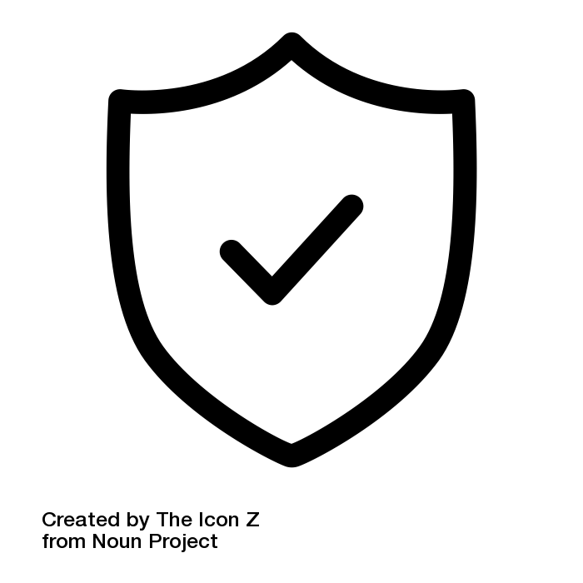
Policies & Mandates

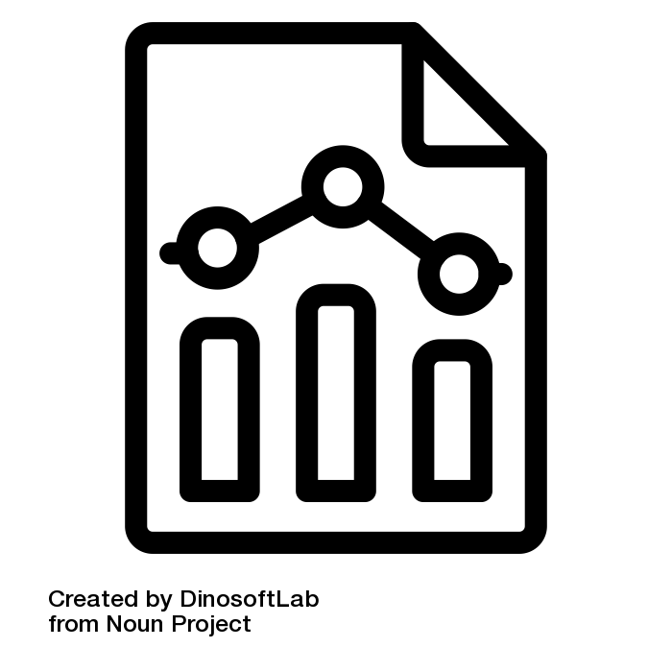
Measurement & Reporting
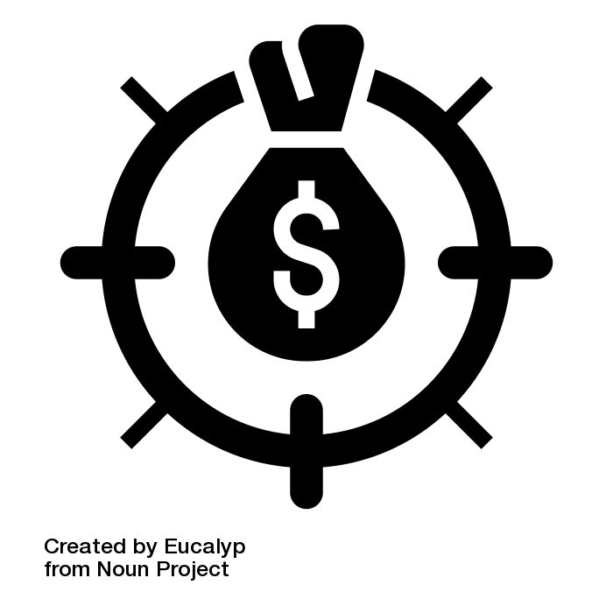
Incentives & Pricing

Regional Strategies
Now is the time to explore a regional recycling strategy to overcome common barriers to successful, clean recycling programs. Working with nearby jurisdictions, or those within your MRF-shed, can yield many shared benefits such as:
- Shared costs between jurisdictions for equipment, transportation, education and outreach, operating costs, and capital for facilities;
- Increased volumes of recyclables that open new marketing possibilities;
- Cooperative marketing possibilities that could increase revenues; and
- Regional economic stimulus from new collection and processing jobs.

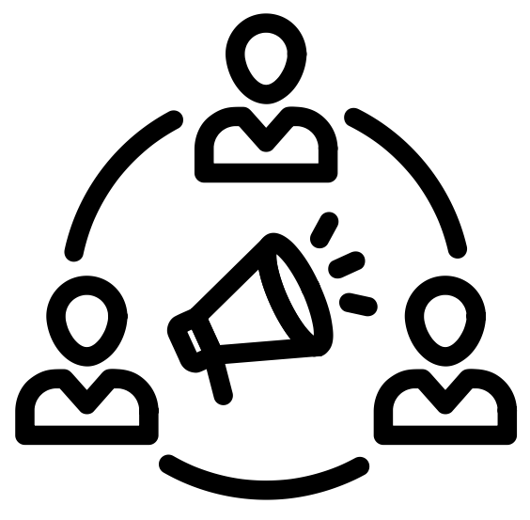
Communications & Outreach
The following strategies relate to community engagement, education and outreach, public relations, marketing, promotion, and behavior change campaigns. These methods are crucial to reducing contamination and increasing participation in recycling programs.

The Community-Based Social Marketing Approach
It’s fairly easy and inexpensive to print and distribute materials, maintain a website, or place ads with the goal of increasing knowledge and building support for recycling programs. While these are important elements to include in your contamination reduction efforts, studies show that information by itself has little effect on behavior.
Community-Based Social Marketing resources:
- Doug McKenzie-Mohr’s website
- Tools for Change website
- Pacific Northwest Social Marketing Association
The Community-Based Social Marketing (CBSM) approach is effective at fostering sustainable behavior change. Its practical approach includes five major steps outlined in this Quick Guide to Community-Based Social Marketing from the University of Pennsylvania.
Utilize existing resources, learn from other communities, and apply CBSM principals to your contamination reduction efforts if possible. Start with a small project targeting a simple behavior or one problematic material contaminating your recycling stream. You can split the CBSM steps over time, or scale up to a comprehensive campaign with a higher budget.

Key strategies for all recycling programs:
- Utilize consistent, clear, and harmonized messaging throughout the community and region.
- Update community, hauler, and Solid Waste Program websites to reflect all changes to recycling lists or collection methods.
  - Include educational elements to clarify what should and should not be recycled. For clarity and overcoming language barriers, use pictures and graphics (green check for acceptable, red x for unacceptable, etc.) rather than words.
  - Provide links to the most applicable education and outreach materials from the hauler or service provider.
- Have separate webpages for single-family, multi-family, commercial, and drobox recycling programs. This helps direct people to the correct information and prevent confusion. Include customized information and tools for multi-family and commercial property managers.
- Work with service providers and/or realtors to create and send informational packets to new homeowners or individuals who switch service providers. Consider combining these with service calendars.
- Invite property managers, maintenance staff, and residents to lead education and outreach efforts in a way that is meaningful to the targeted community.
- Organize and staff an interactive educational booth at diverse community events.
Use transcreation principles to reach diverse populations effectively. See the following resources:
Resource Recycling’s Do you Speak Recycling article about King County’s “Recicla más” campaign.
Waste Management’s transcreated materials and multicultural outreach tools.
888888
- Identify and collaborate with community leaders to engage the community on recycling issues. This is particularly effective for minority and non-English speaking communities
- Utilize existing community-wide messaging channels such as newsletters, media articles, mailers (combined with or in addition to service calendars), and neighborhood-based social sites (like Nextdoor).
- Work with local partners (utility and cable companies, etc.) to put flyers in monthly bills.

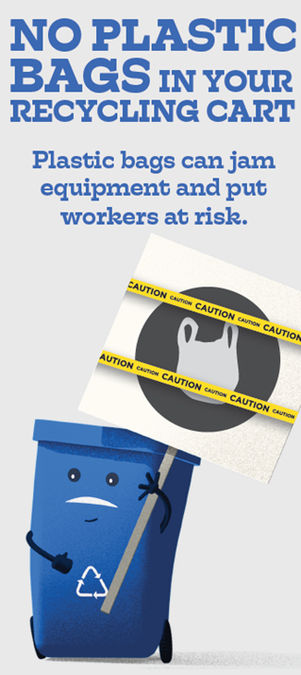
- Conduct direct mailings to all customers in your solid waste area.
- Promote single or multiple social media pages so interested residents can follow for regular updates. Partner with likeminded organizations and community influencers to utilize their social media base and extend the reach of posts.
- Inform residents how, where, and why to recycle using mailers, posters, signage, door-to-door campaigns, bin tags, bill inserts.
- Develop marketing and outreach materials using pictures and short videos to show recyclable and non-recyclable materials. Implement a multi-media (TV, radio, online and print ads, outdoor signage, social media, Reddit pages, etc.) campaign to reach target audiences and create a “brand” that normalizes proper recycling behaviors.
Figure 19: Samples of Spokane's contamination reduction campaign, including postcards, FAQs, and more are in the local programs section of the Resource Library.

Single-Family Residential Recycling
  - Utilize Washington State’s Recycle Right Campaign
materials and messaging to encourage the collection
of empty, clean, dry, and unbagged recyclable materials.
- Cart tagging gives residents/customers direct feedback on their recycling practices by identifying their bin contents. Spokane’s Feet on the Street cart tagging program and Waste Management’s oops tags are helpful resources.
These resources from The Recycling Partnership provide steps and tools to improve the quality of your recycling program.
Curbside Anti-Contamination Kit
Start at the Cart
- Targeted route mailers are a great option if haulers identify specific routes with higher levels of contamination.
- Consistently use blue recycling bins.

Multi-Family Residential Recycling
- Take inventory of all multi-family properties in your jurisdiction. Find contact information for property owners and reach out to them to build a relationship.
- Meet with property managers to assess larger scale and shared problems or concerns.
See Resource Recycling’s series on Multi-Family Recycling.
Multi-Family Mythbusting
The Path Toward Progress
- Have separate pages for multi-family residents and property managers on your website. Include frequently asked questions, educational materials, and resources specific to multi-family recycling.
- Provide resources for other solid waste programs like household hazardous waste collection, large bulky item pick-up or drop-off, food waste, and drop-off centers for recyclables not included in the multi-family collection program.
- Encourage property managers to include links on their website to the appropriate solid waste information.
Cascadia’s 2012 International Multi-family Recycling Case Study provides a range of opportunities to improve multi-family recycling programs.
- The turnover rate of residents in multi-family housing is high, so consistent and ongoing outreach to these communities is crucial.
- Create a moving checklist with common items and simple instructions for how to dispose or recycle them. (e.g. mattresses, moving boxes, microwaves, laptops, cleaning supplies, paint cans, furniture, clothing, and other bulky items)
- Work with the service provider and MRF to develop, or modify their, tenant welcome packet bags. Tenant welcome packet bags have many benefits:
  - Hold all educational materials and prompts. Ensure residents have a simple, picture-based flier outlining what can and cannot go into recycling collection bins.
The City of SeaTac developed a Contamination Plan with Recology, their local hauler, to do on-site customer audits at multifamily complexes. Find more information in the local program section of the Resource Library
  - Distributed to all new tenants and the property owner manages the inventory.
  - Display relevant local information, websites, and messaging on the sides of the bag and build a “culture of recycling”.
  - Can collect recyclables within individual units and transport to the recycling container. Adding a strap to the bottom of the bag is helpful.
- If the property has community gatherings, try to attend at least one per year to engage tenants.
- Create surveys for both property managers and residents. Identify what barriers exist from each perspective.
- Take well-planned steps to tailor your multi-family program and outreach materials to the diverse backgrounds, perspectives, and needs of residents.
- Provide resources for starting a Green Team / Property Recycling Champion. Help property owners empower one or more vocal, motivated tenants by designating them a recycling champion or point person. They can help disseminate information to other residents and communicate observed and shared concerns with property managers.
Toronto’s 3Rs Ambassadors program enlists apartment residents to champion recycling and waste reduction with neighbors, sparking enthusiasm for recycling across linguistic and cultural boundaries.
- Develop a special multi-family advertising or behavior change campaign. Research the barriers residents face and ensure you target those.
- Create a multi-family recycling team of engaged property and facility managers to meet, research issues, and develop solutions.

Commercial Recycling
For unincorporated areas in Washington, residential recycling is a monopoly granted to the hauler with the g-certificate for that area. However, commercial recycling is an open market.
Incorporated areas have more choice over their residential systems. They can default to the nearby g-certificate, contract for services, or provide services themselves. However, the general idea of a residential monopoly and commercial free market remains. Some cities choose to exert their powers over a portion of the commercial sector by having a contract with a hauler that addresses both residential and commercial recycling, etc.
In both unincorporated and incorporated areas, the end result is that while only one hauler serves residents, there may be multiple recyclers serving the commercial sector.
At first glance, the multitude of haulers serving the commercial sector may seem counter-intuitive to the message of uniformity, especially if their accepted materials lists differ from your residential list. However, smaller commercial recyclers often exist because their profit is made off the price they get for the recyclables they collect; not the fee charged (or embedded) to collect it. It is important to allow these entities to compete with the larger haulers, many of whom own their own landfills. These smaller haulers offer specialized services that often prioritize commodity quality and end-use ahead of the quantity of material they collect.
- Include ALL haulers of key commercial recyclables on outreach materials. Example: on the City of Issaquah commercial recycling webpage, they provide contact information for more than just the City’s contracted hauler.
- The planning jurisdiction or service provider should perform walkthroughs for businesses to address their specific needs and identify available services. This is especially helpful for restaurants wanting help locating garbage, recycling, and compost services.
- Work with service providers on outreach materials and provide appropriate indoor and outdoor signage to businesses. Encourage signage in common areas like break or lunch rooms.
- Lunchroom programs should be consistent with household programs in regards to plastic and metal containers.
- Advise businesses to add links to recycling information on their websites.
- Reach out to commercial property managers to reach many commercial accounts at once.
- Work with service providers if they also provide outreach and assistance to commercial recycling customers.
- Work with business organizations like a Chamber of Commerce to engage the business community. Provide presentations or informational booths at their business-related gatherings.
- Provide resources and assistance to businesses about starting a Green Team or appointing a Recycling Champion. Often, there are staff who are vocal, active, and motivated around recycling issues. They can become Recycling Champions, or a point person, to help disseminate information to other employees and communicate tips and concerns.
- Share Best Management Practices tailored for specific types of businesses.
- If commercial and residential recycling are similar enough, combine the education and promotion efforts.
- Commercial recycling should be as similar as possible to residential service. Aim for similar color patterns for garbage (black or grey), recycling (blue), and compost (green).
- For best results, develop specific commercial recycling communications and promotion. Add business specific tips that outline the differences between residential and commercial information. Acknowledge areas that may be particularly confusing for employees who work and live in difference jurisdictions with different rules or programs.
Use The Recycling Partnership’s
Drop-Off Anti-Contamination Kit to kick-start a better quality material stream.

Dropbox Recycling
- Provide staff or volunteers to assist residents and provide education at drobox locations.
- Consider co-locating dropboxes through partnerships with your community such as fire stations, recreation centers, businesses, and schools. This may also help rural multi-family households have access to recycling.
- Create signage with actual objects stuck to them. For paper items, a shadowbox can prevent damage from the rain.
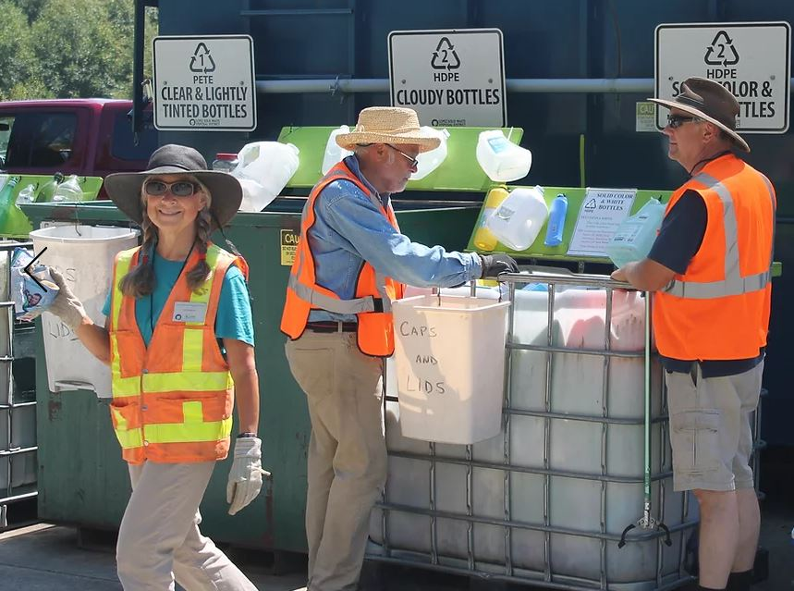
Figure 20: Lopez Solid Waste District uses actual recyclables to create 3D signage at their drobox locations.

Operations and Collection
These strategies address contamination at the infrastructure level rather than consumer behavior. These include logistical solutions like re-locating shared collection containers, designing mini recycling centers, improving container design, and distributing collection bins for individual resident use.

Key strategies for all recycling programs:
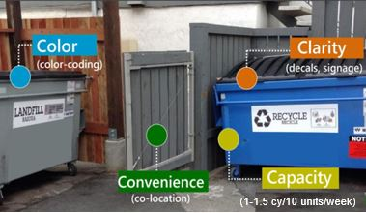
Dropbox, commercial, and multi-family collection programs would benefit from the implementation of the 4 C’s container strategies:
Capacity
- Recycling needs sufficient capacity, the same volume as the garbage service, or 20-30 gallons per unit per week. Or 1-1.5 cubic yards per every 10 units per week.
Figure 21: : Dropbox, commercial, and multi-family collection programs should consider the 4 C’s (Capacity, Convenience, Color, and Clarity). from Cascadia Consulting – 2019 Role of Recycling Policy and Code presentation
- Ensure proper garbage capacity as well. Recycling should never be an overflow for garbage.
Convenience
- Recycling and garbage need to be equally convenient.
- All material will flow first into whatever container is most convenient. This either equals garbage in recycling or recycling in garbage.
Clarity / Color
- It needs to be extremely easy for the average resident to tell what each container is for. There should be consistency with single-family residential collection bins.
- Blue is typically associated with recycling.
- If children take out the garbage and recycling in a family, they need to be able to understand the system.
- Consistent color schemes are a very useful tool. The more consistency there is, the better and easier it is for residents to transition.
- Signage is the other method to share information. Pictures are worth a 1,000 words. Commonly confused items can go on a poster board.
Container Lids
- There are collection container lids with special gaps that only allow targeted recyclables in, and reduce large item contamination. There are specific lids for cardboard, glass, metal cans, and plastic bottles and jugs.
- Impact is one company among others that offer these lid designs.
- Use a locking mechanism for the best effect.
- Mix and match lids for different programs and to address specific barriers.

Single-Family Residential Recycling
In this report, single-family recycling focuses solely on single-family curbside collection services. So the terms single-family and curbside are interchangeable.
Considerations by Collection Service Type
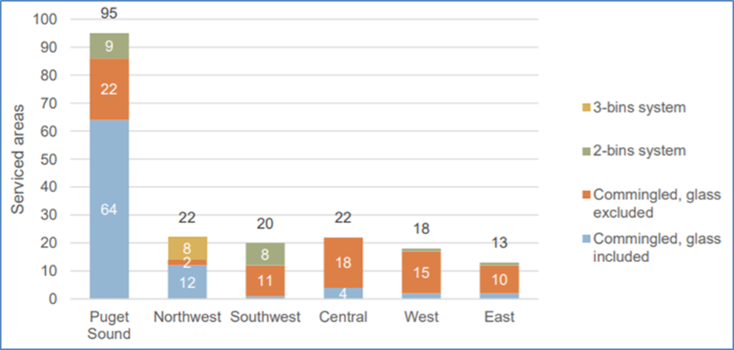
There are unique challenges that come with each single-family recycling collection type. Collection service types vary between Commingled, Dual Stream, and Source Separated. It is important to identify which collection service types and their associated challenges you are facing. See considerations for each service type below.
Commingled Collection
Also known as single stream or mixed recycling. In this system, residents place all recyclables into one bin at the curb. Commingled recycling increased in popularity because it is easy for residential customers to put recyclables in one container, can cost cities less money, and increases recycling collection rates. However, collecting more materials can also cause a rise in contamination levels. Material cross contamination and residential confusion regarding accepted materials contribute to the problem.
Considerations for commingled collection:
Figure 22: ZeroWaste Washington survey of residential recycling collection programs by waste generation area or WGA. See glossary for a definition of a WGA.
- Clarity of accepted materials list, and harmonization of accepted materials within the region or MRF-Shed.
- Material cross-contamination happens frequently. Whether from liquids and food-soiled materials spilling onto other marketable materials, or from clean materials making their way into the wrong bale. The latter commonly occurs with flat lightweight objects that act like paper in the MRF sorting process, or when glass shatters and embeds itself into other materials like paper fibers.
A more comprehensive list of the benefits and limitations of commingled residential collection on Ecology’s commingled collection webpage.

Dual Stream Collection
In this system, residents use two bins for collecting materials for curbside recycling. In one version, residents place all paper and fiber products in one bin and plastics, metals, and glass in the other. This collection system lowers contamination of the paper stream from liquids and other materials. In another version, residents put mixed recyclables in one and keep glass separate in the second container. This prevents broken glass shards from contaminating other materials, especially paper fibers.

Considerations for Dual Stream collection:
- Material cross contamination is still possible
- Increased hauling and infrastructure costs
- If collection is done manually, workers are at greater risk of being injured
- Only effective if the MRF has the technology to handle this system
Source Separated Collection
In this system, residents place materials into multiple bins by material type. The specifics of material separation varies by jurisdiction and depends on preferences and local requirements. Additionally, the ways paper, metal, glass, and plastics are separated varies by jurisdiction. These materials may be broken into types that are more specific. For instance, mixed paper versus newspaper and scrap paper. Plastics can be mixed, 1s and 2s, bottles and jugs only, and 3-7 mixed plastics. Typically, transfer stations and drop off/drobox locations use this method more than curbside. It requires residents to separate and place recyclable materials into multiple dumpsters holding very specific materials.
Considerations for Source Separated collection:
- Contamination via dumping
- If collection is done manually, workers are at greater risk of being injured
- Source separated curbside programs cost more for hauling/infrastructure
- Only effective if the MRF has the technology to handle this system
Other Curbside Strategies
- Refine the accepted materials lists to reflect what is economically and environmentally viable for your region/MRF-shed. This may require removing items from your accepted lists such as: glass, aseptic containers, or difficult to market plastics (e.g. 3-7s). Collecting these materials separately in a drop box system is an option if there is a viable end market or a beneficial reuse options.
- Standardize cart colors within your MRF-shed to reduce residential confusion about which bins are for recycling and which are for garbage.
- Utilize hauler cameras and technology. Some haulers already have technology such as truck cameras and routing software allowing for easy reporting of contaminated loads. Use these systems to identify customers who would benefit from additional information or possible corrective actions.
Read about Whatcom County’s three-bin collection system and its impressively low 1% contamination rate.
Here's why most Whatcom recycling isn't ending up in landfills, despite China's ban.

- Consider switching to a dual-stream collection service. If contamination is most prevalent in paper fibers (from food/liquid, plastics, or glass) and your MRF has the technology to process this material separately, the quality of paper fibers could dramatically improve. That said, this is a discussion heavily influenced by the current infrastructure your haulers and MRFs have in place as well as the feasibility of replacing that infrastructure with dual-stream compatible technology.

Multi-Family Residential Recycling
Multi-family recycling often requires more effort than recycling in a single-family setting. The barriers to resident participation are much more complex than a simple matter of convenience. Many apartments and other multi-family settings lack basic recycling infrastructure and may not be able to develop an effective program. Addressing these issues requires a systematic approach.
- Identify how permitting of multi-family properties works in your area, if there are specific requirements related to recycling, and how they are defined for solid waste. Do they share a garbage bill?
Waste Management’s 2017 Multi-Family Study details best management practices for infrastructure improvements, property management engagement, and resident education.
- Clarify how multi-family properties receive service. Determine if they are on commercial or residential trucks/routes and if garbage and recycling are in the same category (especially if there is a dumpster and roll carts for recycling).
- Take an inventory of all multi-family units/complexes and identify which ones have and don’t have adequate recycling infrastructure. Reach out to determine which ones are willing to accept infrastructure improvements and technical assistance.
- Ensure all recycling containers are properly marked and are located near a garbage container.
- Provide residents with a dedicated container or bag to collect recyclables within individual units and to use to transport materials to central collection areas.
- Consider whether there is a need for a source-separated stream like cardboard. These can be easier to label and can be adapted to ensure only certain sized materials can enter.
- Depending on the circumstances, it may be less costly and labor intensive to educate residents on other places they can recycle such as drop box sites.
- Depending on the hauling service, multi-family recycling collection may be done on the same route as curbside residential service, on a separate service contract overseen by the jurisdiction, on a private contract managed by the multi-family housing complex, or not available at all except at drop box locations. Because of these and other variables and complexities, background research and evaluation is essential.

Commercial Recycling
- Though an open market, local governments may still influence operations and collection:
- Incorporated areas: Contracting for commercial collection can provide a city more control and give them the ability to direct collection methods (such as dual stream vs. single-stream), set the accepted materials list, and reject loads
- Unincorporated areas: Providing the residential accepted items list to commercial recycling providers and/or discussing with them shared goals and priority items for recycling in the local area
- If the business is interested, determine if there are opportunities to collect a unique large waste stream for recycling to save on disposal costs. As an example, packaging and printing companies with adequate space can collect special grade paper separately. Check with your service provider and MRF before starting any new programs with new material streams.
- Encourage business or commercial property owners to request a service and pricing review with their hauler. Occasionally changing service frequency can reduce collection costs.

Dropbox Recycling
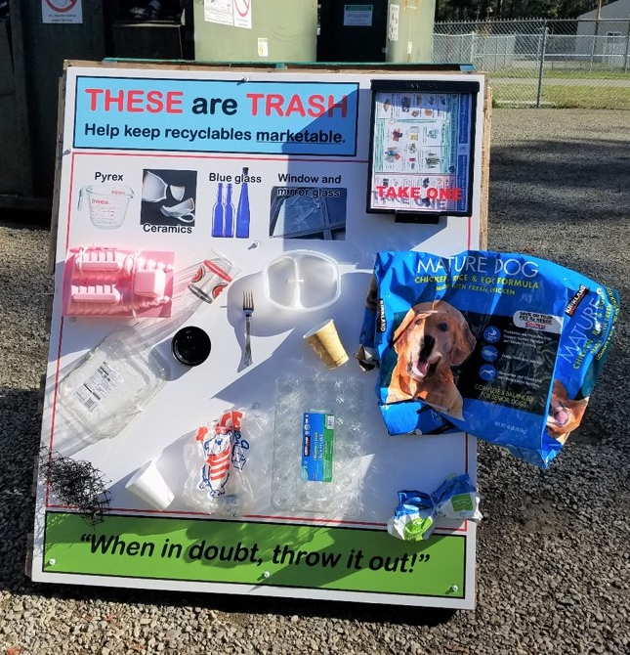
- Use volunteers for monitoring of unattended dropboxes. Volunteers can spend an hour or two a week pulling out obvious contaminants, while also providing basic recycling education to residents as they drop off material.
- Do not leave your site open 24/7. Limit the hours and lock the site.
- Use container lids with special gaps that only allow targeted recyclables in, and reduce large item contamination. There are specific lids for cardboard, comingle, and containers. Lock collection boxes further reduce the potential for contamination.
Figure 23: Jefferson County drobox signage includes actual examples of acceptable and unacceptable materials. Find more information in the local programs section of the Resource Library.
- Select signage that is durable, weather and UV resistant, and preferably made with post-consumer recycled content materials.
- Dual-stream and multi-stream collection can result in lower levels of contamination and a better quality, higher value material that is more marketable for resale by MRFs.
- Consider locating reuse areas near dropboxes.
- Harmonize your material list with curbside programs. This means working with your hauler and recycle partners to have the same information put out on the containers, at the sites, etc.
- Invest in attractive, easily understandable photos or images of acceptable items. You can also use actual items on your signs.
- Select signage that is durable, weather and UV resistant, and preferably made with post-consumer recycled content materials.
- Ensure all recycling containers are properly marked and are located near a garbage container.

Incentives and Pricing
Implementation of economic incentives like variable fees or financial rewards can be effective strategies for residents or property managers to reduce contamination.

Single-Family Residential Recycling
- If contamination is a reoccurring issue with a customer, work with your service provider and consider the following enforcement options:
- not collecting the cart and charging landfill costs
- fine resident/customer if contamination persists
- discontinue recycling service

Multi-Family Residential Recycling
- Property owners or managers should request a service and pricing review with their hauler and ask how changing service frequency or container size impacts price.

Commercial Recycling
- Incorporated areas:
  - Avoid the use of embedded recycling fees. This creates an uneven playing field for competitors and perpetuates the idea that recycling is free.
  - Perform audits on commercial bins and charge for overly contaminated bins, especially if they are dumped as garbage.
  - Use caution if coupling volumes of garbage and recycling.
- Work with business organizations or Chamber of Commerce to develop a business recognition program for businesses that are doing a good job of recycling. Use monetary or promotional rewards.
- Be very careful with any program that incentivizes higher quantities of recyclables. This can increase contamination and reduce overall material quality.

Dropbox Recycling
- Ecology is identifying additional strategies to include in this section. Please share your ideas and resources.

Policies and Mandates
There are several ways that specific jurisdictional policies or ordinances can improve recycling systems and contamination levels. This section provides some common examples.

Key strategies for all recycling programs:
- Minimum service level ordinances can greatly influence the amount of material that is recycled, as well as the contamination.
- Solid waste is generally the last thing considered when designing property layouts. Building codes and the permitting process can address recycling issues such as proper container enclosure specifications and adequate space for services.
- Service providers should supply the specifications.
- Similar to ensuring fire truck spacing, properties should ensure their service location has easy access and capacity for all needed (or wanted) solid waste and recycling services.
- Plan for the future. If you are planning to expand your program to include additional recycling, or organics, think about the space needs for all of these new services.
- If you can’t control contamination in specific geographical areas, work with your hauler to remove recycling service from problem areas to preserve the system as a whole.
- Specify the use of contamination-reducing containers.

Single-Family Residential Recycling
Multi-Family Residential Recycling
Commercial Recycling
Dropbox Recycling
In 2006, Thurston County adopted a minimum service ordinance that specifics what materials are required for recycling collection in the county.

- Ecology is identifying additional strategies to include in these sections. Please share your ideas and resources.

Measurement and Reporting
Evaluation of your current program and contamination materials is vital to moving forward with targeted strategies. You will first need to establish a baseline level of recycling contamination. Without this baseline information, you will not be able to know if you’re making progress toward achieving your contamination reduction goals. Strategies in this section cover the collecting and sharing data on the levels, types, and sources of contamination.

Key strategies for all recycling programs
The backbone of your data collection program are assessments. Conducting assessments will provide you with your baseline levels and types of contamination in your recycling stream so you can measure the effectiveness of your contamination reduction strategies.
Assessments to Consider:
- Waste Characterization Studies: These describe how much and what kinds of materials are in your waste stream
- Visual Assessments and Lid-Lift Audits: Easy way for staff to see what material is in recycling containers and hauled loads.
- Technology: Truck cameras, in-container cameras, and routing software allow for easy reporting of contaminated loads and identifying specific customers or routes for education or possible corrective action.
- Surveys: Conduct surveys with the public, staff, your hauler, and the MRF that processes your material.
- Truck and Trunk Audits: Survey vehicles before they drop off their recyclables.
The Recycling Partnership’s Municipal Measurement Program offers free software to government agencies they can use to create a database to track key recycling program metrics.

Know Your Weight
Talk with your hauler(s) and MRF(s) about how and when they weigh your materials. Do they weigh your bins as they come in? Do they sort the material and then weigh? The answers to these questions will help you design a better data collection system to establish both your baseline level of contamination and the impact of your anti-contamination reduction efforts on reducing those levels.
Accepted Materials in Your MRF-Shed
Assessments go hand-in-hand with your accepted recyclables list. Contamination partly comes from public confusion regarding what is actually accepted for recycling. It also comes from a lack of consistency between what people think can be recycled and what they want to recycle, and what is actually recyclable based on their region’s hauling infrastructure, MRF technology and infrastructure, and market availability.
- Confirm that the materials on your accepted recycling materials list are actually being recycled by your MRF. Learn more about the end markets for your materials through conversations with your hauler, MRF, and Ecology representative.
- If you plan to collect materials beyond the priority items discussed in the The Harmonization Choir section, consult Ecology’s Best Management Practices Guide and the Resource Library.

Understand Your Markets
The Recycling Partnership has a MRF Survey to help you ask the right questions when talking to your MRF.
Developing a relationship with your hauler and MRF allows you to find out what markets are available in your area and in your region.
- Contact the MRF that your material goes to and ask questions about what is acceptable, not acceptable, etc.
- For material that your MRF does not accept, ask if they know of any other MRFs in the region that do accept those materials. This will help you develop your overall marketing strategy. Contact information for the primary MRFs in the state are in the MRF-shed sortable spreadsheet.
- Don’t forget about the small recycling operations in your area, such as the scrap metal haulers, paper collectors, etc. They also have information on what markets are available in your region.

Single-Family Residential Recycling
Multi-Family Residential Recycling
Dropbox Recycling
- Ecology is identifying additional strategies to include in these sections. Please share your ideas and resources.

Commercial Recycling
- For incorporated areas, consider removing commercial recycling from municipal waste hauling contracts.

Glass Collection
This section includes high-level recommendations for glass collection. This includes the type of data to gather when considering glass collection, and criteria to help decide if and how to include glass in your recycling programs.

Before collecting glass, it’s important to weigh the economic and environmental benefits and impacts against the costs. Have discussions with your hauler, MRF, and end markets to decide if glass is a viable option for your community.
Use the following questions to guide decision-making:
- Is there a viable end market for this material?
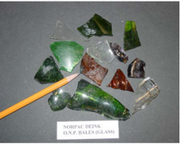
  - Do end markets have the capacity to accept the amount of material generated by your community?
  - What are the restrictions and specifications for glass (e.g. must be source separated)?
  - Is this end market using the material to transform and/or remanufacture it into usable or marketable materials rather than disposal? Keep in mind, that Ecology does not define the use of glass alternative daily cover as recycling.
Figure 24: Glass collected in commingled recycling programs can end up at paper mills and seriously damage paper-making equipment. This 2009 photo shows glass that was in a paper bale and rejected in the pulping process at NORPAC.

- Does the total cost of collection, processing, transportation to the end market, and end market acceptance allow for a net profit? If there is a cost, is it less than disposing of glass?
- Is proper infrastructure in place to collect the glass in a way that aligns with the end market’s specifications? What will it cost to install this infrastructure and to promote the program?
- What are your biggest barriers to glass recycling? These may include: market conditions, haulers not accepting glass, tipping fee and transport to glass processor is greater than landfill tipping fees, contamination, MRF not equipped to clean glass, etc.
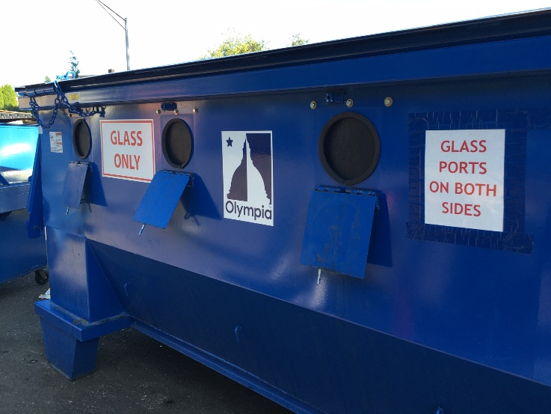
If the answers to these questions demonstrate that there is a viable end market to recycle glass at a net profit, or at a cost you’ve decided is reasonable compared to other glass management options, then your community should continue to explore the feasibility of collecting glass for recycling.
If the answers to these questions demonstrate there are not viable markets and/or the cost is too high to collect glass for recycling, consult NERC’s Glass Recovery Hierarchy for options other than disposal.
Figure 25: City of Olympia removed glass from their commingled residential recycling program in 2020 to reduce cross-contamination of the others materials they collect. They now provide glass recycling at drop off sites around the city.

Additionally, consider the following questions:
- Could resources spent on glass collection be better used to recycle easier and more valuable materials like cardboard?
- What alternatives to traditional glass recycling are available? (e.g. glass manufacturer, fiberglass plant, roadbed aggregate, ADC, crushed landscaping substrate, sandblast medium).
- Have you explored opportunities for regional engagement (coordination, partnerships, hub & spoke model) to improve glass recycling?

Possible reasons to keep glass in recycling programs:
- Resident satisfaction
- Divert tonnage from landfill
- Environmental/sustainability goals
- Prevention of illegal dumping
Questions to ask your MRF:
- What type of processing system do you operate for glass? (Single-stream, color-separated, dual stream, etc.)
- What is the final destination of your collected glass?
- Has there been a constant outlet for glass products to alternative processors and end-users?
- What determines where you sell glass?
- Does your system have glass-cleaning equipment?

Glass Recycling and Reuse Resources
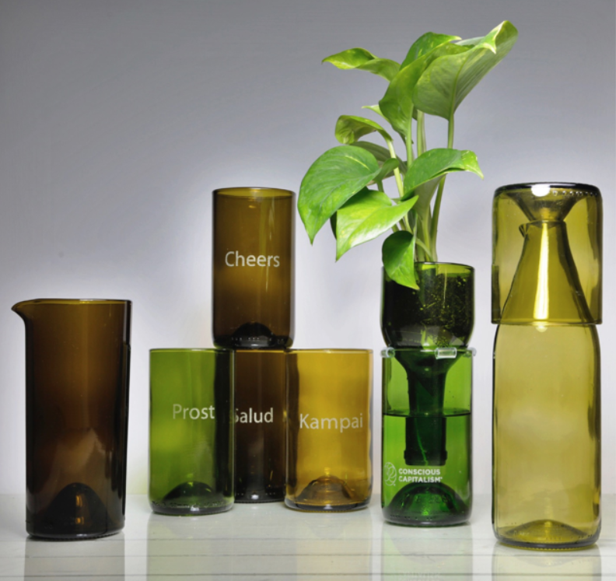
The Northeast Recycling Council has compiled a robust set of resources on glass recycling. Go their resource page and search for glass.
The Glass Recycling Institute offers resources and technical assistance to communities interested in recycling more glass. In this presentation, Scott Defife, the president of the Glass Packaging Institute, provides an overview of the glass recycling industry in the U.S. He also provides a comprehensive list of reasons why drop off programs in communities where MRFs don’t or won’t accept glass.
Figure 26: Refresh Glass is on a mission to rescue 10 million bottles from disposal by transforming wine bottles into exquisite glassware. As of August 6, 2020, they’ve rescued 1,613,747 bottles and counting.
Strategic Materials is the largest recycler of glass in the U.S. and operates a large facility in Seattle. In this presentation, Laura Hennemann, the VP for Marketing and Communications for Strategic Materials, provides an overview of their operations across the country. She lists what she says are the myths about glass, including that broken or mixed colored glass can’t be recycled and that glass contaminates other recyclables. According to her, “Single-stream contaminates every material in the bin. Proper layout, sequence and processing at the MRF maximizes value for all streams.”
Refresh Glass – Refresh Glass upcycles wine bottles into beautiful glassware and other products used in restaurants around the world. In this presentation, Ray DelMuro, the founder of Refresh Glass profiles his company, the new products he’s launching soon.

List of Figures
Page
Figure 1: The State CROP focuses on reducing inbound contamination. Graphic from the TRP 2020 State of Curbside Report. 3
Figure 2: A truly circular economy designs waste and recycling contamination out of the system. Ellen MacArthur Foundation – The Circular Economy in Detail. 9
Figure 3: Mobro's journey is a fascinating tale. Listen to Planet Money's two-part podcast called A Mob Boss, A Garage Boat, and Why We Recycle. It's also profiled in a PBS Frontline Retro Report called The Garbage Barge That Fueled a Movement. 9
Figure 4: The number of recycling programs and the amount of material collected for recycling skyrocketed after the Mobro hit the high seas. 10
Figure 5: China’s export ban shifted the costs of handling low-value and contaminated material onto local communities and MRFs, and caused a dramatic decline in market value. TRP’s 2020 State of the Curbside Report. 11
Figure 6: TRP’s 2019 survey of 196 MRFs across the country found an average contamination rate of 16.9%. It also revealed that what they call Bin/Bag programs or dual- or multi-stream programs had a contamination rate about 5% lower than for single-stream cart programs. 12
Figure 7: 65% of communities surveyed in The Recycling Partnership’s 2019 State of Curbside Survey did not know their inbound contamination rates. 12
Figure 8: The shift to commingled collection dramatically increased the amount of inbound contamination received at MRFs causing pulper rejects at mills like NORPAC in Longview, WA. From David Allaway’s Rethinking Recycling presentation. 14
Figure 9: Figure 10: TRP’s 2019 national survey found high levels of confusion about recyclable in their communities. 14
Figure 11: TRP found there is still strong support for recycling and that people are willing to pay more to make recycling work better – 2020 State of Curbside report 15
Figure 12: TRP’s 2019 national survey found high levels of confusion about recycling in their communities. 15
Figure 13: Well-crafted contracts that reward communities for cleaner materials can pay large dividends. The data above comes from TRP’s How to Build a Better MRF Contract presentation. Their MRF contracting BMP guide provides more detail. The King County Responsible Recycling Task Force also prepared an excellent guide on Using Contract Language to Improve Recycling. 16
Figure 14: Approximately 186 residential curbside collection programs in Washington funnel to 34 curbside collection service providers and 8 MRFs. Beyond the curb, the recycling system is already managed at a regional level. Data from Zero Waste WA - The State of Residential and Organics Collection Washington State. 17
Figure 15: Most materials from smaller counties are processed at the same MRFs as the largest counties. This underscores how important it is for all communities across the state to work together to reduce contamination. Data from Ecology’s 2019 solid waste facility database. 18
Figure 16: Three of the 8 MRFs in the state are owned and operated by Waste Management and handle 45% of all the commingled residential material collected for recycling statewide. Data from Ecology’s 2019 solid waste facility database. 19
Figure 17: Lincoln County’s drop box recycling program only collects the priority materials on Ecology’s, WACSWM’s, and WRRA’s suggested acceptable material lists. 20
Figure 18: MRF-shed maps can help identify opportunities for regional partnerships to lower costs, reduce contamination, and reduce recycling program costs. Data from Ecology’s 2019 solid waste facility database. 23
Figure 19: Samples of Spokane's contamination reduction campaign, including postcards, FAQs, and more are in the local programs section of the Resource Library. 41
Figure 20: Lopez Solid Waste District uses actual recyclables to create 3D signage at their dropbox locations. 45
Figure 21: : Dropbox, commercial, and multi-family collection programs should consider the 4 C’s (Capacity, Convenience, Color, and Clarity). from Cascadia Consulting – 2019 Role of Recycling Policy and Code presentation 46
Figure 22: ZeroWaste Washington survey of residential recycling collection programs by waste composition area or WGA. See glossary for a definition of a WGA. 47
Figure 23: Jefferson County dropbox signage includes actual examples of acceptable and unacceptable materials. Find more information in the local programs section of the Resource Library. 52
Figure 24: Glass collected in commingled recycling programs can end up at paper mills and seriously damage paper-making equipment. This 2009 photo shows glass that was in a paper bale and rejected in the pulping process at NORPAC. 57
Figure 25: City of Olympia removed glass from their commingled residential recycling program in 2020 to reduce cross-contamination of the others materials they collect. They now provide glass recycling at drop off sites around the city. 58
Figure 26: Refresh Glass is on a mission to rescue 10 million bottles from disposal by transforming wine bottles into exquisite glassware. As of August 6, 2020, they’ve rescued 1,613,747 bottles and counting. 59

Resources

Ecology Resources
Ecology’s Recycle Right campaign and Toolkit – a statewide campaign to reduce contamination and increase the value of the material collected for recycling in Washington State.
https://ecology.wa.gov/recycleright#:~:text=Recycling%20Right%20Matters,recyclables%20in%20the%20recycling%20bin.&text=They%20can%20also%20contaminate%20other,support%20local%20jobs%20and%20businesses.

The Recycle Right toolkit includes free customizable outreach materials for local governments and community partners in both English and Spanish - https://ecology.wa.gov/Waste-Toxics/Reducing-recycling-waste/Recycle-Right/Toolkit-request-form

- 2018 – Best Management Practices: Commingled Residential Recycling – updated BMPs to address the impacts of export bans and the high levels of recycling contamination
https://ecology.wa.gov/DOE/files/ed/ed59ba23-7f4c-4053-a47b-5abb644ad228.pdf

- 2016 - Northwest Region Report – Optimizing the Commingled Residential Curbside Recycling Systems in Northwest Washington
https://fortress.wa.gov/ecy/publications/documents/1607028.pdf

- 2011 – Best Management Practices Guides for Local Governments
What to include in Your Residential Commingled Recycling Collection Program
https://fortress.wa.gov/ecy/publications/documents/1107026.pdf

- 2012 – Public Outreach for Your Residential Commingled Recycling Collection Program
https://fortress.wa.gov/ecy/publications/summarypages/1207061.html

- 2010 - Beyond the Curb – Tracking the Commingled Residential Recyclables from Southwest WA
https://fortress.wa.gov/ecy/publications/summarypages/1007009.html

The Recycling Partnership Resources
  - Anti-Contamination Toolkit & Campaign Builder
Free, step-by-step planning guide with lots of links to other resources - https://recyclingpartnership.org/contamination-kit/

The toolkit includes:
    - Contamination fighting readiness assessment tool
    - Artwork – downloadable design files for anti-contamination tools
    - MRF & Hauler contract considerations focused on contamination
- Worksheets to work with your MRF, haulers and other stakeholders to develop a contamination reduction plan
    - Pro Tips – advice form communities that have used the toolkit
- MRF survey tool – to identify issues and goal
- MRF tracking form to track contamination metrics
- Standard Operation Procedures – lays out the roles, responsibilities, timeline and tracking for your anti-contamination plan
- Training video for drivers and enforcement staff to provide curbside feedback
- Set out video – overview of the difference between set-out rate and participation rate and how to calculate
- Tally sheet to track tagging progress

  - Campaign Builder - free, easy-to-customize anti-contamination materials including OOPs tags, top-issue mailers, and annual recycling program info cards https://recyclingpartnership.org/pdf-builder-login/

  - Webinar on how to use the toolkit – NERC – TRP -Massachusetts DEP – April, 2018
https://nerc.org/documents/Implementing%20the%20Recycling%20IQ%20Toolkit%20to%20Reduce%20Contamination%20of%20Residential%20Recycling_%20Lessons%20Learned%20.mp4

- Municipal Measurement Program (MMP) - https://www.municipalmeasurement.com/
The MMP provides municipalities with free access to a centralized database to measure program performance, benchmark results, and access tools and resources to improve curbside recycling programs.

- Best Management Practices for MRF contracting
file:///C:/Users/pgut461/Downloads/RecyclingPartnership-Community-MRF-Contracts-6.24.20%20(1).pdf

The Context for Contamination
  - From Green Fence to Red Alert – A China Timeline – Resource Recycling - regularly updated
https://resource-recycling.com/recycling/2018/02/13/green-fence-red-alert-china-timeline/

  - Why China Stopped Buying U.S. Recycling – CNBC – March 1, 2020
https://www.youtube.com/watch?v=YYjkdYAUa0c&feature=youtu.be

  - Recycling’s dirty truths exposed - Seattle Times - April, 26, 2020 https://www.seattletimes.com/pacific-nw-magazine/with-recyclings-dirty-truths-exposed-washington-works-toward-a-cleaner-more-sustainable-system/#:~:text=Local%20News-,With%20recycling's%20dirty%20truths%20exposed%2C%20Washington%20works,a%20cleaner%2C%20more%20sustainable%20system&text=IN%202017%2C%20ABOUT%20three%2Dquarters,tubs%20%E2%80%94%20was%20shipped%20to%20China.

- Backstory for Times article – I’ve cleaned up my act, but the system needs to be cleaned up too - https://www.seattletimes.com/pacific-nw-magazine/the-backstory-ive-cleaned-up-my-act-but-the-system-needs-to-be-cleaned-up-too/

  - In My Opinion – Fix the Broken System – Plastics Recycling News – Feb. 2, 2017 https://resource-recycling.com/plastics/2018/02/20/opinion-fix-broken-system/

  - NWRA – issue brief on China Sword - https://cdn.ymaws.com/sites/wasterecycling.site-ym.com/resource/resmgr/files/issue_brief/China's_Changing_Policies_on.pdf

  - MRSC – Recycling in Crisis – WA’s response - http://mrsc.org/Home/Stay-Informed/MRSC-Insight/November-2018/A-Recycling-Crisis-in-Washington.aspx

  - Is this the End of Recycling? – The Atlantic- March 6, 2019
https://www.theatlantic.com/technology/archive/2019/03/china-has-stopped-accepting-our-trash/584131/

  - Recycling in the U.S. is Broken. How do we Fix it? - Earth Institute – March 13, 2020
https://blogs.ei.columbia.edu/2020/03/13/fix-recycling-america/#:~:text=Photo%3A%20USEPA-,Recycling%20in%20the%20U.S.%20is%20broken.,actually%20end%20up%20being%20recycled.

  - Monopoly and the U.S. Waste Knot – ILSR - December 4, 2018 - https://ilsr.org/monopoly-and-the-us-waste-knot/

  - The era of easy recycling may be coming to an end – FiveThirtyEight - January 10, 2019 https://fivethirtyeight.com/features/the-era-of-easy-recycling-may-be-coming-to-an-end/

  - The Conflict of Interest that is Killing Recycling – NY Times – August 15, 2018 - https://www.nytimes.com/2018/08/15/opinion/fixes-recycling-labeling-landfills.html

  - All the ways recycling is broken – and how to fix them – Fast Company – April 4, 2019 - https://www.fastcompany.com/90321566/all-the-ways-recycling-is-broken-and-how-to-fix-them

  - Single Stream Recycling: Explaining the Waste Knot– ILSR – August 29, 2018 https://medium.com/@ILSR/single-stream-recycling-explaining-the-waste-knot-16bdf8c47e22

  - Single-Use Plastics – A roadmap for Sustainability – UNEP- June, 5, 2018
https://www.unenvironment.org/resources/report/single-use-plastics-roadmap-sustainability

  - Americans believe strongly in recycling – TRP – June 17, 2020
https://recyclingpartnership.org/americans-strongly-believe-in-recycling/

  - Derek Ruckman – Presentation on Recology’s Zero Waste Mission – April 29, 2020
https://1drv.ms/v/s!AuL3p2W6v4a1iIYpjoSuQTEiicpvNA?e=kdFpnX

Certificated Hauler Service Area Maps
Includes statewide and county maps from the WA Utilities and Transportation Commission
- PDFS of maps
https://www.utc.wa.gov/regulatedIndustries/transportation/solidWaste/Pages/SWServiceMaps-ByCounty.aspx

- Statewide searchable map
https://wutc.maps.arcgis.com/home/webmap/viewer.html?webmap=d379029aa77d4f2086c0570706c02efa

Gable Top - Aseptic Containers
- Expanding Carton Recycling Within Evolving Fiber Markets – Upcyclers Network – 07/08/2020
https://www.upcyclersnetwork.org/wp-content/uploads/2020/07/Evolving-Fiber-Markets-and-Expanding-Carton-Recycling-Access-for-Municipalities-1.pdf

Contracting for Processing of Recyclables
- The Recycling Partnership BMPs for MRF contracting
file:///C:/Users/pgut461/Downloads/RecyclingPartnership-Community-MRF-Contracts-6.24.20%20(1).pdf

- MRF & Hauler contract considerations focused on contamination https://therecyclingpartnership.box.com/s/2cbpcxvgrjkj6tfbhspzjhnb0p3cre49

- SWANA/NWRA contracting guide https://cdn.ymaws.com/wasterecycling.org/resource/resmgr/docs/resource_library/SWANA-NWRA_Best_Contracting_.pdf

- Using Contract Language to Improve Recycling – King County Responsible Recycling Task Force
Includes sample contract language
https://kingcounty.gov/~/media/depts/dnrp/solid-waste/about/planning/documents/task-force-contract-language.ashx?la=en

- City of Palo Alto Contract for Collection & Processing – includes detailed reporting requirements, certificates of end-use, etc.
https://www.cityofpaloalto.org/civicax/filebank/documents/68449

Multi-Family
- WSRA – 2019 Annual Conference
Building for Success: Using Code to Improve Multifamily Recycling - Speakers: Angela Wallis; Seattle Public Utilities, Sarah Kirby; Metro Oregon, Jenna McInnis; City of Kirkland, Andrea Lei; Cascadia Consulting
- SPU – MF Code to Drive diversion https://wsra.xyz/wp-content/uploads/2019/12/WSRA_AOR-Presentation-2019_MF-Code.pdf
- Oregon Metro – MF Community Engagement - https://wsra.xyz/wp-content/uploads/2019/12/WSRA_MF_METRO_final.pdf
- City of Kirkland – Using Simple Code to increase recycling - https://wsra.xyz/wp-content/uploads/2019/12/MF-Code-Conference-Presentation.pdf
- Cascadia – the role of recycling code and policy - https://wsra.xyz/wp-content/uploads/2019/12/Cascadia-WSRA-AOR-2019_MF-Policy-and-Code_DRAFT.pdf

- Salt Lake City Business and MF Recycling Ordinance – Creating a recycling plan – case studies
http://www.slcdocs.com/slcgreen/Waste&Recycling/SLC%20Business%20Recycling%20Toolkit%20FINAL_December%202018_Small.pdf

- MF Recycling guide – from rental association
https://www.rentecdirect.com/blog/create-recycling-program/

- Reducing Contamination at Apartment Complex - Michigan
https://wmich.edu/sites/default/files/attachments/u691/2016/Swanson_1.pdf

- Oregon DEQ MF – Improving access to tenants
https://www.oregon.gov/deq/recycling/Pages/Recycling-for-Tenants.aspx
https://www.oregon.gov/deq/FilterDocs/recMultiTenOppFS.pdf

Cart Tagging
WSRA – 2019 Annual Conference
Cart Tags for a Less Contaminated Tomorrow - Speaker/s: Lindsay Chapman; Spokane County, James Tieken; City of Spokane, Steven Gimpel; Waste Management
Speakers: Joel Kohlstedt; Waste Management, Stacy Ludington; Clackamas County Sustainability and Solid Waste, Cody Marshall, The Recycling Partnership
- TRP – overview - https://wsra.xyz/wp-content/uploads/2019/12/3b_Partnership-Tagging-Presentation-4.22.19.pdf
- City of Spokane, Clackamas County, Waste Management - https://wsra.xyz/wp-content/uploads/2019/12/WSRA_Slides_3b.pdf

Single & Dual Stream
- Experts duel over dual-stream’s merits – Resource Recycling – 5/14/2019
https://resource-recycling.com/recycling/2019/05/14/experts-duel-over-dual-streams-merits/

- Dual-stream collection regains appeal in some areas - Resource Recycling – 7/17/2018
https://resource-recycling.com/recycling/2018/07/17/dual-stream-collection-regains-appeal-in-some-areas/

General Contamination Reduction
- WSRA - https://wsra.net/events/2018-wred-events/- Contamination Fest March – many presentations

- SCS Engineers – high-level guides for reducing contamination and includes other linked resources
https://www.scsengineers.com/minimize-contamination-in-recycling-programs/
https://www.scsengineers.com/proven-methods-reduce-contamination-recycling/

- NWRA – Anti-contamination Poster
https://cdn.ymaws.com/wasterecycling.org/resource/resmgr/images/Reduce_Contamination_Infogra.pdf

- Oregon DEQ – Recycle Right campaign https://www.oregon.gov/deq/recycling/Pages/Recycle-Right.a

- Recycle or Not – Oregon Metro https://www.recycleornot.org/

Hauler Websites
- Republic Services – Recycling Simplified - https://recyclingsimplified.com/
- Waste Management – Recycle Right - https://www.wm.com/us/en/recycle-right
- Waste Connections – Recycle Right – Clark County - https://wcnorthwest.com/recycleright
- Recology – Better at the Bin - https://www.recology.com/better-at-the-bin/

Glass
- Recycling glass with alternative collections – Laura Hennemann, Strategic Materials- 07/22/2020
https://www.upcyclersnetwork.org/wp-content/uploads/2020/07/Upcyclers-Strategic-Materials-July-20_Laura.pptx

- Glass Recycling in Today’s Market – Scott DeFife, Glass Packaging Institute – 07/22/2020
https://www.upcyclersnetwork.org/wp-content/uploads/2020/07/Upcyclers_Glass-Webinar_Scott.pptx

- Refresh Glass – Ray DeMuro, Refresh Glass – wine bottles into glassware – 07/22/2020
https://www.upcyclersnetwork.org/wp-content/uploads/2020/07/Ray-DelMuro_Refresh-Glass-short.pptx

Measurement and Cost Analysis
- Measuring Composition and Contamination at the MRF – NERC Conference – 10/31/2018
https://nerc.org/documents/conferences/Fall%202018%20Conference/Measuring%20Composition%20and%20Contamination%20at%20the%20MRF_John%20Culbertson.pdf

  - Municipal Measurement Program (MMP) - https://www.municipalmeasurement.com/
The MMP provides municipalities free access to a centralized database to measure program performance, benchmark results, and access tools and resources to improve curbside recycling programs.

- 2013 Material Composition Study – Ontario Blue Box Program
https://stewardshipontario.ca/wp-content/uploads/2016/03/2013-MRF-Material-Composition-Study-March-22-16-1.pdf

- Costs of adding non-core materials to processing costs and recovery rates
https://thecif.ca/understanding-how-program-costs-and-recovery-have-changed-over-time/

Life Cycle Analysis
- EPA Waste Reduction Model (WARM) Calculator – estimate GHG emissions reductions, energy savings, and economic impacts of alternative waste management strategies.

- Oregon Department of DEQ Environmental Footprinting for Packaging - https://www.oregon.gov/deq/mm/production/Pages/Packaging.aspx
- Waste Management 2018 Sustainability report – includes data on impacts of recycling on GHG emission - page 31 - https://sustainability.wm.com/downloads/report.php

Product Design for Recyclability
- How2Recycle Recyclability Insights Report
https://how2recycle.info/insights?utm_source=newsletter&utm_medium=email&utm_content=Explore&utm_campaign=H2R%20Guidance%20Doc%207.2017

Glossary, Acronyms, and Abbreviations

Acronyms and Abbreviations

ADA Americans with Disabilities Act
BMP Best Management Practice
C&D Construction and Demolition Debris
CPG Consumer Product Goods
CROP Contamination Reduction Outreach Plan
Ecology Washington State Department of Ecology
EPR Extend Product Responsibility
LCA Life Cycle Analysis
LSWFA Ecology’s Local Solid Waste Financial Assistance program
RCW Revised Code of Washington
RDC Recycling Development Center
SWMP Solid Waste Management Plan. Counties and municipalities must participate per RCW 70.95.080.
TRP The Recycling Partnership
WAC Washington Administrative Code
WACSWM Washington Association of Counties Solid Waste Managers affiliate
WGA Waste Generation Area
WRRA Washington Refuse and Recycling Association

Glossary
Accepted Materials List (AKA Acceptance list): The most recent list published/promoted by a jurisdiction and/or its hauler for residential recycling services that is meant to guide residents on what materials they can put in their recycling containers. Because commercial recycling is an open market, lists may vary by hauler within a jurisdiction. The acceptance list should mirror closely the designated recyclables list found in the Solid Waste Management Plan that the jurisdiction participates in.
Adopt: To adopt a CROP, a local government must formally add its CROP to its SWMP by way of either the locally-defined or Ecology-approved amendment process, or via a revision and the standard local resolutions of adoption by all SWMP signatories as done in the regular SWMP revision process. In either case, Ecology’s subsequent approval of the adopted document is the final step of the process.
Amendment: A minor alteration (update) of an existing Solid Waste Management Plan following the process described in the Plan itself, or a process agreed upon with Ecology.
Aseptic containers: Boxes made from paper layered with polyethylene and aluminum that contain shelf-stable consumables such as milk, soup, and tomatoes.
Cardboard: Contains a wavy middle layer. Mills use old corrugated containers to make new recycled-content shipping boxes and more. AKA - Old Corrugated Containers (OCC).
Cartons: Packaging for food and beverage products, both shelf-stable and refrigerated. Aseptic cartons (defined above) are often used for shelf-stable applications. Gable-top cartons are commonly used in refrigerated applications, such as milk and juice.
China’s export ban: Enacted in March 2018 after being announced the previous year during the National Sword customs contamination enforcement action (which the ban is sometimes erroneously referred to). Both the ban and National Sword are often used as placeholder terms to describe the outsized economic impact of this large export market disruption (estimated at a fifth of all commodities markets).
Commercial recycling: Recycling collected from commercial (business), institutional or industrial sources. (Multi-family is considered as residential recycling, not commercial.)
Commingled Recycling: Mixing recyclable materials for the purposes of efficient collection. This term is almost always used synonymously with single-stream recycling, in which the aggregated recyclables are in a single container such as a wheeled cart with a lid that ranges from 32-90 gallons in capacity, or a multi-yard dumpster, or a drop box. However, it is also technically possible for commingled recycling to be a part of a dual-stream or multi-stream system. An example is a system where commingled recyclables without glass are collected in a cart, and glass is collected in a separate bin placed next to the cart.
Contamination: Per RCW 70.95.100(4)(b), “Contamination means any material not included on the local jurisdiction’s acceptance list.” More broadly, this is any item collected with materials meant for recycling that could create significant negative environmental, financial, or health or safety impact anywhere in the recycling system from collection through remanufacture or disposal.
Contamination Reduction Outreach Plan (CROP): The element that must be included by July 1, 2021 in local solid waste management plans per RCW 70.95.090(10). This local CROP is intended to improve the uniformity, marketability, and environmental benefits of recyclable material streams. The Local CROP Template is included in the State CROP. Ecology prepared a State CROP to assist local governments in preparing and implementing their local CROPs.
Drop box (or drop off) recycling: Recycling collection sites for residential and sometimes commercial recyclables where residents can drop off materials to be recycled. May be used as an alternative for a community that does not offer curbside collection of recyclables.
Dual-stream: One type of a commingled collection system in which some recyclable materials are placed in a cart or bin at the curb, and one or more different materials are placed in another cart or bin (or, less frequently, in different sides of a divided cart). Examples – all materials except glass in one cart, and glass in a bin next to the cart; all fibers in one cart and all containers in another cart.
End User or mill: The facility that first uses recycled material to manufacture a new product. The product of an end-user or mill may be further converted into other value-added products, such as a sheet of boxboard from a paper mill being converted into a box.
Extended Product Responsibility (EPR): EPR is a mandated policy that shifts the responsibility for end-of-life management of products and packaging upstream to producers – rather than the public sector – and creates incentives for producers to incorporate environmental considerations into the design of their products and packaging. Definition from the King County Responsible Recycling Task Force report - EPR Policy Framework and Implementation Model
Life Cycle Analysis (LCA): LCA is a method used to evaluate the environmental impact of a product through its life cycle encompassing extraction and processing of the raw materials, manufacturing, distribution, use, recycling, and final disposal.
Materials Management: A systemic approach to using and reusing materials more productively over their entire lifecycle. Materials management is focused on knowing and reducing the lifecycle impacts across the supply chain; using less material inputs (reduce, reuse, recycle); and using less toxic and more renewable materials.
Mixed Waste Paper (MWP): Mixed paperboard, magazines, and catalogs. Mills use mixed paper to produce paperboard and tissue, as a secondary fiber in the production of new paper, or as a raw material in a non-paper product such as gypsum wallboard, chipboard, roofing felt, cellulose insulation, and molded pulp products such as egg cartons. Typically not used for molded pulp products due to the contamination level and risk of damage to food. Also used for production of medium used in corrugated containers.
Materials Recovery Facility (MRF): Pronounced "merf," is a facility that accepts, sorts, processes, and bales different types of recyclables for sale to an end-user.
MRF-shed: The geographic area that includes the communities that send the material they collect for recycling to same MRF for processing.
Multiple- or multi-family recycling: recycling collection from multiple-family residences such as apartments or generally any buildings containing four or more habitable units.
Plastic bottles and jugs: Plastic containers of any resin type that have a narrower opening than its body (i.e. a “neck”).
Plastic film: A thin flexible sheet of plastic which does not hold a particular shape when unsupported.
Polycoat: A type of fiber packaging that contains an outer layer of plastic coating to protect the fiber from breaking down in wet and freezing conditions.
Recyclable materials: Those solid wastes that are separated for recycling or reuse, including, but not limited to, papers, metals, and glass that are identified as recyclable material pursuant to a local comprehensive solid waste plan. For the purposes of a local CROP, these materials do not need to include organics or construction and demolition waste.
Recycling: means transforming or remanufacturing waste materials into usable or marketable materials for use other than landfill disposal or incineration.
Revision: An alteration (update) of an existing Solid Waste Management Plan (or Combined Solid and Hazardous Waste Management Plan) by way of reviewing and adjusting as necessary every element of the Plan, cover to cover. A revision goes through the full review and adoption process, and restarts the 5-year “review and revise as necessary” timeline in RCW 70.95.110.
Right to Repair: "Right to repair" laws refer to legislation that requires manufactures to give owners or independent repair shops access to data needed to repair their products.
Single-family recycling: recycling collection from single-family homes or generally from buildings up to four habitable units.
Single-stream: One type of a commingled collection system in which all recyclable materials are placed in one container at the curb.
Sustainability: Sustainability focuses on meeting the needs of the present without compromising the ability of future generations to meet their needs. The concept of sustainability is sometimes described as being composed of three pillars: economic, environmental, and social—also known informally as profits, planet, and people.
Transcreation: The merger of two words: translation and creation. It’s an intricate form of translating a message from one language to another, while maintaining its intent, style, tone, and context. A successfully transcreated message evokes the same emotions and carries the same implications in the target language as it does in the source language.
Update: An alteration of an existing Solid Waste Management Plan by way of either an amendment or a revision with the intent of bringing the Plan into compliance or to reflect a change in current conditions.
Waste generation areas (WGA): Geographic areas within the state that have similar economic, environmental, and social characteristics and are dependent upon similar material transport networks. Other variables, such as waste composition, methods of waste collection and disposal, and the availability of recycling and commodity markets, are also considered in the determination of WGAs. from Ecology’s 1988 Best Management Practices for Solid Waste – Volume 1, page 1.
Wishful recycling: The act of tossing items in a recycling bin believing they should be recyclable and with the hope that they will be recycled.

