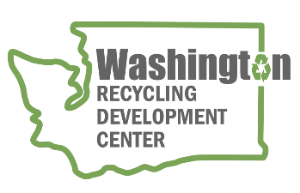
AGENDA
Recycling Development Center Advisory Board
Wednesday, December 14, 2022 | 9 am to 12 pm (Pacific time)
Join us on Zoom - https://waecy-wa-gov.zoom.us/j/86964958516

Meeting Overview  - Roundtable and updates  - Presentations  - Strategic Planning | Meeting materials  - Priority Decision Matrix

Agenda

9:00 am Welcome
- Agenda review

9:10 am Board roundtable and Ecology/Commerce updates
    - Board member roundtable
    - Commerce & Ecology updates
    - NextCycle Washington

9:35 am Presentations and Discussion
    - Funding Opportunities for Small Business
Kirk Esmond - Department of Commerce

    - Mura Technology’s Project Cascade
Kari Mueller – Mura Technology

    - King County Plastic Film Pilot Project
Shari Jackson – American Chemistry Council
10:30 am Bio Break
10:40 am Center Strategic Planning
    - Priority/decision matrix tool

11:30 am Wrap-up
WE WILL HOLD BOARD MEETINGS FOR 2023 QUARTERLY ON THE 2nd WEDNESDAY OF THE MONTH, STARTING MARCH 8, FROM 9 am to Noon, FOLLOWED BY A FACILITY TOUR. DEPENDING ON MEETING LOCATION CAPACITY – BOARD MEMBERS HAVE THE OPTION TO MEET IN PERSON WITH INTERESTED PARTIES ATTENDING IN PERSON OR VIA ZOOM.
For more information about the Recycling Development Center, visit the Advisory Board EZview website.
If you have questions, reach out to the Center team by email: RecDevCenter@ECY.WA.GOV
Please share this information. We welcome interested parties to sign up on the Recycling Development Center email list.

