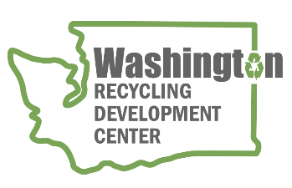
AGENDA
Recycling Development Center Advisory Board
Wednesday, June 8, 2022 | Zoom 9 am to 12 pm (Pacific time)
Join us on Zoom - https://waecy-wa-gov.zoom.us/j/84659027232
Board members option for in-person at NORPAC, Longview WA for meeting, lunch, and mill tour after presenations.

Meeting Overview  - Roundtable and updates  - Paper Markets | Meeting materials  - Recycling Development Center’s Paper paper  - King County Paper

Agenda

9:00 am Welcome
- Agenda review

9:15 am Board roundtable and Ecology/Commerce updates
    - Board member roundtable
    - Commerce & Ecology updates
9:30 am Ecology’s data on material collection, waste, and recovery
    - Dan Weston, Recycling and material management – who collects what?
    - Gretchen Newman, Lead Data Analyst – 2020-2021 Waste Char Study
10:20 am Bio Break
10:30 am Paper presentations and discussion
    - NORPAC Introduction
    - Finished Product Market Overview
    - Wastepaper

11:45 am Wrap-up
- September (quarterly) meeting – in-person/remote
- Focus/topic: Ecology activities and facility tour
The next board meeting is scheduled for September 14, 2022. Please note - board members have the option to meet in person with interested parties attending via zoom.
Remaining Board Meetings for calendar year 2022 will be quarterly on the 2nd Wednesday of September and December from 9 am to Noon, followed by a facility tour.
For more information about the Recycling Development Center, visit the Advisory Board EZview website.
If you have questions, reach out to the Center team by email: RecDevCenter@ECY.WA.GOV
Please share this information. We welcome interested parties to sign up on the Recycling Development Center email list.

