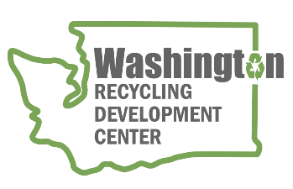
AGENDA
Recycling Development Center Advisory Board
Wednesday, September 14, 2022 | 9 am to 12 pm (Pacific time)

Join us in-person for the board meeting and an afternoon 911 Glass Rescue facility tour. Or sign in remote on Zoom.
- In Person location – Campbell’s Resort on Lake Chelan – Park Room
- Remote Zoom - https://waecy-wa-gov.zoom.us/j/87608586592
Meeting Overview  - Roundtable and updates  - Center report to the Legislature  - Presentations | Meeting materials  - Draft Center Report to the Legislature  - Leavenworth Composting Feasibility Study

Agenda

9:00 am Welcome
- Agenda review

9:15 am Board roundtable and Ecology/Commerce updates
    - Board member roundtable
    - Intro new board members
    - Commerce & Ecology updates
9:30 am Legislative report discussion
    - Overview of the report
    - Advisory board recommendations
9:55 am Mura Presentation
    - David Richey – Scarlet Oak Strategies
10:20 am Bio Break
10:30 am Grants “a year in the life” presentations
    - Carl Florea - City of Leavenworth
    - Andrew Nichols - Lopez ReMakery
    - Julie McCoy - 911 Glass Rescue

11:45 am Wrap-up
Remaining Board Meeting for calendar year 2022 will be on the 2nd Wednesday of December from 9 am to Noon, followed by a facility tour. Depending on meeting location capacity - board members have the option to meet in person with interested parties attending via zoom.
For more information about the Recycling Development Center, visit the Advisory Board EZview website.
If you have questions, reach out to the Center team by email: RecDevCenter@ECY.WA.GOV
Please share this information. We welcome interested parties to sign up on the Recycling Development Center email list.

