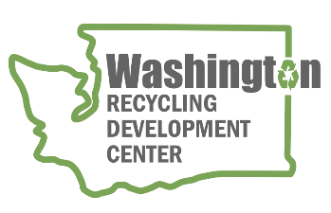
AGENDA
Recycling Development Center Advisory Board
Wednesday, March 8, 2023 | 9 am to 12 pm (Pacific time)
Join us in-person at Evergreen State College-Tacoma or on Zoom

Meeting Overview
- Roundtable updates
- Presentations

Agenda

9:00 am Welcome
- Agenda review

9:10 am Board roundtable and Ecology/Commerce updates
    - Board member roundtable
    - Commerce & Ecology updates
    - Subcommittee report out
9:35 am Legislative Update
    - Julie Robertson – Department of Ecology
9:55 am Bio Break
10:10 am Presentations
    - Natalie Caulkins – Republic Services
    - Allen Langdon – Circular Materials
    - Kevin Kelly – Ridwell

11:30 am Wrap-up
WE WILL HOLD QUARTERLY BOARD MEETINGS FOR 2023 ON THE 2nd WEDNESDAY OF THE MONTH, FROM 9 am to Noon, FOLLOWED BY A FACILITY TOUR. BOARD MEMBERS HAVE THE OPTION TO MEET IN-PERSON WITH INTERESTED PARTIES ATTENDING IN-PERSON OR VIA ZOOM. NEXT QUARTERLY MEETING WILL BE JUNE 14, 2024 (location to be determined).
For more information about the Recycling Development Center, visit the Advisory Board EZview website.
If you have questions, reach out to the Center team by email: RecDevCenter@ECY.WA.GOV
Please share this information. We welcome interested parties to sign up on the Recycling Development Center email list.

