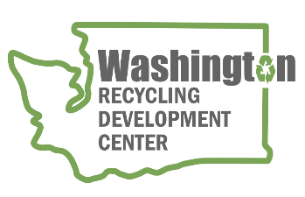
AGENDA
Recycling Development Center Advisory Board
Wednesday June 14, 2023 | 9 am to 12 pm (Pacific time)
Join us in-person at Kent Commons the Olympic room
525 4th Ave in Kent Washington
or register for the remote meeting on Zoom

Meeting Overview  - Roundtable updates  - Presentations | Facilitator: Mya Keyzers  Zoom Host: Caleb Carlson  Notes: Tina Schaefer

Agenda – Recycling Challenges

9:00 am Welcome
- Agenda review

9:10 am Board roundtable and Ecology/Commerce updates
    - Board member roundtable
    - Commerce & Ecology updates
    - NextCycle Pitch Event & Glass Summit recaps
    - WWU report & UW Evans School study
9:40 am Recycle Right Campaign
    - Dan Weston – Department of Ecology
10:00 am Bio Break
10:10 am Presentations
    - Scott Morgan – Evergreen State College
    - Karl Englund – Washington State University
    - Marilyn Lauderdale – Styro Recycle

11:15 am Wrap-up
WE WILL HOLD QUARTERLY BOARD MEETINGS FOR 2023 ON THE 2nd WEDNESDAY OF THE MONTH, FROM 9 am to Noon, FOLLOWED BY A FACILITY TOUR. BOARD MEMBERS HAVE THE OPTION TO MEET IN-PERSON WITH INTERESTED PARTIES ATTENDING IN-PERSON OR VIA ZOOM. NEXT QUARTERLY MEETING WILL BE SEPTEMBER 13, 2023 (location to be determined).
For more information about the Recycling Development Center, visit the Advisory Board EZview website.
If you have questions, reach out to the Center team by email: RecDevCenter@ECY.WA.GOV
Please share this information. We welcome interested parties to sign up on the Recycling Development Center email list.

