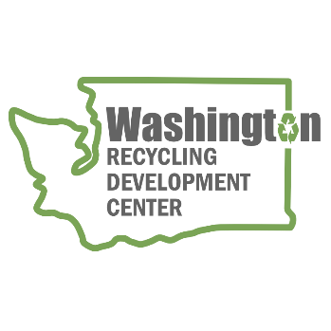
AGENDA
Recycling Development Center Advisory Board
Wednesday, July 10, 2024 | 9 am to 11:30 am (Pacific time)
Join us on Zoom

Meeting Overview  - Roundtable updates  - Presentations | Facilitator: Mya Keyzers  Zoom Host: Calab Carlson  Notes: Tina Schaefer

Agenda

9:00 am Welcome
- Agenda review

9:10 am Board roundtable and Ecology/Commerce updates
    - Commerce & Ecology updates
    - Board member roundtable
9:35 am Data Update
    - Gretchen Newman – Department of Ecology – C&D data
9:55 am Bio Break
10:00 am Reuse & Repair Presentations
    - Dave Bennink – Building Deconstruction Institute & Re-Use Consulting
    - Katie Kennedy – Seattle Public Utilities
    - Hannah Waterstrat – Department of Commerce – State Efficiency & Environmental Performance (SEEP)

11:15 am Wrap-up
WE WILL HOLD QUARTERLY BOARD MEETINGS FOR 2024 VIRTUALLY ON THE 2nd WEDNESDAY OF THE MONTH, FROM 9 am to 11:30 AM. NEXT MEETING WILL BE OCT 9, 2024.
For more information about the Recycling Development Center, visit the Advisory Board EZview website.
If you have questions, reach out to the Center team by email: RecDevCenter@ECY.WA.GOV
Please share this information. We welcome interested parties to sign up on the Recycling Development Center email list.

