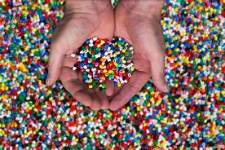
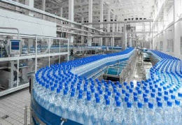
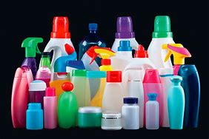
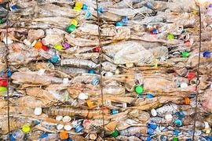
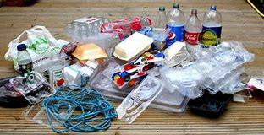
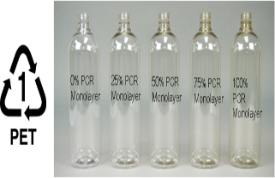

Plastic Packaging Recycling
This is the third report in the Recyclable Material Series prepared by the Recycling Development Center (Center) for its advisory board. The purpose of this report is to provide an overview of plastic packaging recycling markets in Washington State.
PLASTIC PACKAGING RECYCLING

Plastic Overview
The many physical properties of plastics (e.g., low density, flexibility, transparency, chemical resistance, stability) allow their use extensively in manufacturing and consumer products. The most common use for plastics is packaging, often used once and discarded.
China’s 2018 National Sword policy substantially reduced imports of packaging and other waste from the US and other countries. As a result, many curbside programs limited or eliminated collection of plastic for recycling reduced plastic recycling activities in Washington State.
Consumer plastic packaging includes bags, bottles, thermoforms, tubs, tubes, flexible pouches, labels and stickers, and film. In Washington’s 2021 Waste Characterization study, plastic waste comprised 13.1 percent by weight of Washington’s municipal solid waste stream, of which packaging made up more than half (7.4 percent).

Summary of next steps
This report identifies a range of efforts that could increase knowledge, support markets, or boost plastic recycling. Not all of these efforts are within the scope of the Center. The Center focuses on end-markets, and other actions, some led by others, can help increase the potential for circularity or reduction of plastic packaging.
Facilitate research: Determine the amount of plastic packaging used in Washington, by sector: residential, commercial, institutional, and industrial. Identify where packaging material is collected and evaluate the quality of the processed material. Refine list of plastic manufactures and recycling processors in the state and region, as well as export markets that are currently being used.
Support market development: Connect in-state and regional plastic processors and manufacturers to increase demand for and access to recyclable plastic. Developed needed tools to come to entice more growth within the recycling value chain within the State and region.
Consider policy changes: Providing universal access to recycling would expand collection, require more infrastructure, and increase end markets. Creating a deposit return systems for beverage containers would provide a stable high quality material supply for end market users. Establishing an extended producer responsibility programs for packaging would require producers to fund collection services and educational materials, incentivize improved collection and recycling, lead to developing local end markets, and provide financial support to the system.

Manufacturing and Recycling

Plastic production
An estimate of annual global plastic production reported 404 million tons of plastic produced in 2020. Plastic packaging is the largest sector of production, comprising 36 percent. About half of plastic packaging is manufactured for use in the food and beverage sector, with the other half used for packaging in personal and household care, industrial, pharmaceutical, and other applications.

Recycling plastic packaging
U.S. data compiled by the Ocean Conservancy, shown in Figure 1, shows that 82% of the main plastic packaging types end up disposed in a landfill, incinerated, or littered in the environment.
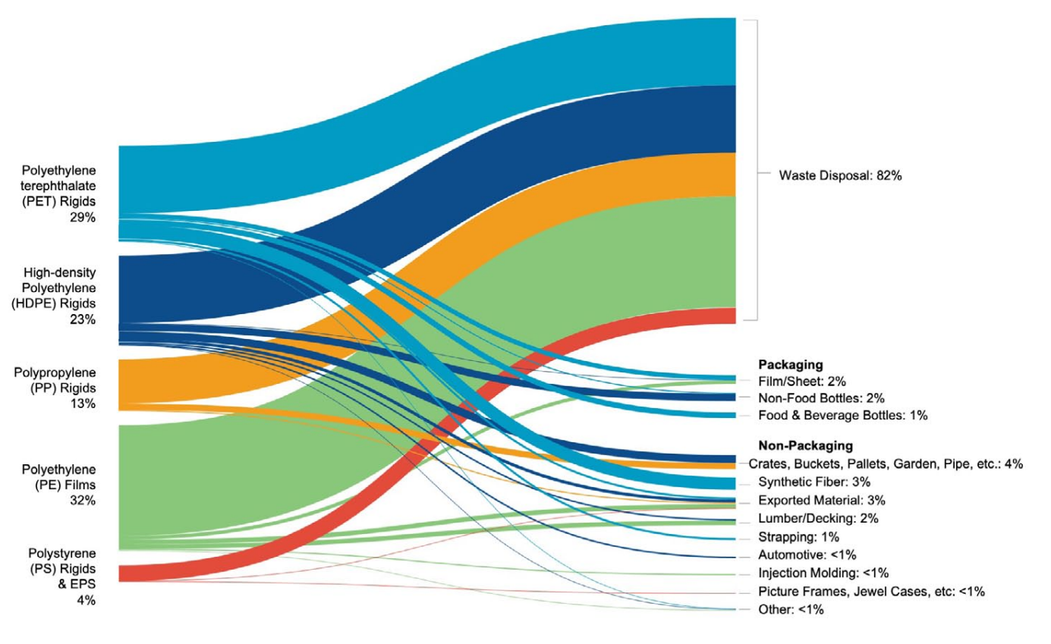
Figure 1. USA residential and commercial plastic packaging waste material flows (by weight).⁷
Plastic recycling occurs through mechanical, thermal, and chemical processes. Nationally, the most robust and mature recycling markets for plastic packaging exist for polyethylene terephthalate (PET) and high-density polyethylene (HDPE) bottles.
Most recycled food grade PET (bottle to bottle) is made from PET bottles collected in the ten states with mandated deposit return systems for beverage containers, commonly referred to as “bottle bills.” Washington does not have a bottle bill. Approximately half of the collected PET bottles are recycled into packaging. PET is also recycled into plastic synthetic fiber (for carpet and clothing), and strapping.
Natural HDPE is a milky white color and has the highest value in the HDPE recycling stream since it has the widest variety of end-use applications. Approximately 40 percent of the collected HDPE bottles are recycled into packaging. HDPE is also recycled into durable goods like crates, buckets, pallets, pipe, lumber/decking, and automotive applications.

Recycling benefits
While the cost of recycling plastic can be higher than using virgin material, using recyclable plastic reduces the consumption of raw material, lowers greenhouse gas emissions, reduces water and air pollution, and decreases waste disposal.
Recycling one ton of plastic saves
16.3 barrels of virgin oil
5,774 kilowatt/hours of energy
98 million British thermal units of energy
30 cubic yards of landfill space
Recycling 1,000 tons creates
1.17 jobs (compared to landfilling)
$65,230 in wages per year
$9,420 in tax revenues per year

Recycling challenges
The recycling process depends on the plastic resin used, the contamination threshold for the final product, and what the recycled plastic feedstocks contained. Additives like fillers, plasticizers, softeners, lubricants, anti-aging additives, flame retardants, colorants, blowing agents, cross-linking agents, and ultraviolet-degradable agents are routinely added to plastic packaging, often compromising their recyclability.
PET is the trophy for plastic resin recycling. Unlike other resin types, PET can return to a useable polymer many times. There are many variables to consider when recycling PET packaging, for example, how much recycled content it started with, what additives have been used, and what its recycled end use will be (food grade or auto parts). Due to that complexity, there is no standard answer for how many times PET can be truly recycled. The highest use for PET is to recycle it into food grade packaging but that requires certain quality in the collected materials. The bale quality will determine the market value resulting in recycled PET as food grade packaging or downcycled into fiber.
In a controlled lab setting starting with clean HDPE, scientists were able to process it ten times without property-altering damage. However, they state it would not be possible to reproduce that many cycles in the real world. This is due in part because no universal recipe or disclosure of ingredients used to manufacture packaging (often for proprietary reasons) exists, further complicating plastic recycling and potential end market supply. Improving recyclability of plastic is a growing area of study for both initial design and improving recoverability.
Manufacturing with recyclable plastic is more expensive than manufacturing with virgin plastic resin. Oil commodities fluctuate, when oil is cheap so is using virgin plastic. Historically virgin plastic has been cheaper and cleaner than plastic collected for recycling. Competition with virgin plastic is a barrier for using recyclable plastic.
Other plastic recycling challenges include lack of access to curbside recycling, inexpensive cost of disposal, insufficiently funded outreach and education to consumers about recycling, lack of incentives for consumers to recycle, contamination in collected plastics, and insufficient infrastructure to recycle the volume of plastic produced.

Washington’s information

Waste generation
In 2017, $165 million was spent to manage and dispose of Washington’s estimated 410,300 tons of plastic packaging waste generated (see Table 1)., Rigid plastic, which comprised just over half of the generated material (211,340 tons) had a recycling collection rate of 24%, while, flexible plastic packaging (198,960 tons) only had 10 percent collected for recycling.
Table 1. Washington data for plastic packaging for 2017
Plastic packaging | Tons Sent to be Recycled | Tons Disposed | Total Tons Generated | Collected for recycling
Rigid | 50,130 | 161,210 | 211,340 | 24%
Flexible | 19,280 | 179,680 | 198,960 | 10%
Total | 69,410 | 340,890 | 410,300 | 17%
Sources: 2020-2021 Statewide Waste Characterization Study, Dept. of Ecology data, Cascadia Report, Eunomia Report.

Plastic manufacturers
Using lists of businesses identified by their North American Industry Classification System code, recent Washington-focused studies,, and Ecology’s data indicates about 87 companies in Washington manufacture, and fabricate plastic (shown in Figure 2). The list of companies is provided as a supplement to this report.
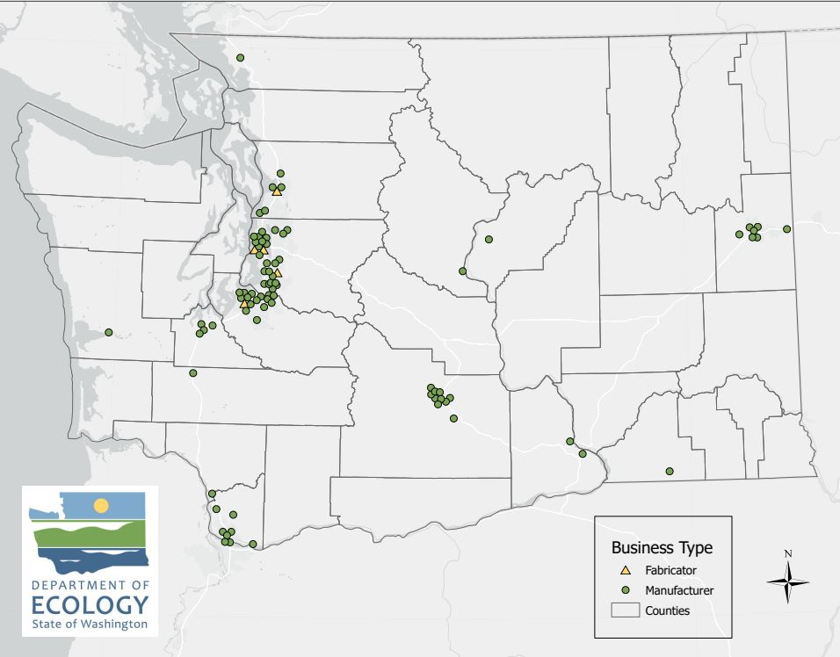
Figure 2. Washington’s map of companies involved in the plastics market.

Demand for recyclable plastic
Ecology receives annual reports from companies who handle solid waste and recyclable materials. However, the final destination of recyclable plastic is not required to be reported to Ecology, therefore minimal end-market information is available. A 2020 Waste Management report provided some end market insights.
Waste Management is one of the 46 solid waste companies certified by the Utilities and Transportation Commission to collect waste and recyclables across Washington State. Waste Management collects about 45 percent of Washington’s curbside residential recyclable and waste materials. In 2020, Waste Management prepared a report detailing the U.S. end markets for four types of plastic they collect: PET, HDPE, polypropylene (PP), and polyethylene (PE) film.
Plastic packaging collected by Waste Management for recycling is delivered to other U.S. states for recycling, shown for PET in Figure 3. The largest PET reclaimers are fiber markets in the southeastern U.S. states. Waste Management’s recovered PET in the Pacific Northwest region is either shipped directly to the textile industry in the southeastern U.S. states, or to reprocessors in other states who produce pellets for the bottle or textile industry.
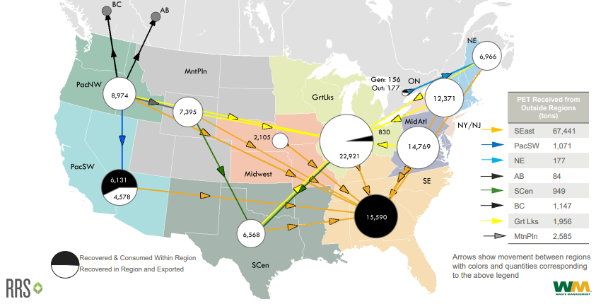
Figure 3. PET flow in the US reported by Waste Management in 2020.²⁰

Research and Policy options

Research
Additional data and information would result in greater understanding of the management of plastic packaging and end uses of recyclable plastic in Washington. The following research is recommended:
- Determine the amount of plastic packaging used in Washington, by sector: residential, commercial, institutional, and industrial.
- Publish recent data for materials handled in Washington.
- Provide detail on where material is collected across the state, where there are opportunities to improve collection.
- Clarify, expand, and more effectively collect data requested from regulated recycling facilities on the final destinations of materials sent for reprocessing, including materials handled by brokers.
Assess the quality of the processed material, including the presence of chemicals of concern. The following efforts could result in a more robust market in Washington for plastics.
- Survey companies in Washington that manufacture plastic products:
  - Identify where they obtain their feedstocks, if they use recycled content in their products, and if they have current or planned future capacity to use more recyclable feedstock.
  - Connect in-state and regional plastic processors and manufacturers to increase demand for and access to recyclable plastic.
- Identify products or packaging where added recycled content would be feasible and beneficial.
- Identify market gaps.
- Take actions to provide cleaner plastic feedstock for manufacturing new products:
  - Provide additional education to improve collection and decrease contamination.
  - Add sorting technology for rigid plastic packaging at material recovery facilities (MRFs).
  - Determine if a secondary MRF or plastic recycling facility (PRF) would economically capture additional recyclable packaging.,
- Invest in new processing technologies for plastic waste.
- Identify opportunities where packaging design could improve material collected for recycling.
- Encourage plastic packaging manufacturers to participate in the American Plastic Recyclers Design Recognition Program.

Policies
Washington State’s current policies related to plastic packaging include:
- Recycled content mandates for specific types of plastic containers (Chapter 70A.245 Revised Code of Washington (RCW)), that apply in:
  - 2023 to trash bags and beverage bottles
    - 2024, state agencies must purchase compliant trash bags
  - 2025 to household cleaner and personal care product containers
  - 2028 to milk and small wine bottles
- Single use plastic carryout bags are prohibited in all retail and grocery stores, restaurants, takeout establishments, festivals, and markets (Chapter 70A.530 RCW).
Other regulatory actions that could drive demand, increase collection, or boost recycling of plastic packaging include:
- Mandatory minimum recycled content laws that require increased use of recycled content, establish long-term demand, stabilize the market, and ensure end markets for recovered materials.
- Deposit return systems for bottles that provide incentives for consumers to return bottles, create a clean and high quality supply of materials, and provide a stable source for end markets.
- Extended producer responsibility programs for packaging that require producers to fund collection services and educational materials, incentivize improved collection and recycling, can lead to developing local end markets, and provide financial support to the system.
- Ban problematic packaging materials and types (which are not recyclable OR are contaminants to other plastics streams)
- Institute truth in labeling
- Government procurement policies that harness the public sector buying power, can commit to the purchase of recycled content products, and support recycling end markets.
- Universal access to recycling that expands collection, requires more infrastructure and end markets, and requires funding.
- Streamlining regulatory requirements that could attract new plastic recycling businesses in the state.

https://www.mckinsey.com/industries/chemicals/our-insights/accelerating-plastic-recovery-in-the-united-states
2020-2021 Washington Statewide Waste Characterization Study
Global plastic production 1950-2020 | Statista
Plastic production by industrial sector globally | Statista
Plastic Packaging Market Trends & Growth Report, 2021-2028 (grandviewresearch.com)
RRS_OceanConReport_Feb2022_Final.pdf (oceanconservancy.org)
Plastic Recycling Market Development for Washington State and the Northwest Region (wsu.edu)
State Beverage Container Deposit Laws (ncsl.org)
Frequently Asked Questions: Benefits of Recycling | Land, Buildings & Real Estate (stanford.edu)
Waste Reduction Model (WARM) | US EPA
Recycling Economic Information (REI) Report | US EPA
HDPE multiple recycling proven in an experiment | ESE World
Recycled Content Use in Washington Report
Phase-III-Report_Final-pipa1w.pdf
Recycled Content Use in Washington Report
Plastics Recycling Market Development for Washington State and the Northwest Region (wsu.edu)
https://www.ezview.wa.gov/Portals/_1962/Documents/rdcab/WAPlasticCompanyMap2022.xlsx
Solid Waste Carriers
Washington State Recycling Contamination Reduction and Outreach Plan (CROP)
WM_Report_on_Recycling.pdf
Recommendations for Managing Plastic Packaging Waste in Washington
Recommendations for Managing Plastic Packaging Waste in Washington
https://perma.cc/3QXP-YMYR
Cyclyx’s New Way to Identify Waste Plastic (waste360.com)
2021 plastics law - Washington State Department of Ecology
Plastic bag ban - Washington State Department of Ecology

