The [**Washington State Recycling Market Development Center**](https://ecology.wa.gov/Waste-Toxics/Reducing-recycling-waste/Strategic-policy-and-planning/Recycling-Development-Center) part of the Department of Ecology, dedicated extensive time and collaborative effort to researching, building partnerships, and establishing a trusted network of local, national, and global textile industry leaders. Supported by a collaborated effort through the Textile Co-Design team, this work culminated in a four-part webinar series: ***Unraveling the Textile Industry for a Regenerative Washington*.** Throughradical collaboration, we level-set, defined, and weaved the global complexities of the textile industry into a regional context. This document provides the summary for **Webinar #1: Cut from the Same Cloth: Level Setting, May 6th 10am - 12:30pm PST.**

|  |  |
| --- | --- |
| Webinar #1 Goal: *Establish a shared understanding of the current state of textile waste, circularity, and market development. This includes providing key data, clarifying terminology, and identifying challenges and opportunities to set the foundation for collaborative action in future sessions.* | |
| **Outcomes:**   * Establish baseline knowledge of the textile industry * Introduce levels of circularity and business models * Clarify existing data gaps and opportunities * Prepare attendees to engage in future textile recovery and reuse discussions | **Key Topics:**   * Textile circularity framework * Existing systems, data, and terminology * Industry challenges and opportunities |

**Recycling Market Development Center:**

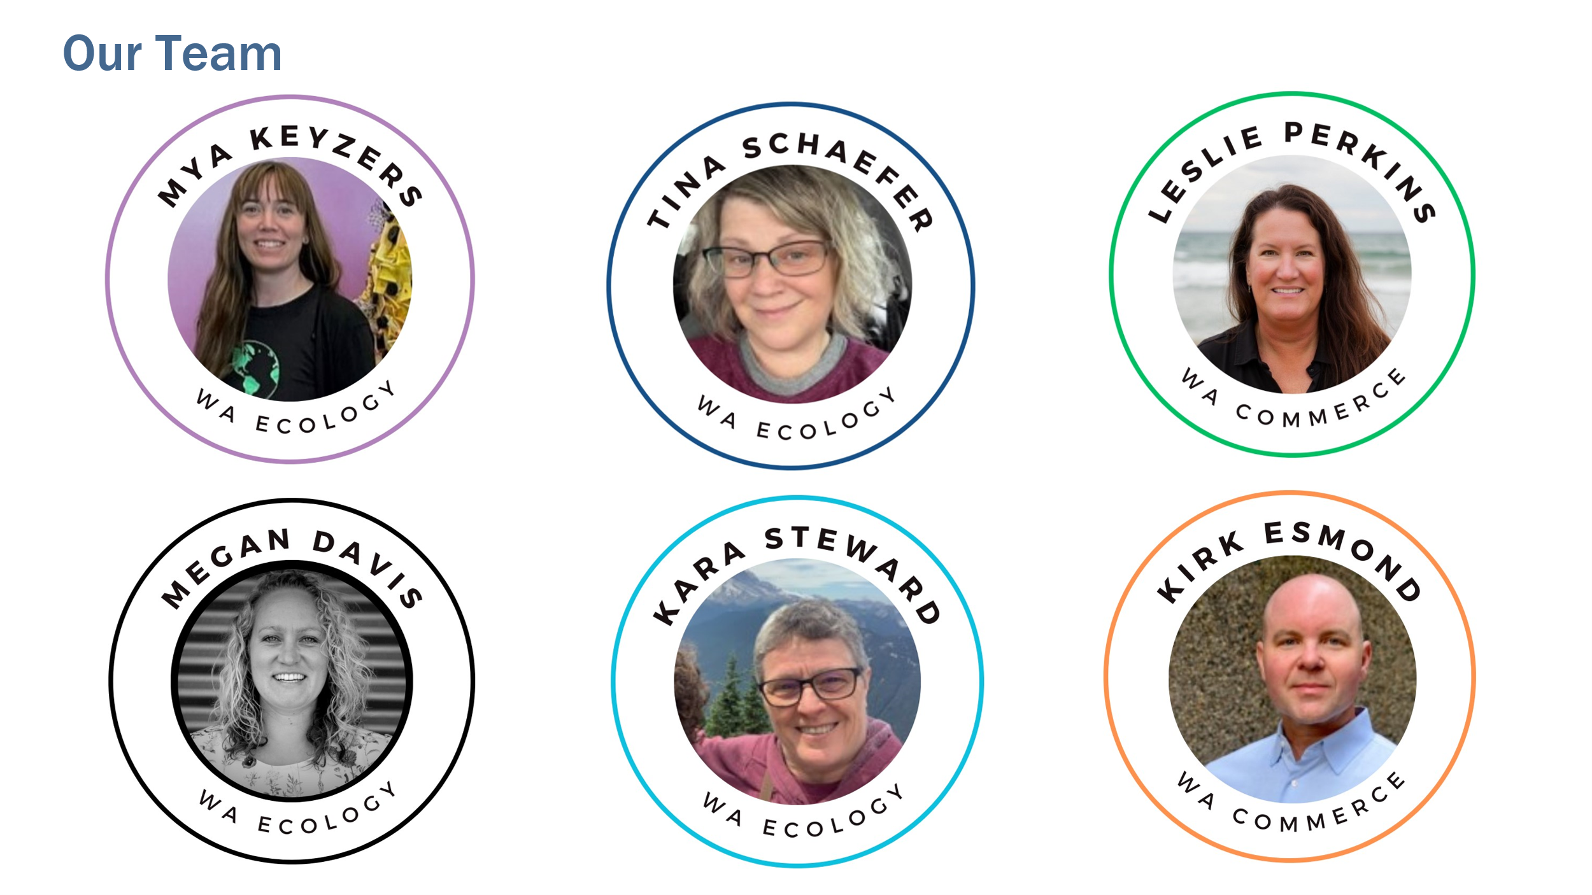

Newsletter

**Hosts:**

* [Timothy Parent](https://www.linkedin.com/in/timothyparent/) fashion advocate for [Reforme U | Home](https://www.reforme.style/)
* [Carly Mick](https://www.linkedin.com/in/carly-mick-a938ab2b/), Director of Sports Product Design, University of Oregon.

**Concept of Circularity Presentations:**

* [Carly Mick](https://www.linkedin.com/in/carly-mick-a938ab2b/)
  + Organization: University of Oregon, [School of Art & Design](https://artdesign.uoregon.edu/pd/grad/sports-product-design)
  + Contact: [cmick@uoregon.edu](mailto:cmick@uoregon.edu)
* [Eileen Mockus](https://www.linkedin.com/in/eileen-mockus-616a182/)
  + Organization: [Accelerating Circularity](https://www.acceleratingcircularity.org/)
  + Contact: [eileen@acceleratingcircularity.org](mailto:eileen@acceleratingcircularity.org)

**Post-Consumer Panel Discussion:**

* Donation
  + Speaker: [Syndey Muñoz](https://www.linkedin.com/in/sydneymunoz/)
  + Organization: [Goodwill International](https://www.goodwill.org/)
  + Contact: [sydney.munoz@goodwill.org](mailto:sydney.munoz@goodwill.org)
* Exporting & Secondary Markets
  + Speaker: [Steven Bethell](https://www.linkedin.com/in/steven-bethell-64341b73/)
  + Organization: [Bank & Vogue](https://www.bankvogue.com/our-products/)
  + Contact: [steven.bethell@bankvogue.com](mailto:steven.bethell@bankvogue.com)
* Landfill
  + Speaker: [Kerwin Pyle](https://www.linkedin.com/in/kerwin-pyle-b66014a9/)
  + Organization: [King County Solid Waste](https://kingcounty.gov/en/dept/dnrp/waste-services/garbage-recycling-compost/about)
  + Contact: [kerwin.pyle@kingcounty.gov](mailto:kerwin.pyle@kingcounty.gov)

**Key Takeaways:**

* Visual media are effective for engaging people, but it’s easy to get stuck in the details.
* There are many opportunities for collaboration across industries—including brands, users, and recyclers—which is vital for achieving circularity.
* Waste and textile hierarchies are useful frameworks for rethinking how materials enter and exit our homes and businesses.
* Technological innovation offers lots of opportunities for improvement.

**Other Resources:**

* [Slide deck](https://www.ezview.wa.gov/Portals/_1962/images/Recycling%20Development%20Center/EcologyTextileWebinar1-CutfromSameCloth.pdf)for webinar #1 Level Setting
* [Slide deck](https://www.ezview.wa.gov/Portals/_1962/images/Recycling%20Development%20Center/EcologyTextileWebinar2-RippingTheStitch.pdf) for webinar #2 Business Transformation
* [Slide deck](https://www.ezview.wa.gov/Portals/_1962/images/Recycling%20Development%20Center/EcologyTextileWebinar3-AdoptingNewInnovations.pdf) for webinar #3 Adopting New Innovations
* [Slide deck](https://www.ezview.wa.gov/Portals/_1962/images/Recycling%20Development%20Center/EcologyTextileWebinar4-Policy-CoalitionBuilding.pdf) for webinar #4 Advocacy & Coalition Building.
* [Contacts and key takeaways](https://www.ezview.wa.gov/Portals/_1962/images/Recycling%20Development%20Center/TextileWebinar2-ContactSummary.docx) for webinar #2 Business Transformation
* [Contacts and key takeaways](https://www.ezview.wa.gov/Portals/_1962/images/Recycling%20Development%20Center/TextileWebinar3-ContactSummary.docx) for webinar #3 Adopting New Innovations
* [Contacts and key takeaways](https://www.ezview.wa.gov/Portals/_1962/images/Recycling%20Development%20Center/TextileWebinar4-ContactSummary.docx) for webinar #4 Advocacy & Coalition Building.
* Megan Davis [megan.davis@ecy.wa.gov](mailto:megan.davis@ecy.wa.gov)
* Mya Keyzers [mya.keyzers@ecy.wa.gov](mailto:mya.keyzers@ecy.wa.gov)