The [**Washington State Recycling Market Development Center**](https://ecology.wa.gov/Waste-Toxics/Reducing-recycling-waste/Strategic-policy-and-planning/Recycling-Development-Center) part of the Department of Ecology, dedicated extensive time and collaborative effort to researching, building partnerships, and establishing a trusted network of local, national, and global textile industry leaders. Supported by a collaborated effort through the Textile Co-Design team, this work culminated in a four-part webinar series: ***Unraveling the Textile Industry for a Regenerative Washington*.** Throughradical collaboration, we level-set, defined, and weaved the global complexities of the textile industry into a regional context. This document provides the summary for **Webinar #2: Ripping the Stitch: Business Transformation, May 8th 10am - 12:30pm PST.**

|  |  |
| --- | --- |
| Goal: Equip textile businesses with practical insights to transition into or maintain circular business models through real-world examples and peer learning. | |
| **Outcomes:**   * Understand circular business model elements (product, model, ecosystem) * Learn from small-to-medium PNW businesses’ real-world experiences * Identify motivations, challenges, and opportunities in circular practices * Connect with like-minded businesses during breakout discussions | **Key Topics:**   * Circular economy business types (upcycling, repair, rental) * Elements of circular business models * Peer sharing: motivations, logistics, costs, and market demand |

**Recycling Market Development Center:**

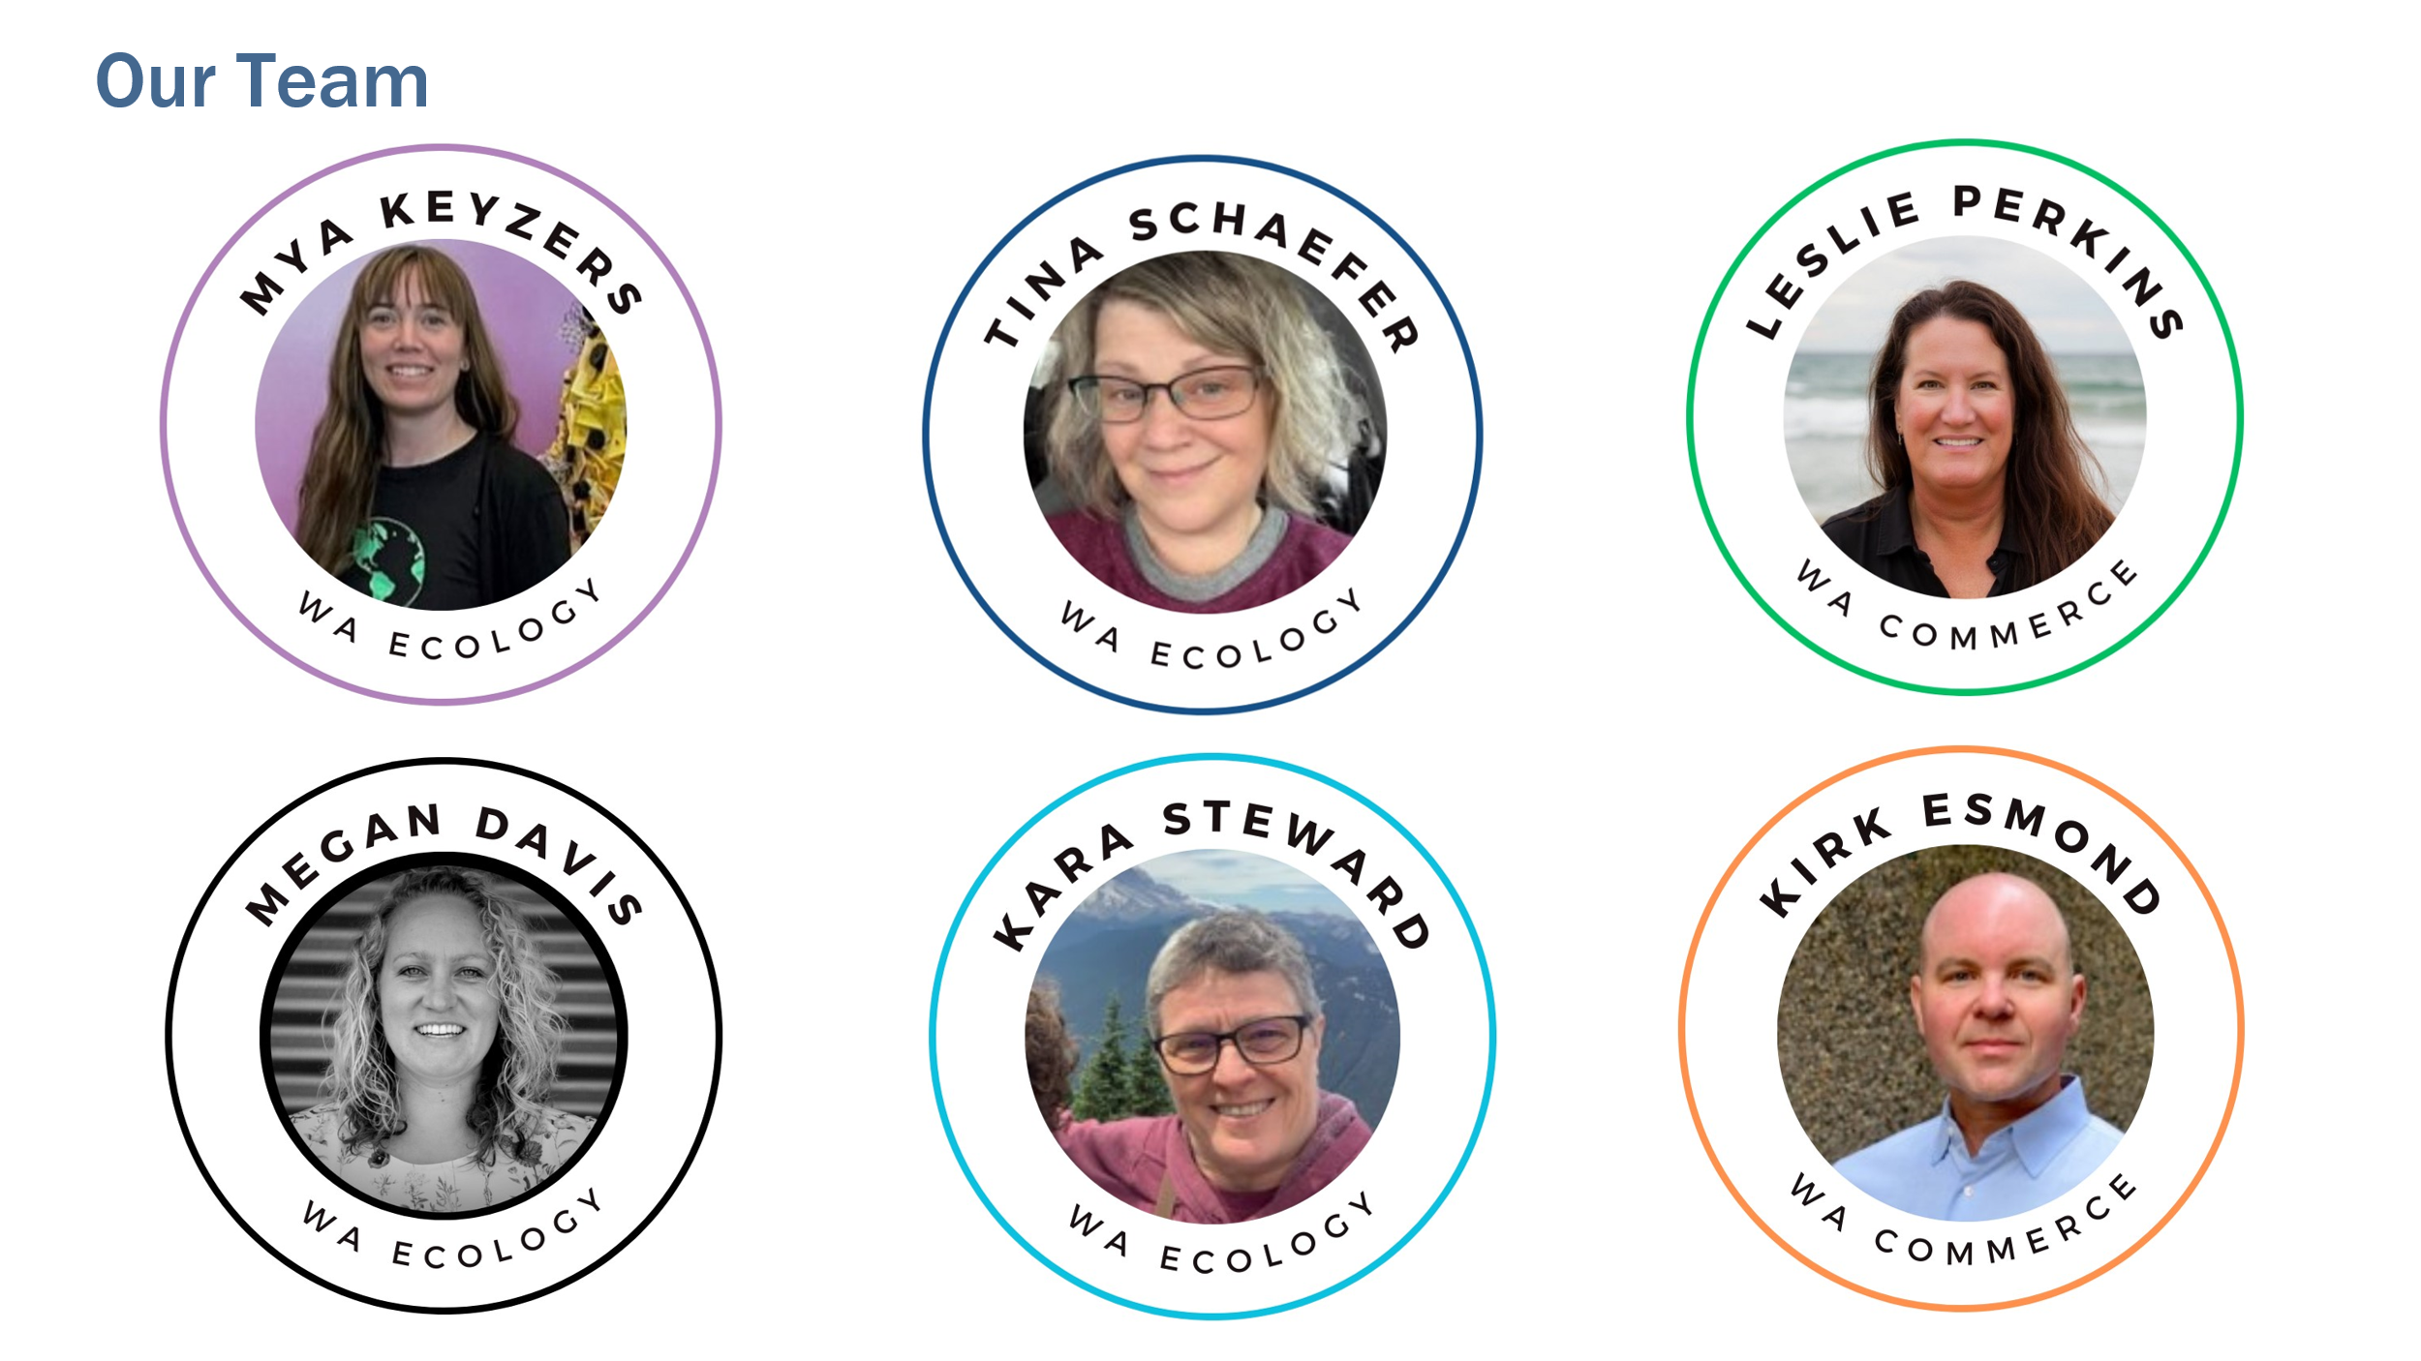

Newsletter

**Hosts:**

* [Timothy Parent](https://www.linkedin.com/in/timothyparent/) fashion advocate for [Reforme U | Home](https://www.reforme.style/)
* [Behnosh Najafi](https://www.linkedin.com/in/behnoshnajafi/), Co-Founder, [The Sustainable Design Project](https://www.linkedin.com/company/the-sustainable-design-project/posts/?feedView=all)

**Exploring Different Business Models:**

* Thrift/Resell/Workforce Development
  + Speaker: [Julie Kimball-Bryant](https://www.linkedin.com/in/juliekimballbryant/)
  + Organization: [Global Neighborhood](https://www.global-neighborhood.org/gn-thrift-vintage)
  + Contact: [julie@global-neighborhood.org](mailto:julie@global-neighborhood.org)
* Micro-Enterprise/Upcycling
  + Speaker: [Lisa Hilbert](https://www.linkedin.com/in/lisailand/)
  + Organization: [Redesign Collective](https://redesign-collective.com/)
  + Contact: lisa@redesign-collective.com
* Polyester Textile Recycling
  + Speaker: [Zalen Titcomb](https://www.linkedin.com/in/zahlen-titcomb/)
  + Organization: [Ravel](https://www.ravelfuture.com/)
  + Contact: <zahlen@ravelfuture.com>
* Circular Business Framework
  + Speaker: [Nicole Bassett](https://www.linkedin.com/in/nicole-bassett-512b0718/)
  + Organization: [Citrus Circular](https://citruscircular.com/) & [Renewal Workshop](https://www.bleckmann.com/solutions/circular-solutions/the-renewal-workshop)
  + Contact: [a.nicole.bassett@gmail.com](mailto:a.nicole.bassett@gmail.com)

**Funding & Resources for Circular Businesses:**

* [Leslie Perkins](https://www.linkedin.com/in/leslie-perkins-086915252/), Circular Economy Development Manager
  + Organization: [Washington Commerce – Office of Economic Development](https://choosewashingtonstate.com/why-washington/our-key-sectors/industrial-symbiosis/)
  + Contact: leslie.perkins@commerce.wa.gov
* [Nina Olivier](https://www.linkedin.com/in/nina-olivier-sustainability/), Circular Economy Program Manager
  + Organization: [King County Washington](https://kingcounty.gov/en/dept/dnrp/waste-services/garbage-recycling-compost/solid-waste-programs/circular-economy)
  + Contact: [nolivier@kingcounty.gov](mailto:nolivier@kingcounty.gov)

**Key Takeaways:**

* The goal is to create a circular economy, which requires collective effort from all stakeholders: startups, corporations, government, regulators, nonprofits, and individuals.
* Washington has a strong ecosystem that offers resources and support for circular economy initiatives, despite challenges in federal funding.
* Local and regional opportunities exist for funding, technical assistance, and business planning in textile circularity.
* There’s a need for policies like extended producer responsibility, which prioritizes domestic reuse and closed-loop upcycling of textiles.
* Pre-consumer textile waste is a major contributor to overall textile waste (41 times more than used clothing).
* Refugee communities often have cultural practices around reuse, repair, and repurposing, and these traditions should be included and honored in sustainability conversations.
* Environmental justice and people-centered approaches are crucial in sustainability work.

**Other Resources:**

* [Slide deck](https://www.ezview.wa.gov/Portals/_1962/images/Recycling%20Development%20Center/EcologyTextileWebinar1-CutfromSameCloth.pdf)for webinar #1 Level Setting
* [Slide deck](https://www.ezview.wa.gov/Portals/_1962/images/Recycling%20Development%20Center/EcologyTextileWebinar2-RippingTheStitch.pdf) for webinar #2 Business Transformation
* [Slide deck](https://www.ezview.wa.gov/Portals/_1962/images/Recycling%20Development%20Center/EcologyTextileWebinar3-AdoptingNewInnovations.pdf) for webinar #3 Adopting New Innovations
* [Slide deck](https://www.ezview.wa.gov/Portals/_1962/images/Recycling%20Development%20Center/EcologyTextileWebinar4-Policy-CoalitionBuilding.pdf) for webinar #4 Advocacy & Coalition Building.
* [Contacts and key takeaways](https://www.ezview.wa.gov/Portals/_1962/images/Recycling%20Development%20Center/TextileWebinar1-ContactSummary.docx) for webinar #1 Level Setting
* [Contacts and key takeaways](https://www.ezview.wa.gov/Portals/_1962/images/Recycling%20Development%20Center/TextileWebinar3-ContactSummary.docx) for webinar #3 Adopting New Innovations
* [Contacts and key takeaways](https://www.ezview.wa.gov/Portals/_1962/images/Recycling%20Development%20Center/TextileWebinar4-ContactSummary.docx) for webinar #4 Advocacy & Coalition Building.
* Megan Davis [megan.davis@ecy.wa.gov](mailto:megan.davis@ecy.wa.gov)
* Mya Keyzers [mya.keyzers@ecy.wa.gov](mailto:mya.keyzers@ecy.wa.gov)