The [Washington State Recycling Market Development Center](https://ecology.wa.gov/Waste-Toxics/Reducing-recycling-waste/Strategic-policy-and-planning/Recycling-Development-Center) part of the Department of Ecology, dedicated extensive time and collaborative effort to researching, building partnerships, and establishing a trusted network of local, national, and global textile industry leaders. Supported by a collaborated effort through the Textile Co-Design team, this work culminated in a four-part webinar series: ***Unraveling the Textile Industry for a Regenerative Washington*.** Throughradical collaboration, we level-set, defined, and weaved the global complexities of the textile industry into a regional context. This document provides the summary for **Webinar #3: Hemmed in to Cutting Loose – Adopting New Innovations, May 13th 10am - 12:30pm PST.**

|  |  |
| --- | --- |
| Goal: *Explore cutting-edge technologies enabling circular textile practices while addressing infrastructure, logistical, and economic barriers to scaling innovation.* | |
| **Outcomes:**   * Learn from 5 case studies in textile tech (fiber ID, sorting, recycling) * Understand physical and digital infrastructure needs and barriers * Identify costs, policy gaps, and implantation roadblocks | **Key Topics:**   * Tech innovations in textile circularity * Concrete, scalable examples relevant to Washington * Infrastructure and investment needs |

**Recycling Market Development Center:**

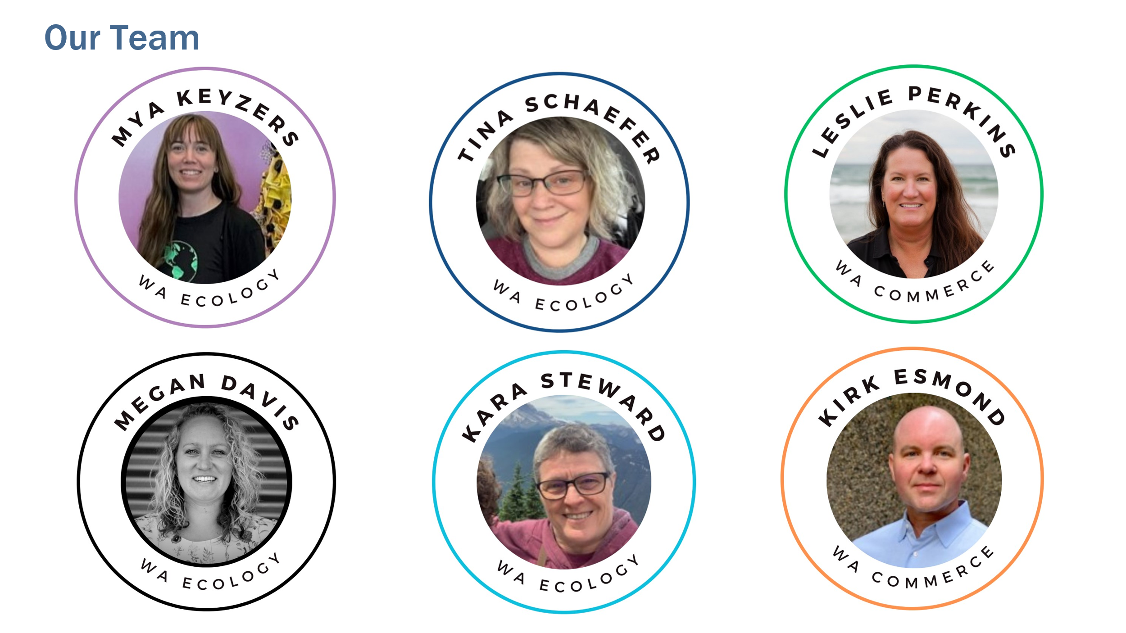

Newsletter

**Hosts:**

* [Timothy Parent](https://www.linkedin.com/in/timothyparent/) fashion advocate for [Reforme U | Home](https://www.reforme.style/)
* [Carly Mick](https://www.linkedin.com/in/carly-mick-a938ab2b/), Director of Sports Product Design, University of Oregon.

**Sorting Tech:**

* [Brian Iezzi](https://www.linkedin.com/in/brianiezzi/), Founder, Fibrarcode
  + Organization: [Fibrarcode](https://www.fibarcode.com/)
  + Contact: [bciezzi@umich.edu](mailto:bciezzi@umich.edu)
* [Constanza Gomez](https://www.linkedin.com/in/constanzagomez/), CEO, Sortile
  + Organization: [Sortile](https://www.sortile.co/)
  + Contact: [cgomez@sortile.co](mailto:cgomez@sortile.co)

**Materials Exchange Platform:**

* [Stephanie Benedetto](https://www.linkedin.com/in/stephaniebenedetto/), CEO, Aloqia
  + Organization: [Aloqia](https://www.aloqia.com/find.html)
  + Contact: [stephanie@queenofraw.com](mailto:stephanie@queenofraw.com)

**New Innovations Through Academics:**

* [Hang Liu](https://www.linkedin.com/in/hang-liu-50303a9/), Associate Professor, WSU & [Patricia Townsend](https://www.linkedin.com/in/patricia-townsend-47405b171/), Associate Professor, WSU
  + Organization: [Washington State University Metropolitan Center for Applied Research and Extension](https://metrocenter.wsu.edu/)
  + [Textiles Work](https://metrocenter.wsu.edu/textiles/)
  + Contact: [patricia.townsend@wsu.edu](mailto:patricia.townsend@wsu.edu) & [hangliu@wsu.edu](mailto:hangliu@wsu.edu)

**Textile-to-Textile Recycling:**

* [Scott Hamlin](https://www.linkedin.com/in/scott-hamlin-b989415/), CEO, Looptworks
  + Organization: [Looptworks](https://looptworks.com/)
  + Contact: [scott@looptworks.com](mailto:scott@looptworks.com)

**Key Takeaways:**

* Digital labeling is here and is crucial for circularity.
* Circular design for labeling is essential to the system.
* Textile recycling scalability relies on effective, accurate, and affordable sorting.
* Promising technologies need further development, better processes, and standards.
* Circularity is active in the Pacific Northwest, with viable waste stream diversion and circular fiber supply chains.
* Use technology to support people, planet, and profit (triple bottom line).
* Embrace the use, reuse, remake, and rethink approach for existing textiles.
* Recognize the abundance of existing clothing—we already have enough for multiple generations.
* Academia is a valuable partner for textile recycling and sustainability initiatives.

**Other Resources:**

* [Slide deck](https://www.ezview.wa.gov/Portals/_1962/images/Recycling%20Development%20Center/EcologyTextileWebinar1-CutfromSameCloth.pdf)for webinar #1 Level Setting
* [Slide deck](https://www.ezview.wa.gov/Portals/_1962/images/Recycling%20Development%20Center/EcologyTextileWebinar2-RippingTheStitch.pdf) for webinar #2 Business Transformation
* [Slide deck](https://www.ezview.wa.gov/Portals/_1962/images/Recycling%20Development%20Center/EcologyTextileWebinar3-AdoptingNewInnovations.pdf) for webinar #3 Adopting New Innovations
* [Slide deck](https://www.ezview.wa.gov/Portals/_1962/images/Recycling%20Development%20Center/EcologyTextileWebinar4-Policy-CoalitionBuilding.pdf) for webinar #4 Advocacy & Coalition Building.
* [Contacts and key takeaways](https://www.ezview.wa.gov/Portals/_1962/images/Recycling%20Development%20Center/TextileWebinar1-ContactSummary.docx) for webinar #1 Level Setting
* [Contacts and key takeaways](https://www.ezview.wa.gov/Portals/_1962/images/Recycling%20Development%20Center/TextileWebinar2-ContactSummary.docx) for webinar #2 Business Transformation
* [Contacts and key takeaways](https://www.ezview.wa.gov/Portals/_1962/images/Recycling%20Development%20Center/TextileWebinar4-ContactSummary.docx) for webinar #4 Advocacy & Coalition Building.
* Megan Davis [megan.davis@ecy.wa.gov](mailto:megan.davis@ecy.wa.gov)
* Mya Keyzers [mya.keyzers@ecy.wa.gov](mailto:mya.keyzers@ecy.wa.gov)