The [**Washington State Recycling Market Development Center**](https://ecology.wa.gov/Waste-Toxics/Reducing-recycling-waste/Strategic-policy-and-planning/Recycling-Development-Center) part of the Department of Ecology, dedicated extensive time and collaborative effort to researching, building partnerships, and establishing a trusted network of local, national, and global textile industry leaders. Supported by a collaborated effort through the Textile Co-Design team, this work culminated in a four-part webinar series: ***Unraveling the Textile Industry for a Regenerative Washington*.** Throughradical collaboration, we level-set, defined, and weaved the global complexities of the textile industry into a regional context. This document provides the summary for **Webinar #4: Fastening the Textile Community – Advocacy & Coalition Building, May 15th 10am - 12:30pm PST.**

|  |  |
| --- | --- |
| Goal: *Unify and empower stakeholders across levels to advance textile policy and collaboration, driving actionable steps for advocacy and ongoing community engagement in WA and beyond.* | |
| **Outcomes:**   * Understand how investment in innovation supports economic and environmental goals * Encourage collaboration to overcome systemic challenges * Lay groundwork for ongoing coalition and policy advocacy | **Key Topics:**   * Global to local policy and partner landscape * Coalition-building framework * Route to sustained collaboration |

**Recycling Market Development Center:**

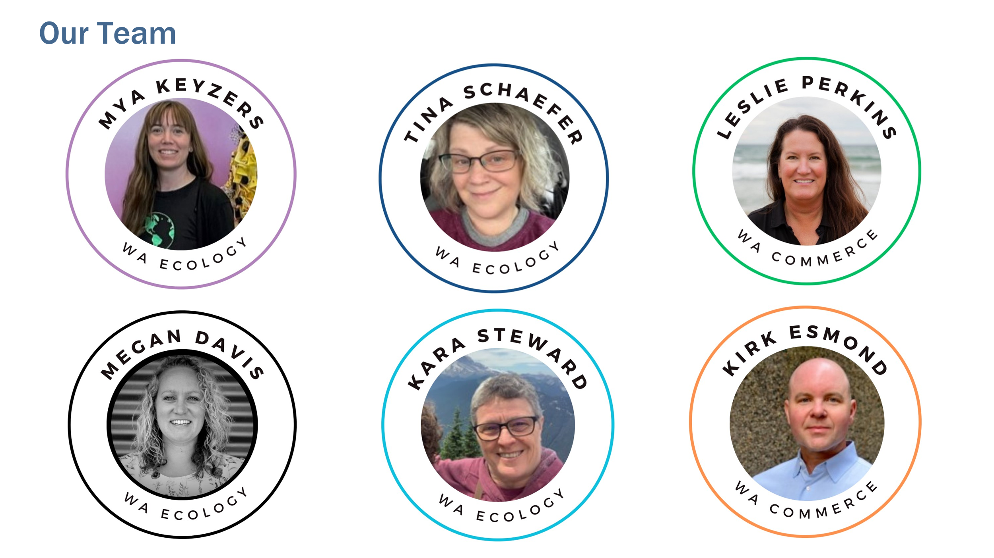

Newsletter

**Hosts:**

* [Timothy Parent](https://www.linkedin.com/in/timothyparent/) fashion advocate for [Reforme U | Home](https://www.reforme.style/)
* [Kathryn Horvath](https://www.linkedin.com/in/kathryn-horvath/) sustainability and fashion advocate.

**Global to Local Textile Policy:**

* Global
  + Speaker: [Marissa Adler](https://www.linkedin.com/in/marisaadler/)
  + Organization: [RRS](https://www.recycle.com/)
  + Contact: madler@recycle.com
* California – [Textile EPR (SB 707)](https://leginfo.legislature.ca.gov/faces/billTextClient.xhtml?bill_id=202320240SB707)
  + [Joanne Brasch](https://www.linkedin.com/in/joannebrasch/)
  + Organization: [California Product Stewardship Council](https://www.calpsc.org/)
  + Contact: joanne@calpsc.org
* Washington – [Textile EPR (HB1420)](https://app.leg.wa.gov/billsummary?BillNumber=1420&Year=2025)
  + Speaker: [Representative Kristine Reeves](https://www.linkedin.com/in/kristinemreeves/)
  + Organization: [(D) 30th Legislative District](https://housedemocrats.wa.gov/reeves/)
  + Contact: kristine.reeves@leg.wa.gov
* City of Seattle – Policy
  + Speaker: [Mckenna Morrigan](https://www.linkedin.com/in/mckennamorrigan/)
  + Organization: [Seattle Public Utilities](https://www.seattle.gov/utilities)
  + Contact: [mckenna.morrigan@seattle.gov](mailto:mckenna.morrigan@seattle.gov)

**Community Spotlight:**

* **Policy/Research/Data/Academia**
  + [JeLisa Marshall, PhD Candidate at Prescott College](https://www.linkedin.com/in/jelisa-marshall-16686447/)
  + 5 High School Students from Seattle World School (represented by T)
* **Swap/Reuse/Repair/Upcycling**
  + [Amanda Miller, Executive Director at South King Tool Library](https://www.linkedin.com/in/amanda-miller-sktl/)
  + [Tali Rausch, Director of Programs & Business Development at Refugee Artisan Initiative](https://www.linkedin.com/in/talirausch/)
  + [Janelle Abbott, Founder of JRAT/Wardrobe Therapy](https://www.linkedin.com/in/janellerabbott/)
* **Workforce Development and Business Solutions**
  + [Sydney Porter, Program Coordinator for Sustainability and Circular Economy at Seattle Good Business Network](https://www.linkedin.com/in/sydney-porter-994391197/)
  + [Zakiya Cita, Founder of The Chayah Movement](https://www.linkedin.com/in/zakiya-nicole-director/)
  + [Cleo Escarez, Founder of Redyoos](https://www.linkedin.com/in/cleoescarez/)
* **Community Engagement and Outreach**
  + [Whit Carter, Development Coordinator, West Seattle Foodbank and Clothesline](https://www.linkedin.com/in/whit-carter-6b037832/)
  + [Sylvaine Bucher, Project Program Manager of the Re+ Program in the King County Department of Natural Resources and Parks](https://www.linkedin.com/in/sylvaine-bucher/)
  + [Nivi Achanta, Founder of Soapbox](https://www.linkedin.com/in/niviachanta/)

**Key Takeaways:**

* **Shared Infrastructure is a Priority**: such as co-warehousing and expanding materials sharing and reuse/repair/upcycling networks
* **Community Engagement & Outreach**:
  + Funding and connections are essential for success in these programs.
  + Networking at in-person and online events is vital to build momentum

**Action Items from Panelists**:

* **Sign up for updates on HB 1420** and contact offices to be included as key stakeholders.
* **Public sector**: Inventory and catalog textile recovery activities in your jurisdiction (formal and informal).
* **Attend the first CAL Recycle Workshop** for SB 707 (hybrid, remote option).
* **Cities in WA**: Add Representative Reese’s proposed textile solution to 2026 legislative agendas and get local government affairs staff engaged.

**Other Resources:**

* [Slide deck](https://www.ezview.wa.gov/Portals/_1962/images/Recycling%20Development%20Center/EcologyTextileWebinar1-CutfromSameCloth.pdf)for webinar #1 Level Setting
* [Slide deck](https://www.ezview.wa.gov/Portals/_1962/images/Recycling%20Development%20Center/EcologyTextileWebinar2-RippingTheStitch.pdf) for webinar #2 Business Transformation
* [Slide deck](https://www.ezview.wa.gov/Portals/_1962/images/Recycling%20Development%20Center/EcologyTextileWebinar3-AdoptingNewInnovations.pdf) for webinar #3 Adopting New Innovations
* [Slide deck](https://www.ezview.wa.gov/Portals/_1962/images/Recycling%20Development%20Center/EcologyTextileWebinar4-Policy-CoalitionBuilding.pdf) for webinar #4 Advocacy & Coalition Building.
* [Contacts and key takeaways](https://www.ezview.wa.gov/Portals/_1962/images/Recycling%20Development%20Center/TextileWebinar1-ContactSummary.docx) for webinar #1 Level Setting
* [Contacts and key takeaways](https://www.ezview.wa.gov/Portals/_1962/images/Recycling%20Development%20Center/TextileWebinar2-ContactSummary.docx) for webinar #2 Business Transformation
* [Contacts and key takeaways](https://www.ezview.wa.gov/Portals/_1962/images/Recycling%20Development%20Center/TextileWebinar3-ContactSummary.docx) for webinar #3 Adopting New Innovations
* Megan Davis [megan.davis@ecy.wa.gov](mailto:megan.davis@ecy.wa.gov)
* Mya Keyzers [mya.keyzers@ecy.wa.gov](mailto:mya.keyzers@ecy.wa.gov)