Meeting Notes
Snohomish (WRIA 7)
WREC Technical Workgroup meeting
January 23, 2020 | 1:00 p.m. - 2:30 p.m. WRIA 7 Committee Webpage

Location
Everett Public Library
2702 Hoyt Ave
Everett
Committee Chair
Ingria Jones
Ingria.Jones@ecy.wa.gov
(425) 649-4210
Handouts
Agenda
Irrigated Area Compatibility Study Memo
Technical Progress to-Date

Participation
Ingria Jones, Dept. of Ecology
Cynthia Carlstad, NHC
Mike Wolanek, Arlington (phone)
Denise DiSanto, King County (phone)
Daryl Williams, Tulalip Tribes
Liz Ablow, Seattle
Matt Baerwalde, Snoqualmie Tribe
Emily Dick, Washington Water Trust
Jason Hatch, Washington Water Trust
Eric Ferguson, King County
Kirk Lakey, Dept. of Fish and Wildlife
Terri Strandberg, Snohomish County
Brant Wood, Snohomish PUD
John Covert, Dept. of Ecology
Paulina Levy, Dept. of Ecology
Julie Lewis, Snoqualmie Tribe

Updates
- Matt provided an update on conducting outreach to water purveyors and cities
  - Matt and Mike have been reaching out to purveyors to better understand their connection policies and policies surrounding permit-exempt wells.
  - Matt has heard back from most purveyors. There is a wide range of existing policies on water service connections and decommissioning. There is no noticeable commonality.
  - A more detailed update will be presented to the committee in March, and the committee will discuss how the responses could be used to develop policy recommendations.

Irrigated Area Compatibility Study
- Objective: Understand purpose and results of irrigated area compatibility study and develop recommendation for committee on consumptive use estimate

Resources:
- Irrigated Area Compatibility Study Memo
- Technical Progress To-Date

- Review and discuss Irrigated Area Compatibility Study results
  - Cynthia provided an overview of the irrigated area compatibility study that GeoEngineers (GEI) & HDR completed for ongoing quality assurance. Based on perceived differences in draft results for outdoor irrigation area analysis. The goal of the study was to determine if there was a difference in results between HDR and GEI, identify reasons for those differences, and to determine the implications, if any, for the work of the WRE Committees.
  - The technical analysis and comparability results do not suggest the need for a systematic reevaluation of the primary data sets or methodologies. The GEI and HDR teams have confidence in their completed work and, notably, in each other’s work for their respective WRIAs. GEI and HDR recommend committees that Ecology and the WRE committees should accept the irrigated area results completed by the GEI and HDR teams.
  - In WRIA 7, 393 parcels were analyzed. GEI set a minimum sample size of 20 parcels per subbasin. More parcels than the target minimum sample were analyzed in each of the subbasins. The target sample size is sufficient to ensure that the sample mean is representative over the WRIA within a 95% confidence limit.

Questions and Discussion
  - Darryl asked for more details on a specific property in the comparibility study that had a difference in results of ~0.48 acres. That property had initially included acreage for lawn beyond fence line, but in the second delineation GeoEngineers removed the western portion of property beyond fence line from the delineation.
  - Brant asked if annual gallons per day use per purveyor was used in the calculator across WRIAs. NHC developed a scenario in the consumptive use calculator to estimate consumptive use based on water use data from Snohomish PUD. This WRIA-wide scenario estimates 261.6 acre-feet, which is much lower than the irrigated area method estimate of 797.4 acre-feet. GeoEngineers also coordinated with HDR to develop a table comparing water use for seven water purveyors that is posted on box. Additional water purveyor information is included in the draft consumptive use technical memo.
  - Jason asked for a clarification on the months technical consultants used when reviewing past Google Earth imagery to determine whether there was irrigation. GeoEngineers used imagery from late July through early September, but also reviewed imagery from late June and early July when available.
  - Matt suggested ground-truthing, or applying nominal acreage to the 80 parcels where the irrigated footprint was delineated as 0 acres (e.g. assume 0.025 acres of irrigation).
    - Eric pointed out that although there were many zeros, there were no subbasins where the acreage used for the CU calculator was zero.
    - Cynthia suggested placing a safety factor on the overall consumptive use estimate for the WRE Plan, instead of changing all the zeros. This could also account for outdoor water uses we are not considering, such as car washing.
    - Liz and Darryl agree with adding a safety factor.
  - Terri pointed out that the current consumptive use calculation did not take into account small group developments.
    - Section 6 in Ecology’s Streamflow Restoration Policy Interpretive Statement specifies that wells supplying water for all the homes in project, per Campbell & Gwinn, are subject to the withdrawal limits (5,000 gallons per day and ½ acre non-commercial lawn or garden) in aggregate.
- The workgroup recommends the committee approve the the consumptive use estimate from the measured irrigated footprint (797.4 acre-feet).
- The chair will bring the recommendation to the Committee at the February 13 Committee meeting, in preparation for a vote at the March 12 Committee meeting.

Consumptive Use Safety Factor
- Objective: Discuss safety factor and additional consumptive use scenarios
- Overview of consumptive use calculator scenarios

Scenario (Indoor / Outdoor) | Annual Consumptive Water Use Estimate (acre-feet per year)
60 gpd pp / measured irrigated footprint | 797
60 gpd pp / 0.5-acre irrigated yard | 1,885
950 gpd* | 2,448
*Legal right to 950 gallons per day (maximum annual average withdrawal) per well connection for indoor and outdoor household use. Assumes 60 gallons per day per person for indoor use and remainder to outdoor use.

- Discuss whether to include a safety factor & options to consider
  - Ingria opened the discussion on developing a safety factor. Committee members have been discussing how to address the uncertainty that will be inherent in some elements of the WRE Plan. While not required, the Committee may choose to add one or more safety factors. If a safety factor is included, it could help ensure that the Net Ecological Benefit (NEB) requirement is met by the plan, even if there is uncertainty in some of the assumptions used in the analysis. Including a safety factor could result in establishing the goal for an offset target, or it could identify a higher “scenario” offset in addition to the offset goal of 747.4 acre-feet.
  - Ingria provided context for magnitude of specific safety factor considerations, including project considerations under discussion at the project subgroup. The committee can also develop an adaptive management plan to address uncertainty in the WRE Plan.

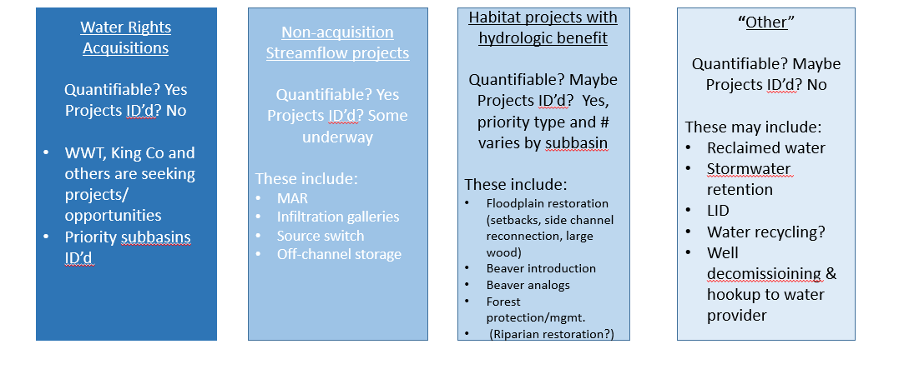

  - Liz opened discussion on how to quantify habitat projects and proposed establishing an agreed-upon “minimum water offset” that certain type of habitat projects provided. GeoEngineers will be providing a proposed method for calculating water offset from habitat projects at the February 13 Committee meeting. The committee and workgroup will continue this discussion.
  - Kirk voiced the importance of having actual measurable water offset projects. He highlighted the need for more stream gauges and the inherent variability in habitat projects. He also brought up the challenges the Tulalip hatchery experiences and the ways projects could help with our offsets and actively manage during drought periods.

Next Steps
- Next Committee Meeting: February 13, Everett Public Library
  - The workgroup recommends the committee approve the consumptive use estimate from the measured irrigated footprint (797.4 acre-feet).
  - The chair will bring the recommendation to the Committee at the February 13 Committee meeting, in preparation for a vote at the March 12 Committee meeting.
- Next Technical Workgroup Meeting: Date TBD
  - Please develop a proposal for a safety factor methodology

Action Items
- Fill out the doodle poll for the next Technical Workgroup Meeting by January 31.
- Send Ingria your proposal for a safety factor.
- Read Appendix B in the Final NEB Guidance (7 pages) and send me any red flag questions or comments by February 11.
  - Appendix B discusses steady-state assumptions for groundwater. John Covert introduced this in his hydrogeology presentation in March last year.

