Memorandum
17245 NE Union Hill Road, Suite 250, Redmond, Washington, 98052 Telephone: 425.861.6000, Fax: 425.861.6050 www.geoengineers.com
To: Stephanie Potts, Washington State Department of Ecology

From: Patty Dillon, Cynthia Carlstad, NHC; Bridget August, John Monahan, GeoEngineers
Date: December 16, 2019
File: 0504-161-00
Subject: WRIA 8 Consumptive Use Estimates

Introduction
The WRIA 8 Watershed Restoration and Enhancement Plan (Plan) must include projects and actions that offset the consumptive use from future domestic permit-exempt wells. Consumptive water use is water that is evaporated, transpired, consumed by humans, or otherwise removed from an immediate water environment. For watershed planning purposes, consumptive use is water that is drawn from groundwater via a domestic permit-exempt well and not replaced through the septic system, irrigation return flow, or other means.
Growth projections and projections for number and location of new domestic permit-exempt well connections within WRIA 8 were developed by King County, Snohomish County, and GeoEngineers (GeoEngineers, 2019) for purposes of the Plan. This memorandum summarizes the methods used to estimate consumptive water use associated with the new well connections and provides results for three water use scenarios. Methodology is based on Appendix A of the Department of Ecology’s (Ecology’s) Net Ecological Benefit guidance (Ecology, 2019) and documented in further detail in the Consumptive Use Estimates Workplan prepared by the GeoEngineers team.

Consumptive Water Use Methodology
Measurement of consumptive water use in any setting is difficult, and it is virtually impossible for residential groundwater use, which must account for both indoor and outdoor use. Permit-exempt wells are generally unmetered, so supply to each home is usually unknown, let alone the amount that is lost to the groundwater system. Therefore, we are limited to estimating consumptive use based on projections of future growth, local patterns and trends in water use, and generally accepted and reasonable assumptions. Water use data from local water purveyors may be useful as a check on calculated estimates but must be used with caution. Homes that pay for municipal water tend to exhibit different water use behaviors, including water saving appliances and reduced landscape watering, that reduce usage compared to homes on wells.
The two categories of household consumptive water use are indoor use and outdoor use. The methodology used to estimate these quantities for WRIA 8 are described in the following sections.

Indoor Consumptive Use
Indoor consumptive use was estimated using Ecology guidance, which was based on groundwater monitoring and modeling studies conducted by the U.S. Geological Survey in several areas of Washington. There are two basic elements to estimating indoor consumptive use:
- Amount of total water used. Ecology’s guidance recommends an assumption of 60 gallons per person per day as a reasonable estimate of indoor water use. To estimate indoor usage per well, the per capita usage was multiplied by the average rural household size, estimated by King County and Snohomish County as 2.73 and 2.75 people per household, respectively. For analysis areas spanning both counties, a weighted value was estimated based on the number of projected permit-exempt well connections in each county. Table 1 summarizes the household sizes for each subbasin and for all of WRIA 8.
- Percentage of total water used that is consumptive. Ecology guidance recommends that 10% of the total indoor water use is considered consumptive when a home is on a septic system. (All indoor water use is considered consumptive for homes with sewer connections.) Areas projected to be served by permit-exempt wells are outside of sewer service areas, so the 10% assumption was applied for all projected indoor water use.

Table 1. Average Residents per Household
Subbasin | % Projected Wells by County |  | Avg. People per Rural Household
 | King | Snohomish
Puget Sound Shorelines |  | 100% | 2.75
Swamp/North |  | 100% | 2.75
Little Bear |  | 100% | 2.75
Sammamish River Valley | 100% |  | 2.73
Bear/Evans | 59% | 41% | 2.74
Greater Lake Washington | 100% |  | 2.73
May/Coal | 100% |  | 2.73
Lake Sammamish Creeks | 100% |  | 2.73
Issaquah | 100% |  | 2.73
Lower Cedar | 100% |  | 2.73
WRIA Total | 77% | 23% | 2.73

Outdoor Consumptive Use
Outdoor water use is typically the larger portion of domestic single-family residential water use, with irrigation of lawn and garden being the dominant outdoor water use component. The GeoEngineers team conducted a subbasin-specific assessment to determine typical outdoor water use patterns, namely the typical size of irrigated lawn, garden, and landscaping areas associated with newer residential development and irrigation water needs, which vary by crop and climate. The consumptive use estimate assumes that current rural residential landscaping practices will continue over the 20-year planning horizon.

Irrigated Footprint Analysis
The GeoEngineers team conducted an aerial photo-based analysis of irrigated lawn and garden area for 153 parcels in seven of the WRIA 8 subbasins. Parcels used for the irrigated footprint analysis were selected based on recent (2006-2017) building permits for new single-family residential homes not served by public water. Permits for accessory dwelling units (ADUs) or reconstruction/remodel were excluded. There were more than 400 permits in WRIA 8 meeting these criteria—more than could be reasonably evaluated for this project. For subbasins with more than 20 applicable building permits, a statistically representative sample size was identified based on statistics from similar analyses in WRIAs 1 and 9 and a pilot study in the Bear/Evans subbasin. The target sample size was set to provide a 95% confidence level (i.e. 95% certainty of the sample capturing the true mean of the population). Sample parcels were selected by assigning a random number to each building permit, and then evaluating sites in rank order up to the target sample size. Using a random selection from the permit list avoids the bias that could be introduced if selecting from the imagery. Table 2 shows the number of permits by subbasin and the targeted minimum sample size.

Table 2. Sample Size for Irrigated Footprint Analysis
Subbasin | Applicable Building Permits (2006-2017) | Target Minimum Sample Size
Bear/Evans | 79 | 30
Issaquah | 108 | 30
Lake Sammamish Creeks | 1 | 1
Lower Cedar | 150 | 30
May/Coal | 7 | 7
Sammamish River Valley | 3 | 3
Little Bear | 98 | 30
WRIA Total | 446 | 131

Each parcel was evaluated visually in Google Earth for irrigated lawn areas. Google Earth’s historical imagery collection allowed for clearer identification of irrigated areas by comparing aerial photos spanning multiple seasons and years. Late summer imagery was particularly helpful in determining boundaries of irrigated (green) vs. non-irrigated (brown) grass areas. More often than not, the parcels did not demonstrate such a clear-cut distinction between green and brown spaces. It appears that many homeowners irrigate enough to keep lawns alive but not lush (or comparable to commercial turf grass/golf course green). Delineating these irrigated spaces is subjective and the GeoEngineers team minimized potential for additional bias to the results by having one GIS analyst evaluate all of the selected parcels in the WRIA. The irrigated area was delineated for each parcel based on several key assumptions:
- Landscaped shrub/flower bed areas were included in the irrigated footprint (not just lawn areas).
- Homes that did not show visible signs of irrigation were tracked as zero irrigated footprint.
- Homes or landscaping still under construction in the most recent Google Earth imagery were excluded.
- Native forest or unmaintained grass/pasture were not included in the irrigated footprint.
- Pre-existing agricultural land use was not considered part of the residential irrigation footprint.
Figure 1 shows examples of irrigated area delineation for two parcels in the Bear/Evans subbasin. On each photo, the parcel boundary is shown in light blue and the area identified as irrigated in white. For the example on the left, photos at different times of year showed a clear break between irrigated and non-irrigated grass.
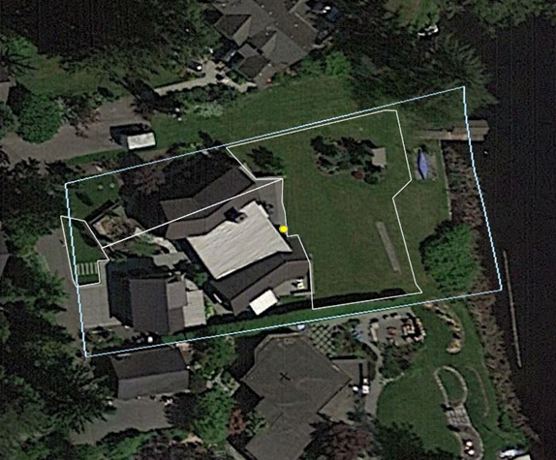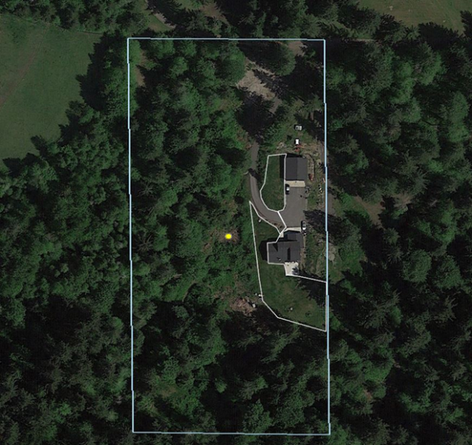
Figure 1. Example Irrigated Area Delineations
Results of the irrigated footprint analysis are summarized in Table 3. The analysis covered seven of the ten subbasins in WRIA 8 with projected permit-exempt well connections. Due to small sample sizes, the subbasin-level results for Lake Sammamish Creeks, Sammamish River Valley, and May/Coal subbasins are not considered representative. Parcels in these subbasins were included in the overall average, but average irrigated areas from similar adjacent subbasins (Bear/Evans, Little Bear, and Lower Cedar, respectively) were used for the purpose of subbasin-scale consumptive use estimates. Note that more permit parcels than the target minimum sample were analyzed in four of the subbasins. When identifying the random list for analysis, the GeoEngineers team identified ten additional sites beyond the target minimum of 30 to allow for dropping parcels that did not meet the analysis criteria (e.g. construction not completed). The full list was analyzed, resulting in a few parcels above the target minimum in each subbasin. Similarly, one of the seven parcels in the May/Coal subbasin had to be dropped, so the analyzed sample is smaller than the projected target.
The Puget Sound Shorelines, Greater Lake Washington, and Swamp/North subbasins (with two, four, and five projected permit-exempt well connections, respectively) did not have any recent building permits for sites without purveyor-provided water service from which to estimate subbasin-specific irrigated area. The average irrigated area for the Little Bear subbasin was applied for purposes of subbasin-scale consumptive use estimates. Puget Sound Shorelines, Greater Lake Washington, and Swamp/North subbasins are almost entirely within the Urban Growth Area (UGA) and may have homes on smaller lots with smaller lawns than homes in Little Bear subbasin, which is mostly outside the UGA.

Table 3. WRIA 8 Irrigated Footprint Summary
Subbasin | Parcels Analyzed | Total Irrigated Area (ac) | Average Irrigated Area (ac)
Bear/Evans | 39 | 12.2 | 0.31
Issaquah | 33 | 12.3 | 0.37
Lake Sammamish Creeks | 1 | 1.5 | 0.31†
Little Bear | 37 | 10.2 | 0.28
Lower Cedar | 35 | 11.6 | 0.33
May/Coal | 6 | 1.4 | 0.23†
Sammamish River Valley | 2 | 0.3 | 0.28†
Full Analysis | 153 | 49.4 | 0.32

† Calculated averages not used due to small sample size. Adjacent subbasins substituted.

Crop Irrigation Requirements
The amount of irrigation water required to grow and maintain vegetation depends on the crop, season, and local climate (temperature and precipitation) and thus varies by location throughout the WRIA. The Washington Irrigation Guide (WAIG) (NRCS, 1997) includes an appendix listing net irrigation requirements for various common crops for 89 locations throughout Washington, derived from water use and meteorological data from the 1970s and 1980s. Since lawn is a fairly water-intensive crop and the most common target of residential irrigation, irrigation requirements for turf were used to estimate outdoor water needs.
Using the one WAIG station within WRIA 8 (Seattle-UW) and surrounding stations to the north, south, and east, the GeoEngineers team spatially interpolated crop irrigation requirements (CIRs) across WRIA 8 by creating a triangulated irregular network (TIN) surface between the WAIG station points. Since there are no stations east of Snoqualmie Falls, a lower value was imposed along the Cascade crest to enforce continued reduction in CIR with increasing precipitation. A value of 8 inches per year was used for the boundary value; this is believed to be a conservative value based on nearby Cascade foothill station estimates from an unpublished irrigation data set being developed by Washington State University (Peters et al., 2019). Values from the resulting TIN surface were averaged over each subbasin to estimate the irrigation requirement for each subbasin. This analysis was performed for both annual and summer (June-July-August) irrigation requirements to provide information to compare peak summer water use to annual use estimates. Figure 2 shows the locations of WAIG irrigation data stations and the interpolated distribution of annual turf irrigation requirements across WRIA 8. Table 4 summarizes the average values for both annual and summer CIRs for subbasins with projected permit-exempt well connections. Annual values were used for the consumptive use calculations described in this memo.
The CIR is the net amount of external water required by the crop, accounting for precipitation inputs. Since irrigation systems are not 100% efficient, additional water must be supplied to ensure that crop needs are met. The application efficiency varies by the type of system (drip irrigation, microsprinklers, pivot sprinklers, etc.). For WRIA 8, the Ecology-recommended value of 75% was used to determine the water applied for irrigation.
Outdoor water use for each home was then estimated as the applied water for irrigation (computed as a depth) times the average irrigation area. The consumptive use fraction is substantially higher for outdoor use than indoor use (to a septic system) because most of the applied water is taken up by plants or evaporated. Based on the Ecology guidance, a consumptive use fraction of 80% was applied to the total outdoor water use, meaning that 80% of water used for outdoor watering does not return to the local groundwater system.
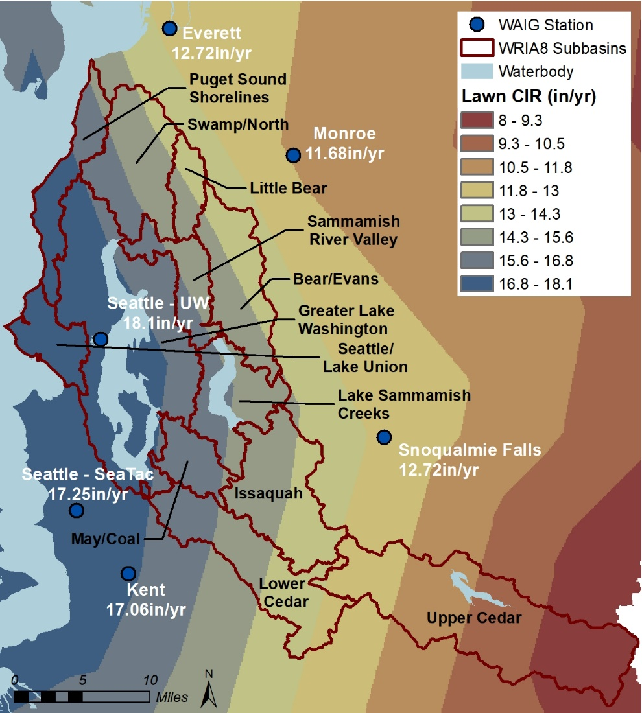
Figure 2. Spatial Distribution of Annual Turf Irrigation Requirement

Table 4. WRIA 8 Crop Irrigation Requirements
Subbasin | Annual Turf CIR (in) | Summer (JJA) Turf CIR (in)
Puget Sound Shorelines | 16.78 | 12.62
Swamp/North | 15.22 | 11.99
Little Bear | 14.35 | 11.51
Sammamish River Valley | 15.55 | 12.31
Bear/Evans | 14.33 | 11.65
Greater Lake Washington | 17.15 | 13.11
May/Coal | 16.15 | 12.67
Lake Sammamish Creeks | 15.46 | 12.28
Issaquah | 14.36 | 11.83
Lower Cedar | 14.53 | 11.89
WRIA Average* | 15.66 | 12.35

* Subbasins with projected PE wells only

Total Consumptive Use
The methods described above were used to compute indoor and outdoor consumptive use per permit-exempt well connection. Totals for each subbasin were then computed by multiplying per home values by the projected number of permit-exempt well connections in each subbasin. The GeoEngineers team developed a consumptive use calculator (Excel spreadsheet) to compute consumptive use for projected permit-exempt well connections for each subbasin and the WRIA as a whole. Table 5 summarizes the consumptive use estimate, which assumes one home with the measured subbasin-average yard area per permit-exempt well. The consumptive use estimate for WRIA 8 is 425.4 acre-feet per year.

Table 5. Annual Consumptive Use for One Home with Subbasin Average Yard
Subbasin ID | # PE Wells Anticipated in Subbasin | Irrigated Area per Well (ac) | Per Well Consumptive Use (gpd) |  |  | Total Consumptive Use (af/yr)
 |  |  | Indoor | Outdoor | Total
Puget Sound Shorelines | 2 | 0.28† | 16.5 | 372.8 | 389.3 | 0.9
Swamp/North | 5 | 0.28† | 16.5 | 338.2 | 354.7 | 2.0
Little Bear | 118 | 0.28 | 16.5 | 318.8 | 335.3 | 44.3
Sammamish River Valley | 8 | 0.28‡ | 16.4 | 345.5 | 361.9 | 3.2
Bear/Evans | 234 | 0.31 | 16.4 | 352.5 | 368.9 | 96.7
Greater Lake Washington | 4 | 0.28† | 16.4 | 381.0 | 397.4 | 1.8
May/Coal | 15 | 0.33‡ | 16.4 | 422.9 | 439.3 | 7.4
Lake Sammamish Creeks | 6 | 0.31‡ | 16.4 | 380.3 | 396.7 | 2.7
Issaquah | 235 | 0.37 | 16.4 | 421.6 | 438.0 | 115.3
Lower Cedar | 340 | 0.33 | 16.4 | 380.5 | 396.9 | 151.2
WRIA 8 Aggregated | 967 | 0.33 | 16.4 | 376.3 | 392.7 | 425.4
† Representative measured value not available; uses Little Bear subbasin average irrigated area.
‡ Calculated average not used due to small sample size. Surrogate subbasin used: Little Bear for Sammamish River Valley, Lower Cedar for May/Coal, and Bear/Evans for Lake Sammamish Creeks.

Consumptive Water Use Scenarios
The consumptive use calculator was also used to explore additional consumptive use scenarios. “Default” input parameters and values discussed in the methods section above can be modified to explore the effect of changes or uncertainties in individual assumptions. Based on requests from the technical workgroup and Committee, two additional scenarios were computed, and annual consumptive use results are summarized in Table 6 and Table 7:
- One home with legal maximum 0.5-acre irrigated lawn area per permit-exempt well. Assumes 60 gallons per day per person indoor use and 0.5-acre outdoor irrigation use.
- Legal right to water use of 950 gallons per day (annual average) per well connection for indoor and outdoor household use. Assumes 60 gallons per day per person and remainder to outdoor use.

Table 6. Annual Consumptive Use for One Home with 0.5-ac Yard
Subbasin ID | # PE Wells Anticipated in Subbasin | Irrigated Area per Well (ac) | Per Well Consumptive Use (gpd) |  |  | Total Consumptive Use (af/yr)
 |  |  | Indoor | Outdoor | Total
Puget Sound Shorelines | 2 | 0.5 | 16.5 | 665.7 | 682.2 | 1.5
Swamp/North | 5 | 0.5 | 16.5 | 603.8 | 620.3 | 3.5
Little Bear | 118 | 0.5 | 16.5 | 569.3 | 585.8 | 77.4
Sammamish River Valley | 8 | 0.5 | 16.4 | 616.9 | 633.3 | 5.7
Bear/Evans | 234 | 0.5 | 16.4 | 568.5 | 585.0 | 153.3
Greater Lake Washington | 4 | 0.5 | 16.4 | 680.4 | 696.8 | 3.1
May/Coal | 15 | 0.5 | 16.4 | 640.7 | 657.1 | 11.0
Lake Sammamish Creeks | 6 | 0.5 | 16.4 | 613.4 | 629.8 | 4.2
Issaquah | 235 | 0.5 | 16.4 | 569.7 | 586.1 | 154.3
Lower Cedar | 340 | 0.5 | 16.4 | 576.5 | 592.9 | 225.8
WRIA 8 Aggregated | 967 | 0.5 | 16.4 | 574.4 | 590.8 | 640.0

Table 7. Annual Consumptive Use for Annual Average 950 gpd Water Use per Connection
Subbasin ID | # PE Wells Anticipated in Subbasin | Irrigated Area per Well (ac) | Per Well Consumptive Use (gpd) |  |  | Total Consumptive Use (af/yr)
 |  |  | Indoor | Outdoor | Total
Puget Sound Shorelines | 2 | 0.47 | 16.5 | 628.0 | 644.5 | 1.4
Swamp/North | 5 | 0.52 | 16.5 | 628.0 | 644.5 | 3.6
Little Bear | 118 | 0.55 | 16.5 | 628.0 | 644.5 | 85.2
Sammamish River Valley | 8 | 0.51 | 16.4 | 629.0 | 645.3 | 5.8
Bear/Evans | 234 | 0.55 | 16.4 | 628.6 | 645.0 | 169.1
Greater Lake Washington | 4 | 0.46 | 16.4 | 629.0 | 645.3 | 2.9
May/Coal | 15 | 0.49 | 16.4 | 629.0 | 645.3 | 10.8
Lake Sammamish Creeks | 6 | 0.51 | 16.4 | 629.0 | 645.3 | 4.3
Issaquah | 235 | 0.55 | 16.4 | 629.0 | 645.3 | 169.9
Lower Cedar | 340 | 0.55 | 16.4 | 629.0 | 645.3 | 245.8
WRIA 8 Aggregated | 967 | 0.55 | 16.4 | 628.7 | 645.1 | 698.9

Daily usage rates shown in Table 5 through Table 7 represent annual average values. While indoor use generally does not vary much from month to month, outdoor water needs range from zero during the winter rainy season to more than three times the annual average during the peak of the summer. Since streamflows are lowest in late summer for most western Washington streams, the Committee may consider peak summer water use along with annual use when developing the watershed restoration and enhancement plan. It is important to remember that pumping rates are likely not equivalent to consumptive use impacts on stream depletion. While Ecology’s NEB guidance recommends considering stream depletion impacts to be a steady-state equivalent, there may be circumstances within a watershed where that is not appropriate.

Total Water Use and Comparison to Water Purveyor Data
Water use data from water purveyors to rural areas in the central Puget Sound were obtained as one benchmark for comparison with estimated permit-exempt well usage. Snohomish County Public Utilities District #1 (Snohomish County PUD), serving about 20,000 customers in central and northern Snohomish County, and Covington Water District, serving about 18,000 customers in southern King County, each provided metered water use data from 2015 and 2017. In addition, Snohomish County compiled annual water demand forecasts from water system plans for 17 water purveyors operating in the county. Table 8 (next page) summarizes the available water purveyor data. Reported values are total water use, not consumptive use. For the two metered systems providing data, the average annual use is approximately 220 gpd per household. About 160 gpd is attributed to indoor uses (year-round) and 50 to 70 gpd (averaged over twelve months) to outdoor uses. Note that outdoor use is typically concentrated over about three months during the summer, which equates to rates of 150 to 200 gpd of outdoor watering for those three months.
Since most water purveyors charge customers by the amount of water delivered (not just consumptively used)—and in some cases at increased rates as water use goes up—metered water users may exhibit more water conservation behaviors than unmetered users. Total water use breakdowns for the projected permit-exempt well scenarios are presented in Table 9. Estimated indoor use of 164 gpd for the permit-exempt well scenarios is very consistent with the water purveyor data (based on metered winter water use), between 150 and 170 gpd.
Average annual total use for permit-exempt wells estimated from this analysis (see Table 9) are considerably higher, however, due to outdoor use estimates about a factor of 10 greater than average metered use: 470 gpd estimated for permit-exempt wells versus 50 to 70 gpd for metered users on an average annual basis or 1,500 gpd estimated for permit-exempt wells versus 150 to 200 gpd for metered users on average during the summer. The magnitude of this difference seems unlikely to be accounted for strictly by price pressures and thus suggests that assumptions in this analysis regarding watering behavior are generally conservative. For example, studies have shown that most residential lawn watering is conducted at a deficit level to maintain some growth and green color (Water Research Foundation, 2016), versus the assumption of watering for optimal growth of commercial crops (like a sod farm for turf grass) implicit in the WAIG crop irrigation requirements. Conservative assumptions for future new household water use, and outdoor water use in particular, can be justified to account for uncertainty inherent in estimating growth patterns, domestic permit-exempt well pumping rates, and potential changes in outdoor watering practices.

Table 8. Water Purveyor household water USe Data
Water Purveyor | Average Annual Water Use (gpd) | Average Winter Water Use (gpd) | Average Summer Water Use (gpd)

Metered Water Use Data†
Snohomish County PUD‡ | 237 | 170 | 370
Covington Water District | 200 | 150 | 300

Comprehensive Plan Forecast
Alderwood | 169
Cross Valley* | 234
Edmonds | 201
Gold Bar | 171
Highland* | 200
Marysville | 168
Monroe | 170
Mukilteo | 179
Olympic View | 189
Roosevelt* | 383
Silver Lake | 177
Snohomish | 190
Snohomish County PUD* | 190
Stanwood | 282
Startup* | 250
Sultan | 190
Three Lakes* | 191
*Average Rural Non-City | 241

†Data from 2015 and 2017 ‡Average use for parcels ≥1 acre *Rural (non-city) water provider

Note: Reported values are total water use, not consumptive use.

Table 9. Estimated Permit-exempt Well Total Water Use
Scenario | Average Annual Water Use (gpd) | Average Indoor Use (gpd) | Average Annual Outdoor Use (gpd) | Average Summer Outdoor Use (gpd)
1 home, average measured yard | 634 | 164 | 470 | 1,522
1 home, 0.5 ac yard | 882 | 164 | 718 | 2,321
1 home using 950 gpd (annual average) | 950 | 164 | 786 | n/a

Note: Reported values are total water use, not consumptive use.

References
Department of Ecology (Ecology), 2019. Final Guidance for Determining Net Ecological Benefit: GUID-2094 Water Resources Program Guidance, Appendix A: Streamflow Restoration Recommendations for Water Use Estimates. Publication 19-11-079, July 2019.
GeoEngineers, 2019. WRIA 8 Growth Projections. Technical memorandum prepared for Washington State Department of Ecology. October 2019.
Natural Resources Conservation Service (NRCS), 1997. Irrigation Guide. National Engineering Handbook, Part 652. U.S. Department of Agriculture, Natural Resources Conservation Service. Issued September 1997.
Peters, R.T., L. Nelson, and T. Karimi, 2019. Consumptive Use and Irrigation Water Requirements for Washington. Washington State University Irrigated Agriculture Research and Extension Center. Not yet published, provided 26 September 2019. Associated database: WA Irrigation Water Reqs.mdb.
RH2 Engineering, 2018. Potential Consumptive Use Impacts of Domestic Groundwater Permit-Exempt Wells Over the Next 20 Years in WRIA 1 – FINAL UPDATED. Technical memorandum prepared for Washington Department of Ecology, August 2018.
Water Research Foundation, 2016. Residential End Uses of Water, Version 2. Executive Report. Published April 2016.

50 gpd over 12 months is equivalent to 200 gpd over 3 months, both totaling about 18,000 gallons
Metered summer usage for several individual homes in the Covington Water District showed outdoor usage ranging from 25 gpd to 2,693 gpd for July-August 2015.

