DECEMBER 2019 MEETING SUMMARY
Cedar-Sammamish (WRIA 8)
Watershed Restoration and Enhancement Committee
Tuesday, December 10, 2019 | 9:30 a.m. - 12:30 p.m. |Committee website

Location

Room 2AB

Ecology NW Regional Office

3190 160th Ave SE, Bellevue
Committee Chair
Stephanie Potts
Stephanie.Potts@ecy.wa.gov
425-649-7138

Next Meeting
Tuesday, January 28, 2020
12:30 p.m. – 3:30 p.m.
Tukwila Community Center

Please send corrections to Stephanie Potts (Stephanie.Potts@ecy.wa.gov) by January 15, 2020.

Attendance

Committee Representatives and Alternates*

Dan Von Seggern, Center for Environmental Law and Policy
Evan Swanson, Kent
Denise Di Santo, King County
Rick Reinlasoder, King County Agriculture Program
Gina Clark, Master Builders Association of King and Snohomish Counties
Carla Carlson, Muckleshoot Indian Tribe
Elizabeth Garcia (alternate), Seattle
Terri Strandberg, Snohomish County
Julie Lewis (alternate), Snoqualmie Indian Tribe
Kurt Nelson, Tulalip Tribes
Stewart Reinbold, Washington Department of Fish and Wildlife
Stephanie Potts (chair), Washington State Department of Ecology
Ingria Jones (alternate), Washington State Department of Ecology
Jason Wilkinson (cities caucus rep), WRIA 8 Salmon Recovery Council, ex officio

Cities caucus members: Bellevue, Bothell, Issaquah, Kenmore, Mukilteo, Redmond, and Sammamish

Committee Members Not in Attendance*

Alderwood Water & Wastewater District

Other Attendees

Eric Ferguson, King County
Joe Hovenkotter, King County
Elisa Dawson, Snohomish County
Susan Gulick (facilitator), Sound Resolutions
Caroline Burney (information manager), Cascadia Consulting Group
Bridget August (technical consultant), GeoEngineers
John Covert, Washington State Department of Ecology
Paulina Levy, Washington State Department of Ecology

*Attendees list is based on sign-in sheet.

Standing Business
Facilitator reviewed the agenda. No revisions to the agenda.
Chair did not receive comments on the meeting summary. The Committee voted to approve the October WRIA 8 WREC meeting summary, with the cities caucus representative abstaining. The final version will be posted on the Committee website.

Updates and Announcements
Chair provided updates from Ecology.
- Box.com: This document-sharing tool contains temporary, draft, resources/reference materials, collaborative documents, and the handouts for Committee meetings. All committee members have permissions to review, edit, download, and upload materials. All meeting materials, agendas, and summaries will continue to be posted on the Committee website. Let Stephanie know if you have technical issues accessing the WRIA 8 Committee folder on box and test your ability to edit on this test document. You can edit using google docs; Microsoft Office online; downloading, editing and uploading; or by downloading Box edit (which opens the document on your computer and syncs changes back to box).
- Committee Overview and Timeline Handout: this brochure is intended to be shared with colleagues and decision makers within your entity as well as outside partners. It provides a summary of the Committee’s task, membership, upcoming decisions, and general timeline of the steps in our process.
- Rural development presentation: Gina Clark, Master Builders of King and Snohomish County, is helping to organize a presentation on rural residential development by Clay White and his colleagues at Land Development Corporation. Clay was previously the Planning and Development Services Director for Snohomish County and participated in watershed planning processes in eastern Washington and can speak about rural development from a variety of perspectives. Please let Stephanie know by 1/13/20 if you have specific topics you’d like Clay to talk about during his presentation at the January 28th meeting.
  - Committee members are interested in hearing about the following topics: regulations/incentives/barriers for low impact development, encouraging native vegetation, limiting fertilizer use; longevity of LID techniques after a home is occupied or when home ownership changes; landscaping requirements in rural areas; water use for swimming pools; county policies to limit domestic wells/require water service connection.
- WRE Plan Outline: The plan itself will be short (about 30 pages long) with a summary of the process, methods, and selected projects. Detailed information, including technical memos prepared by the consultants, will be attached in a technical appendix. Let Stephanie know by 1/27/20 if you have comments on the draft plan template.
- WRE Plan - Local Approval Process Form: Each Committee representative (including cities caucus members) will have a final vote to approve the plan (anticipated for Q4 2020 or Q1 2021). The chair and facilitator would like to have a better understanding of your internal approval process so we can build in time and provide the resources you need to get internal approval before the final vote. Please complete the form and send to Stephanie over email by 3/26/20, or bring to the March meeting.
- 2020 meeting schedule: This is the last Committee meeting of 2019. The next committee meeting will be a joint meeting with the WRIA 9 WREC on January 28, 2020. Please hold the morning of February 27, in case we need to meet. Starting March 2020, meetings will occur the fourth Thursday of every other month, with workgroup meeting during the months between committee meetings.
- Technical Workgroup: the workgroup met on November 26 and the meeting notes are posted in the technical workgroup folder on box. The next workgroup meeting will be January 23 and focus on project screening criteria.
Consumptive Use Update

Objectives
- Review and discuss WRIA 8 consumptive use memo and calculator
- Discuss GeoEngineers and HDR coordination on irrigated footprint analysis
- Discuss next steps for consumptive use estimate
Reference Materials (latest versions in consumptive use folder on box)
- Consumptive use memo
- Consumptive Use Calculator Tool
Bridget August reviewed revisions to the WRIA 8 consumptive use memo and calculator based on feedback at the October meeting and provided by email. Revisions include:
- Corrected the Snohomish County average household size (from 2.9 people per home to 2.75)
- Added additional language regarding using the Little Bear average lawn size for Puget Sound Shorelines, Greater Lake Washington and Swamp-North subbasins
- Revised the description for the 950 gallons per day scenario
- Corrected the subbasin names in the calculator
- Revised language on water purveyor data based on Snoqualmie Tribe’s comments
Ecology had our two consultants evaluate the average outdoor watering areas for parcels relying on permit-exempt wells across 8 planning areas (GeoEngineers for WRIAs 7, 8 and 9, and HDR for WRIAs 10,12,13,14 and 15) and requested that consultants perform limited cross checking (QA/QC). The technical consultant teams are collaboratively developing a memo outlining their results and conclusions, which we will release to the committees in early 2020. The workgroup and Committee will discuss the QA/QC results at upcoming workgroup and Committee meetings. The Committee will discuss timing for a decision on the consumptive use estimate at the January 28 meeting.
Discussion
- The aerial photos used for the outdoor irrigation analysis showed that most parcels are not irrigated at rates high enough to allow a clear distinction between irrigated and non-irrigated areas. The estimate for outdoor water use is likely high because it assumes outdoor watering rates equivalent to commercial turf.
- Muckleshoot Indian Tribe provided written feedback on the consumptive use memo. Stephanie will address that feedback in the next version. Carla suggested including language in the memo about how landowner practices around outdoor irrigation could change in the future as justification for conservative outdoor consumptive use assumptions.
Next Steps
- Committee members should send Stephanie comments on the latest version of the Consumptive Use memo (version dated 12/16/19 in the Consumptive Use folder on box) by 1/13/20.
- Stephanie will send the technical memo on the irrigated footprint QA/QC results in January.
- The workgroup and Committee will review the results of the QA/QC at the next meeting and discuss whether to make any changes to the consumptive use estimate and memo. The technical consultants will revise the consumptive use memo to incorporate changes suggested by the workgroup and Committee.
- The Committee will vote on the consumptive use estimate in early 2020.
- The workgroup and Committee will continue discussions on the offset target at upcoming meetings.

Identifying Potential Projects
Objectives:
- Recap workgroup meeting and discuss priorities for project identification
- Identify approach for developing the project list
- Identify resources and contacts to assist with project identification

Reference materials
- Projects discussion guide

Water Purveyor Outreach
Carla and Julie provided an update on outreach to water purveyors regarding policies for service connection and well decommissioning. See end of meeting summary for email responses from purveyors.
- The water purveyors contacted do not require well decommissioning after a home connects to water service. They require a reduced pressure backflow assembly and the well can still be used for outdoor watering.
- A Group A water system is required to provide water in a timely and reasonable manner within its retail service area (RCW 43.20.260 and RCW 70.116). Washington State Department of Health produced a summary of the timely and reasonable requirement.
- State law allows counties to adopt regulations governing water service connection (RCW 36.94.130).
- Snohomish County is in the process of drafting a water code.
- Covington Water District defines “timely” and reasonable” in Chapter 1.06 of their District Administrative Code. Stephanie will ask Covington Water District (WRA 9 WREC member) to speak about their code language at the January 28th meeting.
- The Committee discussed the challenges water purveyors face to implement service connection policies, including: political will, time, staff capacity and technical expertise (e.g. having a district engineer on staff).
- The Committee will discuss ideas for policy and regulatory recommendations to include in the plan at an upcoming meeting.

Priorities for project locations and project types
- Stephanie provided a report out on the November 26 workgroup discussion on priorities for project locations and project types. The workgroup recommended:
  - Prioritize water offset projects in subbasins with a high number of projected wells: Lower Cedar, Issaquah, Bear/Evans, and Little Bear. Add Sammamish River Valley because of water temperature and streamflow issues.
  - Prioritize habitat projects based on WRIA 8 Salmon Recovery LE priorities: Lower Cedar, Issaquah, Bear Creek, and Sammamish River Valley.
  - Priority species: Chinook, Oncorhynchus (Sockeye and Kokanee), Coho.
  - Priority project types: water offset benefits, water rights acquisition, near term and reliable benefits.
- The Committee had general agreement to focus efforts on identifying water offset projects, with a high priority on water rights acquisitions.
- Committee members suggested adding Lake Sammamish Creeks as a priority subbasin for habitat because that area is important for Kokanee.
- Stephanie shared a draft scope of work for a water rights acquisition assessment. Committee members agreed on immediately moving forward with the scope of work.
- The committee broke into small groups to discuss and answer the following priority questions:
- What are your thoughts about priority locations?
- What are your thoughts about priority projects?
- What's missing?
- What other ideas would you like the committee to explore?

Process for identifying and reviewing projects
- Stephanie reviewed the proposed process for identifying and reviewing projects (see page 2 of the projects discussion guide).
- The process involves the consultants taking the lead on screening and evaluating projects and the workgroup and Committee members actively looking for projects to include in the plan (both detailed project proposals and project concepts). The workgroup will recommend a list of projects for inclusion in the plan and the Committee will make the decisions on which projects to include.
- The Committee expressed general agreement with the process and supported the consultants and workgroup starting to work on project screening and identification.
- The workgroup will talk more about project screening criteria at the next meeting. The initial purpose for the screening criteria is to narrow down the list of projects so the consultants can do more detailed evaluation of a subset of projects.
- Committee members suggested Ecology distribute an official Call for Projects focused on water offset projects.
- The committee continued project discussions in small groups, focusing on the following process questions:
- What are your thoughts on the proposed process and the outlined roles and responsibilities of the consultants, workgroup, and committee for reviewing the projects?
- Do you think developing project screening criteria would be useful?
- Do you have suggestions for how to prioritize projects for the Committee and consultants to spend more time on?
- What is the preferred process for bringing projects forward for committee consideration?
- What additional resources does each committee member have to assist with project identification?
- Who are key individuals/entities that each committee member can connect with for potential project identification by offset project type?
  - Water right purchase
  - Managed aquifer recharge
  - Projects that shift the source of withdrawal from surface to groundwater
  - Groundwater used for stream augmentation
  - Off-channel storage

- Group 1: Stewart, Julie, Joe, Bridget
- Group 2: Evan, Denise, John, Elisa
- Group 3: Gina, Dan, Terri
- Group 4: Rick, Kurt, Jason
- Group 5: Elizabeth, Stephanie, Carla, Eric

Projects | Priority Locations | - Add Lake Sammamish Creeks because of Kokanee habitat*  - Alignment with where PE wells are going in  - Sammamish Valley- opportunities for recycled water for large irrigators?  - Habitat projects in Bear Creek
 | Priority Projects | - Water-for-water*  - Water rights acquisitions*  - Habitat projects with water offset benefits*  - Multi-benefit*  - Habitat projects  - Changing point of withdrawal on existing wells
 | What’s missing?
 | Other ideas? | - Ensure no negative impacts to aquatic habitat for water storage projects  - Projects in perpetuity  - King County finding funding to remove obsolete structures  - Project monitoring for groundwater recharge
Process | Roles and Responsibilities | - Technical workgroup to bring projects forward*  - Project sponsors- solicitation process, call for projects*  - Streamlined  - Timing really important  - Bring in technical experts
 | Screening Criteria | - Don’t recreate the wheel  - Who applies the screening criteria?
 | Project prioritization | - Feasibility*  - Prioritizing projects with water offset potential*  - Tools to determine offset  - Consider multiple scales for projects and prioritization of projects
 | Project identification | - Consultants find water-for-water projects*  - Project sponsors to bring projects forward and present information*  - Committee talk within their agencies to see if any existing projects*
*items shared by more than one small group
See photos of flip charts at the end of the meeting summary

Adaptive Management
Objective: Generate and discuss ideas for adaptive management in the planning process

Reference materials:
- Adaptive management discussion guide
The Committee broke into small groups and discussed ideas for adaptive management. Photos of the flip charts are included at the end of the meeting summary.
- How does this committee want to engage in the monitoring of success and adaptive management of the plan going forward?
- Do they want to commit to a standing meeting to review progress and make adjustments?
- Are there certain “triggers” that would bring the group back together?
- Do we want to have a subset of the committee meet going forward?
Group A: Ingria (facilitator), Kurt, Jason, Rick, Eric, Elizabeth, Stephanie
- Committee role- meet periodically for 5 years
- Annual report developed by Ecology
  - New PE well count
  - Offset achieved
  - New projects completed
  - Sponsors report
  - NEB achieved
- Project level and plan level
  - Monitor/report project outcomes/benefits/what constitutes triggers?
- Tracking
  - Project funding (across watersheds)
- Committee meeting- ECY convene
  - How often? Who aware of process?
- Triggered to meet:
  - Report may determine whether meet/not
- Recommendation to legislature monitoring future needs
Group B: Susan (facilitator), Gina, Dan, Terri, Denise, Elisa, Evan, John
- Already regional groups that do monitoring
  - Who oversees?
  - Build existing programs- add to existing, don’t reinvent
  - Start with an inventory of what exists
- Monitoring tricky- some items are difficult to measure
  - Streamflows
  - New connections
- Put as much into each project design as possible to require monitoring
  - Plan for max buildout would solve problem of number of connections, being high
  - Don’t limit to 20 years
- Monitor at subbasin level would be ideal
- How do we monitor now?
  - Habitat value
  - Stream gauging
  - Tracking PE wells will be easy
    - 1-2 year cycle to track too frequent; 5-8 years is better
- Does ecology have reporting requirements for this program?
  - PE Wells
  - Other items need to be developed
  - Could ecology inform group on annual data (PE wells, project status, streamflows)
- Don’t know what Ecology will be doing in 20 years
  - Stream monitoring should be a priority
Group C: Paulina (facilitator), Stewart, Joe, Bridget, Julie
- Annual report
  - Track PE Wells (dashboard)
  - By subbasin so can crosscheck with project locations
  - Future analysis of impacts- is this mitigation encouraging more PE Wells to go in? Will the trend change?
  - Making sure ECY is collecting the right info from counties
- 5-year check ins (committee come together)
- Can we add or remove projects in the future?
- Need to monitor projects
  - How to get good data?
  - Enforcement?
- PE well metering? Contentious
  - Volunteer
  - Incentive
- How to quantify habitat projects?

Public Comment
No comments.

Action Items for Chair:
- Ask Covington Water District to speak about “timely and reasonable” policy at the January meeting.
- Send workgroup and Committee results of QA/QC on irrigated footprint analysis.
- Work with Ecology staff and consultants to start water rights acquisitions assessment.
- Draft a Call for Projects to solicit water offset projects.

Action Items for Committee Members
- Let Stephanie know by 1/13/20 if you have specific questions or topics for the rural development presentation at the January meeting.
- Review the latest version of the Consumptive Use memo (version dated 12/16/19 in the Consumptive Use folder on box) and send Stephanie comments by 1/13/20.
- Review draft plan template and send Stephanie comments by 1/27/20.
- Complete the WRE Plan Approval Process form and email it to Stephanie by 3/26/20 or bring it to the March meeting. Prepare to share your internal review and approval process during the March meeting.
- Talk with colleagues and partners about project ideas. The project solicitation and Committee overview handouts are on the Committee website.
- Contact Stephanie if you have technical issues accessing the WRIA 8 Committee folder on box and test your ability to edit on this test document. You can edit using google docs; Microsoft Office online; downloading, editing and uploading; or by downloading Box edit (which opens the document on your computer and syncs changes back to box).
- Send Stephanie corrections to the draft December meeting summary by 1/15/2020.

Next Meeting: Tuesday, January 28
- Next meeting: Tuesday, January 28 from 12:30 p.m. - 3:30 p.m., Tukwila Community Center
  - Joint meeting with WRIA 9 WREC.
- Next Technical Workgroup meeting: Thursday, January 23 from 9:30 a.m. – 11:30 a.m.

Water Purveyor Outreach
Responses from questions Carla, Matt and Julie sent to select water purveyors in WRIA 8 in fall 2019.
Utility | Do you have any policies that allow or limit the installation of permit exempt wells in your service area? Keeping in mind that some of the systems are part of city governments and may have ordinances or codes in place, do you know of any of those? | If they are allowed, what is the criteria you apply to determine whether a new home or subdivision must connect to the water system? i.e., distance to a main line, etc. | If they are allowed, are there any proposals to exclude or limit them in the future? | Do you provide any incentives to encourage homeowners to connect to water service? | When a homeowner that previously used a well connects to water service, do you require well decommissioning? Can the homeowner continue to use the well for outdoor water use?
Union Hill Water District | Union Hill Water is a private, non-profit water purveyor. The Association is governed by a Board of Trustees. Association policy only allows permit exempt wells where our facilities are not available in a “timely and reasonable” way. We are located in a rural area so the distances between properties can be significant. If our members can get an irrigation well permitted we have no policies nor are there county policies/regulations against it. | Our criteria has to do with the cost of extending the water main. | Not at this time. | Not really. If the water main is available they have to connect. | We do not require decommissioning. With proper backflow protection they can continue to use the well for outdoor use.
Woodinville Water District | No, we do not permit or decommission wells. | NA | NA | NA | The District does not require homeowners to decommission wells. Physical separation of the systems is required with a backflow device on the public water service.
Cross Valley Water District | I am not aware of any policies you can check with Snohomish County they set land use regulations. | I can tell you if a customer has a well and is hooked to our system and we know about the well we will require them to install a reduce pressure backflow assembly (RPBA). If they do not want to install the RPBA then we require the well to be decommissioned per Snohomish County DOH or WA State DOE requirements. | This is a question for the County | No, we are a public District so everyone has to pay the same. | Answered on bullet 2. They have to install a RPBA or decommission before we turn on the water meter.
Mirrormont Water Service Utility | If we cannot service a lot within our service area in a “timely and reasonable” fashion, we may consider allowing a lot owner to drill a private well. We generally insist on them signing an agreement stating that at such time as our water main extends to/past their property, they must switch over to our service. | Again, if they are in our service area, then the question becomes can we do it in a “reasonable and timely” manner. This can vary slightly, but we try to be fair to property owners. If they are outside our service area, they are under no obligation to be served by us, and we are under no obligation to serve them, though we may be able to potentially if they desire us to. | See answer to number 1, only allowed on certain circumstances, and we’d prefer not to have them at all, but realize that we can’t hold people hostage either if we can’t reasonably provide service (part of the provisions under the Municipal Water Law). | No, they are responsible for the cost to install any new infrastructure required to serve them (water main extensions, new services, etc.). As a regulated utility, we can’t really provide any “incentives” to get people to hook up to our system. | Don’t necessarily require decommissioning, but lot owner would be required to have an RPBA installed to prevent any backflow into our system.
Cedar River Water & Sewer District | No, we are not the governing agency for permit exempt wells. | Water districts have no authority to compel a connection to a public water system. With regard to whether main extensions are required, the District allows a standalone single family residence to extend a service line no more than 1,320 feet to the public system if it desires to connect. Plats and commercial development that are required to obtain water service from a public water system must extend a main to receive service. We are currently drafting policy language to define timely and reasonable water service. | Again, we are not the governing agency for permit exempt wells. | No | No. Per the District’s Premises Isolation Cross Connection Control Program, a property owner may continue using the well provided the two sources are physically disconnected and a backflow device is installed directly behind/downstream of the District’s water meter.
King County Water District No.90 | We do not have specific policies limited wells. However, we depend on the DOE’s policies that typically do not allow wells in properties that are less than 5 acres (not always the case, but typically). | We do not have specific polices about the requirement to connect. Typically we provide a Water Availability Certificate with estimated costs to connect to our system. At that point it is up to the customers to decide if they want to move forward and if they consider the costs reasonable. | This is not a current topic of discussion for us. | Typically we are cheaper than drilling a well unless the water main has to be extended to service the property. | We do not require decommissioning. However we do require an RPBA backflow device that isolates the well and the District’s system. This device must be tested every year.
Covington Water District | Yes, if requested is located within an UGA, or 700 ft away from an existing main in an RGA, then they are required to connect. Chapter 1.06 of their District Administrative Code (https://www.covingtonwater.com/DocumentCenter/View/51/District-Administrative-Code-DAC?bidId=) | Outside UGA, more than 700 ft away from main in RGA |  |  | Must decommission according to section 1.06.040.F

Identifying Potential Projects – Small Group Discussion
- Group 1: Stewart, Julie, Joe, Bridget
- Group 2: Evan, Denise, John, Elisa
- Group 3: Gina, Dan, Terri
- Group 4: Rick, Kurt, Jason
- Group 5: Elizabeth, Stephanie, Carla, Eric

Group 1:
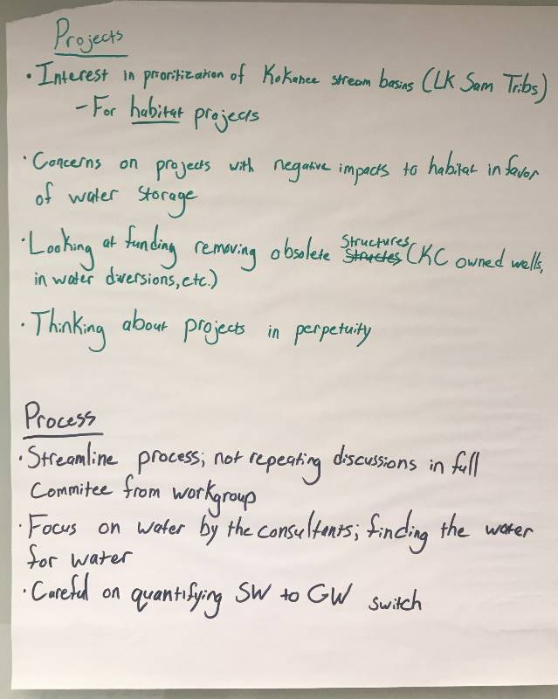

Group 2:
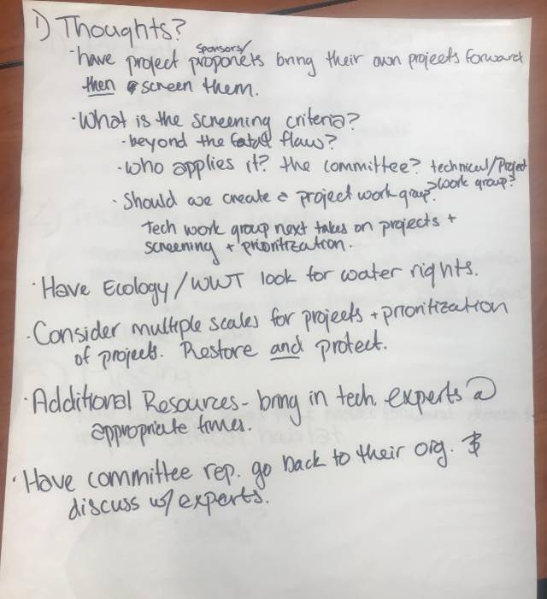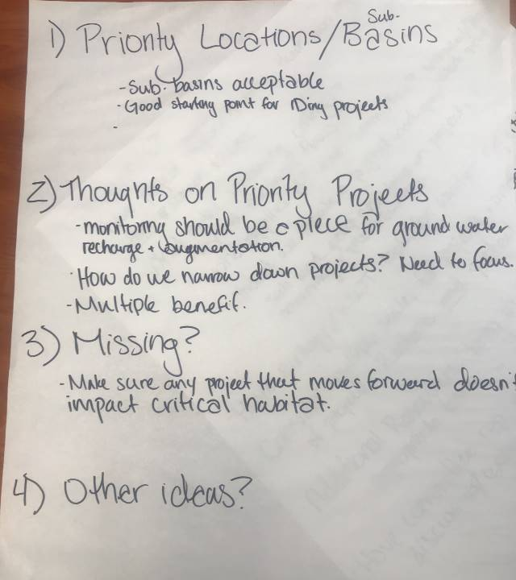

Group 3:
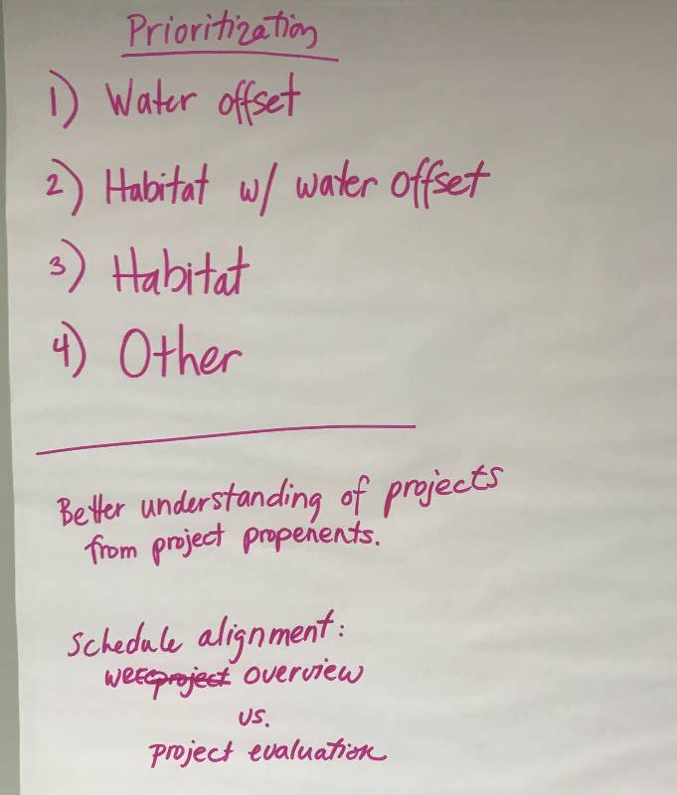

Group 4:
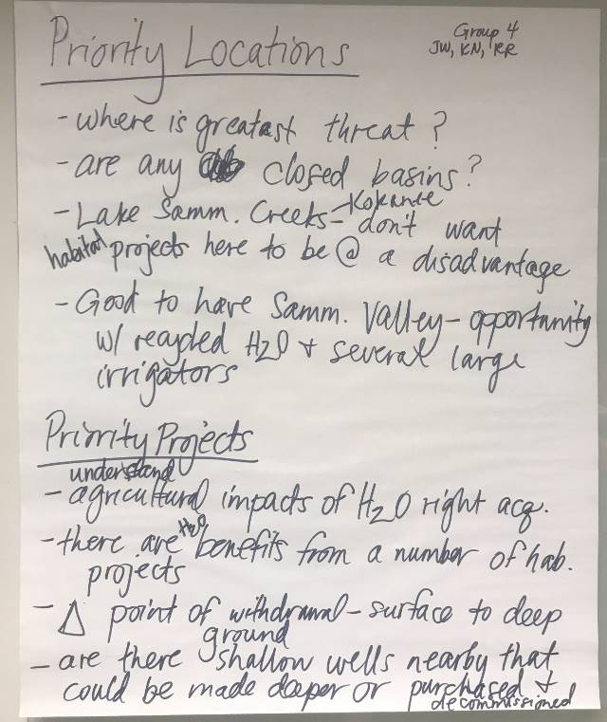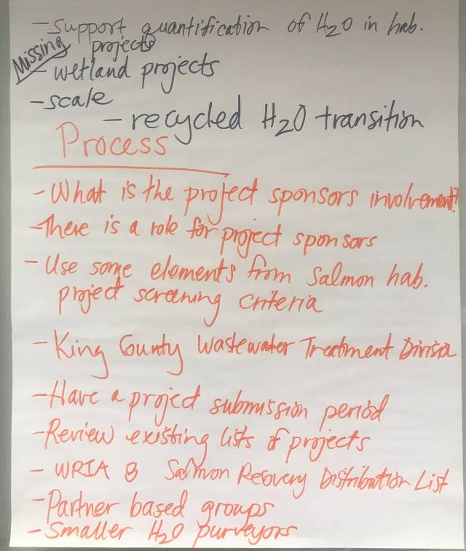

Group 5:
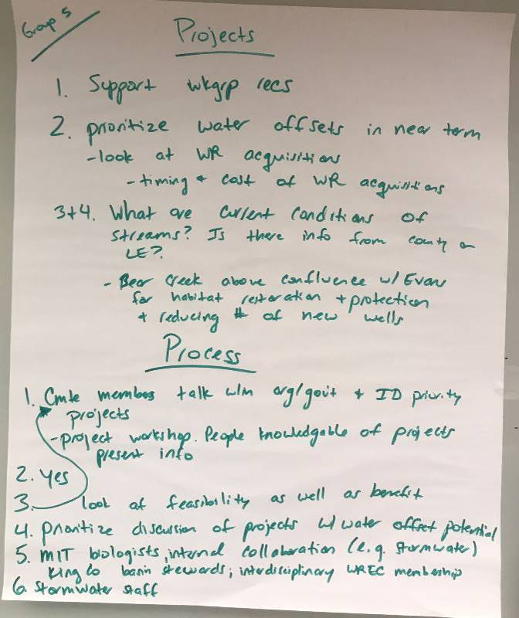

Adaptive Management – Small Group Discussion
- Group A: Ingria (facilitator), Kurt, Jason, Rick, Eric, Elizabeth, Stephanie
- Group B: Susan (facilitator), Gina, Dan, Terri, Denise, Elisa, Evan, John
- Group C: Paulina (facilitator), Stewart, Joe, Bridget, Julie

Group A:
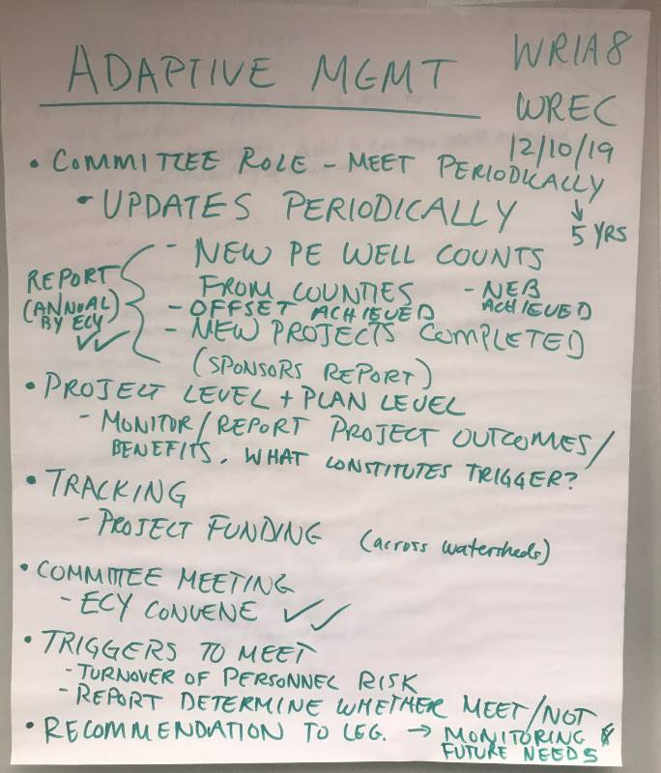

Group B:
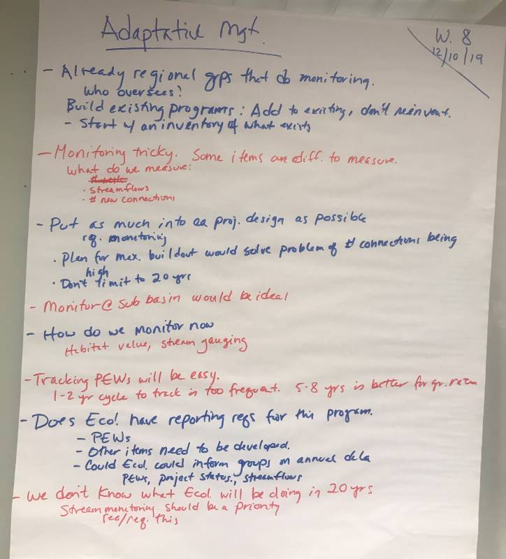

Group C:
