November 2019 DRAFT MEETING SUMMARY
Duwamish-Green (WRIA 9)
Watershed Restoration and Enhancement Committee
November, 19, 2019 | 12:30 p.m. - 3:30 p.m. |Committee website

Location
Black River Room, King Co. South Treatment Plant
1200 Monster Road S.W., Renton

Committee Chair
Stephanie Potts
Stephanie.Potts@ecy.wa.gov
425-649-7138

Next Meeting
January 28, 2020
12:30 p.m. – 3:30 p.m.
Tukwila Community Center
Please send corrections to Stephanie Potts (Stephanie.Potts@ecy.wa.gov) by 1/7/2020.

Attendance

Committee Representatives and Alternates*
Lisa Tobin, Auburn
Trish Rolfe, Center for Environmental Law and Policy
Steve Lee (alternate), Covington Water District
Scott Woodbury, Enumclaw
Evan Swanson, Kent
Josh Kahan, King County
Rick Reinlasoder, King County Agriculture Program
Jennifer Anderson, Master Builders Association of King and Snohomish Counties
Carla Carlson, Muckleshoot Indian Tribe
Kathy Minsch, Seattle
Stewart Reinbold, Washington Department of Fish and Wildlife
Stephanie Potts (chair), Washington State Department of Ecology
Stacy Vynne McKinstry (alternate), Washington State Department of Ecology
Greg Volkhardt, Tacoma Water, ex officio
Matt Goehring (cities caucus rep), WRIA 9 Watershed Ecosystem Forum, ex officio

Cities caucus members: Black Diamond, Normandy Park, and Tukwila

Other Attendees

Eric Ferguson, King County
Joe Hovenkotter, King County
Ruth Bell (facilitator), Cascadia Consulting Group
Caroline Burney (information manager), Cascadia Consulting Group
Bridget August (technical consultant), GeoEngineers
Paulina Levy, Washington State Department of Ecology
John Covert, Washington State Department of Ecology
*Attendees list is based on sign-in sheet.

Standing Business
Facilitator reviewed the agenda. No revisions to the agenda.
Chair did not receive comments on the WRIA 9 WREC October meeting summary. The WRIA 9 Committee voted to approve the October meeting summary, with the cities caucus rep abstaining. The final version will be posted on the Committee website.

Updates and Announcements

Chair provided updates from Ecology.
- Box.com: This document-sharing tool contains temporary, draft, resources/reference, and collaborative documents and the handouts for Committee meetings. All committee members have permissions to review, edit, download, and upload materials. All meeting materials, agendas, and summaries will continue to be posted on the Committee website. Let Stephanie know if you have technical issues accessing the WRIA 9 Committee folder on box and test your ability to edit on this test document. You can edit using google docs; Microsoft Office online; downloading, editing and uploading; or by downloading Box edit (which opens the document on your computer and syncs changes back to box).
- Committee Overview and Timeline Handout: this brochure is intended to be shared with colleagues and decision makers within your entity as well as outside partners. It provides a summary of the Committee’s task, membership, upcoming decisions, and general timeline of the steps in our process.
- WRE Plan Outline: The plan itself will be short (about 30 pages long) with a summary of the process, methods, and selected projects. Detailed information, including technical memos prepared by the consultants, will be attached in a technical appendix. Let Stephanie know if you have comments on the draft plan template.
- WRE Plan - Local Approval Process Form: Each Committee representative (including cities caucus members) will have a final vote to approve the plan (anticipated for Q4 2020 or Q1 2021). The chair and facilitator would like to have a better understanding of your internal approval process so we can build in time and provide the resources you need to get internal approval before the final vote. Committee members suggested creating a standard presentation for internal briefings to explain background information on the streamflow restoration law and the technical components of the plan. Please complete the form and send to Stephanie over email, or bring to the February meeting.
- 2020 meeting schedule: This is the last Committee meeting of 2019. The next committee meeting will be January 28, 2020. Starting February 2020, meetings will occur the fourth Tuesday of every other month, with workgroup meeting during the months between committee meetings.
- Technical Workgroup: the workgroup met on November 13 and the meeting notes are posted in the technical workgroup folder on box. The next workgroup meeting will be mid-January and focus on priorities for project locations and types and project screening criteria.

Consumptive Use

Objectives
- Review and discuss WRIA 9 consumptive use estimate and calculator
- Discuss GeoEngineers and HDR coordination on irrigated footprint analysis
- Discuss next steps for consumptive use estimate

Reference Materials
- Consumptive Use Calculator Tool (latest version in consumptive use folder on box)
Bridget August provided an update on the WRIA 9 consumptive use estimate and reviewed the Consumptive Use Calculator, which the Committee reviewed in detail at the October meeting. GeoEngineers and HDR are doing some coordination and quality control (QA/QC) on the irrigated footprint analysis. GeoEngineers will report the results to the workgroup and Committee in January. We will discuss whether to make any changes to the consumptive use assumptions for lawn size at upcoming workgroup and Committee meetings.

Discussion
- Committee members discussed how the water used for outside irrigation could change in the future – rural residents could use more efficient irrigation practices (lowering the water use) or increase the size of their lawn (increasing the water use). Committee members want all of the assumptions about future outside irrigation practices to be spelled out in the consumptive use technical memo (assume average lawn size remains the same in the future; assume irrigation efficiency of 75 percent, etc). Committee members were comfortable using a safety factor and adaptive management to address potential changes in outside water use, including new policies around water conservation.
- Some committee members commented that the consumptive use calculator is a clear and useful tool to explore the various scenarios and manipulate assumptions (e.g. irrigation efficiency, lawn size, indoor use, etc).

Next Steps
- Stephanie will send more information on the irrigated footprint QA/QC results in the coming weeks.
- The workgroup and Committee will review the results of the QA/QC at the next meeting and discuss whether to make any changes to the consumptive use estimate and memo. The technical consultants will revise the consumptive use memo to incorporate changes suggested by the workgroup and Committee.
- The Committee will vote on the consumptive use estimate in early 2020.
- The workgroup and Committee will continue discussions on the offset target at upcoming meetings.

Identifying Potential Projects

Objective: Review project selection process.
- Recap workgroup meeting and discuss priorities for project identification
- Identify approach for developing project list
- Identify resources and contacts to assist with project identification

Reference Materials
- Project discussion guide (process diagram on page 3)
- Project solicitation handout
- Proposed project screening criteria
- Draft Scope of Work for water rights acquisition assessment

Priorities for project locations and project types
- Ruth provided a report out on the November 13 technical workgroup discussion on priorities for project locations and project types.
  - The workgroup recommends prioritizing water offset projects in subbasins with a high number of projected wells: Soos Creek; Jenkins Creek; Covington Creek; Upper, Middle, and Lower Middle Green; Newaukum Creek; Coal/Deep Creek
  - The workgroup recommends subbasins with little or no wells as a lower priority for water offset projects: Duwamish, Central Puget Sound, Lower Green, and Upper Green.
  - The workgroup did not want to exclude projects in any subbasins.
  - Matt, Carla and Stewart will identify streams to prioritize based on criteria such low flows and critical habitat. The workgroup will discuss how to use this list to prioritize water rights acquisitions, water offset projects, and habitat projects.
  - The workgroup recommends prioritizing water rights acquisitions over other project types.
  - The workgroup discussed the benefits and challenges of some project types and expressed interest in learning more about well consolidation/well decommissioning and the aquifer recharge projects in the Dungeness watershed.
- Stephanie shared a draft scope of work for a water rights acquisition assessment (in the technical workgroup folder on Box). Committee members agreed on immediately moving forward with the scope of work.

Process for identifying and reviewing projects
- Stephanie reviewed the proposed process for identifying and reviewing projects (see page 3 of the projects discussion guide).
- The process involves the consultants taking the lead on screening and evaluating projects and the workgroup and Committee members actively looking for projects to include in the plan (both detailed project proposals and project concepts). The workgroup will recommend a list of projects for inclusion in the plan and the Committee will make the decisions on which projects to include.
- The Committee expressed general agreement with the process and supported the consultants and workgroup starting to work on project screening and identification.
- The workgroup will talk more about project screening criteria at the next meeting. The initial purpose for the screening criteria is to narrow down the list of projects so the consultants can do more detailed evaluation of a subset of projects.

Discussion
The committee broke into small groups to discuss and answer the following priority questions:
- What are your thoughts about priority locations?
- What are your thoughts about priority projects?
- What's missing?
- What other ideas would you like the committee to explore?
The committee continued project discussions in small groups, focusing on the following process questions:
- Considering specific types of projects and project ideas (e.g. water rights acquisition, floodplain restoration, etc). What are the roles and responsibilities of the consultants, workgroup, and committee for reviewing the project? Please consider for each.
- Do you think developing project screening criteria would be useful?
- Do you have suggestions for how to prioritize projects for the Committee and consultants to spend more time on?
- What is the preferred process for bringing projects forward for committee consideration?

- Group 1: Jennifer, Greg, Evan, Josh
- Group 2: Rick, Lisa, Carla, Steve, Eric
- Group 3: Matt, Trish, Scott, Bridget
- Group 4: Kathy, Stewart, Joe, Stephanie

Priority and Process Discussion Summary
Priorities | Priority Locations | - Subbasins with the most PE wells*  - Stream reaches with documented low flows*  - Places with easy aquifer recharge
 | Priority Projects | - Water rights acquisitions & water offset projects (with note that water offset projects cannot impact habitat)*  - Habitat projects with water offset potential*  - How to control water use  - Incentivizing connections to municipal water  - Water storage & habitat (e.g. beavers)  - Agricultural irrigation efficiency through financial incentives  - Floodplain reconnection  - Multiple benefits- ecological restoration
 | What’s missing? | - Cost-benefit analysis  - Long-term benefits  - Certainty of benefits of projects continuing into future; reliable  - Impact of aquifer recharge on water suppliers
 | Other ideas? | - Water augmentation  - Beaver introductions for water storage  - Low impact development - is there credit for going above requirements?  - Multi-benefit projects that are self-sustaining
Process | Roles and Responsibilities | - Consultants workgroup committee*  - All should be involved with project identification  - Challenge: finding a project sponsor
 | Screening Criteria | - Useful to have specific screening criteria  - Durable  - Feasibility  - Water-for-water
 | Project prioritization | - Instream flow benefits over habitat benefits  - Review benefits of past projects  - Caution against prioritizing too quickly  - Criticality of low flow on affected species  - Project type  - Multi-benefits
 | Process for project discussions at WREC meetings | - Organized  - Spreadsheet  - Champion to present projects to committee
*items shared by more than one small group
See photos of flip charts at the end of the meeting summary

Additional comments
- The Committee had general agreement on an overall focus on water offset projects, and a high priority on water rights acquisitions.
- Regarding natural storage, members would like to research how to quantify floodplain storage. The technical consultants are working on a presentation on methods to estimate water offset benefits from habitat projects for the next Committee meeting.
- Members discussed the need to search for project sponsors (to implement a project) and project champions/cheerleaders (Committee members to present on proposed projects during Committee meetings).
- Members suggested Ecology publish an official Call for Projects. The Call for Projects should focus on water offset projects, ask for basic information so it is not burdensome to submit, and go out after the streamflow restoration grant application period closes in order to avoid confusion.
- The Committee will talk about policy and regulatory recommendations in the spring.

Streamflow Restoration Competitive Grants Update

Reference Materials
- Streamflow Restoration Competitive Grants Guidance

Discussion
- Paulina provided an overview of the grant guidance. This round will allocate up to $22 million for eligible projects statewide. Projects include: water rights acquisitions; altered water management or infrastructure; watershed function, riparian, and fish habitat improvements; environmental monitoring; feasibility studies; and water storage. Scoring criteria is outlined in the grant guidance.
- For more information, review the grant guidance and attend an applicant workshop. Details are on the Streamflow Restoration Competitive Grants webpage.

Public Comment
No comments.

Action Items for Chair:
- Send workgroup and Committee results of QA/QC on irrigated footprint analysis.
- Work with Ecology staff and consultants to start water rights acquisitions assessment.
- Continue to work with technical consultants on a presentation on methods to estimate water offset benefits from habitat restoration projects.
- Coordinate with Ecology streamflow restoration staff on creating a standard presentation Committee members can use to brief decision making bodies on the streamflow restoration law, our planning process, and the technical components of the plan (to be completed after plan is drafted).

Action Items for Committee Members
- Review draft plan template and send Stephanie comments before the January committee meeting.
- Complete the WRE Plan Approval Process form and email it to Stephanie by February 23, 2020 or bring it to the February meeting. Prepare to share your internal review and approval process during the February meeting.
- Contact Stephanie if you have technical issues accessing the WRIA 9 Committee folder on box and test your ability to edit on this test document. You can edit using google docs, Microsoft Office online, downloading editing and uploading, or by downloading Box edit (which opens the document on your computer and syncs changes back to box)
- Talk with colleagues and partners about project ideas. The project solicitation and Committee overview handouts are on the Committee website.
- Send Stephanie corrections to the draft November meeting summary by 1/7/2020.

Next Meeting: Tuesday, January 28
Next meeting: Tuesday, January 28 from 12:30 p.m. - 3:30 p.m., Tukwila Community Center

Identifying Potential Projects - Small Group Discussion
- Group 1: Jennifer, Greg, Evan, Josh
- Group 2: Rick, Lisa, Carla, Steve
- Group 3: Matt, Trish, Scott
- Group 4: Kathy, Stewart, Joe, Stephanie

Group 1:
Projects
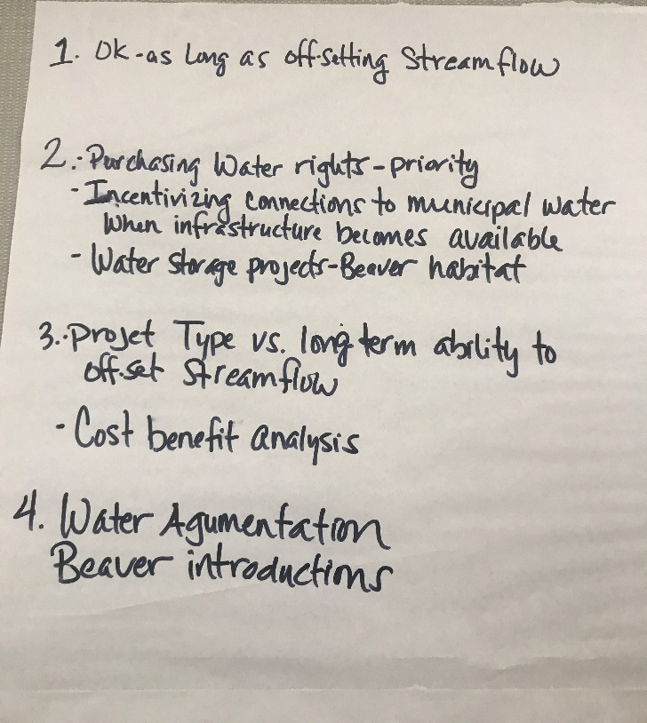
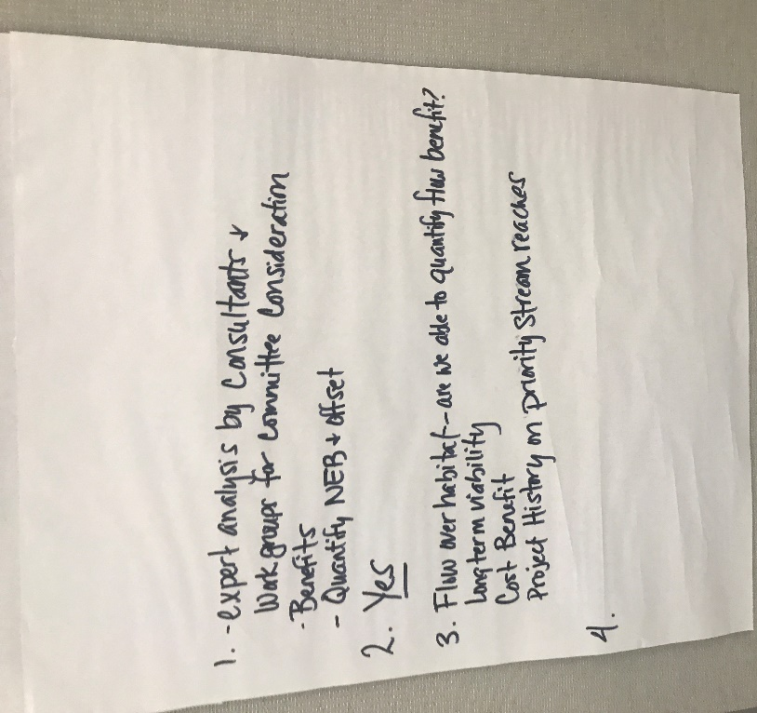
Process
Group 2:
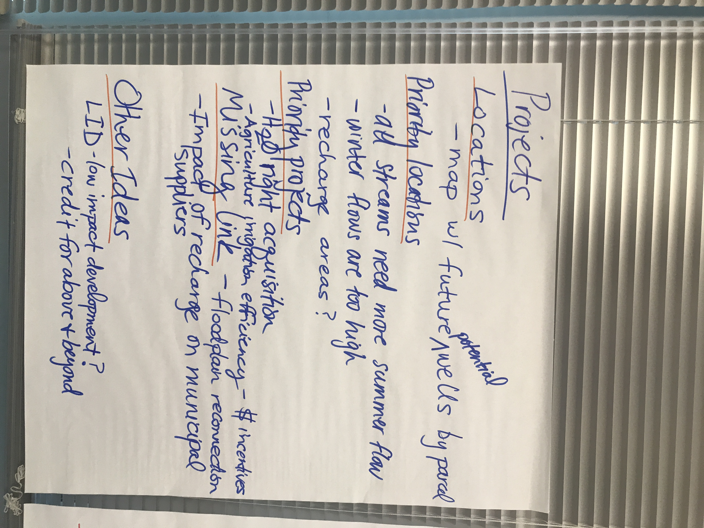

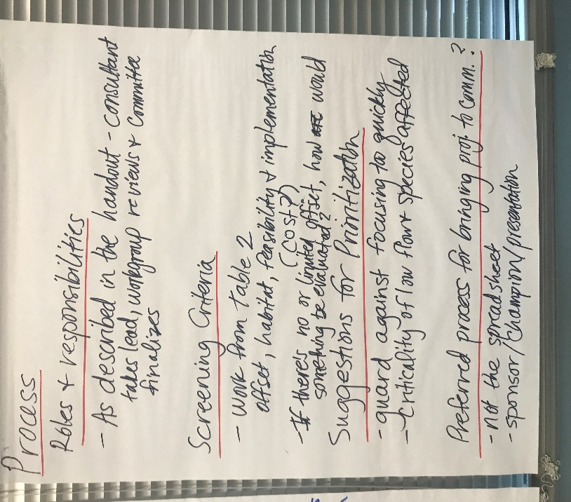

Group 3:

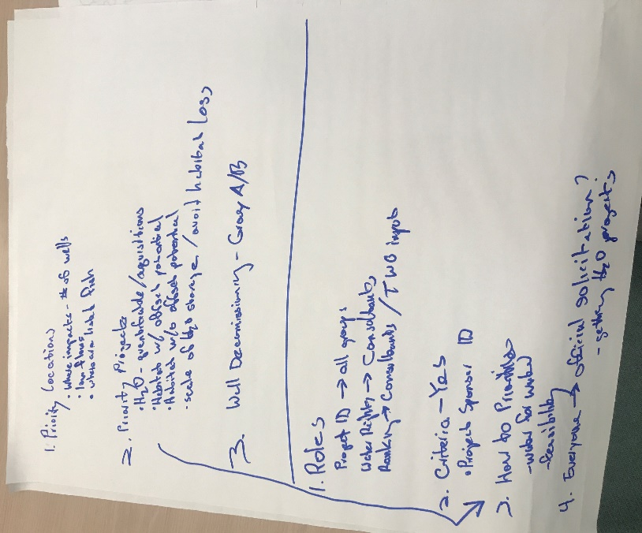

Group 4:

