PE Well Projections in WRIA 12
At the end of August, HDR produced the initial PE well projections for WRIA 12. They are in the middle of developing growth scenarios, which are expected to be complete by the end of September. The WRIA 12 workgroup recommends that HDR move forward with three scenarios, representing high, medium, and low growth periods in the last 20 years. These scenarios are based on the historic PE well data from 1999-2018.
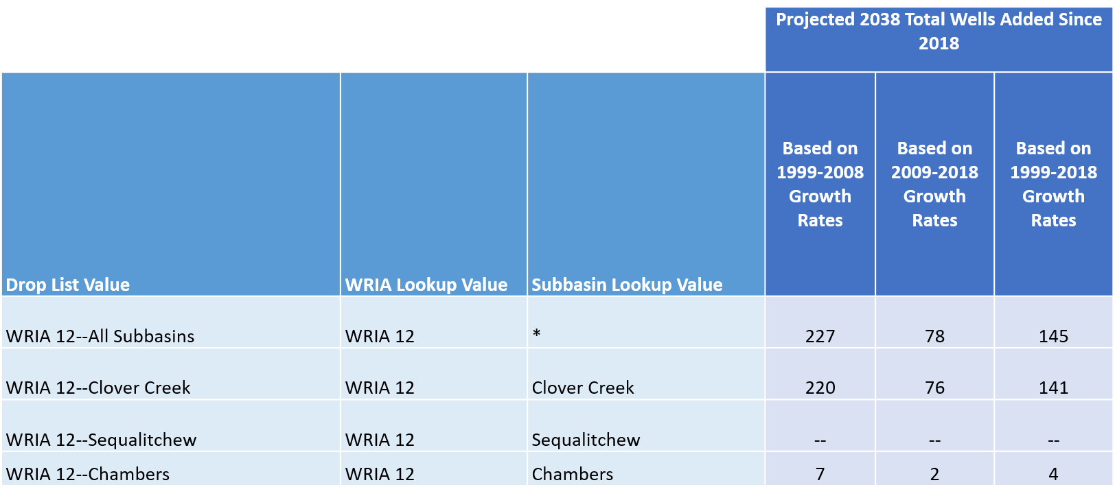
High Growth: the period of 1999-2008 demonstrates high growth as subdivisions and land-use permits issued before GMA was enacted were being finalized. The mid-2000s also saw a housing boom.
Low Growth: the period of 2009-2018 demonstrates low growth as home construction slowed during the recession.
Medium Growth: the period of 1999-2018 represents moderate growth as it averages the high growth times with the low growth times.

