Meeting Summary
WRIA 12 Watershed Restoration and Enhancement Committee
Meeting
January 8, 2020 | 12:30 p.m.-3:30 p.m.| WRIA 12 Webpage | Webmap

Location
Lakewood Community Center
9112 Lakewood Drive SW
Committee Chair
Rebecca Brown
Rebecca.brown@ecy.wa.gov
Handouts
Agenda
Discussion Guide
Project List

Attendance
Committee Representatives and Alternates *

Austin Jennings, alternate (Pierce County)
Char Naylor (Puyallup Tribe)
Rebecca Brown, Chair (Ecology)
Paul Pickett (Squaxin Island Tribe)
Kris Kauffman (Chambers-Clover Watershed Council)
Liz Bockstiegel, alternate (WDFW)
Paul Bucich (City of Lakewood)
Becky Kowalski, ex officio (JBLM)
Calvin Taylor (City of Tacoma)
Renee Buck, alternate (Chambers-Clover Watershed Council)
Ryan Mello (Pierce CD)
Paul Loveless (Town of Steilacoom)
Lisa Spurrier, ex officio (WRIA 10/12 Salmon Recovery Lead Entity)
Don Stanley (Lakewood Water District)

Committee Representatives and Alternates in Not Attendance*

MBA Pierce

Other Attendees*

Spencer Easton (ESA, Facilitator)
Madeline Remmen (ESA, Information Manager)
Jeff Johnson (Spanaway Water)
Burt Clothier (Pacific Groundwater Group)
Angela Johnson (Ecology)
Paulina Levy (Ecology)
Tom Culhane (Ecology)
*Attendees list is based on sign-in sheet.

Welcome, Introductions, and Committee Business
Committee approved November meeting summary with edits.
Committee approved December meeting summary with edits.
Updates:
- Pacific Groundwater Group (PGG) is going to be working on water rights assessment, working on the scope and Rebecca will share it when it is finalized.
- Ecology staff met with Squaxin Island Tribe, was a high level discussion about the importance of projects and implementation.
- Rebecca is putting together a draft work plan for 2020, we are still going to have monthly meetings for quarter 2, but if we work through things faster we can adjust.
- Draft plan should be ready for committee to review by mid-August.
- Draft plan outline on Box and Rebecca will send it out with the meeting notes.
- Grant application workshop webinar on Jan 14 at 10 am and will be recorded and available on Ecology’s website.

Public Comment
No public comment.

Project Discussion
At the project workshop last month, the committee suggested focusing on projects with water offsets where there are impacts, and good habitat projects.

Objective of this discussion: identify projects for HDR to work on. Not the last opportunity to add to the project list.

JBLM presentation: Becky from JBLM spoke about a number of projects on the base (full presentation is available on Box):
- Lake Sequalitchew Repair Project, which will protect JBLM’s drinking water, add water to Sequalitchew Creek instead of a flood control canal, and manage beavers. Water from marshes that used to flow down flood control canal will flow through Sequalitchew Creek. Part of larger effort to restore Sequalitchew Creek.
- Wastewater Treatment Plant Phase 2: Currently produces Class A reclaimed water. Phase would put a purple pipe to distribute water for irrigation. Low on military funding priority. JBLM is adding purple pipe with new projects in preparation for future distribution.
- Retrofitting stormwater.

Jeff from Spanaway Water District suggested an idea to capture stormwater from the North Fork Clover creek and recharge shallow aquifers for benefits downstream.

Committee went through the project list to bucket each project in the appropriate subbasin and project type (offset, habitat with offset, and habitat). Purpose of the activity was to introduce projects on the list, identify gaps, and identify what to ask HDR to start working on. Notes on specific projects are being added to the project list on Box. Photos from the bucket activity are at the bottom of these notes.

Committee discussed how to define NEB and how to choose projects for the list.
- Suggestions to have one good habitat project in each subbasin.
- What are the drawbacks of having many projects on the list. Might not be a problem but committee should prioritize list for both NEB determination and grant funding purposes.

Committee identified options for HDR to work on:
- Develop offset estimate for South Tacoma project based on historical data and new data.
- Underutilized sites study to identify potential opportunities for stormwater infiltration.
  - Focus in upper corner of the Clover basin where future PE well are going to go.
- Identify locations we can do a habitat project that also has an offset benefit, such as floodplain reconnection.

Action Items and Next Steps
- Burt from PGG will do a mapping analysis of infiltration and recharge areas that give us the best base flow benefits. Can be completed in 1-2 weeks. The resulting GIS layer will be useful for additional investigations, such as overlaying heat map or priority stream reaches.
- Rebecca will update the project list based on committee discussion.
- Workgroup will continue the project discussion at their next meeting: Jan. 28, 2020, 10 am -12 pm on WebEx. Agenda includes:
  - Grade projects on 1-5 scale on which ones are the most developed at this point. As we learn more about some projects, their grade may change (ore developed).
  - Review projects for existing sponsors.
    - Add other potential partners in project list.
  - Have conversations about how we want to prioritize habitat projects
- Next meetings:
  - Full Committee Meeting: February 12, 2020, 12:30 pm -3:30 pm, Lakewood Community Center.

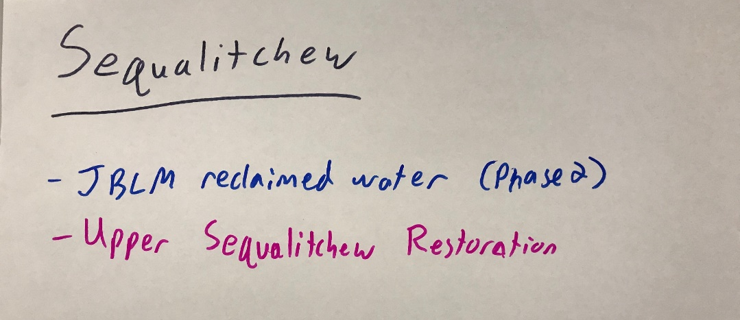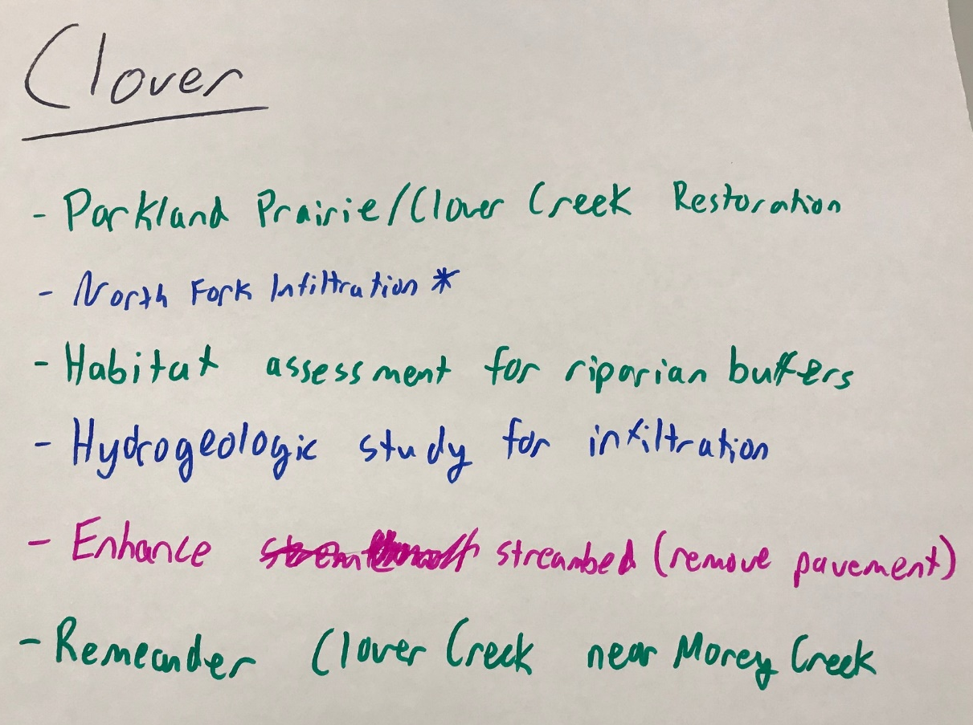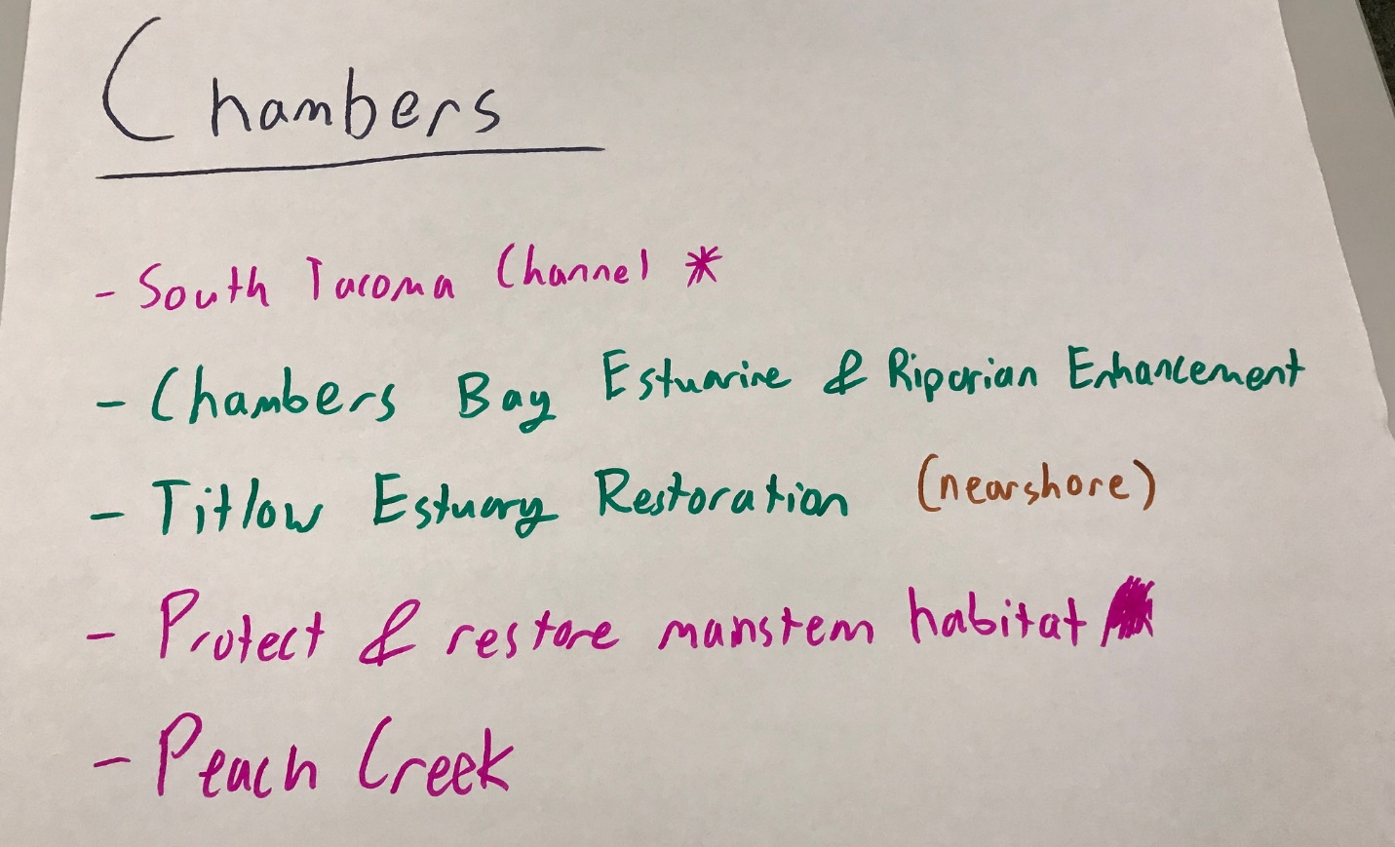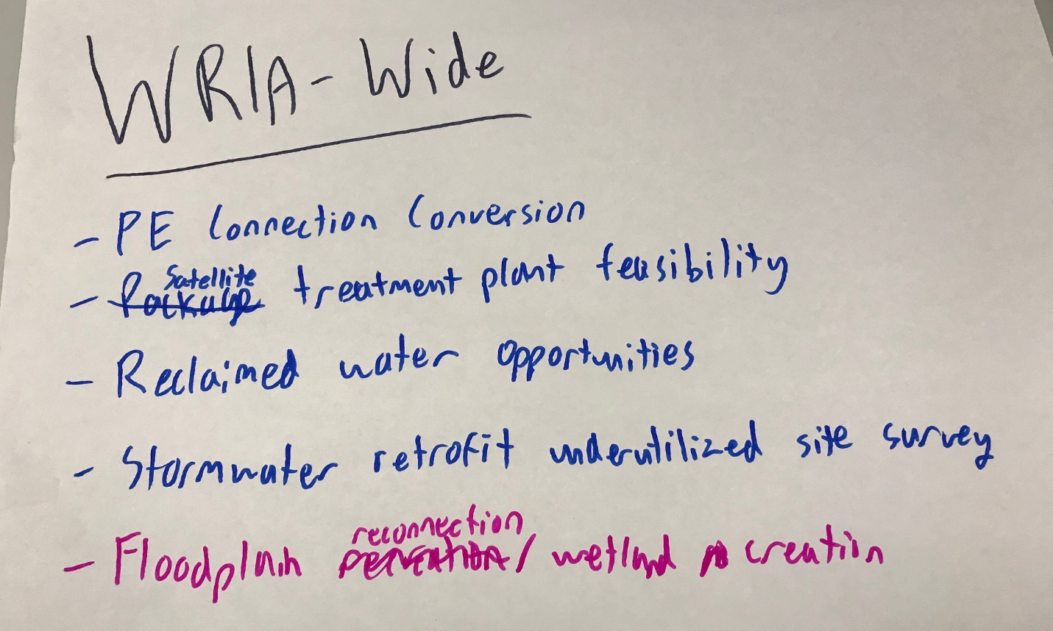
Offset projects are in Blue

Habitat projects are in Green

Habitat + Offset projects are in Pink.

