AGENDA
Watershed Restoration and Enhancement Committee
August 28, 2019 | 9:00 a.m.-12:30 p.m.|WRIA 13 committee website

Location
City of Lacey
City Hall Community Room
420 College St SE
Lacey, WA 98503
Committee Chair
Angela Johnson, Ecology
360-407-6668
angela.johnson@ecy.wa.gov
Handouts
- Workgroup meeting summary

Welcome and Introductions
9:00 a.m. | 10 minutes | Muller

Approval of June Meeting Summary
9:10 a.m. | 5 minutes | Muller | Decision

Updates and Announcements
9:15 a.m. | 10 minutes | Johnson

Ex-officio Membership
9:25 a.m. | 5 minutes | Johnson |Decision
- Consideration of LOTT as WRIA 13 ex-officio member

Workgroup Report
9:30 a.m. | 30 minutes | Johnson/Workgroup | Discussion
- Report from workgroup meeting

LOTT Reclaimed Water Presentation
10:00 a.m. | 30 minutes | Steffensen | Presentation, Discussion
- Wendy Steffenson (LOTT) will provide a presentation to introduce the Committee to reclaimed water as it is produced by LOTT. The Committee will have time for discussions on potential future project types.

Public Comment
10:30 a.m. | 10 minutes | Muller

Field Trip Logistics
10:40 a.m. | 15 minutes | Johnson
- Ecology will provide 2 vans for carpooling that can hold 5/6 people (in addition to the driver) each. Parking at the site is limited, but there should be enough parking for those driving separately.

Action Items and Next Steps
10:55 a.m. | 5 minutes | Johnson/Muller
11:00 am - Break (15 minutes) and Travel (15 minutes to site)

FIELD VISIT - LOTT Hawk’s Prairie Reclaimed Water Ponds
11:30 a.m. | 60 minutes | Steffensen
- Meet at 3001 Hogum Bay Rd NE, Lacey, WA 98516 – Parking lot for Reclaimed Water Ponds
- At this site, Class A Reclaimed Water flows through several wetland ponds before entering shallow basins where it soaks slowly into the ground. Wendy Steffensen (LOTT) will guide the group through the site visit.
- Park in parking area for LOTT ponds – we will meet there before going on the site tour (see image below).

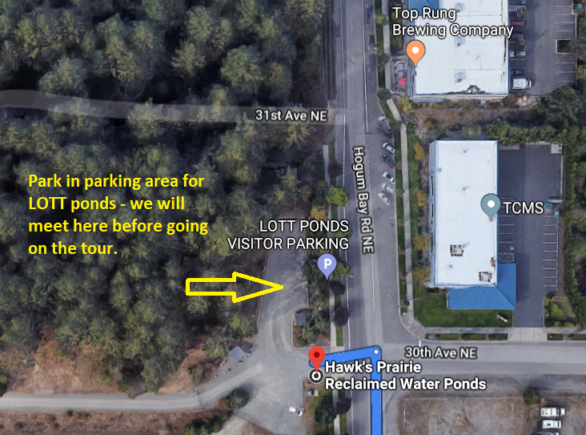

Adjourn
12:30 p.m.
- Those carpooling will return to Lacey City Hall.
- Next meeting— September 25, 2019, 9:00 am – 12:30 pm location TBD

