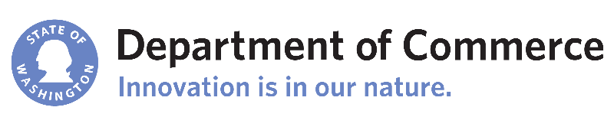
Building Green Cities Project
Incentives for Low Impact Development in Urban Centers
September 2017 – May 2019

Detailed Project Description
Commerce is using a social marketing/economic behaviors approach to research and identify incentives for cities to adopt and developers to use to go beyond municipal stormwater permit requirements in urban centers; specifically, regional growth centers under VISION 2040. It is expected that development and redevelopment in urban centers is planned at higher densities to accommodate population growth. Development and redevelopment is generally expected to include multi-family and commercial development at higher than existing densities. But it may also include single-family residential at higher than existing densities. Incentives could be from state and local governments.

Best practices would include a variety of tools that could be tailored to any size of city. The goal is a suite of tools that could provide any jurisdiction with some suitable options. The focus of the best practices will be on incorporating green infrastructure into new building sites in an urban center, rather than retrofitting existing buildings.

The expected outcome is development and redevelopment in urban centers that provide multiple benefits to the community that could include but are not limited to:
- Increased quality of life for people with green amenities;
- Reduced water quality impacts of stormwater runoff in urban areas;
- Increased flow control on site or for the community; and/or
- Increased tree canopy to reduce urban heat effect and greenhouse gas emissions.

Commerce is convening an advisory committee of cities, counties, municipalities, local developers, the environmental community, and state and federal agencies. With assistance from the advisory committee, Commerce will:

(1) Conduct and produce literature research on the effectiveness of, and barriers to including low impact development (LID) development and redevelopment in urban centers planned for accommodating population growth.

(2) Identify best practices to promote LID to cities, developers, and others involved in the permit process (e.g., commercial developers, architects, engineers, municipal permit officials, etc.) in development and redevelopment in urban centers.

(3) Conduct social marketing research with identified cities, developers and others involved in the permitting process regarding barriers, motivations/benefits to incorporating LID techniques in development and redevelopment of urban centers.

(4) Publish a social marketing report highlighting the results of the research.

(5) Issue guidance for local governments to provide incentives for developers to incorporate LID into projects in urban centers.

“This project is funded wholly or in part by the United States Environmental Protection Agency (EPA) under assistance agreement number WQNEP-2016-WaStDC-00014 to the Washington State Department of Commerce through the Department of Ecology. The contents of this document do not necessarily reflect the views and policies of the EPA, nor does mention of trade names or commercial products constitute endorsement or recommendation for use.”

