DATE: September 1, 2020
TO: Mayor and City Council
FROM: Jesse Reynolds, AICP
SUBJECT: Community Survey Results on Code Changes to Consider Density Increases for Affordable Housing in our Downtown

The purpose of the survey was to help inform staff and elected officials on how to approach downtown redevelopment, specifically regarding the Commerce HB1923 Grant to adopt form-based codes to increase density for affordable housing. Planning Staff and the City’s Architectural Review Consultants Gant Nychay created and distributed widely this survey to gage public sentiment regarding the current status of our downtown, what is valued aesthetically, public safety, and barriers to development. The survey window was August 12th to 24th, 2020 and 351 surveys were completed. This initial section gives a very brief summary of the findings. Councilmembers are encouraged to review a more detailed summary of results that follows this brief narrative. The following pages contain the following results:

- Pages 4 to 5 – summary of downtown services question responses
- Pages 5 to 10 – summary of architecture question responses
- Pages 10 to 11 – summary of responses to questions on views
- Pages 11 to 13 – summary of non-motorized safety question responses
- Pages 13 to 15 – summary of responses questions specifically for developers

From reviewing responses and general reflection on the length and content of the survey, it became apparent some questions were redundant. For this reason, some of the results were omitted due to lack of new info, and to manage the length of this report. Complete results are available upon request.

Downtown Services Results
When asked what people like most about our downtown almost two thirds of the responses to Question 1 were mountain views. The second most popular answer was walkability, followed by access to services. Other answers included people’s enjoyment of the small town feel, the lack of chain stores, and safety.

When asked about the specific services our downtown is lacking in Question 2, restaurants and small shops were mentioned the most, as well as utilizing roof space for seating. Other services were requested. Some also made comments that our downtown needs increased services for what is already present, such as handicap parking. Some also felt there were too many bars but limited basic shopping options. Some felt more amenities for outdoor recreation visitors such as a hotel, while others felt there should be no more growth.
Architectural Results
To develop a theme to the architectural styles most favored by citizens, and to help assist our architects in forming template designs for this effort, we asked survey takers to list the buildings they appreciate most. A list of the top ten is shown under Question 3, most of which fall within our historic district.

Almost half the responses to Question 4 were in favor of keeping the single-family homes in our downtown, whereas the greater portion of respondents felt these areas should be redeveloped. Respondents were also divided as to whether future growth should occur in our downtown or in other areas. The results of Question 5 show a third favor future growth exclusively in our downtown, a third feel future growth should only happen outside of our downtown, the other third is somewhere in the middle. A pattern emerged in this response, presenting the alternative of increasing density for affordable housing near Exit 31 and to a lesser degree Exit 34 were raised by several surveyed. This raises the question of where else Council would feel increasing density for affordable housing is appropriate.

Over half of the respondents felt old buildings should be kept regardless of historic significance, but this result could be related to the way Question 6 was formatted. Staff feels this question was worded poorly, and should have just stated old buildings, and not mentioned historic.

The surveyors were also queried on other communities they see as good examples of city centers. Staff was surprised to find Leavenworth received the most responses to Question 7, given our diversion from a Bavarian theme decades ago. It may be possible the respondents were not referring to the Bavarian theme, but to the outdoor restaurants and shops, mountain town feeling, and size of their downtown. The most mentioned town outside of the WA State was Bend, OR, which warrants further exploration. Overall, Staff sees Bend as a city that creates good people space, meaning there are taller buildings, but there is still vibrant street activity.

Preservation of Views Results
The survey has revealed that the participants value all mountain views, not just the iconic Mount Si. In Question 8 almost 80% ranked the other mountains just as important as views of Mount Si. Revealed in Question 9 is the willingness to have density away from our downtown core to preserve views in this area. Because of these strong values for views, the City may want to consider requiring viewshed analyses for taller developments.

Pedestrian and Bike Safety
Question 10 indicates increased non-motorized transportation infrastructure is greatly desired. On a scale of 1 to 5, 5 being most important, the average score was a shade under 4. Also, in Question 11 three quarters of respondents were in favor of a riverfront park along the banks of the South Fork of the Snoqualmie. Opposition to this park was a minority, and negative comments were mostly associated with private property rights.

Questions for Developers
A set of questions were directed specifically to developers, but Staff should have clarified this better or had a completely different survey for developers, as most answers appear to be from citizens and contain a wide-range of colorful responses, some threatening and some contrasting State law. Regardless, Staff was able to filter the answers and delineate some meaningful themes, as is evident in the summaries of Questions 12 through 14.

Some suggestions from developers to help with creating affordable housing were fairly obvious, such as the suggestion to cut fees and review costs, but there were some innovative examples cited. These examples include cities who have successfully woven affordable housing into their centers without changing their character. There are also good insights to perceived barriers to creating affordable housing in North Bend.
Survey Results Summary:
Gauging what our downtown is currently lacking

Question 1: What do you like most about Downtown North Bend right now?
339 responses received
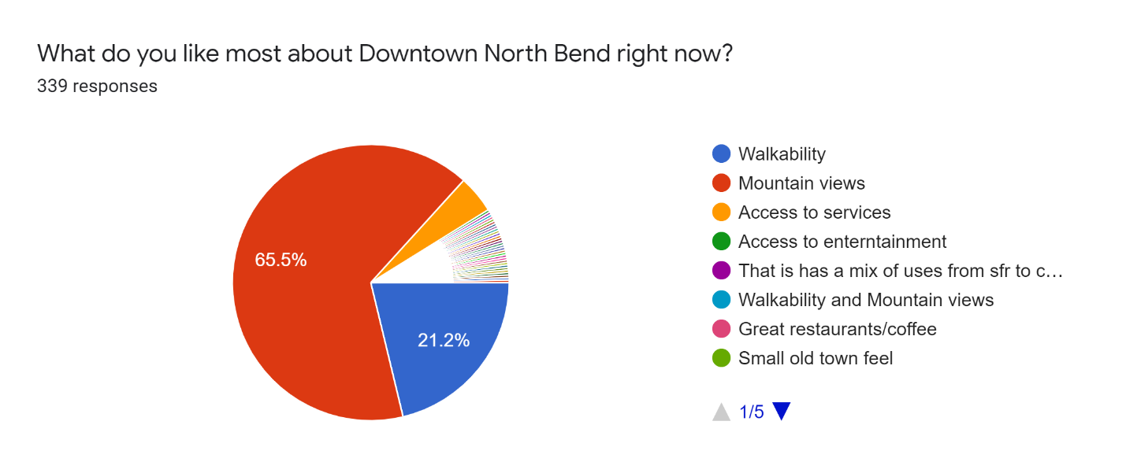
- 222 chose mountain views (65.5%)
- 72 chose walkability (21.2%)
- 15 chose access to services (4.4%)
- 12 left the question blank
The 18 (5.3%) remaining chose freeform answers which can be summarized in the following statements. People love the small town feel, the people, the historic character, the smaller feel than Issaquah, the lack of chain stores, and the safety.

Question 2: Do you feel our downtown lacks access to services such as food, entertainment, places to purchase basic needs?
348 responses received
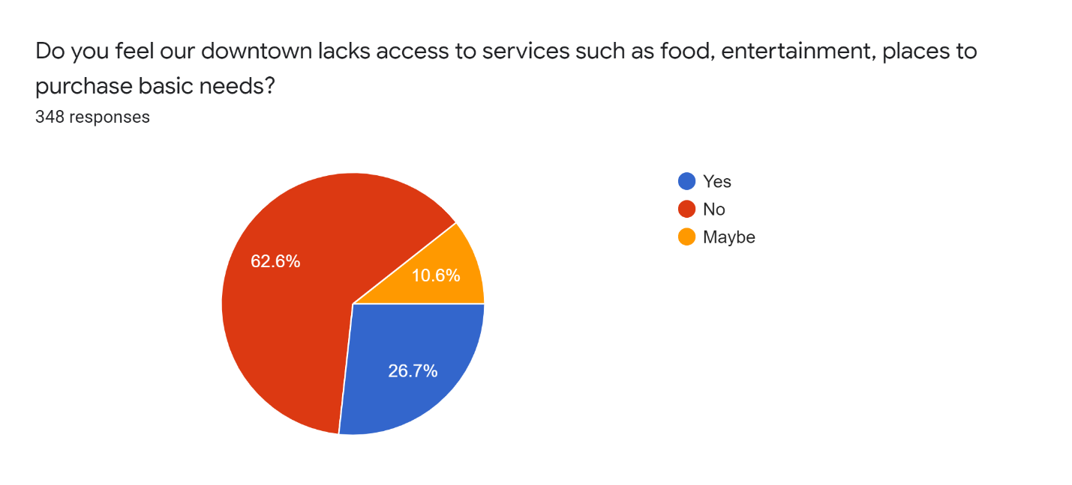
- 218 chose ‘No’ (62.6%)
- 93 chose ‘Yes’ (26.7%)
- 37 chose ‘Maybe’ (10.6%)
- 3 left the question blank
When asked about the specific services our Downtown is lacking restaurants and small shops were mentioned the most, as well as utilizing roof space for seating. Other services were requested. Some also made comments that our downtown, more than needing more, needs increased services for what is already present such as handicap parking. Some also felt there were too many bars but limited basic shopping options. Some felt more amenities for outdoor recreation visitors such as a hotel, while others felt there should be no more growth.

Architectural character of our downtown

Question 3: In terms of architectural character, what buildings/areas within our downtown should be preserved? Are there certain buildings/areas that you feel are sacred to the community??
219 responses received
The purpose of this question was to find themes as to the type of architectural character is favored for our downtown. Key words were searched in the results and the below results were gathered. From this we can see the main preference is the existing historic buildings, with appreciation for some of the newer and remodeled buildings. The below list shows order of frequency, 1 being the most mentioned down. Number of mentions is in parenthesis.
- Twede’s Café (31)
- North Bend Theater (29)
- North Bend Bakery (23)
- Sunset Garage (20)
- Birches building (11)
- North Bend Bar & Grill (11)
- Scott’s Dairy Freeze (10)
- Iron Duck building (10)
- Cook Building (9)
- Train Depot (5)

Question 4: There are several single-family homes sprinkled throughout Downtown North Bend. These properties are unique for our region in that they are zoned for multi-family and commercial use and will likely redevelop in the coming years. How do you feel they should be redeveloped over time?
345 responses received
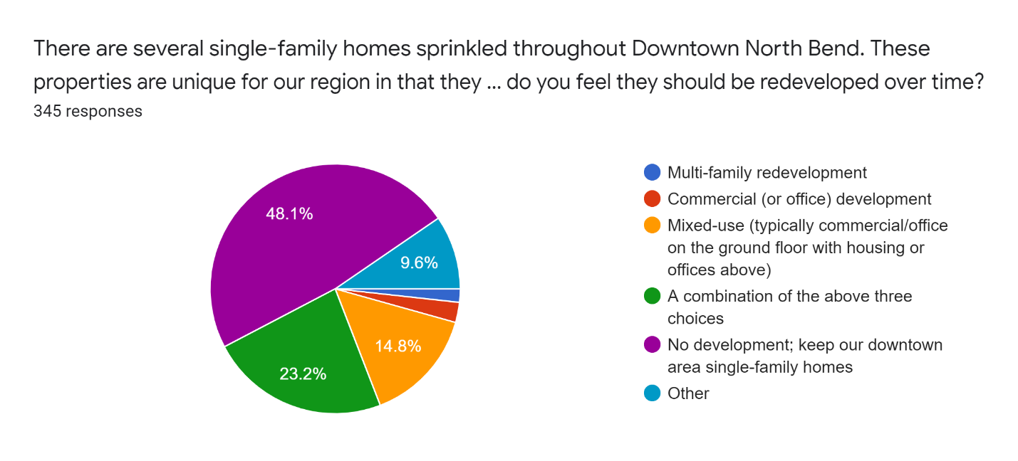
- 166 chose ‘No’ (48.1%)
- 80 chose ‘A combination of the above three choices’ (23.2%)
- 51 chose ‘Mixed-use’ (15.8%)
- 33 chose ‘Other’ (9.6%)
- 9 chose ‘Commercial’ (2.6%)
- 6 chose ‘Multi-family’ (1.7%)
- 6 left the question blank
There were a variety of answers when asked to explain the choice of ‘other,’ most pertaining to maintaining a small-town character, and to include single-family housing.

Question 5: The Growth Management Act of Washington State requires cities like North Bend to accommodate regional growth through land use zoning changes and encourages cities to do so by densifying their downtowns. Do you believe this accommodation of growth should happen in our Downtown or other areas within our City?
322 responses received
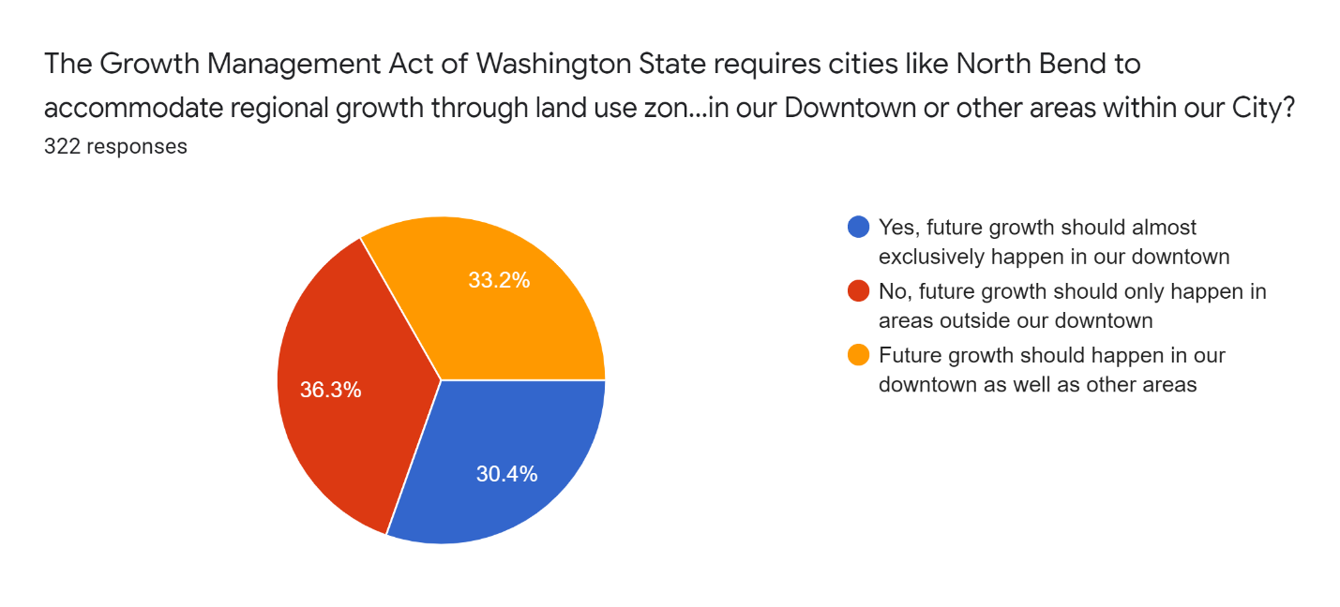
- 117 chose ‘No, future growth should only happen in areas outside our downtown’ (36.3%)
- 107 chose ‘Future growth should happen in our downtown as well as other areas’ (33.2%)
- 98 chose ‘Yes, future growth should almost exclusively happen in our downtown’ (30.4%)
- 29 left the question blank
Those who chose areas outside of our downtown to focus future development elaborated on a few areas. Most answers relevant to the question centered around Exit 31 (Safeway, Outlet Mall, etc) and Exit 34 (Trucktown), with some generally suggesting East North Bend Way between downtown and trucktown. Specifically, 30 answers mentioned Trucktown, 24 answers mentioned Exit 31, and 14 answers mentioned North Bend Way east of downtown.
For those who chose yes or maybe for multifamily housing within the City but outside our downtown had a follow-up question, emphasizing multi-family housing developments should either be in the outskirts of downtown and along East North Bend Way, or near the freeway exits. Specifically, 24 answers mentioned the lands near Exit 31, 21 mentioned Trucktown/Exit 34, 17 mentioned North Bend Way east of downtown, and 10 mentioned the areas just outside of downtown.
Question 6: Downtown North Bend has a colorful history, with many buildings that are historic. Some buildings while also old, do not contain significant architectural features to be considered historically significant. How would you recommend commemorating these buildings?
317 responses received
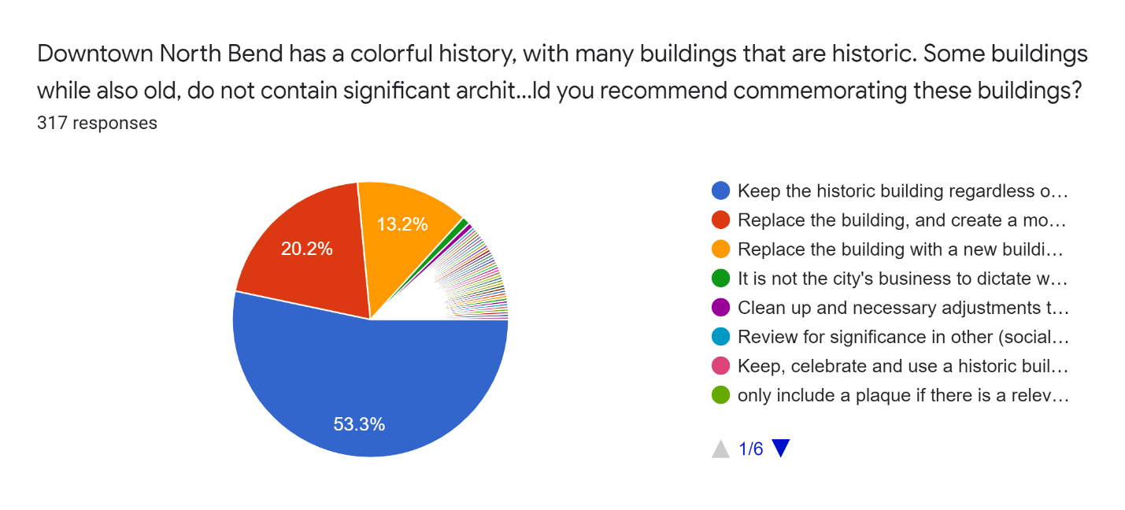
- 169 chose ‘Keep the historic building regardless of historic significance’ (53.3%)
- 64 chose ‘Replace the building, and create a monument or a plaque in place of it (20.2%)
- 42 chose ‘Replace the building with a new building without commemoration’ (13.2%)
- 34 left this question blank
The rest of the answers were a wide range of response content, ranging from suggestions to minor improvements to facades, to taking offense to this question as an infringement to property rights, to stating each building should be taking case by case, to demanding nothing be touched.

Question 7: Modeling other small cities: The City of North Bend welcomes the opportunity to learn from others. What are the elements of other mountainous, picturesque downtowns with more density and housing that you appreciate? Please specify.
198 responses received

Of 198 responses, several towns were mentioned as well as comments on what about these towns was liked. Common features were that the towns were generally small, had a cohesive plan and design theme, were walkable, and maintained mountain views. One other common theme was the interest in supporting locally owned businesses and not allowing chains/national corporations within the downtown.
The most common cities mentioned at a state and local level were:
- Leavenworth (mentioned 16x)
- Snoqualmie (11x)
- Issaquah (10x)
- Carnation (5x)
- Snohomish (4x)
- Duvall (3x)
- La Conner (3x)
- Redmond (2x)
- Kirkland (2x)
- Cle Elum (2x)
- Langly (2x)
- Bellingham (2x)
The most common cities mentioned at a regional and national level were:
- Bend, OR (10x)
- Park City, UT (6x)
- Telluride, CO (4x)
- Jackson Hole, WY (3x)
- Whitefish, MT (3x)
- Hood River, OR (2x)
- Sand Point, ID (2x)
- Sun Valley, ID (2x)
International cities mentioned were:
- Courmayeur, Italy
- Chamonix, France
- Whistler, Canada
- York, England

Preservation of views

Question 8: How much should we consider other mountain views (Rattlesnake Ridge, Mt. Washington, Mailbox Peak, etc.) when accommodating growth in our downtown?
343 responses received
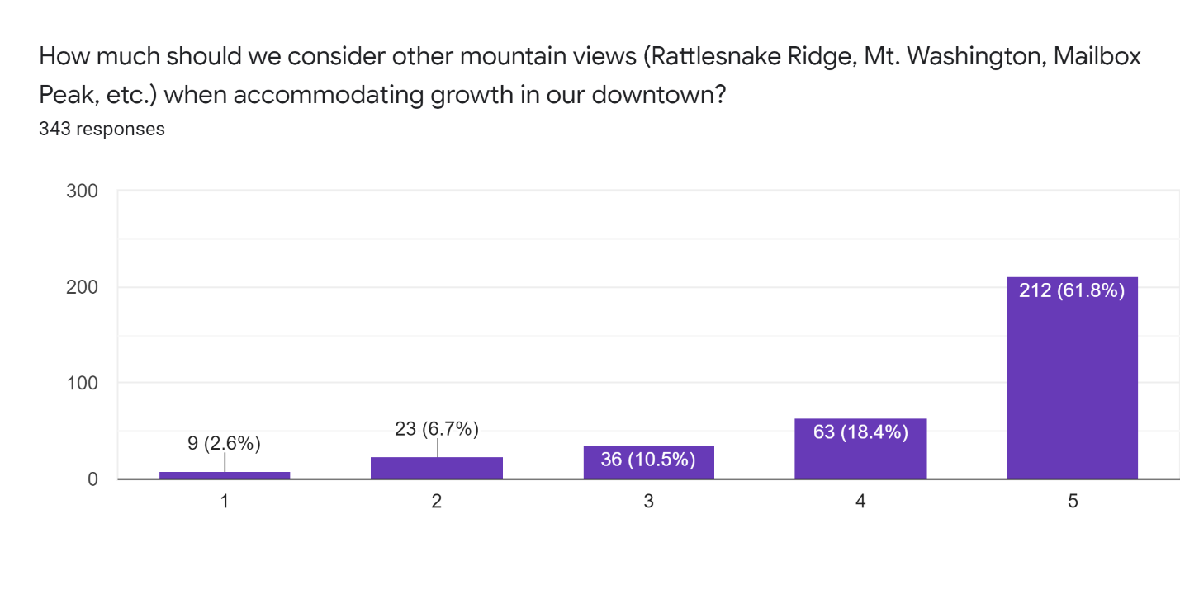

Survey takers were asked to rank the level of importance of other mountain views, ranging from 1 meaning “Not at all” and 5 meaning “The same consideration as Mt. Si.” With almost 80% of takers ranking the other mountains as important as Mt Si, it is evident Mt Si is not the only view of significant value.

Question 9: With a goal of historic preservation, character and retaining our famous views, where do you believe the tallest buildings would fit in Downtown North Bend?
288 responses received
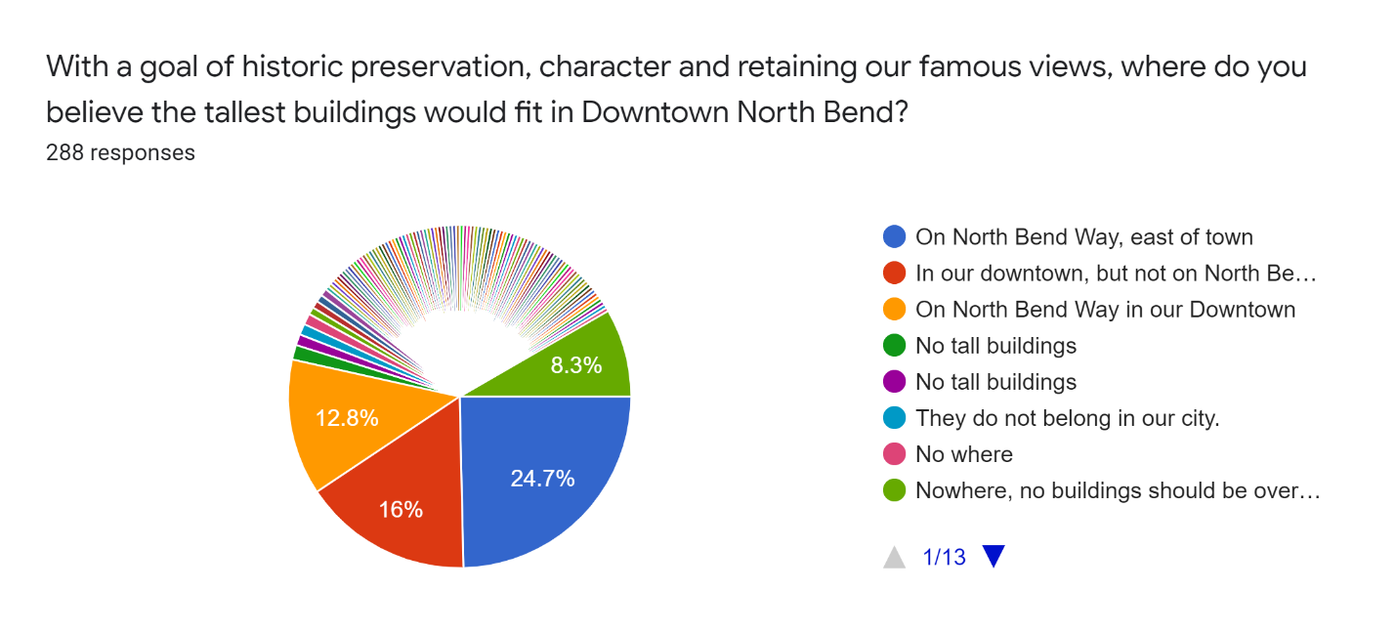
- 71 chose ‘On North Bend Way, east of town’ (24.7%)
- 46 chose ‘In our downtown, but not on North Bend Way’ (16%)
- 37 chose ‘On North Bend Way in our Downtown’ (12.8%)
The rest of the answers either stated areas within North Bend that are outside of our downtown, a mix of locations, in other cities, or nowhere.
When asking survey takers who chose “Other” to specify, common answers included near the freeway exits, i.e. by Safeway and where the hotel was going to go. To a lesser degree, west of downtown was mentioned. Ace Hardware shopping center was mentioned a few times, which should have been added to the ‘In our downtown, but not on North Bend Way’ answer.

Pedestrian & Bike Considerations

Question 10: How important is it to connect our downtown parks with safe, vehicle-free paths for pedestrians and bicycles?
245 responses received
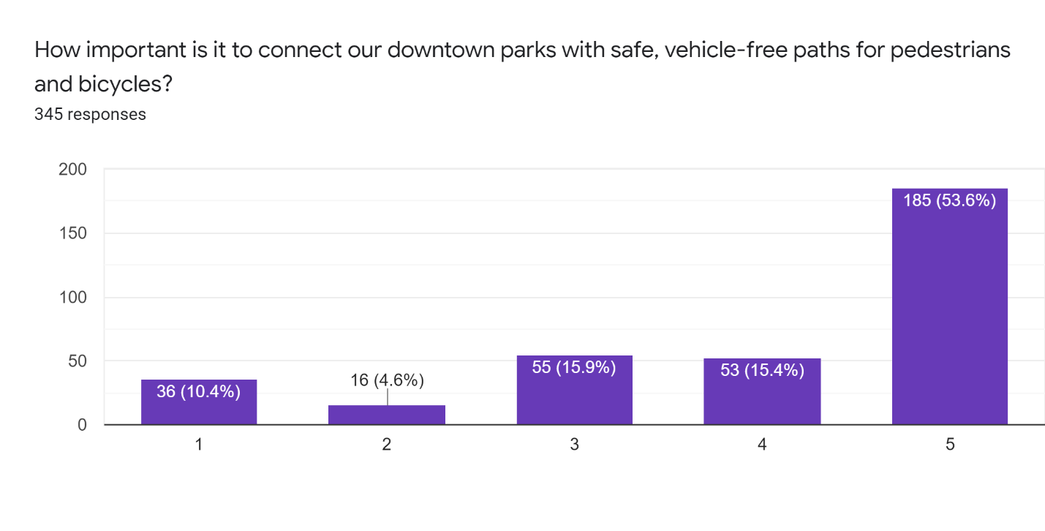
With 1 being ‘Not Important’ and 5 being ‘Extremely Important’, it can be said that the majority of the community values non-motorized transportation infrastructure and safety. The mean response result was 3.97, a shade under extremely important.

Question 11: Would you be supportive of improvements designed to create safe, people-oriented space along the South Fork of the Snoqualmie Riverfront Trail?
245 responses received
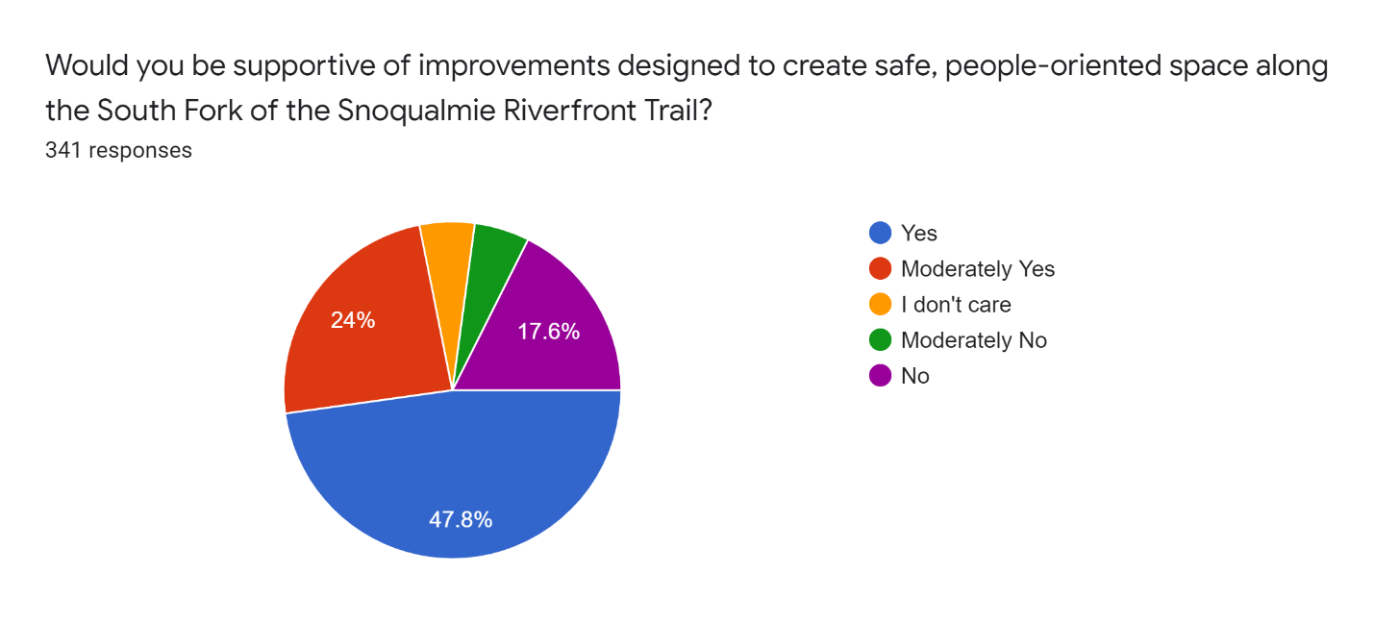
- 163 chose ‘Yes’ (47.8%)
- 82 chose ‘Moderately Yes’ (24%)
- 60 chose ‘No’ (17.6%)
- 18 chose ‘Moderately No’ (5.3%)
- 18 chose ‘I don’t care’ (5.3%)
Despite some polarity, i.e. strong feelings at either end of the spectrum for this answer, the majority almost three quarters, is in favor of a trail.
When inquired about additional comments on the Riverfront Trail, survey respondents had a variety of answers. A few responses claimed these lands are private property and to leave them alone, others were exuberant for such a trail. Some responses provided desired details of specific trail designs and materials, as well as additions such as bridges. Others complained about the garbage left in the proposed trial areas, due to homeless and tourists/visitors. Some also mentioned these areas are already pedestrian friendly and do not need improvement, while others desired improvements for the disabled and small children.

Questions specifically for developers or those interested in the development process
Question 12: How could the City of North Bend’s current regulations and standards be updated to improve our development review process and allow for more affordable housing stock?
103 responses received
A wide range of responses were given, some off-topic, others illegal, some rather offensive. Below is a list of the most frequently mentioned topics received that directly answer the question.
- Cut costs, impact fees, contracted engineering services (mentioned 8x)
- Density increases in general, allow subdivision of smaller lots (3x)
- Better predictability of requirements, process, costs, and vesting (3x)
- Clearer architectural standards & review (3x)
- Gain more political support from elected officials (2x)
- More flexibility in allowed homes and development review process in general (2x)
- Increased heights (2x)
Other responses include:
- Require a percentage of affordable housing for larger developments
- Streamlining lot consolidations
- Better stormwater solutions
- Promote accessory dwelling units
- Better communication with low-income families
Some example design standards were mentioned, and include: Mountlake Terrace Town Center, Snoqualmie and Issaquah.

Question 13: What are examples of other municipalities that have development regulations you feel effectively promote the vision of their downtown and affordable housing?
48 responses received
The most frequently cited municipalities with regulations that effectively tie their vision with affordable housing were the following:
- Issaquah (mentioned 5x)
- Kirkland (4x)
- Redmond (3x)
- Bellevue (2x)
- Mukilteo (2x)
- Snoqualmie (2x)
When asked what codes specifically make these codes effective, people stated:
- Maintained consistency in, vision, feel, blending with other parts of community (mentioned 6x)
- Clear standards, simplified code (2x)
- Design flexibility, open to several typologies (2x)
- Closely working with affordable housing advocates
- More density to "pencil-out" for non-profit developers
- Lessened parking requirements for ADUs/DADUs, cottage, carriage housing
- Adjusted setback requirements for ADUs/DADUs, cottage, carriage housing
- Streamlined review process

Question 14: What are the current hurdles you see with developing affordable housing in downtown North Bend?
104 responses received
Below is a list of the most frequently mentioned topics received that directly answer the question.
- NIMBY, anti-growth attitude (mentioned 15x)
- Cost (14x)
- Water availability (11x)
- Current development code/regulations (2x)
- Density, it is currently insufficient, no credits (2x)
- Lack of vision
- Parking
When asked how could a zoning code update help this, answers included better master planning that includes trade-offs in certain areas when comparing to the zoning map, increased density in general, increased density with a set amount of affordable housing incorporated, and tax breaks.

