Environmental Justice in Remedy Selection
STAG Briefing and Discussion on March 5, 2020
Introduction
The Department of Ecology (Ecology) proposes making targeted changes to the remedial investigation and cleanup action requirements in Sections 350 and 360 of Chapter 173-340 WAC, the Model Toxics Control Act (MTCA) Cleanup Regulation, to require consideration of environmental justice. The proposed changes are intended to provide a framework for Ecology to develop any needed policies or guidance.
Background
WAC 173-340-350 specifies the requirements and procedures for conducting a remedial investigation of the site and a feasibility study of cleanup action alternatives.
- The purpose of a remedial investigation is to collect and evaluate sufficient information to establish cleanup standards and select a cleanup action (WAC 173-340-350(7)).
- The purpose of a feasibility study is to develop and evaluate an appropriate range of cleanup action alternatives to enable a cleanup action to be selected for the site (WAC 173-340-350(8)). The study involves evaluating each alternative to determine whether it meets the requirements for cleanup actions. See Figure 1 below.
WAC 173-340-360 specifies the requirements for cleanup actions and the procedures for determining whether a cleanup action alternative evaluated in the feasibility study meets those requirements. As specified in WAC 173-340-360(2), a cleanup action alternative must:
- Protect human health and the environment.
- Comply with cleanup standards.
- Comply with applicable state and federal laws.
- Comply with other action-specific requirements (such as for dilution or dispersion) and media-specific requirements (such as for groundwater and certain land uses).
- Provide for compliance monitoring.
- Provide for a reasonable restoration timeframe.
- Use permanent solutions to the maximum extent practicable. To make this determination, one must consider the relative costs and benefits of the alternatives (such as protectiveness, permanence, and long-term effectiveness) in a disproportionate cost analysis.
- Consider public concerns raised during the public involvement process.

Figure 1: Remedy selection process under WAC 173-340-350 and 173-340-360
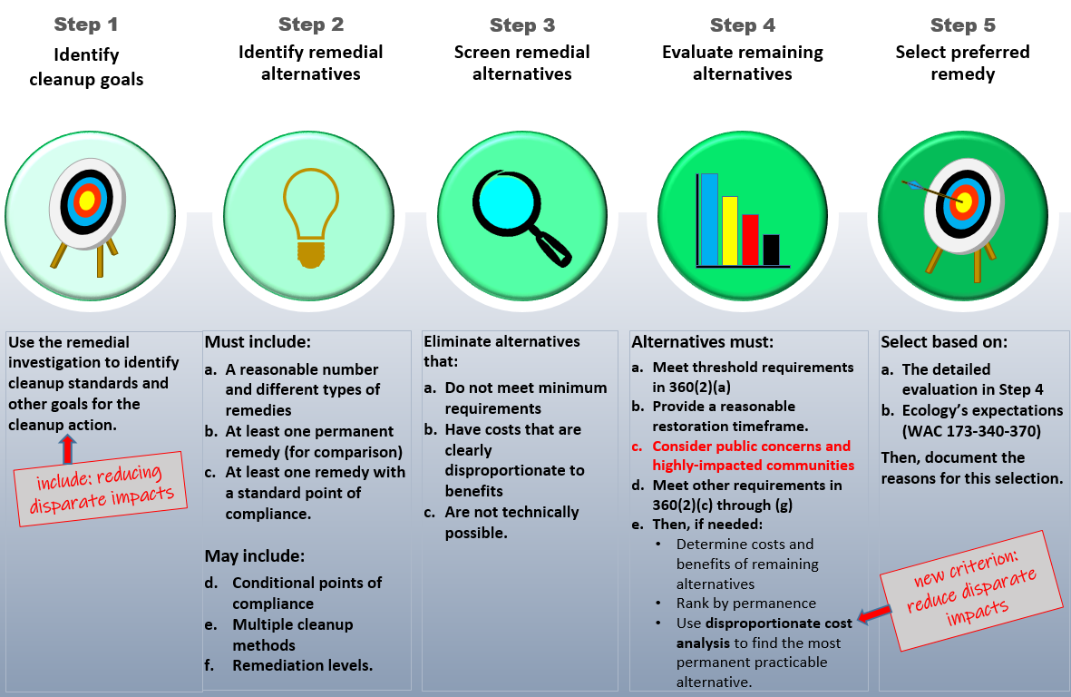
Draft Rule Text and Questions for STAG
To help ensure that environmental justice is considered in the remedy selection process, Ecology is proposing to make the following changes to the requirements for remedial investigations in
WAC 173-340-350 and the requirements for cleanup actions in WAC 173-340-360.
- Remedial investigations Identify disproportionate impacts
  - Overview
In WAC 173-340-350, Ecology is proposing to add a provision requiring an investigation of whether and how a contaminated site may affect a highly impacted community. The information collected would be used to:
- Determine whether and how a community may be disproportionately impacted by the site; and
- Establish cleanup standards and select cleanup actions for the site that reduce disproportionate public health impacts.
  - Draft rule text
Specifically, in subsection (7)(c), the rule would require:
“The collection of sufficient information to determine whether and how the site is likely to affect highly impacted communities.”
  - Questions for STAG:
    - Is it appropriate to require such an investigation?
    - What type of effects should be investigated?
    - What methods should be used to conduct the investigation?
    - Ecology is proposing to specify in guidance, as opposed to rule, the type of effects that should be investigated and the type of methods that may be used to conduct the investigation. Is that appropriate?

- Cleanup action requirements Reduce or eliminate disparate impacts
- Overview and draft rule text
In WAC 173-340-360, Ecology is proposing to add two provisions:
- First, the rule would require that cleanup actions must:
“As appropriate, reduce disproportionate public health impacts of the site, and minimizes disproportionate impacts of the cleanup, on highly impacted communities.”
- Second, when determining whether permanent solutions are used to the maximum extent practicable, the rule would require the following as a comparative factor in the disproportionate cost analysis:
“The extent to which the cleanup action reduces disproportionate public health impacts of the site, and minimizes disproportionate impacts of the cleanup, on highly impacted communities.”
- Questions for STAG:
- Should Ecology require reductions in the disproportionate public health impacts of the site? If so, only “as appropriate”? And if so, based on what considerations?
- Should Ecology require that cleanup actions minimize disproportionate impacts (short or long-term) of the cleanup? For this requirement, should impacts other than public health impacts be considered? If so, how?
- Should the provisions be included both as a general requirement and as a comparative factor in the disproportionate cost analysis?
- Should the provisions be included as a stand-alone requirement and factor, as opposed to under an existing requirement or factor (such as under protectiveness)?
- In practice, what would you do differently to meet these requirements?

https://apps.leg.wa.gov/wac/default.aspx?cite=173-340
https://apps.leg.wa.gov/wac/default.aspx?cite=173-340-350
https://apps.leg.wa.gov/wac/default.aspx?cite=173-340-360

